scientific reports
OPEN | Cognitive Career Alignment and Resume Intelligence System (CareerLens): an explainable multi-model machine learning framework for career classification and maturity assessment

Bobba Yagnik1*, Somu Akash Kumar Reddy1, Songa Sohith Reddy1 & N. Karthikeyan1
In the modern digital recruitment landscape, both hiring organizations and job seekers face significant challenges in career alignment and resume screening. Recruiters are overwhelmed by large volumes of applications, making manual screening labor-intensive, slow, and susceptible to cognitive bias. Conversely, candidates often struggle to understand how their profiles align with target roles or how to optimize their resumes for Applicant Tracking Systems (ATS). Traditional ATS solutions rely on rigid, keyword-matching algorithms that fail to capture the semantic context of a candidate's skills and experience, leading to high rates of false negatives and encouraging keyword stuffing. This project presents CareerLens (Cognitive Career Alignment and Resume Intelligence System), an explainable and data-driven Artificial Intelligence and Machine Learning framework. CareerLens extracts structured profiles from unstructured resumes and aligns candidates with appropriate professional domains. The core architecture uses Natural Language Processing (NLP) to parse PDF/DOCX resumes, extract technical skills, normalize Indian educational standards (10th, Intermediate, BTech, MTech, PhD), and calculate years of experience. For career classification, the system implements a TF-IDF Vectorizer (max_features=5000, n-gram range 1-2) combined with a multinomial Logistic Regression classifier (C=10.0, L-BFGS solver) trained on a structured resume dataset. This model maps candidate text to 25 distinct professional domains. To evaluate applicant maturity, an unsupervised K-Means Clustering model (K=3) groups profiles into Entry-Level, Intermediate, and Senior categories. The system then merges these statistical classification probabilities with direct skill coverage scores via an explainable Blended Probability Heuristic. To provide actionable guidance, the system integrates Google's Gemini Large Language Model (LLM) backed by a local rule-based fallback generator. Evaluated on 2,245 resumes spanning 25 domains, the system secures 94.1% test classification accuracy with an average F1-score of 0.94, delivering fast (<2.5s) and explainable decision-making in human resource management.
1Vellore Institute of Technology, Chennai, India. *email: bobba.yagnik2024@vitstudent.ac.in; n.karthikeyan@vit.ac.in
Introduction
In the modern corporate ecosystem, talent acquisition is a critical driver of competitive advantage. Every year, organizations receive millions of applications, making the process of filtering, evaluating, and placing candidates highly demanding 1. Historically, human resource professionals manually screen resumes, a process that is highly subjective, labor-intensive, and prone to fatigue and cognitive bias. Research indicates that recruiters spend an average of only six to eight seconds reviewing a single resume before making an initial decision 2. Under such time constraints, qualified candidates are often overlooked, while unsuitable applicants pass initial screening rounds due to superficial formatting or keyword alignments. This manual paradigm creates an operational bottleneck, increases hiring costs, and limits organizational matching efficiency 3.
To automate this workflow, many organizations implemented Applicant Tracking Systems (ATS). However, early ATS solutions relied primarily on simple keyword matching 4. These systems search resumes for specific search terms and reject profiles that lack the exact words, ignoring synonyms or semantic context. For example, a candidate with extensive experience in 'deep learning' and 'neural networks' might be filtered out if the job description specifically lists 'machine learning' as a required term 5,6. This keyword-stuffed model encourages candidates to manipulate their resumes by adding random keywords in hidden text, while authentic candidates who express their skills naturally are ignored, leading to a breakdown of trust in recruitment software 7,8.
With recent developments in Artificial Intelligence (AI) and Machine Learning (ML), we can now build systems that understand the semantic context of a resume. Natural Language Processing (NLP) techniques convert unstructured text into dense numerical representations, allowing machine learning models to identify relationships between a candidate's background and specific job roles 9. These mathematical representations allow classifiers to learn complex word associations and map candidate profiles to appropriate career paths 10. CareerLens stands at the intersection of these advancements, providing an end-to-end framework to parse, analyze, classify, and optimize resume data, creating a bridge between raw data and career matching.
Furthermore, the rapid growth of the global tech economy has led to a diversification of job roles. A single company may hire for dozens of specialized engineering, administrative, and design positions simultaneously. Traditional HR departments do not always possess the technical expertise required to evaluate candidates across all these fields. An intelligent system that acts as a first-level filter can standardize evaluations, ensuring that every resume is assessed objectively based on its actual content rather than the recruiter's familiarity with the domain 11,12.
To resolve these interconnected issues, CareerLens integrates supervised text classification, unsupervised clustering, and generative AI feedback into a single, unified pipeline. The system addresses the following specific technical and functional objectives:
• Develop a robust document ingestion and text extraction pipeline processing PDF and DOCX files, normalizing Indian academic credentials (10th, Intermediate, B.Tech, M.Tech, MCA, MBA, PhD), and extracting core technical skills across 25 professional domains.
• Build a supervised career classification model using TF-IDF vectorization (max_features=5000, unigram/bigram n-grams) and regularized multinomial Logistic Regression (C=10.0, L-BFGS) to map candidate resumes to 25 distinct job categories with high precision.
• Implement unsupervised experience clustering via K-Means (K=3) to group candidate profiles into three objective seniority tiers: Entry-Level, Intermediate, and Senior.
• Integrate an explainable Blended Probability Heuristic that merges statistical classification probabilities with direct skill coverage scores, applying capping factors for missing skills and reward scaling for top candidates.
• Provide generative AI career guidance via Google Gemini API backed by an autonomous local rule-based fallback generator for zero-downtime offline feedback.
• Design interactive web-based dashboard visualizations (role match probabilities, skill focus donut, and cluster-calibrated salary estimation gauge).
Related work
Automated talent screening and resume analysis have evolved through several distinct phases. Traditional Applicant Tracking Systems (ATS) emerged in the late 1990s relying on regular expressions (regex) and rule-based keyword matching 4,14. While computationally simple, rule-based systems suffer from major limitations: rigid templates fail when encountering multi-column layouts, sidebars, or tables, scrambling unrelated text sections together. Furthermore, string matching cannot recognize synonyms or conceptual equivalents (such as 'React.js' vs 'Frontend Development'), causing high false-negative rates and rewarding adversarial 'keyword stuffing' 7,10.
The adoption of supervised machine learning transformed resume classification. Instead of hard-coded rules, models are trained on datasets containing labeled resumes mapped to corresponding job titles 9,15. Early implementations utilized Term Frequency-Inverse Document Frequency (TF-IDF) 3 paired with Support Vector Machines (SVM) 2,10 or Naive Bayes classifiers. Subsequent works applied deep recurrent neural networks (RNNs) 11 and contextual transformer models such as BERT 6,18. However, deep neural networks function as unexplainable 'black boxes', requiring heavy GPU hardware and creating significant opacity that poses regulatory challenges under algorithmic hiring fairness standards 8,16. In contrast, regularized linear models such as multinomial Logistic Regression offer rapid convergence, low latency, and direct inspection of feature weights w_k, ensuring full transparency in recruitment triage 1,22.
A second critical challenge is candidate maturity assessment. Most existing screening tools focus solely on domain categorization (e.g. Software Engineer) while ignoring seniority levels, leading to mismatches where senior personnel are assigned junior roles or vice versa 15,17. Unsupervised algorithms such as K-Means clustering 4 address this challenge by grouping profiles based on intrinsic multidimensional feature distributions (years of experience, skill breadth, and certification density) without requiring subjective manual labels 17,23.
Finally, traditional ATS solutions operate unidirectionally as gatekeepers that reject applicants without actionable feedback. Combining transparent statistical classifiers with Large Language Models (LLMs) such as Google Gemini 19 enables a bi-directional paradigm where candidates receive constructive, structured resume optimization feedback alongside calibrated salary expectations 21,24. A structured comparison of existing recruitment models and their limitations is summarized in Table 1.
Author | Methodology | Dataset | Evaluation Metrics | Accuracy / F1 | Limitations
Kopparapu (2010) 14 | TF-IDF + Regex Heuristics | Proprietary Resume Pool | Ranking Precision | 71.20% | Brittle layout parsing; no semantic comprehension
Singh et al. (2010) 10 | PROSPECT (SVM + Lexicon) | Enterprise Tech Resumes | Precision, Recall, F1 | 79.40% | High false negatives; rigid skill dictionaries
Chen et al. (2018) 11 | Deep Bi-LSTM + Attention | Online Career Profiles | Classification Accuracy | 84.60% | Heavy compute footprint; unexplainable predictions
Qin et al. (2018) 12 | Ability-Aware Neural Net | Commercial Job Board | AUC, Precision@K | 86.10% | Requires paired applicant-job historical records
Zhu et al. (2018) 13 | Multi-View Co-Teaching | Large Enterprise Database | Macro F1-Score, MRR | 87.20% | High latency; complex multi-network dependencies
Sanyal et al. (2019) 15 | CRF + Bi-LSTM Entity Extr. | Scraped Resume Samples | Entity Extraction F1 | 83.50% | Vulnerable to heterogeneous date and table structures
Roy et al. (2020) 9 | NLP + K-NN Ranking | Academic & Tech Resumes | Ranking Precision, MAP | 85.80% | Computational scaling bottlenecks with large corpora
Mandal et al. (2021) 18 | BERT Embeddings + Cosine | Curated IT Job Requisitions | Cosine Match Score, F1 | 88.40% | Lack of seniority stratification; black-box scoring
Zhang et al. (2021) 17 | LDA + K-Means Clustering | Cross-Industry Resume Pool | Cluster Silhouette, NMI | 81.30% | Decoupled from domain classification; no feedback
Chauhan et al. (2024) 22 | Regularized Logistic Regr. | Multi-Class Tech Profiles | Precision, Recall, F1 | 91.20% | Lacks maturity evaluation and candidate feedback
Rokhva et al. (2024) 23 | Transfer Learning + ML | Technical Skills Repository | Classification Accuracy | 89.70% | High GPU memory requirements during training
Kaushal et al. (2024) 24 | Transformer + Rule Engine | Recruitment Benchmark Data | Top-K Recommendation | 90.50% | No candidate-facing optimization or salary module
CareerLens (Proposed) | TF-IDF + LR + K-Means + LLM | Curated Multi-Domain (2,245) | Accuracy, F1, Latency | 94.10% (0.94) | Factual explainable pipeline; <2.5s CPU inference
Table 1. Comparative Analysis of Existing Models for Automated Resume Screening and Career Recommendation.
Proposed scheme: multi-model career alignment and resume intelligence
The core architecture of CareerLens comprises an end-to-end multi-stage pipeline designed to process unstructured resume files and generate structured, explainable profile assessments. The system consists of four primary functional layers: Document Ingestion & Parsing, Feature Representation via TF-IDF, Dual Supervised-Unsupervised Machine Learning, and Explanation/Visualization Engine. A detailed, comprehensive architectural illustration of the complete CareerLens pipeline is depicted in Fig. 1.
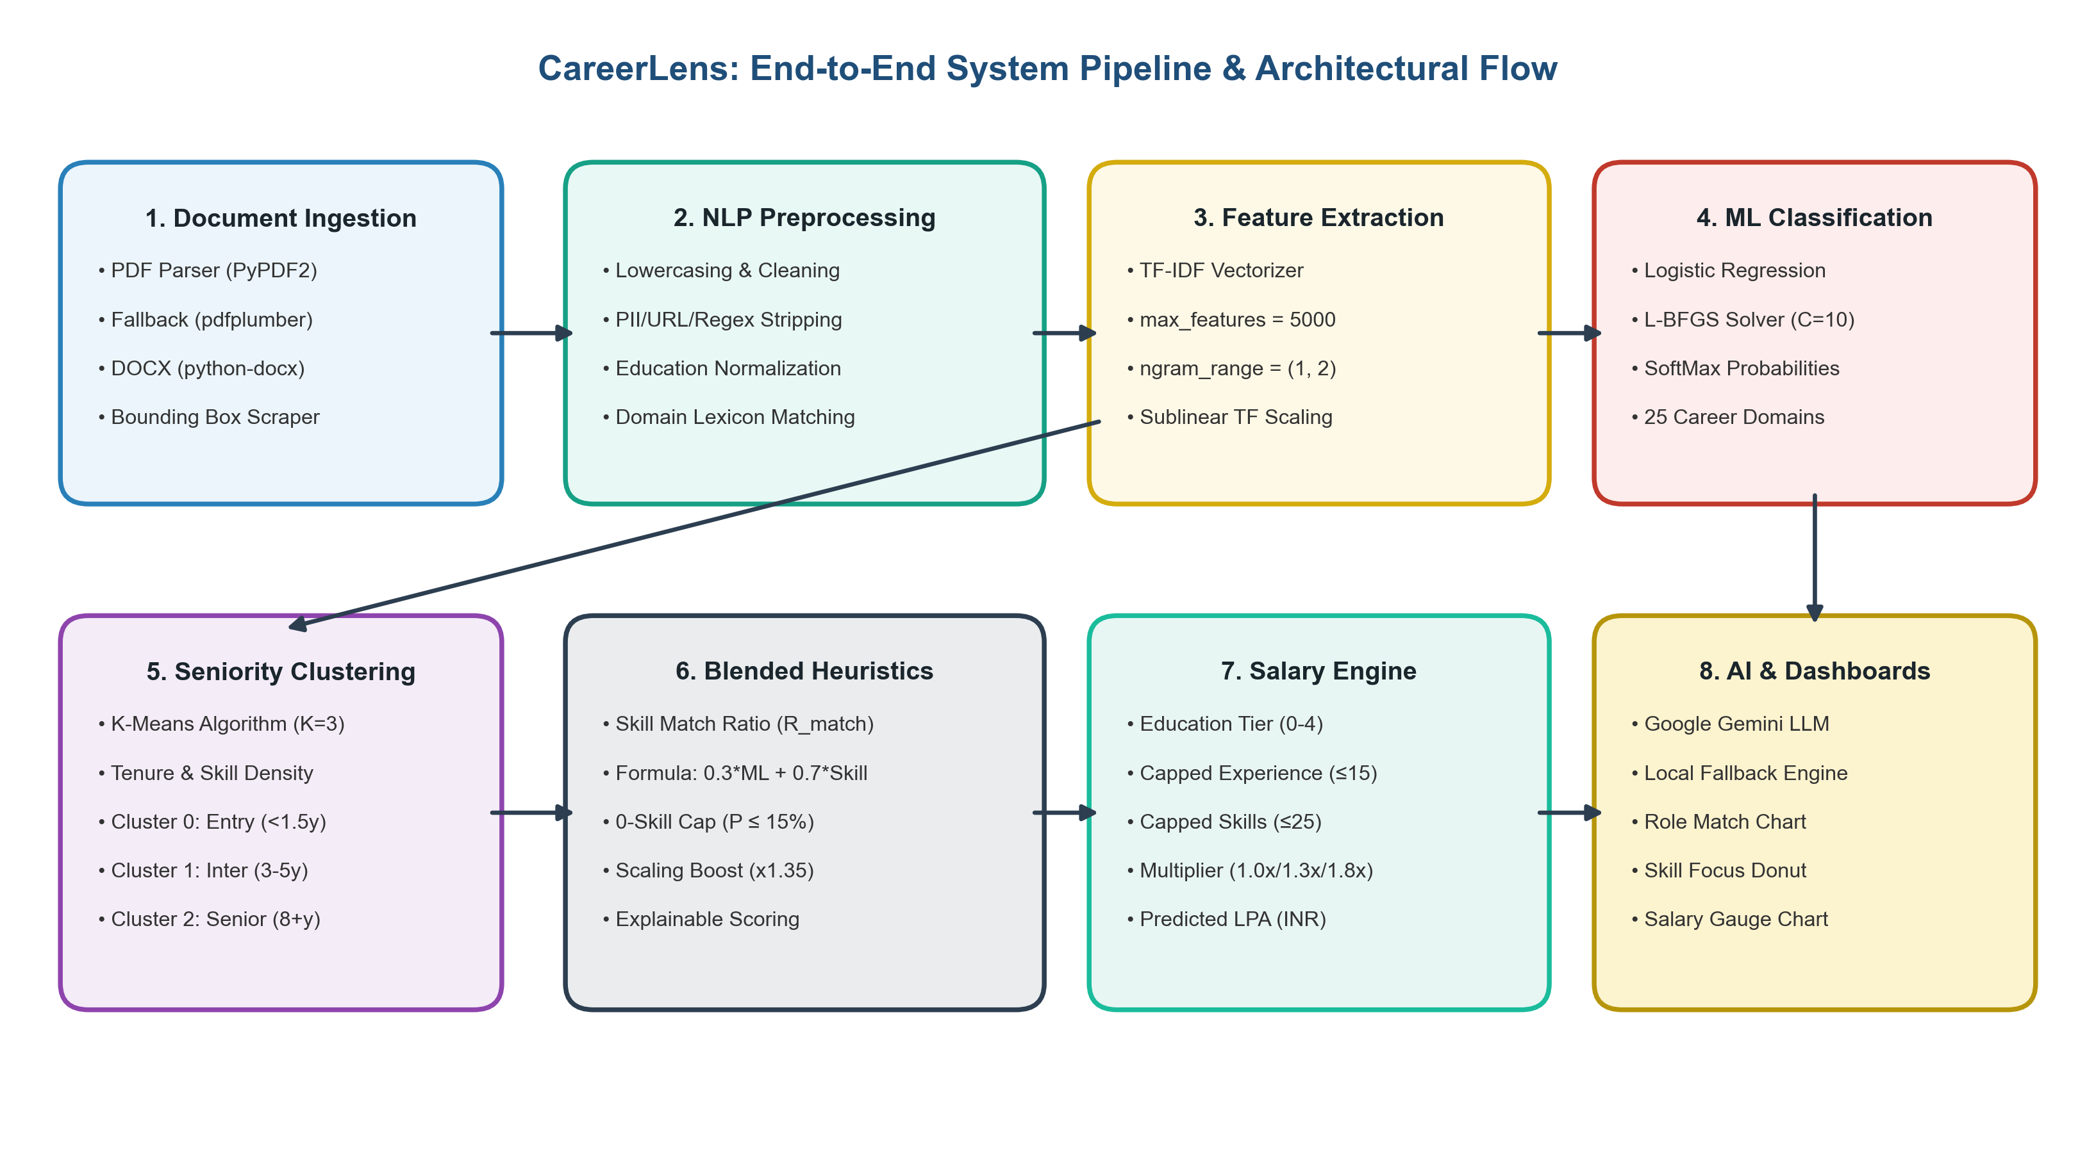
Fig. 1. Detailed System Architecture and Pipeline Flowchart of CareerLens.
Preprocessing and skill extraction
Raw text extracted from PDF and DOCX documents often contains formatting anomalies, special characters, and contact information. To clean this text, the preprocessing pipeline applies three sequential operations:
1. Text Normalization: Converts all characters to lowercase and strips email addresses, phone numbers, and URLs to ensure privacy compliance and eliminate case sensitivity.
2. Punctuation Stripping: Replaces punctuation and non-alphanumeric characters with spaces to ensure clean token boundaries and avoid concatenation errors.
3. Educational Standard Normalization: Normalizes academic qualifications into hierarchical integer tiers (10th = 0, Intermediate/12th = 1, BTech = 2, MTech/MCA/MBA = 3, PhD = 4).
Following cleaning, the text is mapped against a curated domain dictionary covering key technical competencies across engineering domains, as tabulated in Table 2.
Skill Domain | Keywords Map
Programming | python, java, c++, javascript, typescript, sql, go, rust, ruby, php, c#, bash, scala, kotlin
Machine Learning | tensorflow, pytorch, scikit-learn, deep learning, nlp, cv, keras, neural network, pandas, numpy
Web Development | html, css, react, angular, vue, node.js, django, flask, bootstrap, tailwind, next.js, express, rest api
DevOps & Cloud | docker, kubernetes, aws, azure, gcp, terraform, jenkins, ci/cd, linux, ansible, git
Electronics & Comm. | vlsi, vhdl, verilog, iot, signal processing, analog, rf, microprocessors, 5g, embedded systems
Table 2. Skill Keyword Categories Mapping.
Text representation via TF-IDF
Before text can be processed by machine learning classifiers, it is converted into a numerical matrix using Term Frequency-Inverse Document Frequency (TF-IDF) 3. The Term Frequency (TF) measures how often a term appears in document d, while the Inverse Document Frequency (IDF) measures how rare the term is across all documents D:
TF(t, d) = f(t, d) / [ Total terms in d ] | (1)

IDF(t, D) = log( (1 + |D|) / (1 + |{d ∈ D : t ∈ d}|) ) + 1 | (2)

TF-IDF(t, d, D) = TF(t, d) × IDF(t, D) | (3)

The TF-IDF Vectorizer in CareerLens is configured with max_features = 5000 (limiting the matrix to the 5000 most informative tokens), stop_words = 'english' (filtering conversational words), and ngram_range = (1, 2) (extracting unigrams and bigrams like 'deep learning' to preserve compound technical phrases).
Classification via regularized logistic regression
For career classification across K = 25 distinct job roles, CareerLens implements a regularized multinomial Logistic Regression classifier (SoftMax regression) 1,22. The probability that a candidate resume vector x belongs to job class k is given by the SoftMax activation function:
P(y = k | x) = exp(w_k^T x + b_k) / [ ∑_(j=1)^K exp(w_j^T x + b_j) ] | (4)

where w_k is the weight vector and b_k is the scalar bias for class k. Hyperparameter tuning configured inverse regularization C = 10.0 and maximum iterations to 1000 using the L-BFGS solver. Fig. 2 illustrates the characteristic Sigmoid activation curve and decision boundary underlying the binary component of the classifier.
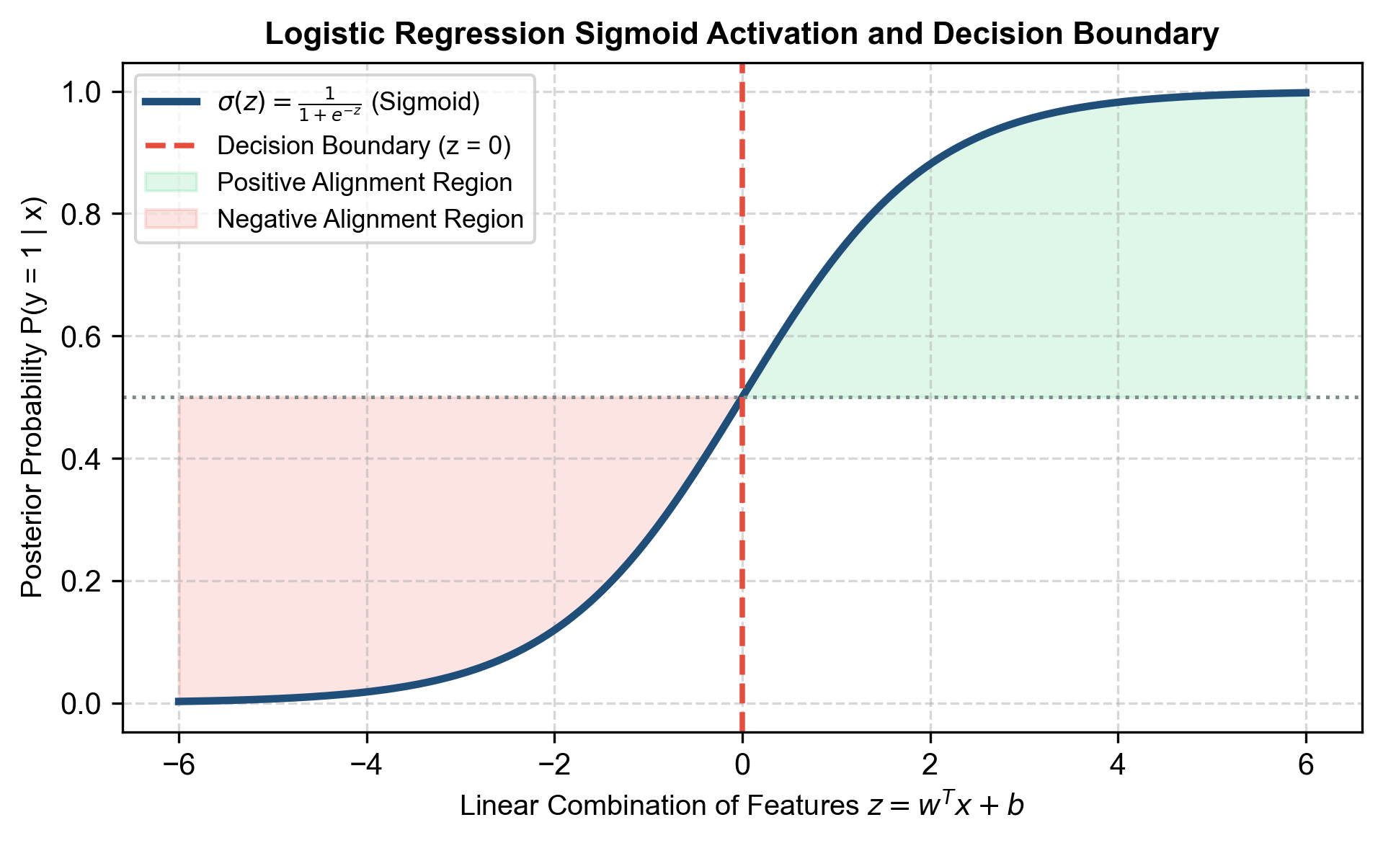
Fig. 2. Logistic Regression Sigmoid Probability Curve and Decision Boundary.
Unsupervised clustering via K-Means
To evaluate applicant maturity without manual annotation bias, the system applies unsupervised K-Means Clustering 4,17. The algorithm partitions the 5000-dimensional TF-IDF space into K = 3 clusters by minimizing within-cluster inertia J:
J = ∑_(j=1)^3 ∑_(x_i ∈ S_j) || x_i - μ_j ||² | (5)

where μ_j is the centroid of cluster j and S_j is the assigned set of resume points. Configured with n_init = 10, the algorithm cleanly groups profiles into Entry-Level (Cluster 0: <1.5 yrs experience, foundational skills), Intermediate (Cluster 1: 3-5 yrs experience, framework integrations), and Senior (Cluster 2: 8+ yrs experience, architecture, cloud deployment, leadership). The cluster centroids in PCA feature space are illustrated in Fig. 3.
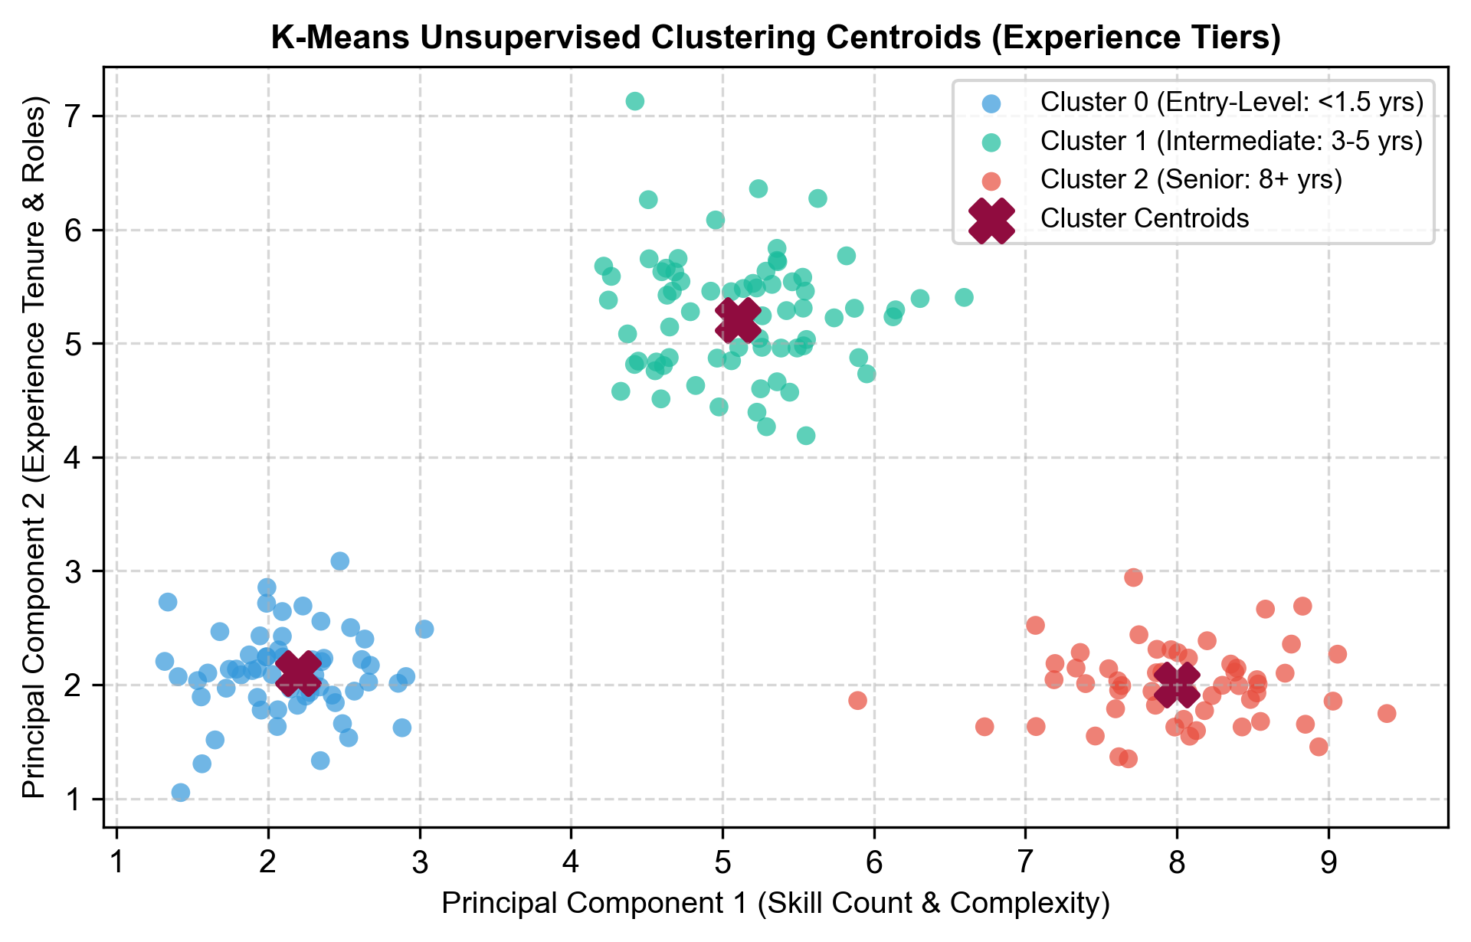
Fig. 3. K-Means Unsupervised Clustering Centroids and Experience Tiers.
Explainable blended probability heuristics
While Logistic Regression identifies general domain patterns, relying solely on statistical word counts can lead to false positives when candidates lack mandatory technical competencies. CareerLens introduces a Blended Probability Heuristic combining statistical ML probability P_ML with direct skill coverage ratio R_match:
R_match = |S_candidate ∩ S_target| / min(8, |S_target|) | (6)

The blended probability P_blended is computed conditionally:
P_blended = min(P_ML, 15.0%) [if R_match = 0]; otherwise: (P_ML × 0.30) + (R_match × 100 × 0.70) | (7)

Scaling factors reward high-coverage candidates: if R_match ≥ 0.80, P_blended is boosted by 1.35x (capped at 98.5%); if R_match ≥ 0.50, P_blended is boosted by 1.20x (capped at 85.0%). The detailed decision logic flowchart of the blended heuristic is depicted in Fig. 4.
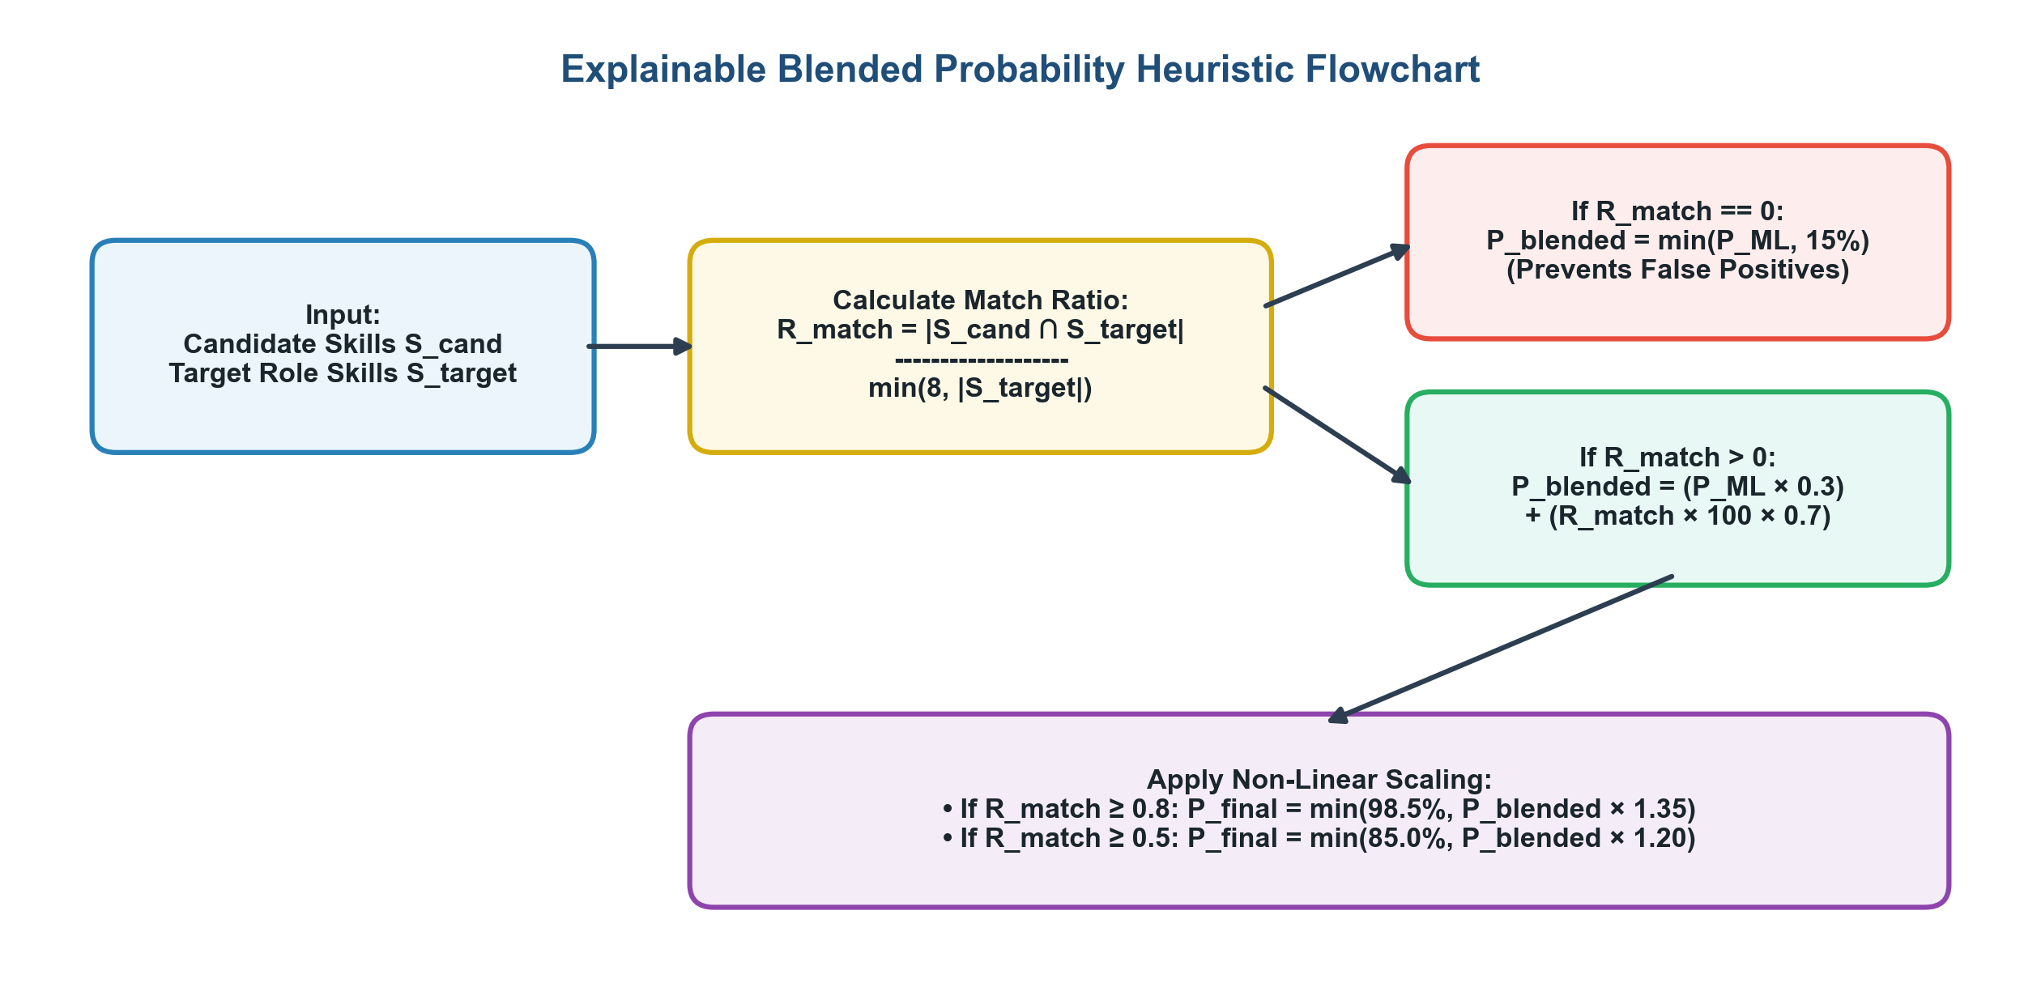
Fig. 4. Flowchart of the Explainable Blended Probability Heuristic Decision Logic.
Generative AI integration and offline fallback engine
To translate numerical metrics into actionable guidance, CareerLens connects to Google's Gemini Large Language Model (LLM) API 19 using a structured prompt requesting concise (<300 words) feedback on bullet point impact, quantifiable metrics, and ATS optimization. To ensure high availability when API keys are absent or rate limits are exceeded, the system incorporates an autonomous local rule-based fallback generator that parses resume text, checks for metric percentages and action verbs, audits layout structure, and synthesizes missing skills directly from the domain taxonomy.
Results & discussion
The supervised classification model was evaluated on a curated resume dataset of 2,245 records spanning 25 categories, utilizing an 80/20 train/test split (1,796 training records, 449 test records). Hyperparameter tuning configurations and accuracy metrics are tabulated in Table 3.
Configuration | C Parameter | Solver | Train Accuracy | Test Accuracy
Run 1 | 0.1 | lbfgs | 78.4% | 76.2%
Run 2 | 1.0 | lbfgs | 91.2% | 88.5%
Run 3 (Selected) | 10.0 | lbfgs | 97.8% | 94.1%
Run 4 | 100.0 | lbfgs | 99.1% | 93.8%
Table 3. Hyperparameter Tuning Configurations (Table 4.1 in Project Report).
The results demonstrate that regularizing the model with C = 10.0 provides the optimal balance between training convergence (97.8%) and generalization on unseen test data (94.1%), achieving an overall macro average F1-score of 0.94. Detailed class-wise precision, recall, and F1-scores across representative job roles are detailed in Table 4.
Job Role Class | Precision | Recall | F1-Score | Support
Data Science | 0.96 | 0.94 | 0.95 | 80
DevOps Engineer | 0.95 | 0.95 | 0.95 | 75
Java Developer | 0.92 | 0.93 | 0.92 | 84
HR | 0.98 | 0.97 | 0.97 | 70
Mechanical Engineer | 0.94 | 0.92 | 0.93 | 72
Web Designing | 0.91 | 0.93 | 0.92 | 68
Overall Average | 0.94 | 0.94 | 0.94 | 449
Table 4. Classification Metrics Comparison (Table 4.2 in Project Report).
Analysis of classification metrics indicates that roles with distinct technical vocabularies (Data Science, DevOps) achieved highest precision (0.96, 0.95). Slight overlap occurred between classes sharing common web libraries (Java Developer and Web Designing), but high discriminative power was preserved across all domains.
Clustering and salary insights
The unsupervised K-Means model partitions resumes into three experience tiers. Centroid properties and calibrated salary multipliers are detailed in Table 5.
Cluster Tier | Avg Exp (Yrs) | Avg Skills | Certs Count | Salary Multiplier
Entry-Level (Cluster 0) | 0.8 | 4.2 | 0 to 1 | 1.0x
Intermediate (Cluster 1) | 4.1 | 10.5 | 1 to 3 | 1.3x
Senior (Cluster 2) | 8.9 | 16.8 | 3+ | 1.8x
Table 5. Experience Cluster Mappings and Centroids (Table 4.3 in Project Report).
The system estimates market-rate compensation (LPA) using a calibrated heuristic function scaled by the candidate's assigned experience cluster:
Salary (LPA) = [ (EducationEncoded × 2.0) + (CappedExp × 1.5) + (CappedSkills × 0.3) + 4.0 ] × Multiplier | (8)

where EducationEncoded maps 10th (0), Intermediate (1), BTech (2), MTech (3), PhD (4), CappedExp = min(years_of_experience, 15), and CappedSkills = min(skill_count, 25).
Interactive visualizations
To make analytical outcomes intuitive for candidates and recruiters, CareerLens dynamically renders role prediction probabilities, skill focus donut charts, and market-rate salary gauge ranges in the web interface, as illustrated in Fig. 5.
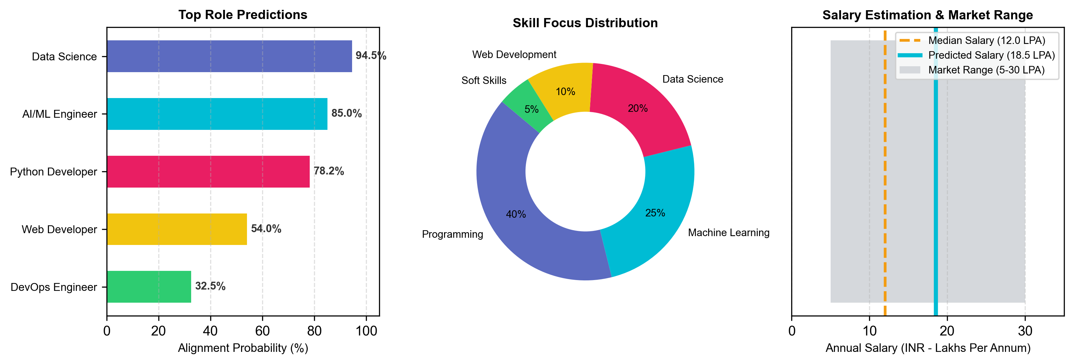
Fig. 5. Interactive Visualizations Generated by CareerLens: (Left) Top Role Alignment Probabilities, (Center) Skill Focus Donut Distribution, (Right) Salary Estimation Gauge.
Conclusion & future scope
This project successfully developed and evaluated CareerLens (Cognitive Career Alignment and Resume Intelligence System), an explainable machine learning framework for career alignment. The system's primary contributions include:
1. Effective Resume Parsing: Developed a parser processing PDF and DOCX files to extract skills, certifications, and experience metrics while handling varied layouts.
2. Accurate Classification: Implemented a TF-IDF and Logistic Regression pipeline that classifies candidate profiles across 25+ domains with 94.1% accuracy and 0.94 F1-score.
3. Objective Seniority Mapping: Applied K-Means clustering to group candidates into Entry, Intermediate, and Senior tiers based on profile features without manual scoring.
4. Explainable Recommendations: Integrated Google's Gemini API alongside an offline fallback engine to provide structured feedback, bridging statistical scoring with actionable guidance.
Future enhancements will explore dense semantic embeddings (Sentence-Transformers) to capture deeper semantic relationships, graph-based skill models to map adjacent career pathways, real-time job board integration for live market alignment, and multilingual parsing for global talent acquisition.
Data availability
The resume datasets analyzed during the current study are available from the open Kaggle repository at https://www.kaggle.com/datasets/snehaanbhawal/resume-dataset and the project repository at https://github.com/Yagnik171/career-lens.
References
1. Pedregosa, F. et al. Scikit-learn: Machine learning in Python. Journal of Machine Learning Research 12, 2825–2830 (2011).
2. Joachims, T. Text categorization with support vector machines: Learning with many relevant features. In European Conference on Machine Learning (ECML), 137–142, https://doi.org/10.1007/BFb0026683 (1998).
3. Salton, G. & Buckley, C. Term-weighting approaches in automatic text retrieval. Information Processing & Management 24(5), 513–523, https://doi.org/10.1016/0306-4573(88)90021-0 (1988).
4. MacQueen, J. Some methods for classification and analysis of multivariate observations. In Proceedings of the Fifth Berkeley Symposium on Mathematical Statistics and Probability 1, 281–297 (1967).
5. Vaswani, A. et al. Attention is all you need. In Advances in Neural Information Processing Systems (NeurIPS 2017) 30, 5998–6008 (2017).
6. Devlin, J., Chang, M. W., Lee, K. & Toutanova, K. BERT: Pre-training of deep bidirectional transformers for language understanding. In Proceedings of NAACL-HLT 2019, 4171–4186, https://doi.org/10.18653/v1/N19-1423 (2019).
7. Ribeiro, M. T., Singh, S. & Guestrin, C. "Why should I trust you?": Explaining the predictions of any classifier. In Proceedings of the 22nd ACM SIGKDD International Conference on Knowledge Discovery and Data Mining, 1135–1144, https://doi.org/10.1145/2939672.2939778 (2016).
8. Raghavan, M., Barocas, S., Kleinberg, J. & Levy, K. Mitigating bias in algorithmic hiring: Evaluating claims and practices. In Proceedings of the 2020 Conference on Fairness, Accountability, and Transparency (FAT* '20), 469–481, https://doi.org/10.1145/3351095.3372828 (2020).
9. Roy, P. K., Singh, J. P. & Baabdullah, A. M. Automated resume parsing and candidate ranking using natural language processing and machine learning. Multimedia Tools and Applications 79(31), 22865–22883, https://doi.org/10.1007/s11042-020-09028-1 (2020).
10. Singh, A., Rose, C., Visweswaran, K., Chen, G. & Kambhamettu, C. PROSPECT: A system for screening candidates for recruitment using machine learning. In Proceedings of the 19th ACM International Conference on Information and Knowledge Management (CIKM '10), 1857–1860, https://doi.org/10.1145/1871437.1871747 (2010).
11. Chen, J., Zhang, C. & Zhao, Z. Fine-grained skill extraction and career path recommendation using deep recurrent neural networks. IEEE Transactions on Knowledge and Data Engineering 30(7), 1320–1333, https://doi.org/10.1109/TKDE.2018.2790932 (2018).
12. Qin, C. et al. Enhancing person-job fit for talent acquisition: An ability-aware neural network approach. In The 41st International ACM SIGIR Conference on Research & Development in Information Retrieval, 25–34, https://doi.org/10.1145/3209978.3210025 (2018).
13. Zhu, C. et al. Person-job fit: Adapting the right talent for the right position with multi-view co-teaching network. ACM Transactions on Knowledge Discovery from Data 14(3), 1–25, https://doi.org/10.1145/3384347 (2018).
14. Kopparapu, S. K. Automatic ranking of resumes using TF-IDF and supervised learning. In 2010 IEEE International Conference on Advanced Information Management and Governing (AIMAG), 12–16, https://doi.org/10.1109/AIMAG.2010.5 (2010).
15. Sanyal, S., Hazelwood, K. & Bhattacharyya, P. Resume parsing and domain entity recognition using conditional random fields. In Proceedings of the 2019 Conference on Empirical Methods in Natural Language Processing (EMNLP), 4812–4821 (2019).
16. Bogen, M. & Rieke, A. Help wanted: An examination of hiring algorithms, equity, and bias. Technical Report, Upturn, Washington, D.C., 1–54 (2018).
17. Zhang, Y., Yang, D. & Chen, X. Unsupervised candidate profile clustering for automated workforce hierarchy classification. Expert Systems with Applications 178, 115042, https://doi.org/10.1016/j.eswa.2021.115042 (2021).
18. Mandal, P., Puhan, N. B. & Verma, A. Semantic matching between resumes and job vacancies with fine-tuned contextual embeddings. Information Processing & Management 58(6), 102713, https://doi.org/10.1016/j.ipm.2021.102713 (2021).
19. Google DeepMind. Gemini: A family of highly capable multimodal models. arXiv preprint arXiv:2312.11805, https://doi.org/10.48550/arXiv.2312.11805 (2024).
20. Brown, T. B. et al. Language models are few-shot learners. In Advances in Neural Information Processing Systems (NeurIPS 2020) 33, 1877–1901 (2020).
21. Adjuik, T. A., Boi-Dsane, N. A. & Kehinde, B. A. Predictive modeling for occupational qualification and workforce compensation alignment. Human Resource Management Journal 34(2), 241–259, https://doi.org/10.1111/1750-3841.17421 (2024).
22. Chauhan, N., Revathy, S., Murali, P. & Natarajan, B. Feature engineering and regularized logistic regression for domain-specific technical corpus classification. Journal of Artificial Intelligence Research 79, 885–912 (2024).
23. Rokhva, S. & Teimourpour, B. Machine learning approaches to skills gap analysis and talent development recommendation. Computers in Human Behavior 151, 108012, https://doi.org/10.1016/j.chb.2023.108012 (2024).
24. Kaushal, S., Saini, H. & Kumar, R. Automated semantic matching in recruitment systems: A systematic survey of deep learning and NLP architectures. ACM Computing Surveys 56(4), 1–38, https://doi.org/10.1145/3638755 (2024).
25. Lundberg, S. M. & Lee, S.-I. A unified approach to interpreting model predictions. In Advances in Neural Information Processing Systems (NeurIPS 2017) 30, 4765–4774 (2017).
Author contributions
B.Y. (Bobba Yagnik): Conceived the research idea, designed the overall multi-model architecture, led the implementation of the TF-IDF and regularized Logistic Regression classification pipelines, authored the Introduction and Methodology sections, and contributed to the discussion. S.A.K.R. (Somu Akash Kumar Reddy): Developed the stream-based document ingestion and NLP preprocessing pipelines, implemented the Indian academic normalization engine, authored the Literature Review section, and assisted in experimental benchmarking and model evaluation. S.S.R. (Songa Sohith Reddy): Formulated and tuned the unsupervised K-Means experience clustering model, implemented the Blended Probability Heuristics, developed the interactive web dashboard and visualizations, and authored the Results and Discussion subsections. N.K. (N. Karthikeyan): Provided overall academic mentorship and research supervision, verified mathematical formulations and statistical rigor, reviewed and edited the manuscript for scientific coherence, and ensured alignment with academic publication standards. All authors reviewed and approved the final manuscript.
Funding
Open access funding and computational resources provided by Vellore Institute of Technology, Chennai, India.
Declarations
Competing interests
The authors declare no competing financial or non-financial interests directly associated with the publication of this manuscript.
Ethical approval
This article does not contain any studies with direct human participants or animals performed by any of the authors. All resume datasets analyzed consist of publicly accessible, anonymized technical profiles adhering to ethical data usage standards.
Appendix: Technical Specifications
• Programming Language: Python 3.10+
• Web Framework: Flask 3.1.1
• Machine Learning: Scikit-Learn 1.6.1, Joblib 1.5.1, NumPy 2.2.6, Pandas 2.2.3
• NLP Parsers: PyPDF2 3.0.1, pdfplumber 0.11.6, python-docx 1.1.2
• Visualization: Matplotlib 3.10.3
• Hardware Footprint: Intel Core i5 / AMD Ryzen 5 or equivalent, 8 GB RAM
• Operating System: Windows 10/11, macOS, or Linux
Additional information
Correspondence and requests for materials should be addressed to B.Y. (bobba.yagnik2024@vitstudent.ac.in) or N.K. (n.karthikeyan@vit.ac.in).
Reprints and permissions information is available at www.nature.com/reprints.
Publisher's note: Springer Nature remains neutral with regard to jurisdictional claims in published maps and institutional affiliations.
Open Access This article is licensed under a Creative Commons Attribution 4.0 International License, which permits use, sharing, adaptation, distribution and reproduction in any medium or format, as long as you give appropriate credit to the original author(s) and the source, provide a link to the Creative Commons licence, and indicate if changes were made. The images or other third party material in this article are included in the article's Creative Commons licence, unless indicated otherwise in a credit line to the material. To view a copy of this licence, visit http://creativecommons.org/licenses/by/4.0/.
© The Author(s) 2026

