SYSTEM DESIGN DOCUMENT
MediCore Hospital Management System
Version 1.8 · August 2026
Companion documents: SRS v1.3 · Effort Estimation (UCP) v1.0
Prepared by: Kelvin Addae Kwarteng · Student ID 22427564

Document Control
Version | Change | Impact assessment
1.0 | Initial design baseline. Backend platform: Node.js/Express. | —
1.1 | Backend platform changed to Java 21 / Spring Boot 3 at stakeholder request. Architecture diagram (Fig. 1), component responsibilities (§2.2), technology mapping (§2.3) and ADRs DD-01/02/03 updated. All architectural decisions, the data model, sequence flows, wireframes and the technical-debt register are platform-independent and carry over unchanged. | SRS updated to v1.1 (§2.4 operating environment). Effort estimation v1.0 remains valid: UCP inputs are size-based, not language-based; environmental factor E8 (language difficulty = 1, mainstream stack) applies equally to Spring Boot. Milestone 1 code is re-implemented on the new stack; schema, policy model and tests translate one-to-one.
1.2 | Build tool changed from Maven to Gradle (Kotlin DSL) at stakeholder request. Technology mapping (§2.3) updated. | No architectural impact: build tooling only. SRS and effort estimation unaffected. Docker image and Render deployment unchanged (bootJar output replaces the Maven-built JAR).
1.3 | Payment gateway changed from Paystack to ITC Payments at stakeholder request. New ADR DD-07 introduces a PaymentGateway port/adapter isolating gateway specifics; Fig. 1 and Fig. 8 regenerated; §6.3 and TD-04 updated. ITC API specification pending (SRS OI-5). | SRS updated to v1.2 (FR-BIL-03, NFR-SEC-06, §§1–2, 6). Effort estimation unaffected: UC-22 remains one Complex use case regardless of gateway vendor. Milestones 1–2 unaffected; adapter implemented at M3 when the specification arrives.
1.4 | ITC Transflow Checkout API Definition received; ItcGatewayAdapter implemented against it. Port extended with customer name and vendor-callback parsing (extractReference). Callback endpoint always answers HTTP 200 per vendor requirement; a /payments/{id}/verify endpoint covers the missed-callback case (spec §3). Fig. 8 regenerated with concrete endpoints. | SRS updated to v1.3 (OI-5 resolved). Verification rule unchanged and now vendor-mapped: success = outer 200 AND data.responseCode = 01 AND exact amount match. Estimation unaffected (UC-22 delivered within its Complex sizing).
1.5 | Notifications delivered (TD-08) with a durable database outbox that also retires TD-02: MailPort port + SmtpMailAdapter (DD-08, mirroring DD-07), notification_outbox table (V5) with UNIQUE(template, ref_id) idempotent enqueue in the same transaction as the business change, and a scheduled worker draining with FOR UPDATE SKIP LOCKED, exponential backoff (OutboxPolicy, capped 24h) and terminal failed state after 8 attempts. Producers: booking confirmation, cancellation, 24h reminders (hourly scan), payment receipts (manual and verified-online). | Testing Report v1.2 (templates/backoff harness 11/11; outbox state machine rehearsed on PostgreSQL; OutboxIT in CI). Ledger v1.2: TD-02 and TD-08 retired. Vendor-neutral SMTP: provider is an env-var change.
1.6 | Nursing and laboratory workspaces delivered. Ward board pinned to the nurse's assigned ward with observation charting; laboratory bench implementing the FR-LAB-04 lifecycle; doctor-side test ordering and result release. New policy actions: ward.roster, lab.catalogue, directory.read (department/doctor pickers split out of slot.list so non-booking roles can drive a filter). | SRS unchanged — FR-EMR-05 and FR-LAB-01/03/04/05 were already specified; this is delivery, not new scope. Testing Report v1.3 (LabWorkflow 8/8). The release step stays with the ordering doctor, so AC-04 is unchanged.
1.7 | Node.js Milestone 1 reference implementation (server/) retired and removed from the delivered tree. It was never deployed and shared no code with the production backend; the M1 change records (v1.0, v1.1) that document the platform decision are unchanged, and the implementation remains in the repository history. | Testing Report v1.4: the auth evidence it carried (FR-AUTH-01/02/06) is re-anchored to a new AuthIT against real PostgreSQL, written before the removal. Writing it exposed a live defect — lockout was rolled back with the rejecting transaction and never engaged — now fixed via LoginAttempts (REQUIRES_NEW) and recorded in the Testing Report defect log. CI drops the Node job; the Gradle and web jobs are unchanged.
1.8 | Staff administration delivered: sys_admin can create staff accounts, deactivate leavers, reactivate and clear lockouts, behind the existing admin.users action which until now had no endpoint. Role rules live in a pure StaffRoles class: a doctor must have a department and a nurse an assigned ward, because without them the account is created but silently cannot work. | SRS unchanged (FR-ADM-01 already specified). Testing Report v1.5: 71/71 including AdminStaffIT (13) and StaffRolesTest (7). AuditService moved to REQUIRES_NEW after this work exposed that a rejected audit row aborted the caller's transaction and silently discarded the business write.

Table of Contents

1. Introduction and Design Goals
This document records the architectural and detailed design of MediCore ahead of implementation, per the project lifecycle (SRS §1.5, brief §2.4). Every design element cited here traces to requirement IDs in SRS v1.1, and design-time shortcuts are logged immediately in the technical-debt register (Section 8) so the debt ledger spans the full lifecycle as the brief requires.
Design goals, in priority order:
- Correctness of access control — the permission matrix (SRS §4) is enforced in exactly one place (AC-06), testable in isolation.
- Data integrity under concurrency — booking, dispensing, bed assignment and payment crediting are transactional and race-safe (FR-APT-04, FR-FAC-03, NFR-AVL-03).
- Deliverability — a modular monolith sized for one developer and free-tier hosting, with clean seams for Phase 2/3 evolution.
- Auditability — every clinical access and sensitive action leaves an append-only trail (FR-EMR-06, NFR-SEC-04).

2. Architectural Design

2.1 Architectural Style and Rationale
MediCore is a layered modular monolith implemented in Java 21 on Spring Boot 3: one deployable service (fat JAR in a Docker container) whose interior is partitioned into domain services (Scheduling, Clinical/EMR, Pharmacy, Laboratory, Billing, Facility, Notification) behind a single Policy Engine. Microservices were rejected for v1: they would multiply deployment surface, cross-service transactions (dispensing touches stock and billing atomically — handled here by Spring’s declarative @Transactional boundaries), and hosting cost — without any team-scaling benefit for a solo developer. The module boundaries are, however, drawn along the same lines a future service split would use, which is the deliberate evolution path noted in the maintenance plan.
The single most important structural decision is that no controller reaches a domain service except through the Policy Engine — implemented as a custom Spring Security AuthorizationManager with ReBAC permission evaluators — which evaluates role + relationship and emits the audit event in the same step. This makes the SRS permission matrix a data-driven artefact with one enforcement point and one test suite.
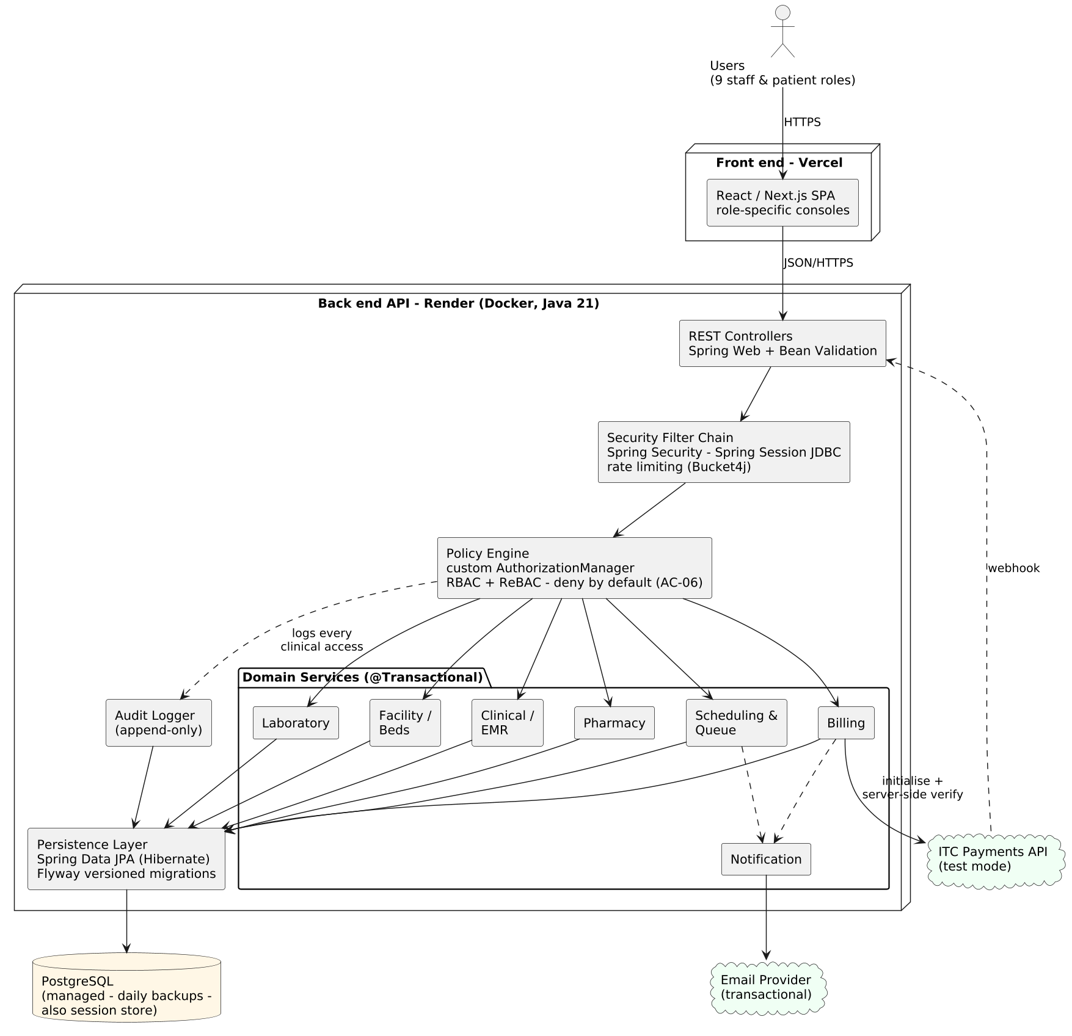
Figure 1 — System architecture and deployment mapping (Vercel SPA; Spring Boot API in Docker on Render; PostgreSQL doubling as session store; ITC Payments and email as external services).

2.2 Component Responsibilities
Component | Responsibility
REST Controllers (Spring Web) | HTTP concerns only: request mapping, Jakarta Bean Validation, status codes. No business logic.
Security Filter Chain (Spring Security + Spring Session JDBC) | Session resolution from httpOnly cookie, account-lockout counters, rate limiting (Bucket4j) on auth/payment endpoints (NFR-SEC-07).
Policy Engine (custom AuthorizationManager + ReBAC PermissionEvaluators) | Single authorisation layer: evaluates (role, relationship, resource, action) against the matrix; deny-by-default (NFR-SEC-03); writes audit events for clinical data (FR-EMR-06).
Domain Services (@Service, @Transactional) | Business rules per module: slot generation, queue transitions, FEFO stock, invoice aggregation, bed lifecycle. Transaction boundaries live here.
Persistence Layer (Spring Data JPA / Hibernate + Flyway) | Repositories and entity mapping; versioned SQL migrations via Flyway (NFR-MNT-03).
Audit Logger | Append-only writes; no update/delete API exists (NFR-SEC-04).
Notification Service | Outbound email adapter, provider-agnostic; fire-with-retry queue.

2.3 Technology Mapping
Concern | Technology | Notes
Language / runtime | Java 21 (LTS) | Records, pattern matching; supported to 2029+
Framework | Spring Boot 3.3 | Spring Web MVC (REST), Actuator health endpoint
Authentication & sessions | Spring Security + Spring Session JDBC | DD-02: server-side sessions, httpOnly/Secure/SameSite cookie, stored in PostgreSQL; BCryptPasswordEncoder (FR-AUTH-02)
Authorisation | Custom AuthorizationManager + PermissionEvaluators | DD-03: data-driven matrix + ReBAC resolvers; method-level enforcement at the service boundary
Persistence | Spring Data JPA (Hibernate) + Flyway | Entities mirror the 27-table schema; Flyway owns DDL, including triggers and partial indexes (raw SQL migrations)
Validation | Jakarta Bean Validation | Request DTO constraints; server-side always (NFR-SEC-02)
Rate limiting | Bucket4j servlet filter | Auth and payment endpoints (NFR-SEC-07)
Testing | JUnit 5 + Spring Boot Test + Testcontainers (PostgreSQL) | Race and trigger tests run against a real containerised database
Build & packaging | Gradle 8 (Kotlin DSL, wrapper committed); Docker (eclipse-temurin:21-jre) | gradlew bootJar produces the deployable fat JAR; reproducible builds via the committed wrapper; deployed to Render as a container; front end unchanged on Vercel

3. Key Design Decisions (ADR Summary)
ID | Decision | Rationale | Alternatives rejected
DD-01 | Modular monolith: Spring Boot 3 (Java 21) service in Docker on Render; SPA on Vercel | Solo deliverability, free/low-cost tier, atomic cross-module transactions via @Transactional; stakeholder-required platform (v1.1) | Microservices (ops cost); Node.js/Express (v1.0 baseline — superseded by platform requirement); single full-stack server (couples UI deploys to API)
DD-02 | Server-side sessions via Spring Session JDBC in httpOnly, Secure, SameSite cookies (resolves SRS Open Issue #2) | Instant revocation on role change/ward reassignment (AC-03) and lockout; sessions in PostgreSQL survive restarts; no token storage in JS-accessible memory | JWT access+refresh: revocation requires denylist infrastructure; stale claims violate AC-03 between refreshes
DD-03 | Policy Engine as custom Spring Security AuthorizationManager + data-driven matrix + ReBAC PermissionEvaluators | Matrix in code-reviewed config; enforcement at the service boundary so no controller can bypass it; one negative-test suite proves every denied cell (SRS §8) | Per-controller @PreAuthorize expressions scattered through the codebase (inconsistency risk — the exact debt AC-06 forbids)
DD-04 | Slots materialised as rows on schedule save | Booking = single INSERT under a unique index; trivially race-safe (FR-APT-04) | Computed-on-read slots: booking check requires range logic under lock; harder to prove correct
DD-05 | Invoice as append-only line items; totals computed | Charges post from four sources concurrently (FR-BIL-02); append-only avoids lost updates and gives a financial audit trail | Mutable running total column (race-prone, unauditable)
DD-06 | Queue ordering by (priority, checked_in_at) sort keys | Reordering = single priority update; no renumbering cascade under concurrency | Integer position column (renumber races — pre-empted debt)
DD-07 | Payments behind a PaymentGateway port with an ItcGatewayAdapter (hexagonal/adapter pattern) | ITC API specification is pending (SRS OI-5); the port fixes the contract (requestPayment, verifyStatus, parseCallback) so billing logic, database states and tests are built now and only the adapter is written when the spec arrives. Also enables a conformant stub for CI and UAT without live gateway dependence | Direct coupling of Billing Service to gateway HTTP calls (blocks M3 work on an external dependency; untestable offline; vendor swap would repeat this change)
DD-08 | Outbound mail behind a MailPort with a durable database outbox (enqueue-with-the-transaction, scheduled drain, backoff to terminal failure) | In-process queues drop mail on restart (was TD-02); a port keeps the provider swappable (SMTP speaks to Resend/SendGrid/Gmail alike); same-transaction enqueue means a booking and its confirmation commit or roll back together | Direct synchronous send in request path (couples booking latency to SMTP); vendor SDK (lock-in); message broker (operationally heavy for this scale)

4. Use-Case View
Figure 2 shows the principal use cases grouped by module with their primary actors; the full 34-item inventory with transaction counts is maintained in the Effort Estimation document §3 and traces to SRS §3 requirement IDs. Dashed arrows show the «include» relationships that make billing the system’s integration hub: dispensing, lab ordering, and admissions all post charges into the consolidated invoice.
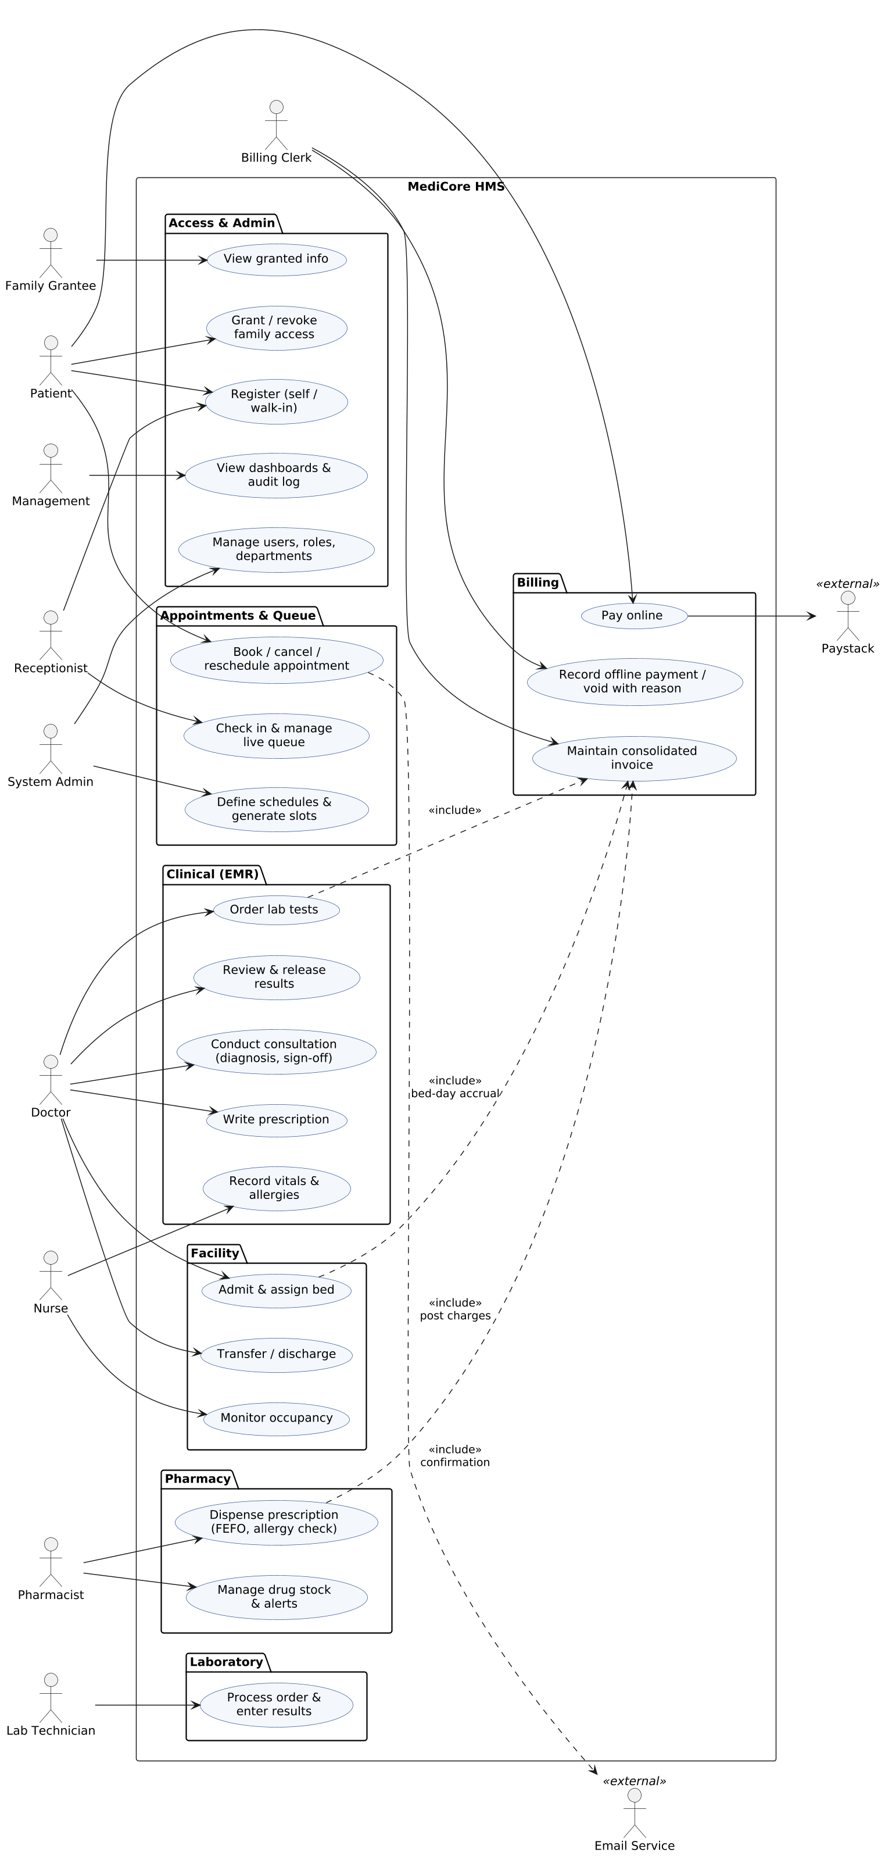
Figure 2 — Use-case diagram (principal use cases; Paystack and Email as external actors).

5. Data Design
The schema comprises 27 relations, presented in three domain views for readability. PATIENT and STAFF appear in each view as reference entities. Notation is crow’s-foot; all primary keys are UUIDs except the append-only audit log (bigserial for cheap ordering).
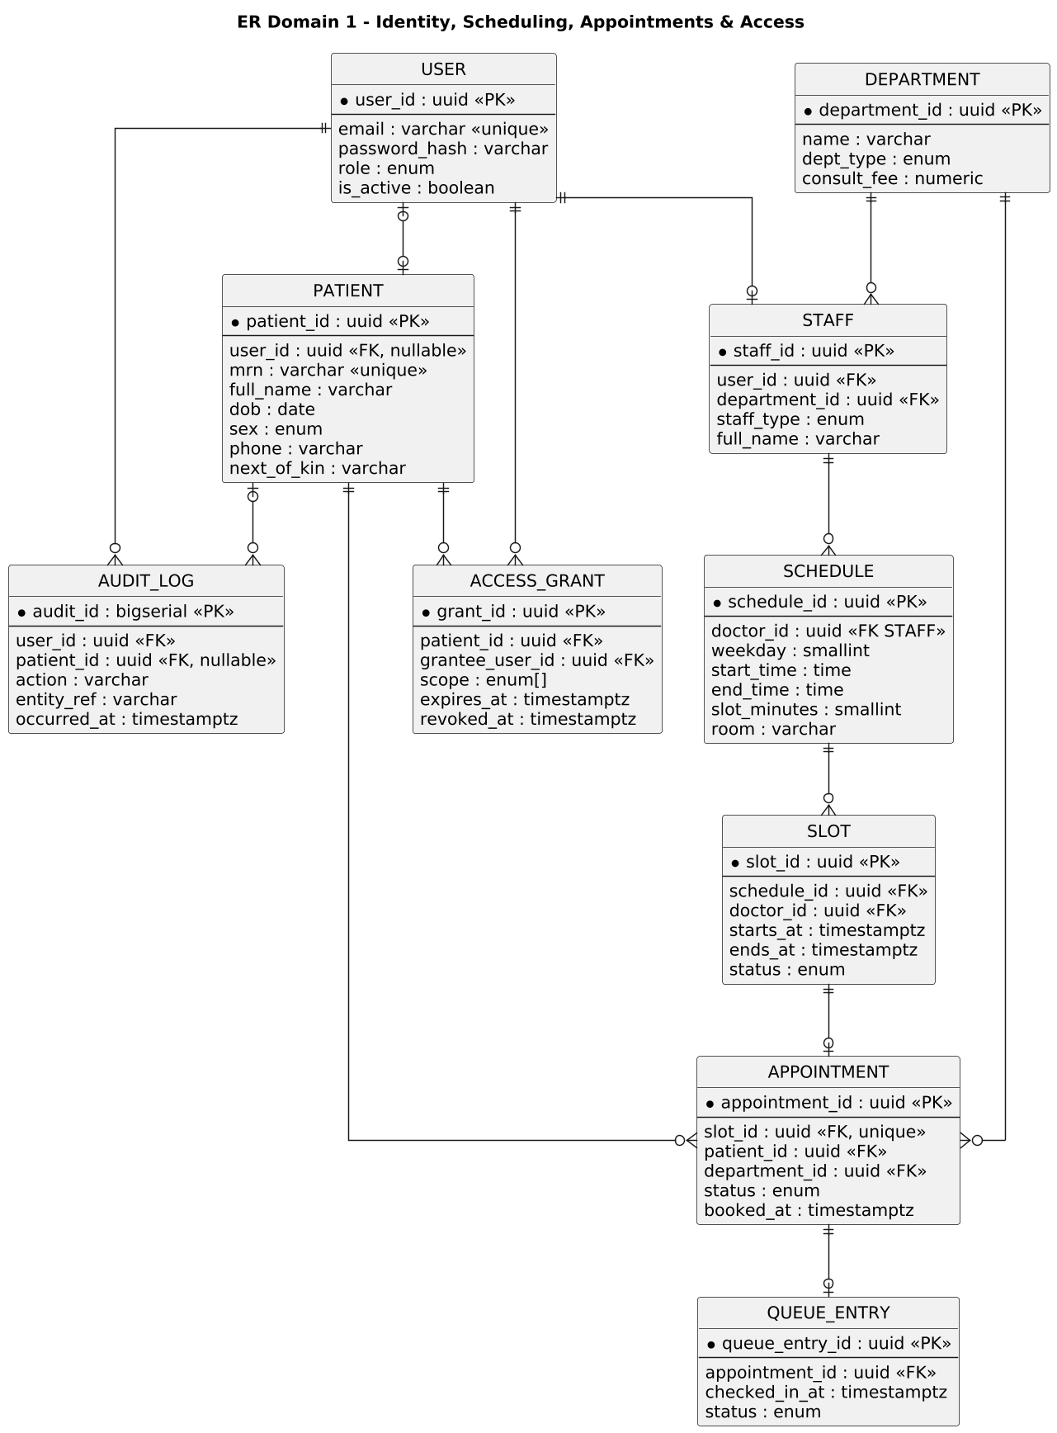
Figure 3 — ER Domain 1: identity, scheduling, appointments, queue, access grants, audit.
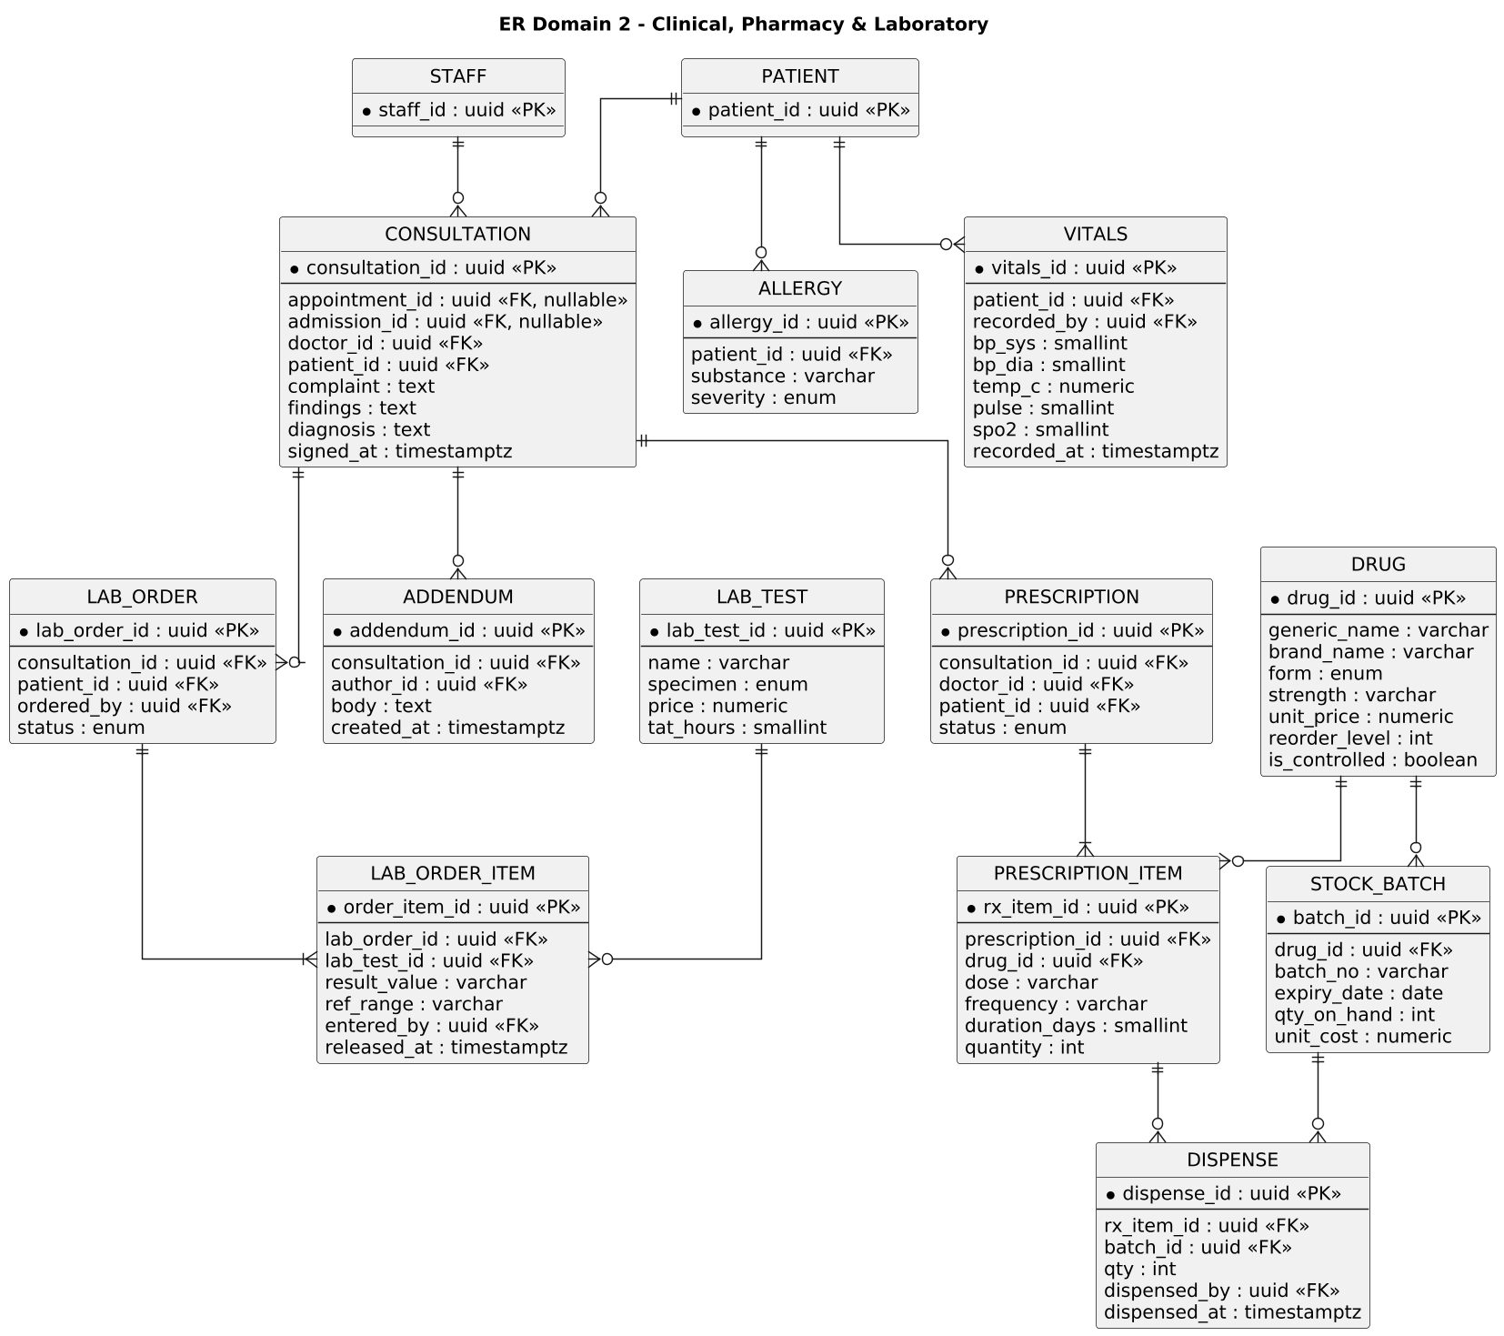
Figure 4 — ER Domain 2: clinical records, pharmacy, laboratory.
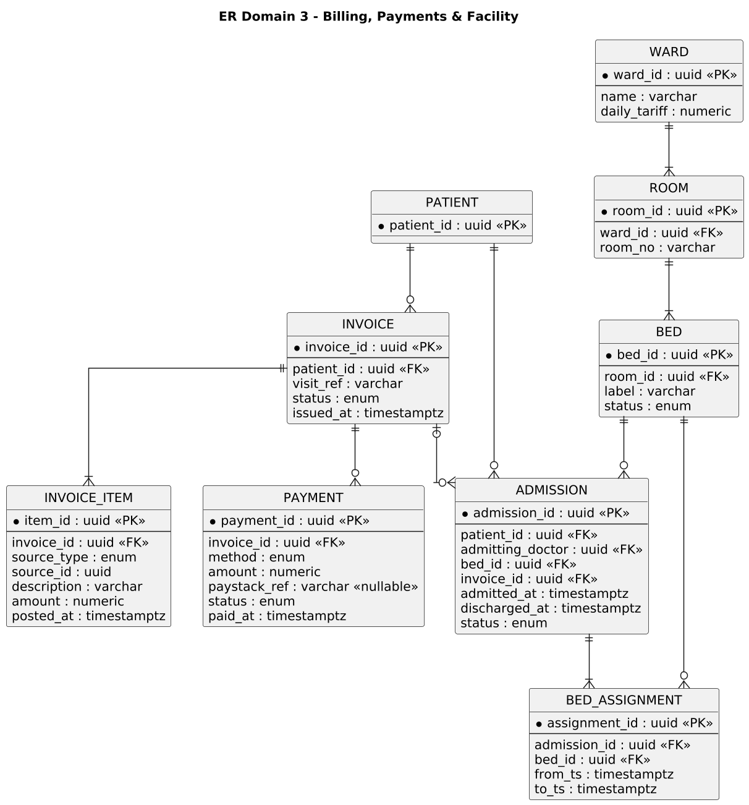
Figure 5 — ER Domain 3: billing, payments, facility (ward → room → bed) and admissions.

5.1 Integrity Constraints That Carry Requirements
- UNIQUE(appointment.slot_id) — the double-booking guard (FR-APT-04) lives in the database, not just application code.
- Partial unique index on ADMISSION(bed_id) WHERE status = ‘active’ — one live occupant per bed (FR-FAC-03).
- CHECK (qty_on_hand >= 0) on STOCK_BATCH plus SELECT … FOR UPDATE during FEFO dispensing — stock can never go negative (FR-PHM-05).
- CONSULTATION rows immutable after signed_at is set (enforced by trigger + no UPDATE path in the DAL); corrections via ADDENDUM only (FR-EMR-03).
- AUDIT_LOG: INSERT-only role grants at the database level reinforce NFR-SEC-04 beneath the application.
- INVOICE_ITEM.source_type + source_id give every charge a provenance link back to the dispensing, lab order, consultation, or admission that created it.

6. Behavioural Design (Sequence Diagrams)

6.1 Book Appointment
The booking flow shows the unique-index guard doing the concurrency work: two patients racing for one slot resolve at the INSERT, and the loser receives 409 with fresh alternatives. The email confirmation is enqueued after commit so a mail-provider outage can never roll back a booking (NFR-AVL-01).
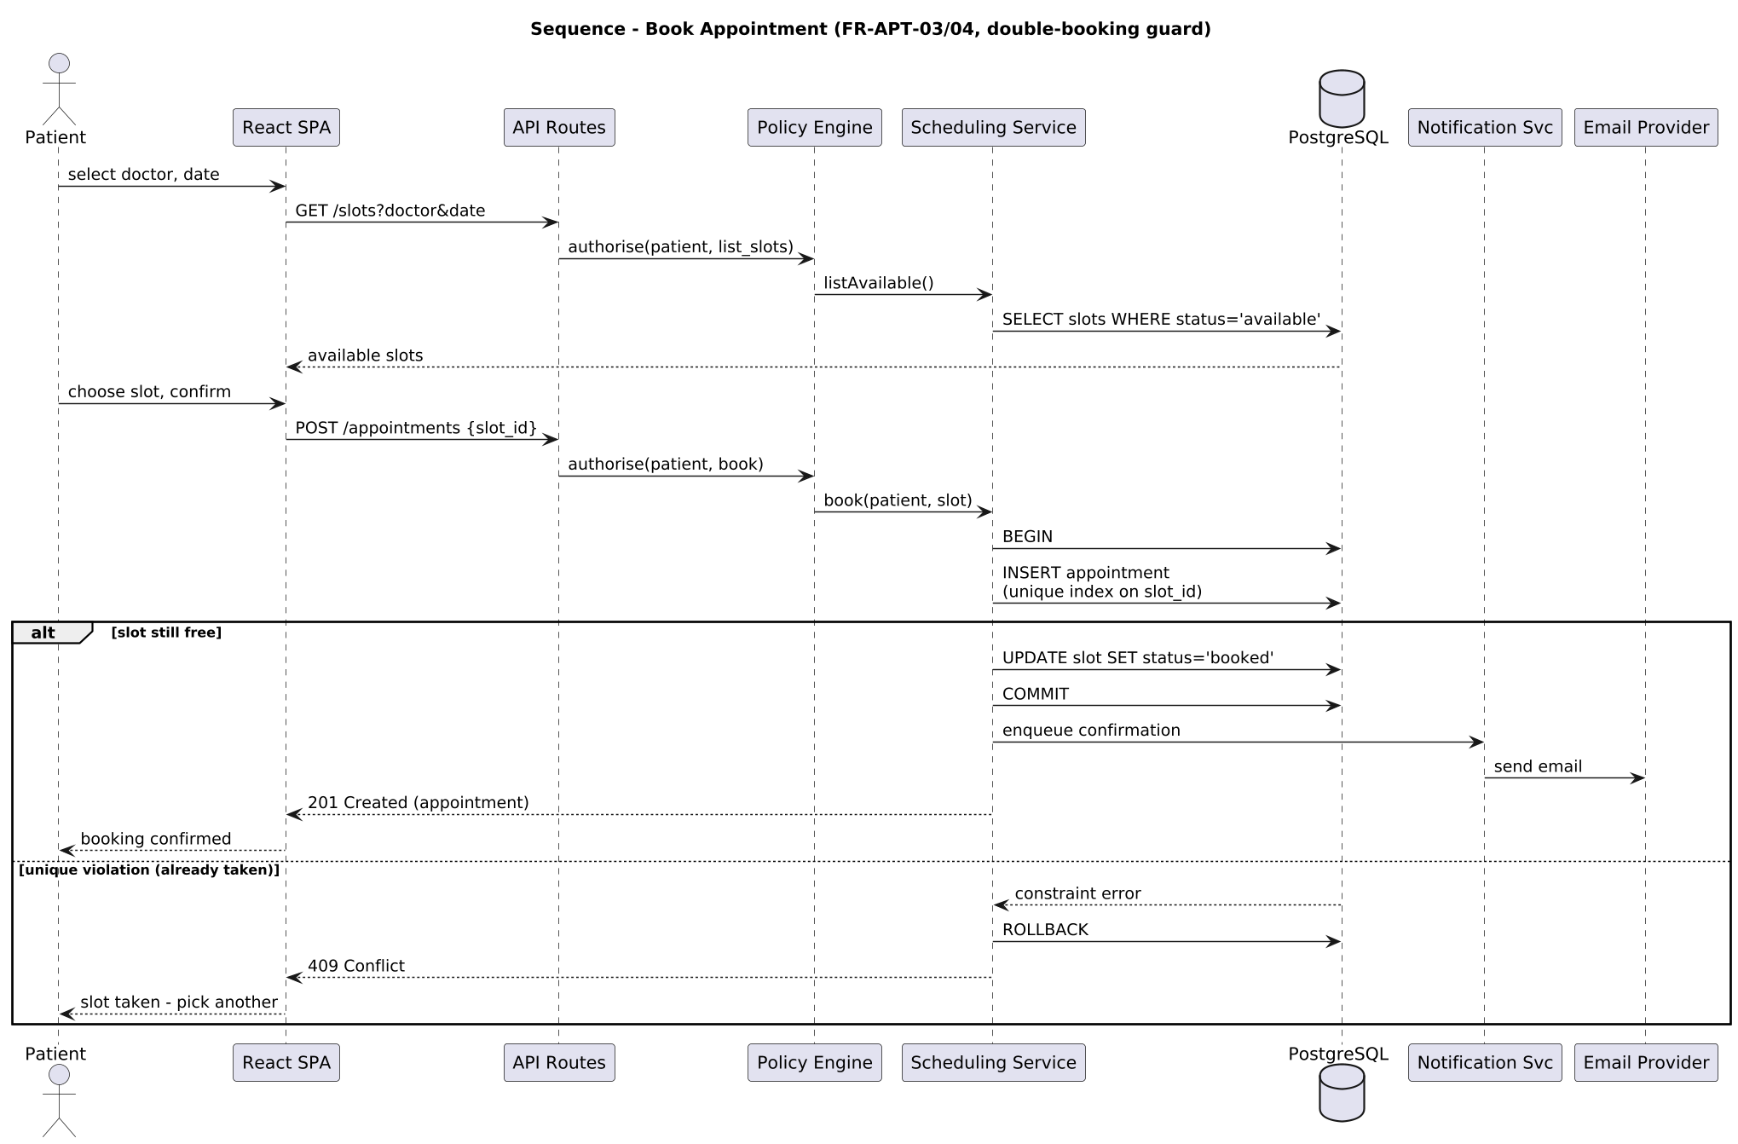
Figure 6 — Book appointment with double-booking guard (FR-APT-03/04, FR-APT-06).

6.2 Dispense Prescription
Dispensing is the busiest transaction in the system: allergy screening before confirmation (FR-PHM-04), FEFO batch selection under row locks, atomic stock decrement, and charge posting to the invoice — all inside one database transaction so a failure at any step leaves stock and billing consistent (NFR-AVL-03).
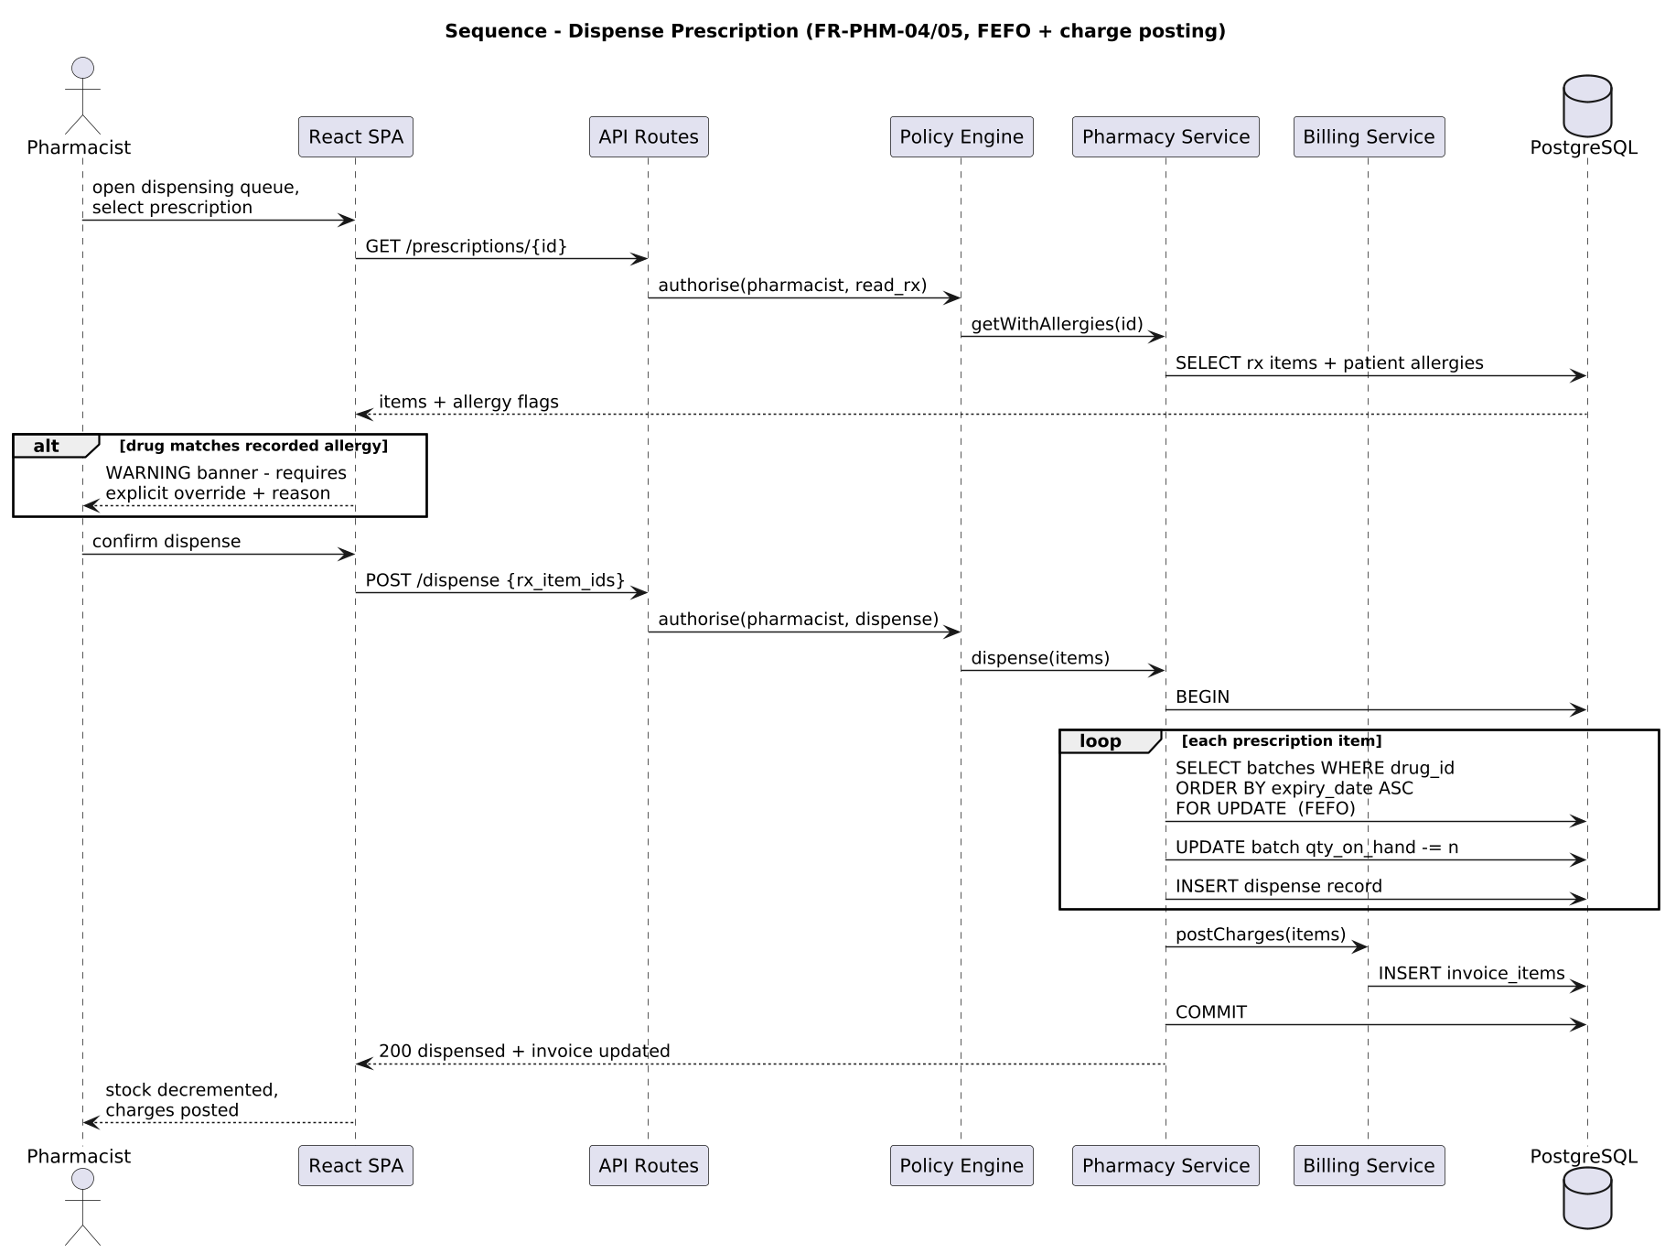
Figure 7 — Dispense prescription: allergy check, FEFO consumption, charge posting (FR-PHM-04/05).

6.3 Online Payment via ITC Payments
The payment flow encodes NFR-SEC-06 with the vendor specifics now bound: the patient is redirected to ITC’s hosted checkoutUrl from /request-payments; the callback (refNo = transactionReference) is untrusted and always answered with HTTP 200 per the vendor spec; crediting requires an independent /check-transaction-status round-trip mapping success = outer 200 AND data.responseCode = 01, plus an exact amount match (PaymentVerifier). Missed callbacks are settled by re-verification (/payments/{id}/verify). Response-shape mapping is a pure class (ItcResponseMapper) unit-verified against the vendor document’s own sample payloads — including the checkoutUrl/paymentLink naming discrepancy between its sample and its parameter table.
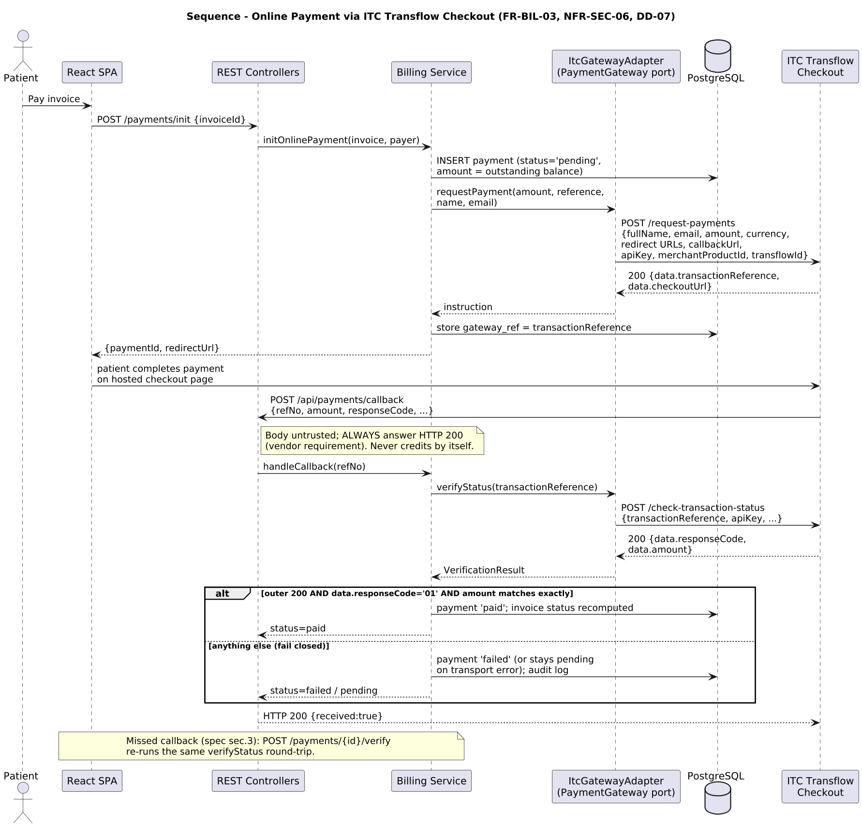
Figure 8 — Online payment via ITC Transflow Checkout with mandatory server-side verification through the PaymentGateway port (FR-BIL-03, NFR-SEC-06, DD-07).

7. User Interface Design
Nine role-specific consoles share one design system. Principles: role-appropriate information density (reception and pharmacy optimise for throughput; the patient portal for clarity), WCAG 2.1 AA essentials (NFR-USA-02), confirmation on destructive actions (NFR-USA-04), and 360 px-first responsive layout (NFR-USA-01). Two representative wireframes follow; the remaining consoles reuse the same header/navigation shell and table patterns.
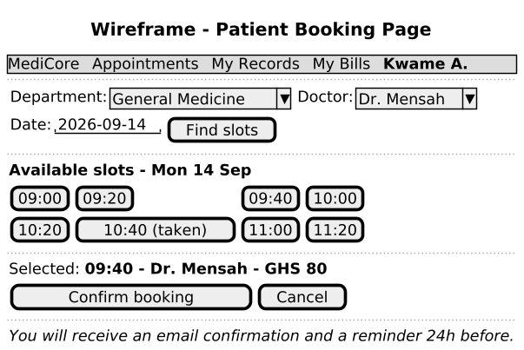
Figure 9 — Patient booking page: department → doctor → date → slot grid → confirm.
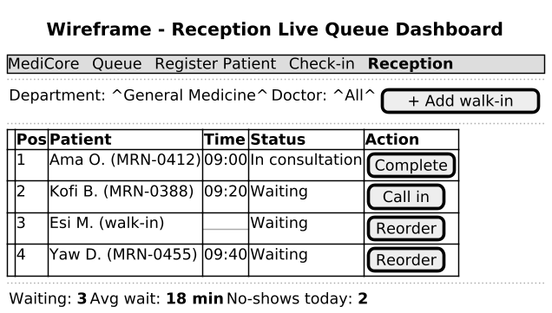
Figure 10 — Reception live queue dashboard with walk-in insertion and reorder (FR-APT-07/08/09).

8. Technical Debt Registered at Design Time
The brief requires debt tracking across the whole lifecycle, so items knowingly accepted during design are logged now in the standard format (Cause → Impact → Priority → Resolution). These entries seed the project debt ledger and reappear in the maintenance plan’s repayment schedule.
ID | Cause (shortcut taken) | System impact | Priority | Proposed resolution
TD-01 | Slot materialisation runs synchronously inside the schedule-save request (DD-04) | Saving a schedule for many weeks blocks the request; will degrade as doctors/horizon grow | Medium | Move generation to a background job with idempotent regeneration (v1.1)
TD-02 | Email sending is fire-with-retry from an in-process queue, not a durable job store | Process restart on the free tier can drop queued reminders (FR-APT-06 best-effort) | Medium | Durable job table + worker; dead-letter review screen (v1.1)
TD-03 | Bed-day charge accrual computed by a daily scheduled task | Missed task run under free-tier sleep delays charges; discharge recomputes as safety net | Low | Accrue on read (compute from admitted_at) and drop the cron (v1.1)
TD-04 | Callback replay handling relies on paid-status idempotency (a replayed callback for a paid payment is ignored) rather than a nonce store | Duplicate callbacks for still-pending payments trigger redundant status queries (no double-credit — proven by test) | Low | Optionally dedupe by uniwalletTransactionId (v2); risk largely retired by the idempotency test
TD-05 | Policy relationship resolvers query live tables on every request (no caching) | Adds one indexed query per clinical request; fine at reference load, hot at scale | Accepted for v1 | Introduce short-TTL relationship cache when load testing justifies it

9. Design-to-Requirements Traceability (Extract)
Design element | Implements | Verified by (planned)
Policy Engine + matrix config (DD-03) | SRS §4 matrix, AC-01…AC-06, FR-AUTH-04/05 | Negative-test suite: one test per denied matrix cell
UNIQUE(slot_id) + transactional booking (DD-04) | FR-APT-04 | Concurrency unit test: parallel bookings, one winner
FEFO SELECT … FOR UPDATE + CHECK constraint | FR-PHM-02/05 | Unit tests: expiry ordering; stock floor
Append-only invoice items (DD-05) | FR-BIL-01/02, FR-BIL-07 | Integration test: four-source charge posting
Signed-note trigger + ADDENDUM path | FR-EMR-03 | Integration test: UPDATE after sign-off rejected
PaymentGateway port + server-verify flow (DD-07) | FR-BIL-03, NFR-SEC-06 | Contract tests against a gateway stub: callback without successful status query never credits; adapter E2E in ITC test mode at M3
Sessions in httpOnly cookies (DD-02) | FR-AUTH-08, AC-03 | Test: ward reassignment revokes visibility next request
LabWorkflow forward-only lifecycle + doctor-only release | FR-LAB-04, FR-LAB-05, AC-04 | Unit tests: step skipping and reversal rejected; release refused until every requested test has a result
Ward board pinned to staff.assigned_ward_id (ward.roster) | AC-03, FR-EMR-05, FR-FAC-01 | API test: nurse reads and charts on her own ward, 403 on a patient admitted elsewhere
AuditService isolated with REQUIRES_NEW propagation | FR-EMR-06, NFR-SEC-04 | AdminStaffIT: a staff record survives an audit row the database rejects

The full traceability matrix (every FR → design element → test case) is maintained in the testing documentation and consolidated in the master project document.

