Software Engineering Project
On
ONLINE VOTING SYSTEM
Submitted in partial fulfilment of the Requirements for the award of the degree of
SOFTWARE ENGINEERING
In
Computer Science and Engineering
By
1) N.G.Sai Bhargavi – O190042
2) A.L.Priyanka - O190056
3) P.Harsha Vardhan - O190585
4) R.Sriharshitha - O190910
5) Sk.Mubeena - O190676
Under the guidance of
Mrs J.Mrudhula , Assistant Professor
Dept of Computer Science.

Department of Computer Science and engineering
Dr.APJ Abdul Kalam,RGUKT-AP,IIIT Ongole
(International Institute of Information and Technology-Ongole Campus)
KurnoolRoad, Ongole, Prakasam(Dt.)
AndhraPradesh-523225

CERTIFICATE

This is to certify that the project entitled “Online Voting System” being submitted by N.G.Sai Bharghavi bearing the Id number O190042 and A.L.Priyanka bearing the Id number O190056 and
P. Harsha Vardhan bearing the Id number O190585 and R. Sriharshitha bearing the Id number O190910 and Sk.Mubeena bearing the Id number O190676 in partial fulfilment of the requirements for the award of the degree of the Bachelor of Technology in Computer Science and Engineering to Rajiv Gandhi University of knowledge Technologies is a record of bonafide work carried out by them under my guidance and supervision from August 2023 to December 2023.
The results presented in this project have been verified and found to be satisfactory. The results embodied in this project report have not been submitted to any other University for the award of any other degree.

Faculty- In- Charge Head Of The Department

Internal Examiner External Examiner

ACKNOWLEDGEMENT
It is our privilege and pleasure to express a profound sense of respect, gratitude and in debtedness to our guide Mrs J.Mrudhula, Assistant Professor, Dept. of Computer Science and Engineering, Rajiv Gandhi University Of Knowledge Technologies, for his/her indefatigable inspiration, guidance, cogent discussion, constructive criticisms and encouragement throughout this dissertation work.
We express our sincere gratitude to Mr. Buthapati Sampath Babu, Professor & Head,
Department of Computer Science and Engineering, Rajiv Gandhi University Of Knowledge Technologies, for his suggestions, motivations and co-operation for the successful completion of the work.
We extend our sincere thanks to Dean Mr. M. Rupas Kumar, Research and Development, , Rajiv Gandhi University Of Knowledge Technologies, for his encouragement and constant help.
We extend our sincere thanks to Prof.B.jayarami Reddy, Director, , Rajiv Gandhi University Of Knowledge Technologies, for his encouragement.

N.G.Sai Bharghavi (O190042)
A.L.Priyanka (O190056)
P.Harsha Vardhan (O190585)
R.Sriharshitha (O190910)
Sk.mubeena (O190676)

DECLARATION
We hereby declare that the project work entitled “Online Voting System” submitted to the Rajiv Gandhi University Of Knowledge Technologies in partial fulfilment of the requirements for the award of the degree of SOFTWARE ENGINEERING in Computer Science and Engineering is a record of an original work done by us under the guidance of Mrs J.Mrudhula, Assistant Professor and this project work have not been submitted to any other university for the award of any other degree.

N.G.Sai Bharghavi (O190042)
A.L.Priyanka (O190056)
P.Harsha Vardhan(O190585)
R.Sriharshitha (O190910)
Sk.mubeena (O190676)

Date:

ABSTRACT
In the digital age, it has become imperative to adapt traditional democratic processes to the conveniences of technology. Our project, "Student Voice Hub" introduces an Online Voting System designed specifically for campus elections. This system aims to streamline and enhance the electoral process, making it more accessible, efficient, and secure. The core features of our system include user-friendly registration, candidate profiles, and secure ballot submission. Utilizing encryption techniques, the system ensures data integrity and confidentiality. Real-time result tracking and reporting simplify the counting process and provide transparency to voters and candidates. By eliminating physical ballots and in-person voting, our system promotes inclusivity and encourages higher voter turnout among students. It offers flexibility by allowing students to vote from any internet-connected device, fostering a culture of participation and engagement in campus politics. This project exemplifies the potential for technology to revolutionize democracy at the grassroots level, emphasizing the importance of secure, convenient, and accessible voting systems in educational institutions. "Student Voice Hub" is a stepping stone towards embracing the digital era while upholding the democratic values that lie at the heart of campus elections..

CONTENTS
S.NO PAGE NO
- Introduction 7
  - Motivation 7
  - Problem Definition 7
  - Objective of the Project 7
- Literature Survey 8
- Analysis 10
  - Existing System 10
3 .2. Proposed System 10
3.3. Software Requirement Specification 10
    - Purpose 11
    - Scope 11
    - Overall Description 11
- Design 12
  - UML diagrams 12

1.INTRODUCTION
Student Voice Hub is aimed to streamline and enhance the electoral process, making it more accessible, efficient, and secure. The core features of our system include user-friendly registration, candidate profiles, and secure ballot submission.
1.1.Motivation
Our project is motivated by the need to modernize and improve the campus election process, making it more accessible, efficient, secure, and engaging for all students, while aligning with the trends of the digital age.It also offers flexibility by allowing students to vote from any internet-connected device, fostering a culture of participation and engagement in campus politics.
1.2.Problem Definitions:
Traditional campus elections using paper ballots and in-person voting face challenges of limited accessibility, inefficiency, security concerns, low voter turnout, and limited transparency. Our project aims to overcome these issues with an Online Voting System for Campus Elections, enhancing accessibility, efficiency, security, and engagement in the electoral process.
1.3.Objectives of Project:
Our project main theme is to design and develop a website which is integrated with the features like Accessibility, Efficiency, Security. It also increases Voter Turnout , Enhances Transparency, Promote technological Literacy and provides a Scalable solution. These objectives collectively aim to modernize and optimize the campus election process through the introduction of an online voting system.

2. LITERATURE SURVEY

There are lot of practices are made to introduce the variations in electronic and online voting systems
where different techniques and methodologies are used. Some of them guarantees the confidentiality and security to the system at some extent, still the voting information and process need to be control and manage with advanced systems that will ensures and guarantees the security and privacy of voter’s and voter’s information.

• Basic E-voting approach/architecture:
The systems that are developed to caste the vote by means of digital approach using online portals and
electronic devices use various encryption and decryption techniques to guarantee the secure data
transaction.

• Homomorphic Encryption Technique :
Homomorphic encryption is a well-known powerful technique with many useful applications. Recently, it has been applied to the design of online voting system. The voting system based on this encryption uses the exponential ElGamal cryptosystem. Before submission, the contents of each cast ballot are encrypted using the exponential ElGamal encryption. The additive homomorphism property of this crypto system makes it possible to tally encrypted ballots directly without decrypting them.

• Centralized architecture :
However, numbers of techniques are present to convert the data in coded format to prevent from manipulation while transferring to the network. One drawback can be discussed here that after the correct data have been stored in the database trust and security is required at substantial level. Centralized storage is inconvenient ifthe data is esteemed because unauthorized access and attack by hackers will challenge the system in terms of reliability.

3.ANALYSIS
3.1. Existing system:
The voting system currently being used by the association is a paper based system, in which the voter simply picks up ballots sheets from electoral officials, tick off who they would like to vote for, and then cast their votes by merely handing over the ballot sheet back to electoral official. The electoral officials gather all the votes being cast into a ballot box. At the end of the elections, he electoral officials converge and count the votes cast for each candidate and determine the winner of each election category.
3.2. Proposed system:
Here we are proposing an web application for voting process that is Online Voting System through SMS. The online voting system will manages the voter’s details, Candidate details. The main feature of the project includes voters information and candidate information, voter can login and use his/her voting rights. The system can manage the information data very efficiently. The proposed system is more reliable, faster, accurate and easy to handle compared to existing manual system. It helps to computerize everything and reducing the errors as compare to manual voting system
Advantages of proposed system:
1. Accessibility: Online voting systems make it easier for a wide range of voters, including those with disabilities or living in remote areas, to participate in elections.
2. Convenience: Voters can cast their ballots from anywhere with an internet connection, reducing the need for physical travel to polling stations.
3. Speed and Efficiency: Online voting can expedite the counting and reporting of election results, minimizing delays and errors associated with manual vote counting.
4. Cost Savings: Over time, online voting systems can be more cost-effective than traditional methods, as they reduce the need for physical infrastructure and printed materials like paper ballots.
5. Increased Voter Turnout: Online voting can potentially increase voter turnout, as it eliminates many of the barriers associated with traditional in-person voting.
3.3.SOFTWARE REQUIREMENT SPECIFICATION:
Our website contains both Frontend and Backend. In the process of creation of websites we use different programming languages in frontend and backend.
Frontend Programming Languages:
- Html
- Css
- Javascript &Bootstrap

Backend Programming Languages:
- Php
- MySQL
By using the above mentioned Programming Languages we completed our project.In this project we use Software languages as well as some Hardware Materials also. They are:
Hardware Requirements:
- Laptop
- Internet
By using the Above mentioned Software and Hardware requirements we completed our project successfully.

3.3.1.PURPOSE:
The purpose of your project, an online voting system for campus elections, is to provide a convenient and efficient way for students to cast their votes during campus elections, ultimately ensuring a fair and transparent electoral process.
3.3.2. SCOPE:
The scope of your online voting system for campus elections includes creating a user-friendly platform for student registration, candidate registration, secure online voting, and result calculation.

3.3.3.OVERALL DESCRIPTION:
Our project Student Voice Hub aims to develop an online voting system for campus elections. This system will allow students to register, vote securely, and enable candidates to register and campaign. It ensures a transparent and accessible election process, complies with relevant regulations, and provides administrative tools for election organizers. The system's scope encompasses user registration, ballot creation, secure voting, result calculation, and various features to support a fair and efficient campus election process.

4.DESIGN
4.1 UML DIAGRAM
A UML Diagram is based on UML(Unified Modeling Language) with the purpose of visually representing a system along with its main actors, roles, actions, artifacts or classes, in order to better understand, alter, maintain, or document information about the system. The UML diagrams are divided into Structural and Behavioural UML Diagrams.
❖ STRUCTURAL UML DIAGRAMS:
Structural diagrams depict a static view of a structure of a system.It is widely used in the Documentation of software architecture.The Structural UML Diagrams involves 7 diagrams
They are:
- Class Diagram
- Object Diagram
- Component Diagram
- Composite Structure Diagram
- Deployment Diagram
- Package Diagram
- Profile Diagram

❖ BEHAVIOURAL UML DIAGRAMS:
Behavioural diagrams portray a dynamic view of a system or the behaviour of a system, which describes the functioning the system. It involves 7 diagrams

They are:
- Usecase Diagram
- Sequence Diagram
- Activity Diagram
- State Machine Diagram
- Interaction Overview Diagram
- Communication Diagram
- Timing Diagram

CLASS DIAGRAM
The class diagram is the main building block of object-oriented modelling. It is used for general conceptual modelling of the structure of the application, and for detailed modelling translating the models into programming code. Class diagrams can also be used for data modelling.

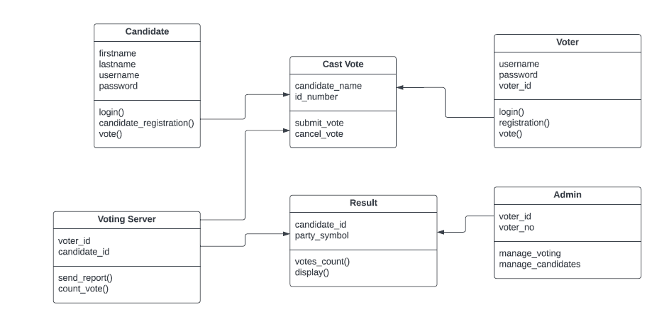

OBJECT DIAGRAM

It describes the static structure of a system at a particular point in time. It can be used to test the accuracy of class diagrams. It represents distinct instances of classes and the relationship between them at a time.

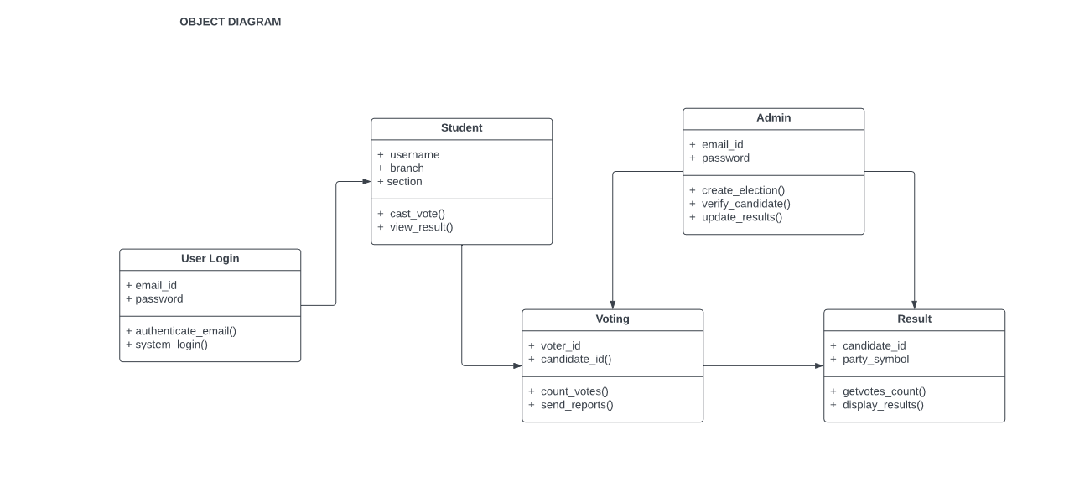

COMPONENT DIAGRAM
Component diagrams are used in modelling the physical aspects of object-oriented systems that are used for visualizing, specifying, and documenting component-based systems and also for constructing executable systems through forward and reverse engineering. Component diagrams are essentially class diagrams that focus on a system's components that often used to model the static view of diagram.

COMPOSITE STRUCTURE DIAGRAM
Composite Structure Diagram is one of the new artifacts added to UML 2.0. A composite structure diagram is a UML structural diagram that contains classes, interfaces, packages, and their relationships, and that provides a logical view of all, or part of a software system. It shows the internal structure (including parts and connectors) of a structured classifier or collaboration.
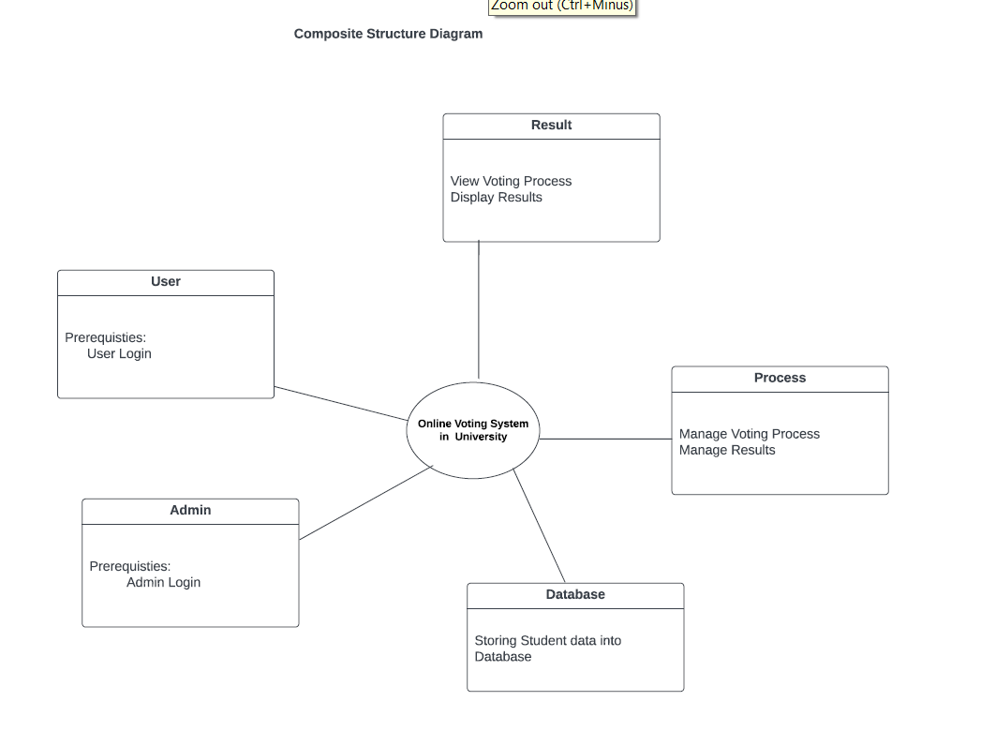

PACKAGE DIAGRAM
Package diagrams are used, in part, to depict import and access dependencies between packages, classes, components, and other named elements within your system. Each dependency is rendered as a connecting line with an arrow representing the type of relationship between the two or more elements.
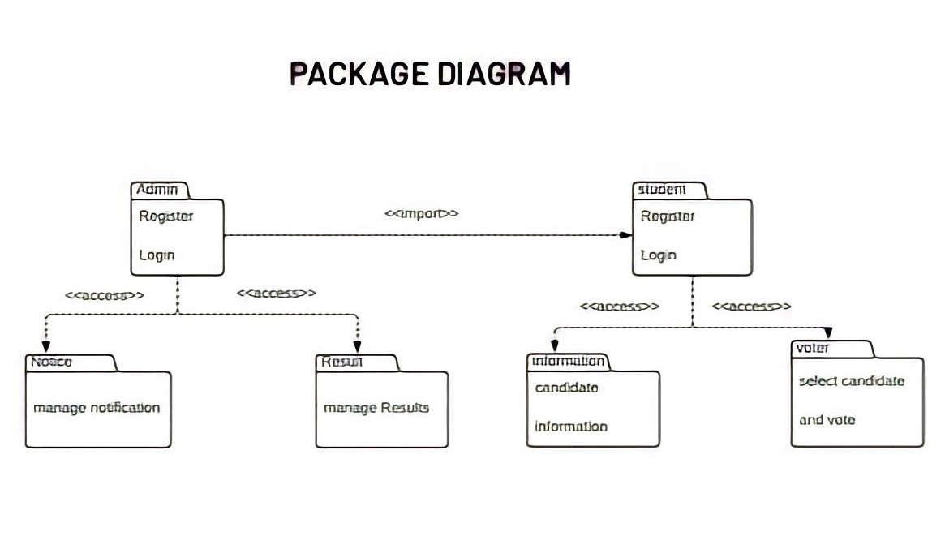

PROFILE DIAGRAM

Profile diagram is basically an extensibility mechanism that allows you to extend and customize UML by adding new building blocks, creating new properties and specifying new semantics in order to make the language suitable to your specific problem domain.

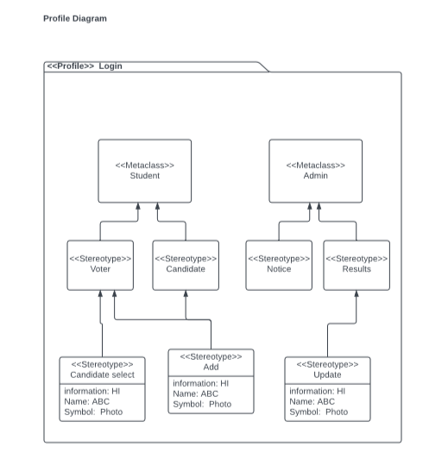

SEQUENTIAL DIAGRAM
A sequence diagram consists of a group of objects that are represented by lifelines, and the messages that they exchange over time during the interaction. A sequence diagram shows the sequence of messages passed between objects. Sequence diagrams can also show the control structures between objects.
COMMUNICATION DIAGRAM
A Communication diagram models the interactions between objects or parts in terms of sequenced messages. Communication diagrams represent a combination of information taken from Class, Sequence, and Use Case Diagrams describing both the static structure and dynamic behavior of a system.
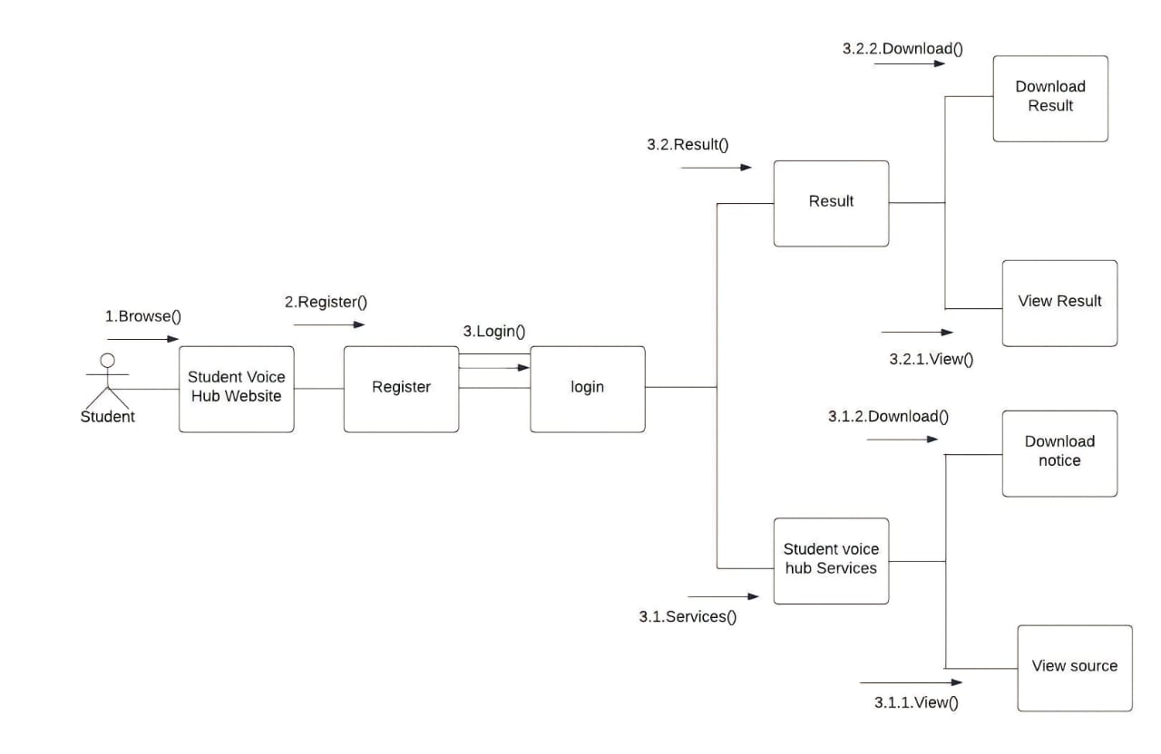

ACTIVITY DIAGRAM
An activity diagram visually presents a series of actions or flow of control in a system similar to a flowchart or a data flow diagram. Activity diagrams are often used in business process modeling. They can also describe the steps in a use case diagram. Activities modeled can be sequential and concurrent.

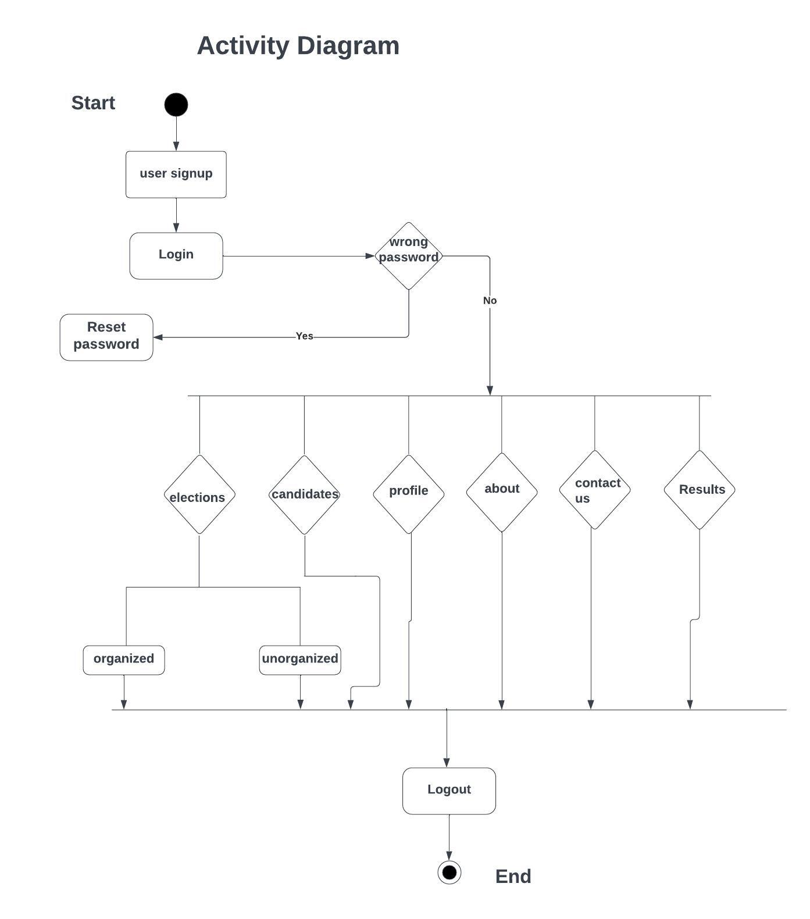

INTERACTION OVERVIEW DIAGRAM
An interaction diagram is a type of UML diagram that's used to capture the interactive behavior of a system. Interaction diagrams focus on describing the flow of messages within a system, providing context for one or more lifelines within a system.
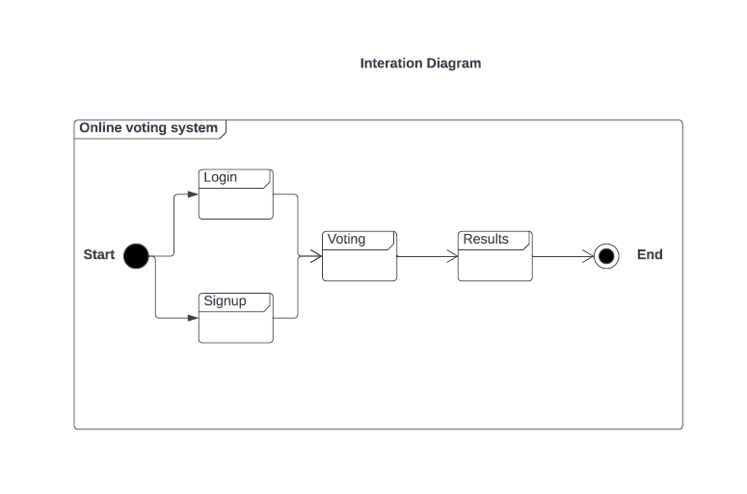

STATE MACHINE DIAGRAM

A state diagram, also known as a state machine diagram or statechart diagram, is an illustration of the states an object can attain as well as the transitions between those states in the Unified Modeling Language (UML).
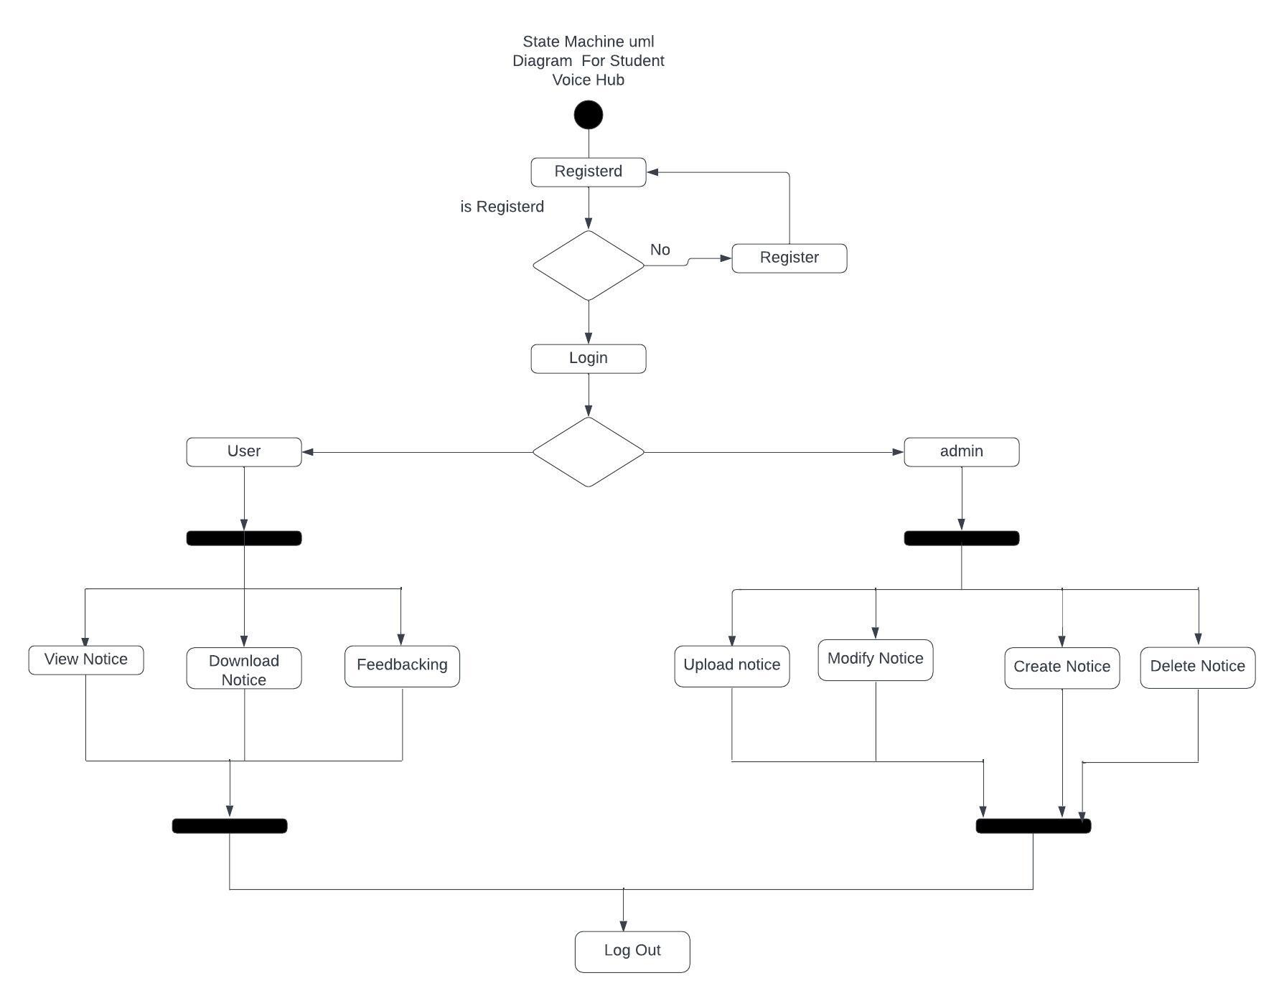

TIMING DIAGRAM
A timing diagram includes timing data for at least one horizontal lifeline, with vertical messages exchanged between states. Timing diagrams represent timing data for individual classifiers and interactions of classifiers. You can use this diagram to provide a snapshot of timing data for a particular part of a system.
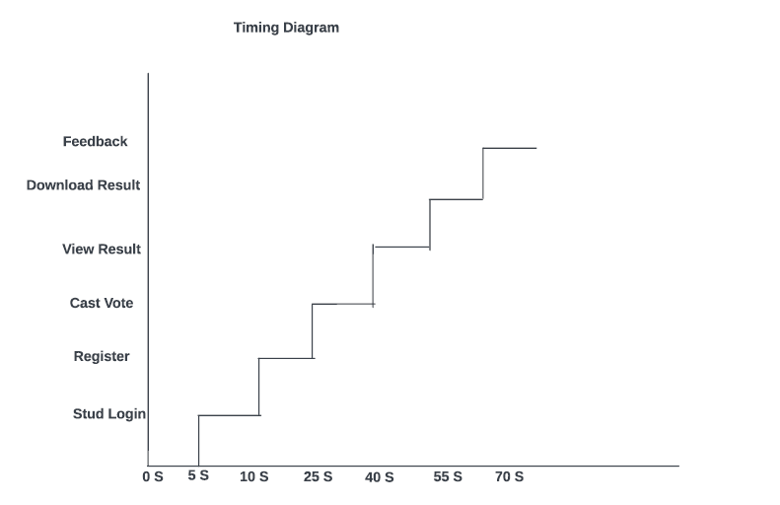

USECASE DIAGRAM
Use-case diagrams describe the high-level functions and scope of a system. These diagrams also identify the interactions between the system and its actors. The use cases and actors in usecase diagrams describe what the system does and how the actors use it, but not how the system operates internall.

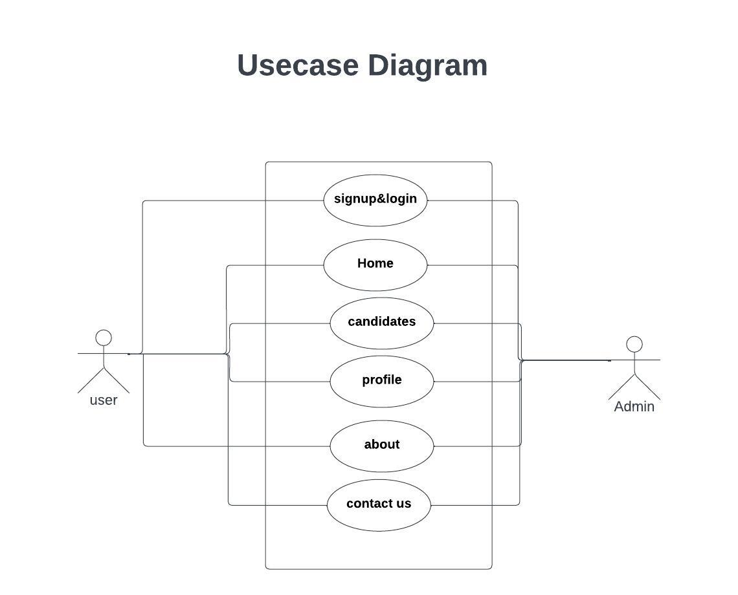

DEPLOYMENT DIAGRAM
A deployment diagram is a UML diagram type that shows the execution architecture of a system, including nodes such as hardware or software execution environments, and the middleware connecting them. Deployment diagrams are typically used to visualize the physical hardware and software of a system.

