Phase 0.1: Complete Architecture Audit (Backend, Frontend, DB, Infrastructure)

1. Product Architecture (Frozen)
Product
ReelSync
Product Type
Multi-tenant SaaS
Target Users
- Individual Content Creators
- Influencers
- Freelancers
- Marketing Agencies
- Social Media Teams
- SMBs
Core Features (MVP)
Authentication
- Signup
- Login
- Forgot Password
- Email Verification
- Role Based Access
Workspace Management
- Create Workspace
- Invite Members
- Manage Roles
Social Media Integration
- Instagram
- Facebook
- LinkedIn
- YouTube
- X (Twitter)
Content Management
- Upload Media
- Media Library
- Content Tagging
Publishing
- Schedule Posts
- Instant Publish
- Bulk Scheduling
AI Features
- Caption Generation
- Hashtag Suggestions
- Content Optimization
Billing
- Subscription Plans
- Usage Limits
- Invoices
Analytics
- Post Performance
- Account Growth
- Engagement Metrics

2. Frontend Architecture (Frozen)
Framework
Next.js 16
Reason:
- SSR
- SEO
- Modern App Router
- Large ecosystem

Language
TypeScript
Mandatory.

UI Library
ShadCN

Styling
Tailwind CSS

State Management
Zustand
Global state only.

Server State
TanStack Query

Form Management
React Hook Form
Zod

Folder Structure
frontend
│
├── app
├── components
├── modules
├── hooks
├── services
├── store
├── types
├── lib
└── utils

3. Backend Architecture (Frozen)
Framework
FastAPI
Reason:
- High performance
- Async support
- Excellent documentation

Architecture Pattern
Modular Monolith
Not microservices.

Folder Structure
backend
│
├── auth
├── users
├── workspaces
├── social
├── scheduler
├── analytics
├── ai
├── billing
├── notifications
├── common
└── core

API Standard
REST API
Versioning:
/api/v1/
Example:
/api/v1/auth/login
/api/v1/posts
/api/v1/workspaces

4. Database Architecture (Frozen)
Database
PostgreSQL

ORM
SQLAlchemy 2.x
Alembic

Multi Tenancy
Shared Database
Shared Schema
workspace_id isolation
Reason:
- Lower cost
- Easier operations
- Suitable for SaaS MVP

Core Tables
users
workspaces
workspace_members

roles
permissions

social_accounts

media_assets

posts
post_schedules

subscriptions

ai_generations

notifications

audit_logs

Soft Delete Strategy
All business entities:
deleted_at
column.

5. Cache Architecture (Frozen)
Cache
Redis
Used for:
- Sessions
- Rate Limits
- Queue backend
- Temporary caches

6. Queue Architecture (Frozen)
Queue System
Celery
Redis
Queues:
Publish Queue
Scheduled Posts
Analytics Queue
Analytics Sync
AI Queue
Caption Generation
Notification Queue
Email Sending

7. Storage Architecture (Frozen)
Object Storage
AWS S3
Store:
- Videos
- Images
- Thumbnails
- Exports
Never store media inside PostgreSQL.

8. Authentication Architecture (Frozen)
Authentication Method
JWT

Security
Access Token
Refresh Token

Password Storage
Argon2

Future Support
Google OAuth
LinkedIn OAuth

9. AI Architecture (Frozen)
Provider Layer
AI Provider Abstraction
Providers:
OpenAI
Gemini
Claude
No vendor lock-in.

MVP AI Features
- Caption Generation
- Hashtag Suggestions
- Post Optimization

10. Billing Architecture (Frozen)
Provider
Stripe

Plans
Free
Starter
Pro
Agency
Enterprise

Billing Cycle
Monthly
Yearly

11. Infrastructure Architecture (Frozen)
Frontend Hosting
Vercel

Backend Hosting
AWS ECS Fargate

Database
AWS RDS PostgreSQL

Cache
Redis

Storage
AWS S3

CDN
Cloudflare

12. Security Architecture (Frozen)
Mandatory
- HTTPS Everywhere
- JWT Validation
- RBAC
- Input Validation
- SQL Injection Protection
- XSS Protection
- CSRF Protection
- Rate Limiting

Secrets
AWS Secrets Manager
Production only.

13. Observability Architecture (Frozen)
Logging
Structured JSON Logs

Error Tracking
Sentry

Metrics
OpenTelemetry

Dashboard
Grafana

14. Backup & Recovery (Frozen)
PostgreSQL
- Daily Backup
- 35-Day Retention

S3
- Versioning Enabled

Redis
- Snapshot Persistence

15. Scalability Targets (Frozen)
Phase 1
1,000 Users
Phase 2
10,000 Users
Phase 3
100,000 Users
No architectural rewrite expected before 100k users.

Architecture Decisions Finalized
✅ Frontend Stack Frozen
✅ Backend Stack Frozen
✅ Database Stack Frozen
✅ Queue Stack Frozen
✅ Storage Stack Frozen
✅ Authentication Strategy Frozen
✅ AI Strategy Frozen
✅ Billing Strategy Frozen
✅ Infrastructure Strategy Frozen
✅ Security Strategy Frozen
✅ Observability Strategy Frozen
✅ Scalability Strategy Frozen

Phase 0.1 Architecture Diagram

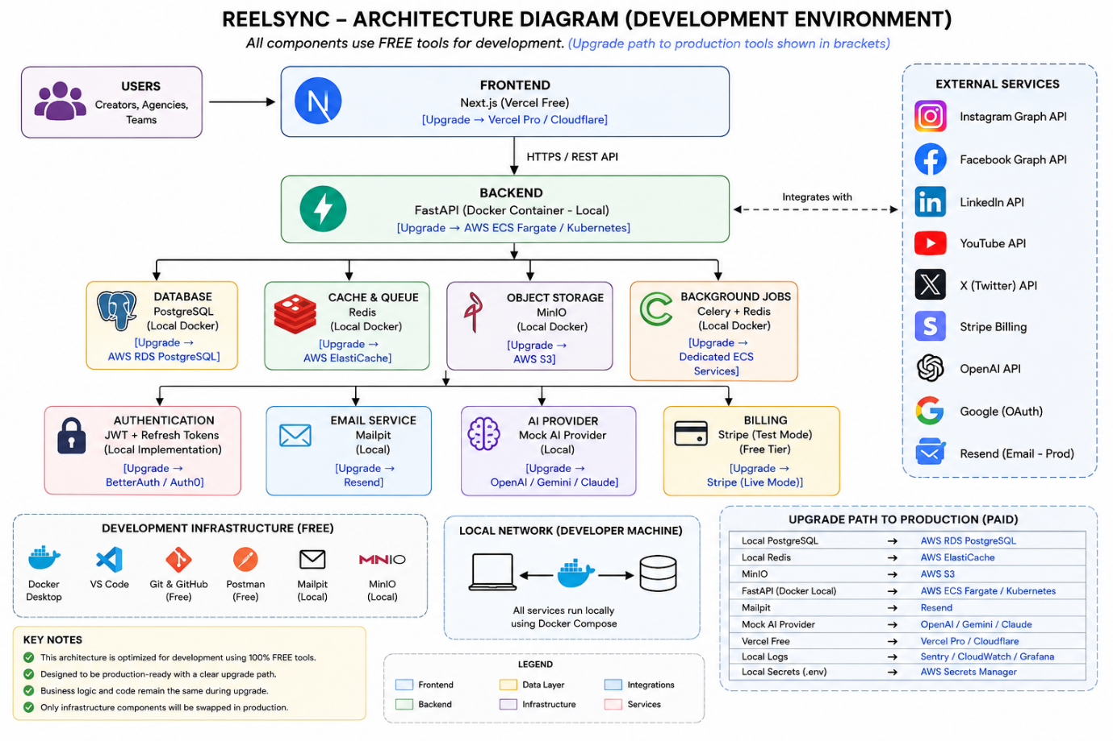

Phase 0.2: Database ER Diagram

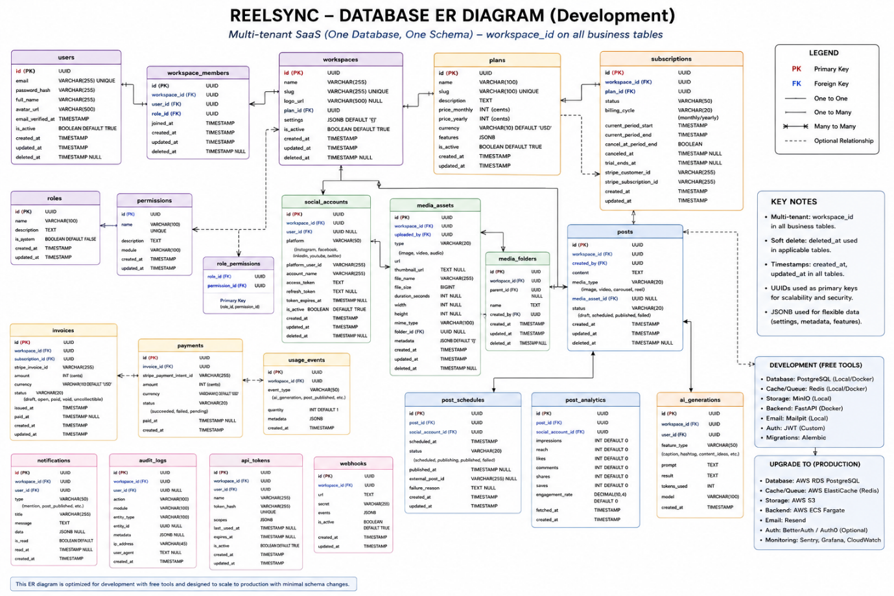

Phase 0.4.: API Inventory Documentation

Objective: Define every API endpoint before development starts.

This becomes the contract between:

Next.js Frontend
FastAPI Backend

Deliverables Required for 100%

1. Authentication APIs
POST /api/v1/auth/register
POST /api/v1/auth/login
POST /api/v1/auth/logout
POST /api/v1/auth/refresh
POST /api/v1/auth/forgot-password
POST /api/v1/auth/reset-password
GET /api/v1/auth/me

2. User APIs
GET /api/v1/users/me
PUT /api/v1/users/me
DELETE /api/v1/users/me

3. Workspace APIs
POST /api/v1/workspaces
GET /api/v1/workspaces
GET /api/v1/workspaces/{id}
PUT /api/v1/workspaces/{id}
DELETE /api/v1/workspaces/{id}

4. Team Member APIs
POST /api/v1/workspaces/{id}/members
GET /api/v1/workspaces/{id}/members
PUT /api/v1/workspaces/{id}/members/{memberId}
DELETE /api/v1/workspaces/{id}/members/{memberId}

5. Role & Permission APIs
GET /api/v1/roles
POST /api/v1/roles
PUT /api/v1/roles/{id}
DELETE /api/v1/roles/{id}

6. Social Account APIs
POST /api/v1/social/connect
GET /api/v1/social/accounts
GET /api/v1/social/accounts/{id}
DELETE /api/v1/social/accounts/{id}
POST /api/v1/social/refresh-token

Supported:
Instagram
Facebook
LinkedIn
YouTube
X

7. Media Library APIs
POST /api/v1/media/upload
GET /api/v1/media
GET /api/v1/media/{id}
DELETE /api/v1/media/{id}

8. Post APIs
POST /api/v1/posts
GET /api/v1/posts
GET /api/v1/posts/{id}
PUT /api/v1/posts/{id}
DELETE /api/v1/posts/{id}

9. Scheduler APIs
POST /api/v1/schedules
GET /api/v1/schedules
GET /api/v1/schedules/{id}
PUT /api/v1/schedules/{id}
DELETE /api/v1/schedules/{id}
POST /api/v1/schedules/{id}/publish

10. Analytics APIs
GET /api/v1/analytics/overview
GET /api/v1/analytics/posts
GET /api/v1/analytics/accounts
GET /api/v1/analytics/growth

11. AI APIs
MVP
POST /api/v1/ai/caption
POST /api/v1/ai/hashtags
POST /api/v1/ai/optimize

Future
POST /api/v1/ai/script
POST /api/v1/ai/voice
POST /api/v1/ai/dub
POST /api/v1/ai/avatar

12. Billing APIs
GET /api/v1/billing/plans
POST /api/v1/billing/subscribe
POST /api/v1/billing/cancel
GET /api/v1/billing/invoices
GET /api/v1/billing/usage

13. Notification APIs
GET /api/v1/notifications
PUT /api/v1/notifications/{id}/read
DELETE /api/v1/notifications/{id}

14. Audit APIs
GET /api/v1/audit-logs
GET /api/v1/audit-logs/{id}

15. Health & System APIs
GET /api/v1/health
GET /api/v1/version

API Standards (Must Be Frozen)

Versioning
/api/v1/

Success Response
json
{
"success": true,
"data": {}
}

Error Response
json
{
"success": false,
"message": "Error description"
}

Authentication
Bearer JWT Token

Phase 0.5: Infrastructure Inventory

Objective: Document every infrastructure component needed for development and future production deployment.
This task is not about deploying anything. It is about knowing exactly what infrastructure exists, why it exists, and what it upgrades to later.

Development Infrastructure (Current)
Layer | Tool | Purpose | Upgrade Later
Frontend | Next.js Local | UI Development | Vercel Pro
Backend | FastAPI Local | API Development | AWS ECS
Database | PostgreSQL Docker | Data Storage | AWS RDS
Cache | Redis Docker | Cache & Queue | AWS ElastiCache
Storage | MinIO Docker | File Storage | AWS S3
Queue | Celery + Redis | Background Jobs | ECS Worker Services
Authentication | JWT | User Auth | Same
Email | Mailpit | Local Email Testing | Resend
AI | Mock Provider | Development | OpenAI/Gemini/Claude
Source Control | GitHub | Code Repository | Same
Containerization | Docker | Environment Consistency | Same

Local Development Architecture
Developer Machine
│
├── Frontend (Next.js)
│
├── Backend (FastAPI)
│
├── PostgreSQL
│
├── Redis
│
├── MinIO
│
├── Celery Worker
│
├── Mailpit
│
└── Docker Compose

Production Infrastructure (Future)
Edge Layer
Cloudflare
Purpose:
- CDN
- SSL
- WAF
- DDoS Protection

Frontend
Vercel Pro
Purpose:
- Next.js hosting
- Global deployment

Backend
AWS ECS Fargate
Purpose:
- API hosting
- Auto scaling

Database
AWS RDS PostgreSQL
Purpose:
- Managed PostgreSQL
- Automated backups

Cache
AWS ElastiCache Redis
Purpose:
- Cache
- Queue backend

Storage
AWS S3
Purpose:
- Images
- Videos
- Audio
- Exports

Workers
AWS ECS Worker Services
Purpose:
- Scheduled posting
- Analytics sync
- AI generation
- Email processing

CI/CD Inventory
Source Control
GitHub

CI/CD
GitHub Actions
Pipelines:
Lint
Unit Tests
Build
Deploy

Environment Inventory
Local
Developer Machine
Purpose:
- Development

Development
Shared Dev Environment
Purpose:
- Team testing

Staging
Pre-production Validation
Purpose:
- Release testing

Production
Live Customers
Purpose:
- Real users

Secrets Inventory
Development
.env

Production
AWS Secrets Manager
Store:
Database Passwords
JWT Secrets
Stripe Keys
OpenAI Keys
Social API Keys

Monitoring Inventory
Development
Application Logs

Production
Sentry
OpenTelemetry
Grafana

Backup Inventory
Database
Daily Backup
35 Day Retention

Storage
S3 Versioning

Cost Inventory (Development)
Next.js ₹0
FastAPI ₹0
PostgreSQL ₹0
Redis ₹0
MinIO ₹0
Mailpit ₹0
Docker ₹0
GitHub ₹0

Total ≈ ₹0/month

Cost Inventory (Early Production)
Estimated:
Vercel Pro
AWS RDS
AWS S3
AWS ECS
Redis

Approx:
₹3,000–₹8,000/month
depending on traffic.

Infrastructure Upgrade Matrix
Local PostgreSQL → AWS RDS
Local Redis → ElastiCache
MinIO → AWS S3
Mailpit → Resend
Mock AI → OpenAI/Gemini/Claude
Local Docker → ECS Fargate
.env → AWS Secrets Manager
Logs → Sentry/Grafana

Deliverables Completed
✅ Development Infrastructure Inventory
✅ Production Infrastructure Inventory
✅ Environment Inventory
✅ CI/CD Inventory
✅ Secrets Inventory
✅ Monitoring Inventory
✅ Backup Inventory
✅ Upgrade Path Inventory
✅ Cost Inventory

Phase 0.6: Technical Debt Report

Objective: Identify shortcuts, compromises, future refactoring areas, scalability bottlenecks, and vendor dependencies before development starts.
This prevents surprises later.

Executive Summary
Current Architecture Quality:
Architecture Quality Score: 8.5/10

Technical Debt Risk: LOW

Reason:
Well-designed foundation,
but some intentional shortcuts
exist to reduce MVP complexity.

Debt Category 1 — Development Infrastructure
Current Decision
Local PostgreSQL
Local Redis
MinIO
Docker Compose
Future Debt
As team size grows:
Environment drift
Different developer setups
Impact:
LOW
Mitigation:
Docker Compose
Environment documentation

Debt Category 2 — Shared Database Multi-Tenancy
Current Decision
Single Database
Single Schema
workspace_id isolation
Future Risk:
Large enterprise customers
may require isolated databases.
Impact:
MEDIUM
Mitigation:
Repository layer abstraction.
Future migration path:
Shared Schema
↓
Dedicated Database

Debt Category 3 — Social Platform APIs
Current Decision
Direct integrations.
Platforms:
Instagram
Facebook
LinkedIn
YouTube
X
Risk:
API changes
Rate limits
Permission revocations
Impact:
HIGH
Mitigation:
Create:
SocialProvider Interface
Never call platform APIs directly from business logic.

Debt Category 4 — AI Providers
Current Decision
Provider Abstraction Layer
Risk:
Pricing changes
Rate limits
Model deprecation
Impact:
MEDIUM
Mitigation:
OpenAI
Gemini
Claude
switchable providers.

Debt Category 5 — Voice Provider Dependency
Future Feature
Potential provider:
ElevenLabs
Risk:
Vendor lock-in
Pricing increases
Impact:
HIGH
Mitigation:
VoiceProvider Interface

Debt Category 6 — Celery Architecture
Current Decision
Celery + Redis
Risk:
At large scale:
Complex queue monitoring
Impact:
LOW
Mitigation:
Remain on Celery until:
100k+ users
No action required now.

Debt Category 7 — Analytics Aggregation
Current Decision
Analytics stored in PostgreSQL.
Future Risk:
Heavy reporting queries
Impact:
MEDIUM
Mitigation:
Future:
ClickHouse
or
BigQuery
Not required for MVP.

Debt Category 8 — Media Storage
Current Decision
MinIO
Future:
AWS S3
Risk:
Minimal.
Impact:
LOW

Debt Category 9 — Authentication
Current Decision
Custom JWT
Risk:
Security bugs.
Impact:
MEDIUM
Mitigation:
Use:
FastAPI Security
Argon2
Refresh Tokens
Avoid custom crypto.

Debt Category 10 — Notification System
Current Decision
Mailpit
Future:
Resend
Risk:
Minimal.
Impact:
LOW

Debt Category 11 — Infrastructure Simplicity
Current Decision
Modular Monolith
Risk:
Some engineers prematurely move to microservices.
Reality:
No need before 100k+ users.
Impact:
LOW
Mitigation:
Remain monolith.

Debt Category 12 — AI Voice Studio (Future)
Features:
Voice Cloning
Voice Dubbing
Emotion Control
Current Status:
Not implemented.
Risk:
Future schema expansion.
Impact:
LOW
Mitigation:
Reserved architecture module.

Top 5 Technical Risks
Priority | Area | Impact
1 | Social Platform APIs | High
2 | Voice Provider Lock-in | High
3 | Multi-Tenant Scaling | Medium
4 | Analytics Growth | Medium
5 | Custom Authentication | Medium

Technical Debt Scorecard
Area | Debt Level
Frontend | Low
Backend | Low
Database | Low
Infrastructure | Low
AI | Medium
Voice Studio | Medium
Social Integrations | High
Analytics | Medium

Recommendations
Must Do
✅ Provider Abstraction Layer
✅ Social Provider Abstraction
✅ Modular Monolith
✅ Dockerized Development
Do Later
ClickHouse
Kubernetes
Dedicated Tenant DBs
Not needed now.

Deliverables Completed
✅ Technical Debt Inventory
✅ Vendor Dependency Analysis
✅ Scalability Debt Analysis
✅ Infrastructure Debt Analysis
✅ Future Refactor List
✅ Risk Ranking

Phase 0.7: Risk Register

Objective: Create a formal register of all known business, technical, operational, security, legal, and financial risks before development starts.
Unlike the Technical Debt Report, this focuses on:
What can go wrong?
How likely is it?
What happens if it does?
How do we reduce the risk?

Risk Scoring Matrix
Probability
Low = 1
Medium = 2
High = 3
Impact
Low = 1
Medium = 2
High = 3
Critical= 4
Risk Score
Probability × Impact

RISK-001 Social Media API Changes
Description
Instagram, Facebook, LinkedIn, YouTube, and X can change APIs at any time.
Probability
High
Impact
Critical
Score
12
Mitigation
Provider abstraction layer
Versioned integrations
Monitoring of API deprecations
Status
OPEN

RISK-002 Social Platform Account Suspension
Description
Connected accounts may lose permissions.
Probability
Medium
Impact
High
Score
6
Mitigation
Token refresh system
Reconnection workflow

RISK-003 AI Provider Cost Explosion
Description
AI usage becomes expensive as users grow.
Probability
High
Impact
High
Score
9
Mitigation
Usage limits
Caching
Multiple providers

RISK-004 ElevenLabs Dependency
Description
Voice cloning depends on a third party.
Probability
Medium
Impact
High
Score
6
Mitigation
VoiceProvider abstraction
OpenAI fallback
Future Cartesia support

RISK-005 Security Breach
Description
Unauthorized access to customer data.
Probability
Low
Impact
Critical
Score
4
Mitigation
JWT
RBAC
HTTPS
Input validation
Security audits

RISK-006 Data Loss
Description
Database corruption or accidental deletion.
Probability
Low
Impact
Critical
Score
4
Mitigation
Daily backups
Point-in-time recovery

RISK-007 Single Founder Dependency
Description
Project knowledge concentrated in one person.
Probability
High
Impact
High
Score
9
Mitigation
Documentation
Architecture records
Development standards

RISK-008 Scope Creep
Description
Adding too many AI features before MVP launch.
Probability
High
Impact
High
Score
9
Mitigation
Freeze MVP scope
Follow roadmap

RISK-009 Large Video Storage Costs
Description
Storage costs increase rapidly.
Probability
Medium
Impact
Medium
Score
4
Mitigation
Storage quotas
Lifecycle rules
Compression

RISK-010 Vendor Lock-In
Description
Dependence on one cloud vendor.
Probability
Medium
Impact
Medium
Score
4
Mitigation
Containerized architecture
Provider abstraction

RISK-011 Performance Bottlenecks
Description
Slow analytics and reporting queries.
Probability
Medium
Impact
Medium
Score
4
Mitigation
Indexes
Caching
Analytics warehouse later

RISK-012 Legal & Compliance
Description
Changes in social media platform policies.
Probability
Medium
Impact
High
Score
6
Mitigation
Terms monitoring
Compliance reviews

Top Priority Risks
Risk ID | Risk | Score
RISK-001 | Social API Changes | 12
RISK-003 | AI Cost Explosion | 9
RISK-007 | Single Founder Dependency | 9
RISK-008 | Scope Creep | 9
RISK-002 | Account Suspension | 6
RISK-004 | ElevenLabs Dependency | 6
RISK-012 | Legal & Compliance | 6

Risk Response Strategy
Avoid
Scope Creep
Reduce
Security Risks
Performance Risks
Transfer
Cloud Infrastructure Risks
Accept
Minor Vendor Risks

Deliverables Completed
✅ Technical Risks
✅ Business Risks
✅ Infrastructure Risks
✅ AI Risks
✅ Voice Platform Risks
✅ Security Risks
✅ Compliance Risks
✅ Mitigation Plans
✅ Risk Prioritization

Tracker Update
Phase 0
Task 7: Risk Register

Status: COMPLETE
Completion: 100%

Phase 0.8: Production Readiness Assessment

Objective: Verify that the architecture, design, planning, documentation, and technical decisions are mature enough to begin actual development.
This is the final gate before writing production code.

Section 1 — Product Readiness
Check | Status
Product Vision Defined | ✅
Target Users Defined | ✅
MVP Scope Defined | ✅
Future Scope Defined | ✅
Subscription Model Defined | ✅
AI Strategy Defined | ✅
Score
100%

Section 2 — Architecture Readiness
Check | Status
Frontend Architecture Finalized | ✅
Backend Architecture Finalized | ✅
Database Architecture Finalized | ✅
Queue Architecture Finalized | ✅
Storage Architecture Finalized | ✅
Security Architecture Defined | ✅
AI Architecture Defined | ✅
Voice Architecture Reserved | ✅
Score
100%

Section 3 — Database Readiness
Check | Status
Multi-Tenant Strategy Defined | ✅
ER Diagram Created | ✅
Core Tables Identified | ✅
Relationship Model Defined | ✅
Future Expansion Strategy Defined | ✅
Score
100%

Section 4 — API Readiness
Check | Status
API Standards Defined | ✅
API Versioning Defined | ✅
Authentication Strategy Defined | ✅
Endpoint Inventory Created | ✅
Response Format Defined | ✅
Score
100%

Section 5 — Infrastructure Readiness
Check | Status
Development Environment Defined | ✅
Production Environment Defined | ✅
CI/CD Strategy Defined | ✅
Backup Strategy Defined | ✅
Monitoring Strategy Defined | ✅
Upgrade Path Defined | ✅
Score
100%

Section 6 — Security Readiness
Check | Status
JWT Strategy Defined | ✅
Password Hashing Defined | ✅
RBAC Defined | ✅
Rate Limiting Planned | ✅
Secrets Management Defined | ✅
HTTPS Requirement Defined | ✅
Score
100%

Section 7 — AI Readiness
Check | Status
AI Provider Strategy Defined | ✅
Multi-Provider Support Planned | ✅
Vendor Lock-In Mitigation Defined | ✅
Voice Studio Roadmap Defined | ✅
Future Dubbing Strategy Defined | ✅
Score
100%

Section 8 — Risk Readiness
Check | Status
Risk Register Created | ✅
Technical Debt Identified | ✅
Top Risks Prioritized | ✅
Mitigation Plans Defined | ✅
Score
100%

Section 9 — Documentation Readiness
Deliverable | Status
Architecture Audit | ✅
Architecture Diagram | ✅
ER Diagram | ✅
API Inventory | ✅
Infrastructure Inventory | ✅
Technical Debt Report | ✅
Risk Register | ✅
Production Assessment | ✅
Score
100%

Final Assessment
Architecture Health
9/10
Scalability
9/10
Security
8.5/10
Maintainability
9/10
Development Cost
Excellent
Time To MVP
Good

Go / No-Go Decision
GO
Reason:
- Architecture is defined.
- Database is defined.
- API contract is defined.
- Infrastructure is defined.
- Risks are known.
- Technical debt is documented.
- Development stack is finalized.
There are no blocking architecture decisions remaining.

Deliverables Completed
✅ Production Readiness Assessment
✅ Architecture Validation
✅ Security Validation
✅ Infrastructure Validation
✅ Risk Validation
✅ Development Readiness Approval

Tracker Update
Phase 0
Task 8: Production Readiness Assessment

