T E C H N I C A L I M P L E M E N T A T I O N P L A N
Precision Farming Ecosystem
for Irrigated Wheat
Implementation Plan — Remote-Sensing-Enabled Tools and Decision-Support System for Ethiopia
Project: Ethiopia Irrigated Wheat Precision Farming Program
Pilot Sites: Bishoftu ARC • Asella AERC • Ambo ARC
Sponsor: Ethiopian Institute of Agricultural Research (EIAR)
Source Repository: github.com/DivergenTechnology/smartfarming-ecosystem
Duration: 18 months (Pilot-then-Scale phasing)
Document Version: 1.1 (Repo-anchored baseline)
Date: October 2026

Prepared for: EIAR / Ministry of Agriculture Confidential — Technical Annex

Document Control
Table 1. Revision History
Version | Date | Author | Description | Status
0.1 | 2026-09-15 | Project Team | Initial outline drafted from project background | Internal draft
0.5 | 2026-10-05 | Project Team | Module specs and architecture added | Review
0.9 | 2026-10-18 | Project Team | Budget, risk register, Gantt timeline integrated | Review
1.0 | 2026-10-25 | Project Team | Final version for stakeholder review | Released
1.1 | 2026-10-25 | Project Team | Repo-anchored baseline: source repo at github.com/DivergenTechnology/smartfarming-ecosystem confirmed; repository bootstrap section, monorepo structure figure, and CC0 license notes added | Released
All revisions are archived in the project document repository. Please quote the version number in any correspondence.
Table 2. Distribution List
Role | Organization | Responsibility
Director-General | Ethiopian Institute of Agricultural Research (EIAR) | Project sponsor, strategic oversight
Project Coordinator | EIAR — Department of Agricultural Research | Day-to-day project lead, reporting
Research Center Directors | Bishoftu / Asella / Ambo ARC | Site-level coordination, field access
GIS & RS Specialist | Project Team | Spatial DB, satellite & UAV pipelines
ML Engineer | Project Team | Yield model, disease detection model
Irrigation Agronomist | EIAR / Ministry of Agriculture | FAO-56 calibration, advisory review
M&E Officer | EIAR | KPI tracking, validation campaigns
Donor Liaison | World Bank / FAO (as applicable) | Funding & compliance oversight

Document Conventions
This implementation plan follows a technical/engineering style. Throughout the document, the following typographic conventions are used to distinguish between prose, structured data, and machine-readable artifacts.
Convention | Meaning
Bold body text | First occurrence of a key technical term or a critical metric
Italic body text | Captions, notes, document meta-information
Monospace block | Code, SQL, JSON schema, shell commands, API endpoints
Table cell with light fill | Reference values, lookup data
Figure N / Table N | Sequential numbering with cross-references
[Please fill in] | Placeholder requiring user-supplied information before final release
Table of Contents
Document Conventions
Document Conventions 1
1. Executive Summary 2
2. Background and Strategic Context 2
2.1 National Agricultural Context 3
2.2 The Case for Remote-Sensing-Enabled Precision Agriculture 3
2.3 Specific Challenges Addressed by This Project 3
3. Project Objectives, Scope and Deliverables 4
3.1 General Objective 4
3.2 Specific Objectives 5
3.3 Scope 5
3.4 Expected Deliverables 5
4. Pilot Study Areas 5
4.1 Site Selection Rationale 6
4.2 Agro-Ecological Profile per Site 6
4.2.1 Bishoftu ARC — Phase 1 Pilot Site 6
4.2.2 Asella AERC — Phase 2 Replication Site 7
4.2.3 Ambo ARC — Phase 2 Replication Site 7
4.3 Cross-Site Stratification Value 7
5. System Architecture Overview 7
5.1 Layered Architecture 8
5.2 End-to-End Data Flow 8
5.3 Component Inventory 9
5.4 Data Governance Principles 9
6. Prescriptive Technology Stack 9
6.1 Stack Summary 9
6.2 Stack Justification Notes 10
6.3 Cloud vs On-Premise Trade-off 10
7. Module Specifications 10
7.1 M1 — Spatial Database 10
7.1.1 Purpose 11
7.1.2 Inputs 11
7.1.3 Core Schema (PostgreSQL DDL — illustrative) 12
7.1.4 Outputs 12
7.2 M2 — UAV Disease Early Detection 12
7.2.1 Purpose 12
7.2.2 Inputs 12
7.2.3 Processing 13
7.2.4 Outputs 13
7.3 M3 — Vegetation Index Computation Service 13
7.3.1 Purpose 13
7.3.2 Computed Indices 14
7.4 M4 — Irrigation Water Scheduling Service (IWSS) 14
7.4.1 Purpose 14
7.4.2 Inputs 14
7.4.3 Outputs 15
7.5 M5 — Irrigated Wheat Crop Yield Estimation System (IWCYES) 15
7.5.1 Purpose 15
7.5.2 Input Feature Families 16
7.5.3 Model Strategy 16
7.6 M6 — Decision-Support Dashboard 16
7.6.1 Purpose 16
7.6.2 Attention Mechanisms 16
7.6.3 Deployment Topology 16
8. Repository Bootstrap and Project Setup 17
8.1 Source Repository 17
8.2 License and Governance 17
8.3 Planned Monorepo Structure 18
8.4 Bootstrap Activities (Month 1) 18
8.5 Repository Hygiene Standards 18
9. Pilot Site Implementation Strategy 19
9.1 Phasing Philosophy 19
9.2 Phase 1 — Bishoftu Pilot Build (Months 1–9) 19
9.3 Phase 2 — Replication to Asella and Ambo (Months 10–15) 19
9.4 Phase 3 — Stabilization and Handover (Months 16–18) 20
9.5 Per-Site Deployment Checklist 20
10. Implementation Timeline and Milestones 20
10.1 18-Month Phased Schedule 20
10.2 Milestone Decision Gates 21
10.3 Critical Path 21
11. Resource and Cost Plan 21
11.1 Budget Summary 22
11.2 Detailed Budget by Module 22
11.3 Cost Categories Explained 23
11.4 Funding Path 23
12. Risk Management 23
12.1 Risk Identification Approach 23
12.2 Risk Register 24
12.3 Risk Governance 24
13. Quality Assurance and KPIs 24
13.1 Quality Assurance Framework 24
13.2 Key Performance Indicators 25
13.3 Validation Campaigns 25
14. Capacity Building and Sustainability 25
14.1 Capacity Building Plan 25
14.2 Knowledge Transfer Artifacts 26
14.3 Sustainability Roadmap 27
15. Conclusion and Next Steps 28
15.1 Summary 28
15.2 Immediate Next Steps 28
15.3 Success Factors 29
15.4 Contact 29

Note: This Table of Contents is generated via field codes. To ensure page number accuracy after editing, please right-click the TOC and select "Update Field."

1. Executive Summary
Ethiopia's irrigated wheat sector sits at the intersection of three national priorities: food security, agricultural modernization, and climate resilience. Wheat is the second-most consumed cereal after teff, yet domestic production covers only roughly 60 percent of national demand, with the balance met through costly imports that strain foreign exchange reserves. The government has prioritized the expansion of irrigated wheat production in lowland and mid-altitude belts to close this gap, but productivity gains are constrained by sub-optimal irrigation scheduling, late detection of wheat diseases such as yellow rust and stem rust, and limited decision-support tools that translate remote-sensing data into actionable advisories for farmers and extension officers.
This implementation plan describes a remote-sensing-enabled precision farming ecosystem to be deployed at three Ethiopian Institute of Agricultural Research (EIAR) pilot sites — Bishoftu Agricultural Research Center (ARC), Asella Agricultural Engineering Research Center (AERC), and Ambo ARC — covering the principal wheat agro-ecologies of the country. The system comprises six interlocking modules: (1) a PostGIS-based spatial database integrating parcel shapefiles, satellite imagery, UAV orthomosaics, and in-situ sensor telemetry; (2) a UAV-based wheat disease early-detection service using convolutional neural networks; (3) a vegetation-index computation service processing Sentinel-2 and UAV multispectral data; (4) an Irrigation Water Scheduling Service (IWSS) implementing the FAO-56 dual-crop-coefficient soil-water balance; (5) an Irrigated Wheat Crop Yield Estimation System (IWCYES) integrating vegetation indices, soil properties from NPK probes, disease severity, and weather data through gradient-boosted regression and time-series deep models; and (6) a state-of-the-art decision-support dashboard with parcel-level map overlays and multiple attention mechanisms for prioritization of high-risk fields.
The plan adopts a pilot-then-scale phasing strategy over eighteen months. Phase 1 (months 1–9) delivers a complete end-to-end build at Bishoftu ARC, validated against ground-truth yield and disease data collected during a single wheat season. Phase 2 (months 10–15) replicates the validated stack to Asella and Ambo, exercising multi-AOI scale and agro-ecological transferability. Phase 3 (months 16–18) is dedicated to model refinement, capacity building, and handover to EIAR for sustained operation. The total indicative budget is approximately USD 606,000, weighted toward year-one capital expenditure (sensors, UAV platforms, compute) and year-two operational expenditure (cloud services, replication travel, training).
Key success factors include timely procurement of NPK probes and UAV platforms, EIAR commitment to release three to five qualified technical staff for the project duration, reliable 2G/3G/4G rural connectivity at the pilot sites (with offline-tolerant edge caching as fallback), and a calibration campaign for low-cost NPK probes against Ethiopian vertisol and nitosol reference soils. The principal risks — sensor calibration drift, persistent cloud cover during UAV mission windows, and limited adoption by extension officers — are mitigated through the design choices described in Section 11.
Upon successful completion, the project will deliver a comprehensive spatial database of irrigated wheat farmlands for the three pilot zones, a working IWCYES, parcel-level information products in the form of maps and statistics for small, medium, and large-scale irrigable wheat farmlands, and an operational Irrigation Water Scheduling Service. These deliverables fulfill the four expected outputs of the original assignment and position EIAR to scale the system nationally.

2. Background and Strategic Context

2.1 National Agricultural Context
Agriculture remains the backbone of Ethiopia's economy. The sector contributes approximately 46 percent of gross domestic product, generates 83 percent of export earnings, and employs between 65 and 85 percent of the active labor force, with the highest concentration in rural areas where roughly 80 percent of the population resides. Crop farming and animal husbandry together sustain the livelihoods of close to 120 million people, making any productivity gain in the sector a direct contributor to national poverty reduction, shared prosperity, and food security. The cattle population is the largest in Africa, providing both draft power and a basis for export-oriented leather and live-animal trade.
Despite this strategic weight, Ethiopian agriculture is largely subsistence-oriented. Average cereal yields remain below regional comparators, mechanization is limited, and adoption of improved inputs and digital tools is uneven across agro-ecologies. Recurrent drought, land degradation, fragmented landholdings, and water insecurity compound these structural constraints. The Ethiopian government has therefore prioritized the modernization and transformation of the agricultural sector, with explicit emphasis on managing crops and animals sustainably, protecting land and water resources, and integrating technology to lift production and productivity.

2.2 The Case for Remote-Sensing-Enabled Precision Agriculture
Remote sensing — through satellite platforms such as Sentinel-2 and Landsat, unmanned aerial vehicles (UAVs), and proximal in-situ sensors — has matured into a reliable, cost-effective source of timely, spatially explicit information for agricultural decision-making. Combined with modern data science, machine learning, and the unprecedented availability of free and open satellite imagery, the remote-sensing community has never been better positioned to deliver operational products and services in Ethiopia.
Precision agriculture distinguishes itself from conventional advisory approaches by treating each parcel as a managed unit with its own soil, water, and crop-health trajectory. Decisions about irrigation timing, fertilizer application, and disease control are tailored to observed conditions rather than calendar schedules. For irrigated wheat specifically — a high-input, high-yield-potential system — this precision translates directly into water savings, input efficiency, and yield protection against disease and moisture stress.

2.3 Specific Challenges Addressed by This Project
The project responds to four interlocking challenges documented in the project background:
- Persistent low productivity of irrigated wheat relative to agronomic potential, due in part to sub-optimal irrigation scheduling.
- Late detection of wheat diseases — yellow rust, stem rust, leaf rust, powdery mildew, Septoria leaf blotch — which often reach economically damaging severity before visual scouting identifies them.
- Weak integration between heterogeneous data sources (satellite imagery, UAV, soil sensors, weather stations) and limited operational decision-support tools for farmers and extension officers.
- Scarcity of in-situ ground-truth data for training and validating machine-learning models for yield estimation and disease detection, and a limited skilled workforce to operate such systems sustainably.
By deploying an integrated, sensor-and-satellite-driven system at three strategically chosen pilot sites, the project demonstrates a replicable pathway for national scale-up while directly producing decision-grade information for the 2026–2027 wheat production seasons.

3. Project Objectives, Scope and Deliverables

3.1 General Objective
The general objective of the project is to develop remote-sensing-enabled tools, services, and a decision-support system for irrigated wheat farming systems in Ethiopia so as to enhance the efficiency, sustainability, and profitability of wheat irrigated farming systems. The system is designed to be operable at small, medium, and large scales of irrigable wheat farmlands, with explicit consideration of the agro-ecological diversity of the Ethiopian wheat belt.

3.2 Specific Objectives
The project pursues six specific objectives, each mapped to a system module:
# | Specific Objective | Module
O1 | Establish a comprehensive spatial database of irrigated wheat farmlands, integrating shapefile parcel boundaries, satellite imagery, UAV orthomosaics, soil-sensor telemetry, and administrative reference layers. | M1 Spatial Database
O2 | Deliver a parcel-level Irrigation Water Scheduling Service that computes daily soil-water balance using FAO-56 methodology, real-time NPK probe moisture, and weather-station evapotranspiration data, and pushes actionable advisories. | M4 IWSS
O3 | Deliver an Irrigated Wheat Crop Yield Estimation System that integrates vegetation indices, soil properties, disease severity, and weather data through machine learning, validated against farmer-reported and crop-cut yields. | M5 IWCYES
O4 | Build a UAV-based wheat disease early-detection service using RGB and multispectral imagery, validated against field scouting for yellow rust, stem rust, leaf rust, and powdery mildew. | M2 UAV Disease
O5 | Produce a parcel-level vegetation-index computation service ingesting Sentinel-2 and UAV multispectral data, with growth-stage weighting and cloud-mask-robust compositing. | M3 Indices
O6 | Deliver a state-of-the-art decision-support dashboard with parcel-level map overlays, multiple attention mechanisms, and drill-down per farming field, accessible to decision-makers and extension officers. | M6 Dashboard

3.3 Scope
Geographically, the assignment is carried out in irrigated wheat farmlands associated with three EIAR pilot sites: Bishoftu Agricultural Research Center, Asella Agricultural Engineering Research Center, and Ambo Agricultural Research Center. The sites together cover mid-altitude Rift Valley (Bishoftu, ~1,920 m), high-altitude Arsi plateau (Asella, 2,430 m), and mid-highland West Shewa (Ambo, 2,225 m) agro-ecologies, providing the stratification needed to test transferability of models and advisories across the broader Ethiopian wheat domain.
Topically, the project covers the full chain from spatial data infrastructure to operational advisory delivery, but excludes large-scale national rollout, hydrological basin modeling, and post-harvest supply-chain optimization. These exclusions are deliberate to keep the project scope tractable within the eighteen-month window and to leave clear handover paths to subsequent programs.

3.4 Expected Deliverables
Four primary deliverables, each with explicit acceptance criteria, are produced:
ID | Deliverable | Acceptance Criteria
D1 | Comprehensive spatial database of irrigated wheat farmlands | PostGIS schema deployed, ≥95% of pilot-zone parcels ingested with valid topology and metadata, shapefile uploader documented and operable by EIAR staff.
D2 | Irrigated Wheat Crop Yield Estimation System (IWCYES) | Trained yield model with mean absolute error ≤0.4 t/ha on held-out parcels, validation report covering one wheat season per AOI, documented API.
D3 | Information products (maps & statistics) for small/medium/large scale irrigable wheat farmlands | Map book delivered per AOI and per scale tier, statistics tables exported as CSV and GeoJSON, metadata ISO 19115-compliant.
D4 | Irrigation Water Scheduling Service (IWSS) | Daily irrigation advisory generated for every active parcel, advisory pushed to dashboard and Firebase, soil-water-balance methodology documented, validation against tensiometer readings.

4. Pilot Study Areas

4.1 Site Selection Rationale
The three pilot sites were selected jointly with EIAR to provide agro-ecological stratification, institutional readiness, and operational feasibility. All three centers fall under the Ethiopian Institute of Agricultural Research, ensuring consistent data governance, land-access permissions, and continuity of operations beyond the project lifetime. Their geographic spread — Rift Valley, Arsi plateau, and West Shewa — covers the three principal wheat-growing environments of Ethiopia, increasing confidence that any model validated across these sites will generalize to the broader national domain.
Table 3. Pilot Site Spatial Reference
Site | Latitude (°N) | Longitude (°E) | Elevation (m) | Region / Zone | Distance from Addis Ababa
Bishoftu ARC | 8.7347 | 39.0085 | 1,920 | Oromia / East Shewa | ~45 km SE
Asella AERC | 7.9500 | 39.1170 | 2,430 | Oromia / Arsi | ~175 km SE
Ambo ARC | 8.9500 | 37.8667 | 2,225 | Oromia / West Shewa | ~115 km W
Coordinates verified against Ethiopian Institute of Agricultural Research (EIAR) and open geographic sources. CRS storage: EPSG:4326 (WGS84); analysis CRS: EPSG:32637 (WGS84 / UTM zone 37N) — all three sites fall within UTM zone 37N.
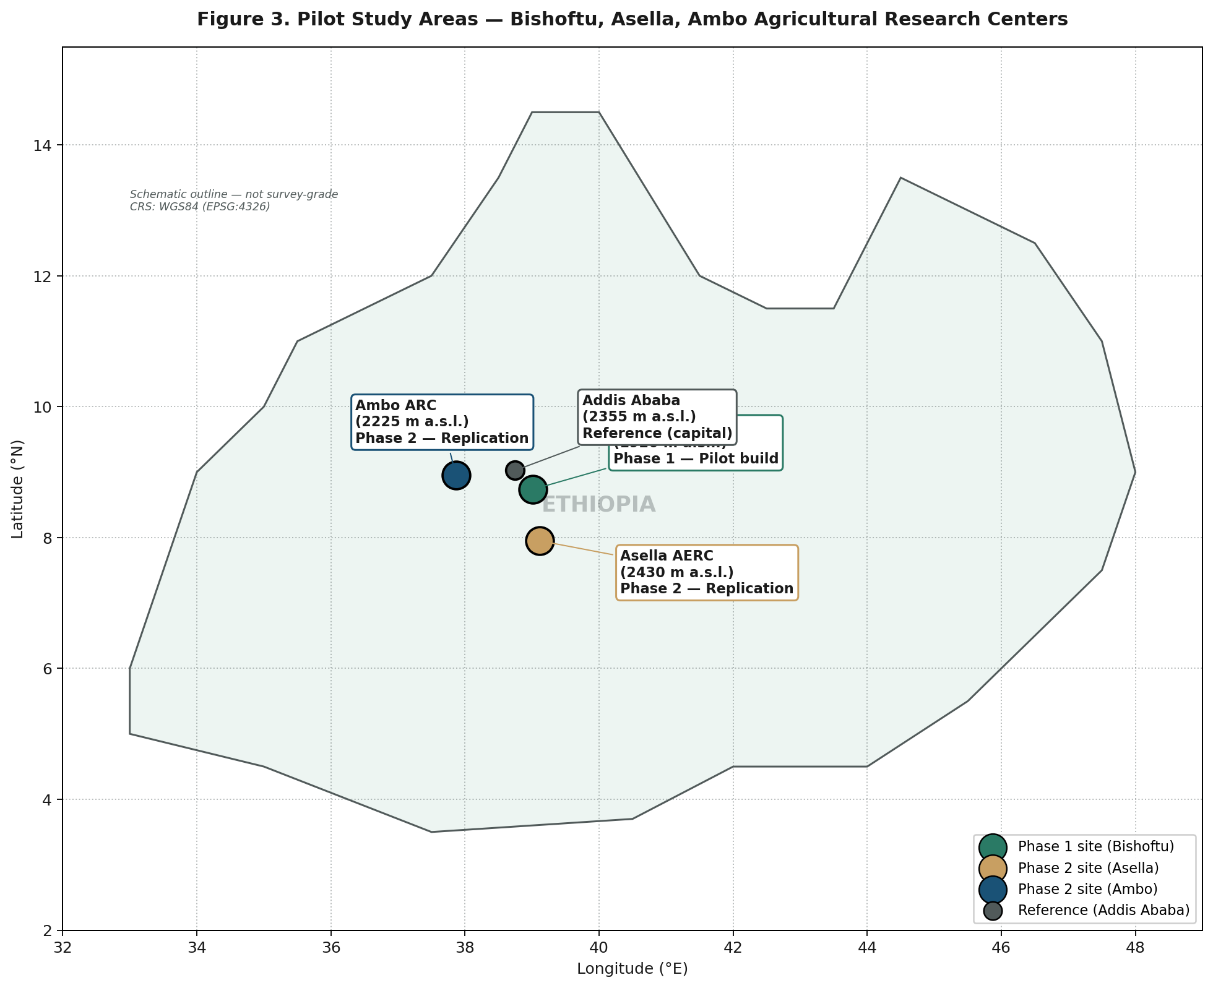
Figure 3. Pilot study areas — Bishoftu, Asella, and Ambo Agricultural Research Centers, with Addis Ababa as geographic reference. Phase 1 pilot build at Bishoftu; Phase 2 replication to Asella and Ambo.

4.2 Agro-Ecological Profile per Site

4.2.1 Bishoftu ARC — Phase 1 Pilot Site
Bishoftu (formerly Debre Zeit) is located in the East Shewa zone of Oromia, approximately 45 km south-east of Addis Ababa. The site sits at 1,920 m elevation in the Rift Valley lakes region, with a semi-arid, warm temperate climate (Köppen Cwb / BSh transition). Mean annual rainfall is approximately 850 mm, bimodally distributed with the main Belg and Kiremt seasons. Soils are predominantly Vertisols and Fluvisols, with significant clay content that influences infiltration and irrigation timing. The center maintains ongoing wheat breeding and agronomy trials and has existing infrastructural capacity (laboratory, climate station, and trained technical staff) suitable as the primary pilot build site.

4.2.2 Asella AERC — Phase 2 Replication Site
Asella is the administrative seat of the Arsi zone, located approximately 175 km south-east of Addis Ababa at 2,430 m elevation. The Arsi plateau is Ethiopia's premium wheat belt, hosting the Kulumsa Agricultural Research Center (national wheat breeding hub) in close proximity. The climate is cool temperate (Köppen Cwb), with mean annual rainfall ranging from 900 mm (lower Arsi) to 1,200 mm (upper Arsi), unimodally distributed during the main Kiremt season (June–September). Soils are predominantly Nitisols and Andosols of volcanic origin, generally well-drained and fertile. Asella AERC hosts the EIAR Agricultural Engineering Research program, providing engineering and mechanization expertise complementary to the project's UAV and sensor integration activities.

4.2.3 Ambo ARC — Phase 2 Replication Site
Ambo is the seat of the West Shewa zone, located approximately 115 km west of Addis Ababa at 2,225 m elevation. The site represents a transitional moisture regime between the wetter West and the drier Rift Valley, making it an informative third point for testing model transferability. Climate is temperate (Köppen Cwb) with mean annual rainfall around 1,100 mm. Soils are predominantly Nitisols and Vertisols, with significant spatial heterogeneity in clay content and water-holding capacity. Ambo ARC has long-standing wheat and barley breeding programs and serves as a key research hub for the central highlands.

4.3 Cross-Site Stratification Value
The three sites together span an elevation gradient of 510 m, two principal soil orders (Nitisol and Vertisol), three rainfall regimes (semi-arid Rift, transitional West Shewa, and wetter Arsi plateau), and both Belg-dominant and Kiremt-dominant rainfall patterns. This stratification is the foundation for the project's claim that models and advisories developed across the three sites will generalize across the bulk of the Ethiopian wheat domain, supporting the eventual national scale-up envisioned in the project background.

5. System Architecture Overview

5.1 Layered Architecture
The system is organized into five horizontal layers, each with well-defined inputs, processing responsibilities, and outputs. The layered design isolates concerns — for example, sensor-firmware upgrades do not affect the analytics layer, and model retraining does not require schema changes in the spatial database. Vertical data flow is bidirectional: field data flows upward for processing, while queries and advisories flow downward to devices and end users. Figure 1 illustrates the layered architecture and the principal modules mapped to each layer.
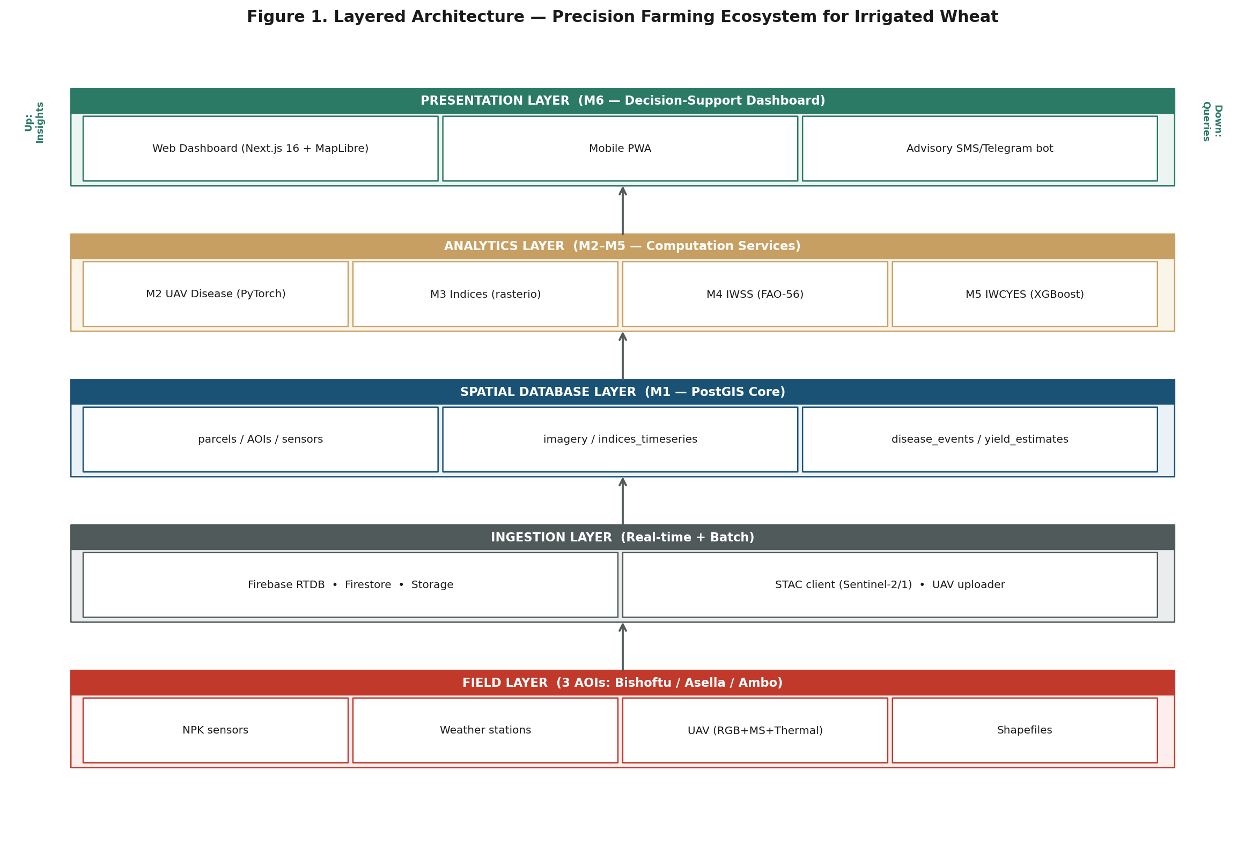
Figure 1. Layered architecture of the precision farming ecosystem, with the six modules (M1–M6) mapped to their respective layers. Edge devices feed the ingestion layer, which writes to the spatial database core; analytics modules read from the database and write outputs back; the presentation layer serves decision-makers and extension officers.

5.2 End-to-End Data Flow
Figure 2 shows the data flow from field sources through ingestion to the dashboard. Field sources (NPK devices, weather stations, UAV missions, satellite imagery via STAC, parcel shapefiles) feed three ingestion channels: Firebase Realtime Database for live sensor streams, Firebase Storage for large binary objects (UAV orthomosaics, multispectral rasters), and a shapefile uploader that writes directly to PostGIS. A nightly batch job syncs Firebase snapshots into PostGIS for archival and analytical workloads, isolating Firebase's real-time hot-store from heavy analytical queries.
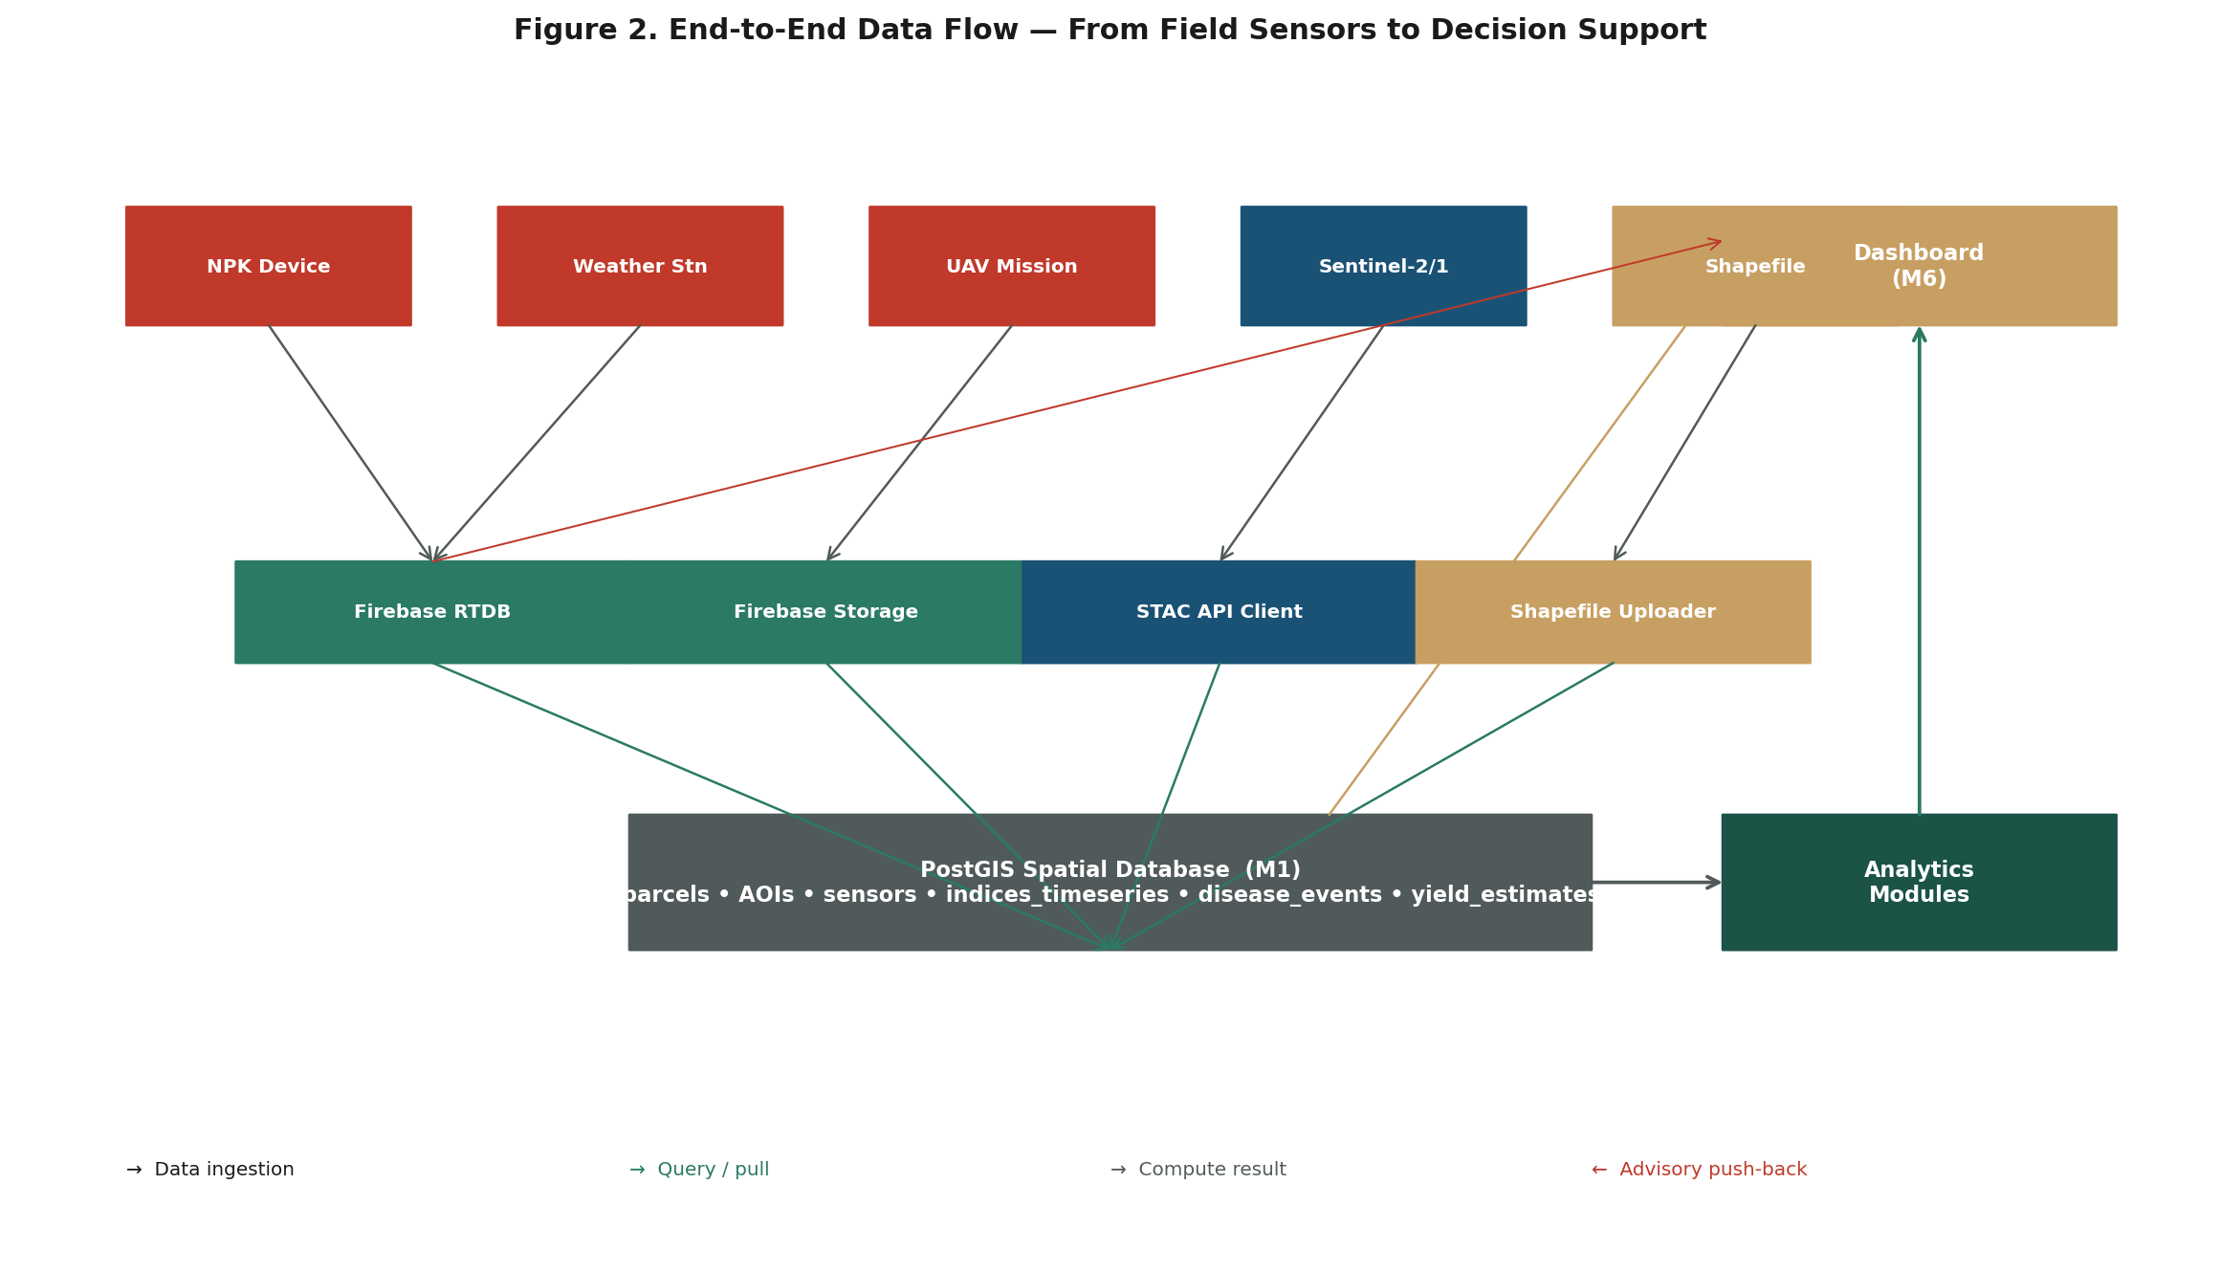
Figure 2. End-to-end data flow — field sources to dashboard. Solid arrows indicate ingestion paths; the gold arrow shows advisory push-back to Firebase for distribution to farmer devices.

5.3 Component Inventory
The principal components, with their primary hosting and runtime, are summarized in Table 4. The split between edge (rural AOI with intermittent connectivity) and cloud (managed infrastructure) is deliberate — the edge layer provides offline-tolerant caching and local compute, while the cloud layer provides durable storage, batch analytics, and the public dashboard.
Table 4. Component Inventory
Component | Layer | Hosting | Runtime / Stack
NPK + weather station | Field | Per AOI (3 sites) | ESP32 / Arduino + 4G modem
UAV platform | Field | Per AOI | DJI Mavic 3M (RGB + multispectral)
Local gateway | Edge | Per AOI | Raspberry Pi 4 + SQLite/Spatialite cache
Firebase RTDB | Ingestion | Google Cloud (managed) | Firebase SDK
Firebase Firestore | Ingestion | Google Cloud (managed) | Firebase SDK
Firebase Storage | Ingestion | Google Cloud (managed) | Google Cloud Storage
STAC client | Ingestion | Cloud Run | Python (pystac-client)
PostGIS | Spatial DB | Cloud Run / VM | Docker (postgis/postgis)
GeoServer / pg_tileserv | Spatial DB | Cloud Run | Docker (pg_tileserv lightweight)
Analytics workers | Analytics | Cloud Run jobs | Python (rasterio, geopandas, scikit-learn, PyTorch)
UAV disease inference | Analytics | Cloud Run (GPU) | PyTorch + ONNX runtime
Dashboard (web) | Presentation | Vercel / Cloud Run | Next.js 16 + MapLibre
Dashboard (mobile PWA) | Presentation | Vercel | Next.js PWA
Advisory bot | Presentation | Cloud Functions | Telegram / SMS gateway

5.4 Data Governance Principles
All spatial data are stored in EPSG:4326 (WGS84) for interoperability with global datasets and reprojected to EPSG:32637 (WGS84 / UTM zone 37N) for metric analytical workloads. All timestamps are stored in UTC with an Ethiopia-specific display layer (EAT, UTC+3). Parcel identifiers are stable UUIDs assigned at shapefile ingestion time, retained across all joins, and never reused. Sensor telemetry is retained in Firebase hot-store for 90 days and archived nightly to PostGIS for long-term analytics. Personally identifying information (PII) on parcel owners is stored encrypted, with role-based access control enforced at the Firebase Auth and PostGIS row-level-security layers.

6. Prescriptive Technology Stack

6.1 Stack Summary
The technology stack is intentionally prescriptive to reduce integration risk, accelerate procurement, and simplify long-term maintenance by EIAR. Open-source components are preferred throughout, with Firebase chosen as the only proprietary dependency owing to its mature real-time and offline-tolerant capabilities unmatched by open-source alternatives at the project's scale. Table 5 enumerates the recommended components by category.
Table 5. Prescriptive Technology Stack
Category | Recommended Component | Rationale
Frontend framework | Next.js 16 (React 19, App Router) | Mature SSR/ISR, file-based routing, first-class TypeScript, mature MapLibre bindings.
Map rendering | MapLibre GL JS + deck.gl | Open-source, WebGL-accelerated, handles parcel polygons + raster tiles + heatmap layers.
UI components | shadcn/ui + Tailwind CSS 4 | Composable, accessible, low lock-in.
Backend runtime | Node.js 22 LTS (Cloud Run) | Same-language full-stack; cold-start acceptable for dashboard workload.
Real-time store | Firebase Realtime Database | Offline-tolerant sync for rural connectivity; mature SDK; pay-as-you-go.
Document store | Firebase Firestore | Advisory events, device registry, audit log.
Object storage | Firebase Storage (= GCS) | UAV orthomosaics, multispectral rasters, field photos.
Spatial database | PostgreSQL 16 + PostGIS 3.4 | De-facto open-source spatial DB; rich query language; mature tooling.
Raster tile service | pg_tileserv + TiTiler | Lightweight, Docker-friendly; serves COG and PostGIS raster catalogs.
Analytics language | Python 3.12 | De-facto standard for geospatial + ML ecosystems.
Raster I/O | rasterio + rio-tiler + xarray | Performant, COG-friendly, integrates with PostGIS.
Vector I/O | geopandas + shapely + fiona | Standard pandas-like interface for vector data.
ML framework (yield) | XGBoost + scikit-learn | Strong tabular baseline; interpretable; works with small training sets.
ML framework (disease) | PyTorch + torchvision + timm | EfficientNet-B0 / U-Net; ONNX export for inference.
Satellite imagery source | Sentinel-2 L2A via STAC (Element-84 / AWS Open Data) | Free, 10 m, 5-day revisit, public domain.
SAR source (cloud robustness) | Sentinel-1 GRD via STAC | Covers cloud-obscured windows; useful for soil moisture.
UAV platform | DJI Mavic 3M (RGB + 4-band multispectral) | COTS, reliable, supports reflectance calibration.
UAV processing | Open Drone Map (ODM) + MicMac | Open-source photogrammetry + reflectance calibration.
Container orchestration | Google Cloud Run + Docker | Pay-per-use, no cluster management; suits intermittent workloads.
CI/CD | GitHub Actions | Free for OSS-grade projects; mature ecosystem.
Auth | Firebase Auth (email/password + Google SSO) | Free tier covers expected user base; integrates with Firestore security rules.

6.2 Stack Justification Notes
Three architectural choices warrant explicit justification. First, Firebase is preferred over a self-hosted MQTT broker + TimescaleDB combination because the project's edge devices face intermittent connectivity and require offline-tolerant sync, which Firebase provides out-of-the-box at low cost. Self-hosted equivalents exist but require operational capacity that EIAR does not yet have. Second, Next.js 16 is preferred over Remix or Astro because the dashboard requires both server-rendered maps (heavy initial data) and rich client-side interactivity (attention mechanisms, time scrubbers) — Next.js's hybrid rendering model is the cleanest fit. Third, XGBoost is preferred as the yield-model baseline over deep-learning time-series models because the ground-truth training set will be small (one to two seasons, three AOIs, perhaps 200–500 parcel-yield observations); XGBoost generalizes better with small data and provides feature importance, which is critical for the project's interpretability requirement.

6.3 Cloud vs On-Premise Trade-off
The recommended cloud-first deployment (Google Cloud Run + Firebase + PostGIS in Docker) minimizes operational overhead during the project lifetime. For long-term sustainability, the PostGIS database can be migrated to an EIAR-hosted on-premise server (single node, 16 cores, 64 GB RAM, 4 TB SSD, estimated USD 6,000 capex) with no application code changes — only configuration updates to the connection string and tile-service URL. This migration is the recommended Phase-4 sustainability path and is documented in Section 13.

7. Module Specifications
This chapter specifies each of the six modules in detail. For every module, the specification follows a uniform structure: purpose, inputs, processing, outputs, dependencies, and external API surface. This consistency supports both implementation and long-term maintenance by EIAR staff.

7.1 M1 — Spatial Database

7.1.1 Purpose
M1 is the persistent geospatial anchor of the entire ecosystem. It stores parcel boundaries (from uploaded shapefiles), AOI boundaries, sensor-station point locations, satellite imagery catalogs, UAV orthomosaics, time-series of vegetation indices, soil properties per parcel, disease events per parcel per date, and yield estimates per parcel per season. Every other module reads from and writes to M1.

7.1.2 Inputs
- Shapefiles from each AOI (parcel boundaries, AOI boundaries, sensor locations).
- Satellite imagery catalogs (Sentinel-2 L2A, Sentinel-1 GRD) ingested via STAC.
- UAV orthomosaics from M2 ingestion pipeline.
- Firebase snapshots synced nightly (live sensor telemetry, advisory events).
- Reference layers: administrative boundaries, soil maps, agro-ecological zones.

7.1.3 Core Schema (PostgreSQL DDL — illustrative)
-- AOI table
CREATE TABLE aoi (
aoi_id UUID PRIMARY KEY DEFAULT gen_random_uuid(),
site_code TEXT NOT NULL UNIQUE, -- 'bishoftu', 'asella', 'ambo'
name TEXT NOT NULL,
center_type TEXT, -- 'ARC', 'AERC'
lat NUMERIC(8,4),
lon NUMERIC(8,4),
elevation_m INT,
region TEXT,
zone TEXT,
geom GEOGRAPHY(POINT, 4326)
);

-- Parcel table
CREATE TABLE parcel (
parcel_id UUID PRIMARY KEY DEFAULT gen_random_uuid(),
aoi_id UUID REFERENCES aoi(aoi_id),
parcel_code TEXT NOT NULL,
area_ha NUMERIC(10,3) GENERATED ALWAYS AS (
ST_Area(ST_Transform(geom, 32637)) / 10000) STORED,
owner_name TEXT,
owner_phone TEXT,
geom GEOGRAPHY(POLYGON, 4326),
created_at TIMESTAMPTZ DEFAULT now()
);

-- Vegetation index time-series
CREATE TABLE index_timeseries (
id BIGSERIAL PRIMARY KEY,
parcel_id UUID REFERENCES parcel(parcel_id),
obs_date DATE NOT NULL,
index_name TEXT NOT NULL, -- 'NDVI', 'EVI', 'NDRE', 'NDMI'
value NUMERIC(6,4),
source TEXT, -- 'sentinel2', 'uav'
cloud_pct NUMERIC(4,1),
UNIQUE(parcel_id, obs_date, index_name, source)
);

7.1.4 Outputs
M1 exposes data via three channels: (1) SQL access for analytical modules; (2) pg_tileserv for raster and vector tile services consumed by the dashboard; (3) a REST API for parcel queries and time-series retrieval. Schema migrations are managed via Flyway.

7.2 M2 — UAV Disease Early Detection

7.2.1 Purpose
M2 processes UAV imagery (RGB + multispectral + thermal) into parcel-level disease severity maps. The service detects seven priority wheat diseases documented in Ethiopia: yellow (stripe) rust, stem rust, leaf (brown) rust, powdery mildew, Septoria leaf blotch, tan spot, and Fusarium head blight. Detection occurs at two levels: classification (healthy vs. disease class) and segmentation (severity percentage per canopy patch).

7.2.2 Inputs
- UAV orthomosaics (RGB, multispectral 5-band, thermal) per mission per AOI.
- Parcel boundaries from M1 (for tiling and aggregation).
- Field-scouting ground truth labels (collected weekly during wheat season).

7.2.3 Processing
Mission imagery is orthorectified (Open Drone Map), reflectance-calibrated (MicaSense sunshine sensor or downwelling light sensor), and georeferenced to UTM 37N. The orthomosaic is tiled into 256×256 patches at native UAV resolution (typically 2–5 cm/px for RGB, 10–20 cm/px for multispectral). Each tile is classified by a fine-tuned EfficientNet-B0 backbone (pretrained on ImageNet, retrained on a project-labeled dataset of healthy and disease-class tiles). Severity is computed per tile and aggregated to parcel-level by area-weighted averaging.

7.2.4 Outputs
Per parcel × date × disease_class, the service writes: severity_pct (0–100), confidence (0–1), area_affected_ha, and a per-tile heatmap PNG stored in Firebase Storage. Outputs are written to the disease_events table in M1 and trigger advisory push notifications if severity exceeds 15 percent or area exceeds 0.1 ha.

7.3 M3 — Vegetation Index Computation Service

7.3.1 Purpose
M3 computes and stores the ten vegetation indices used by the yield and irrigation modules. The service ingests Sentinel-2 L2A (10 m, 5-day revisit) and UAV multispectral (5-band, mission-based), applies cloud and shadow masks, composites cloud-free observations per parcel per date, and writes the resulting index values to the index_timeseries table in M1.

7.3.2 Computed Indices
Index | Formula | Signal
NDVI | (NIR − R) / (NIR + R) | General vigor & green biomass
EVI | 2.5·(NIR − R) / (NIR + 6R − 7.5B + 1) | Canopy structure, less saturating than NDVI
GNDVI | (NIR − G) / (NIR + G) | Chlorophyll content
NDRE | (NIR − RE) / (NIR + RE) | Chlorophyll at red-edge, late-season N status
NDMI | (NIR − SWIR1) / (NIR + SWIR1) | Canopy water content (Sentinel-2 only)
NDWI | (G − NIR) / (G + NIR) | Water stress, alternative formulation
SAVI | ((NIR − R) / (NIR + R + L)) · (1 + L), L=0.5 | Soil-adjusted vigor for sparse canopy
LAI (empirical) | f(NDVI) — site-specific coefficients | Leaf area index
GCVI | (NIR / G) − 1 | Chlorophyll, robust to lighting
SIPI | (NIR − B) / (NIR − R) | Carotenoid/chlorophyll ratio (senescence)

7.4 M4 — Irrigation Water Scheduling Service (IWSS)

7.4.1 Purpose
M4 generates daily, parcel-level irrigation advisories. The service implements the FAO-56 dual-crop-coefficient methodology (Allen et al., 1998, with revisions): reference evapotranspiration ET₀ is computed from weather-station data using the Penman-Monteith equation; crop coefficient Kc is split into basal Kcb and evaporation Ke; soil-water balance is tracked daily per parcel; and irrigation depth and timing are recommended when depletion exceeds the management-allowed depletion (MAD) threshold.

7.4.2 Inputs
- Daily weather data per AOI (T_max, T_min, T_mean, RH, wind speed, solar radiation, precipitation) from on-site weather stations.
- Real-time soil moisture (%) and soil temperature (°C) from NPK probes per parcel.
- Soil physical properties per parcel (field capacity, permanent wilting point, bulk density, rooting depth) from soil samples and SSAF soil maps.
- Crop parameters (Kcb_init, Kcb_mid, Kcb_end, growth-stage lengths, plant height, MAD) for the wheat cultivars grown at each AOI.
- Sowing date per parcel (from shapefile attributes or field log).

7.4.3 Outputs
Per parcel × date, IWSS writes: current soil-water depletion (mm), current growth stage, recommended irrigation depth (mm), recommended timing (today / tomorrow / this week), and a one-line advisory text (in Amharic and English) suitable for SMS or dashboard display. Outputs are written to PostGIS and pushed to Firebase for downstream advisory distribution.

7.5 M5 — Irrigated Wheat Crop Yield Estimation System (IWCYES)

7.5.1 Purpose
M5 produces parcel-level yield forecasts (t/ha) at three phenological decision points: tillering (early-season stress check), heading (mid-season forecast), and post-harvest (reconciliation with actuals). The system integrates four signal families — vegetation indices, soil properties, disease severity, and weather — through a gradient-boosted regression model (XGBoost baseline), with a time-series deep model (1D-CNN over NDVI/NDRE/moisture) as a complement once sufficient training data accumulate.

7.5.2 Input Feature Families
Family | Features | Source
Vegetation indices | NDVI, EVI, GNDVI, NDRE, NDMI — growth-stage-weighted means, slopes, and area-under-curve | M3 service
Soil properties | N (ppm), P-Olsen (ppm), K-exch (ppm), pH, EC (dS/m), SOM (%), texture class, soil moisture mean | NPK probes + lab
Disease severity | Max severity %, area affected (ha), dominant disease class, disease onset Julian day | M2 service
Weather | Cumulative GDD, total rainfall, ET₀ sum, max temperature during flowering | M4 / weather
Management | Sowing date, cultivar, irrigation events, fertilizer applications | Field log

7.5.3 Model Strategy
The XGBoost baseline is chosen for interpretability (feature-importance plots support agronomist review) and small-data robustness. Target metric is mean absolute error (MAE) with a project goal of ≤0.4 t/ha on held-out parcels. A hybrid pipeline (process-based AquaCrop features + XGBoost residual corrector) is documented as a Phase-3 upgrade if baseline performance is insufficient. The yield model is retrained monthly during the wheat season as new ground-truth data arrive.

7.6 M6 — Decision-Support Dashboard

7.6.1 Purpose
M6 is the principal interface for decision-makers and extension officers. It surfaces parcel-level status, advisories, and historical trends through a state-of-the-art web interface with multiple attention mechanisms designed to direct user attention to high-priority parcels.

7.6.2 Attention Mechanisms
Mechanism | Function | Use Case
Heatmap overlay | Choropleth by moisture / yield / risk | Identify driest or lowest-yield fields
Pulse markers | Animate parcels crossing threshold | Highlight fields needing irrigation today
Ranking panel | Top-10 / bottom-10 lists with arrows | Surface worst-performing parcels this week
Anomaly badges | Color-coded flags on parcels | Flag NDVI drop >20% vs 7-day mean
Time scrubber | Slider for trend replay | Investigate when stress started
Comparison swipe map | Side-by-side time layers | Compare before vs after irrigation
Predictive highlight | Forecast confidence shading | Show expected yield gap per parcel

7.6.3 Deployment Topology
Figure 7 illustrates the deployment topology, splitting the edge zone (per AOI) from the cloud zone (managed infrastructure). Edge devices handle offline-tolerant caching and local sensor reading; cloud services handle durable storage, batch analytics, and the public dashboard. This split ensures the system remains functional during rural connectivity outages, which are common at all three AOIs.
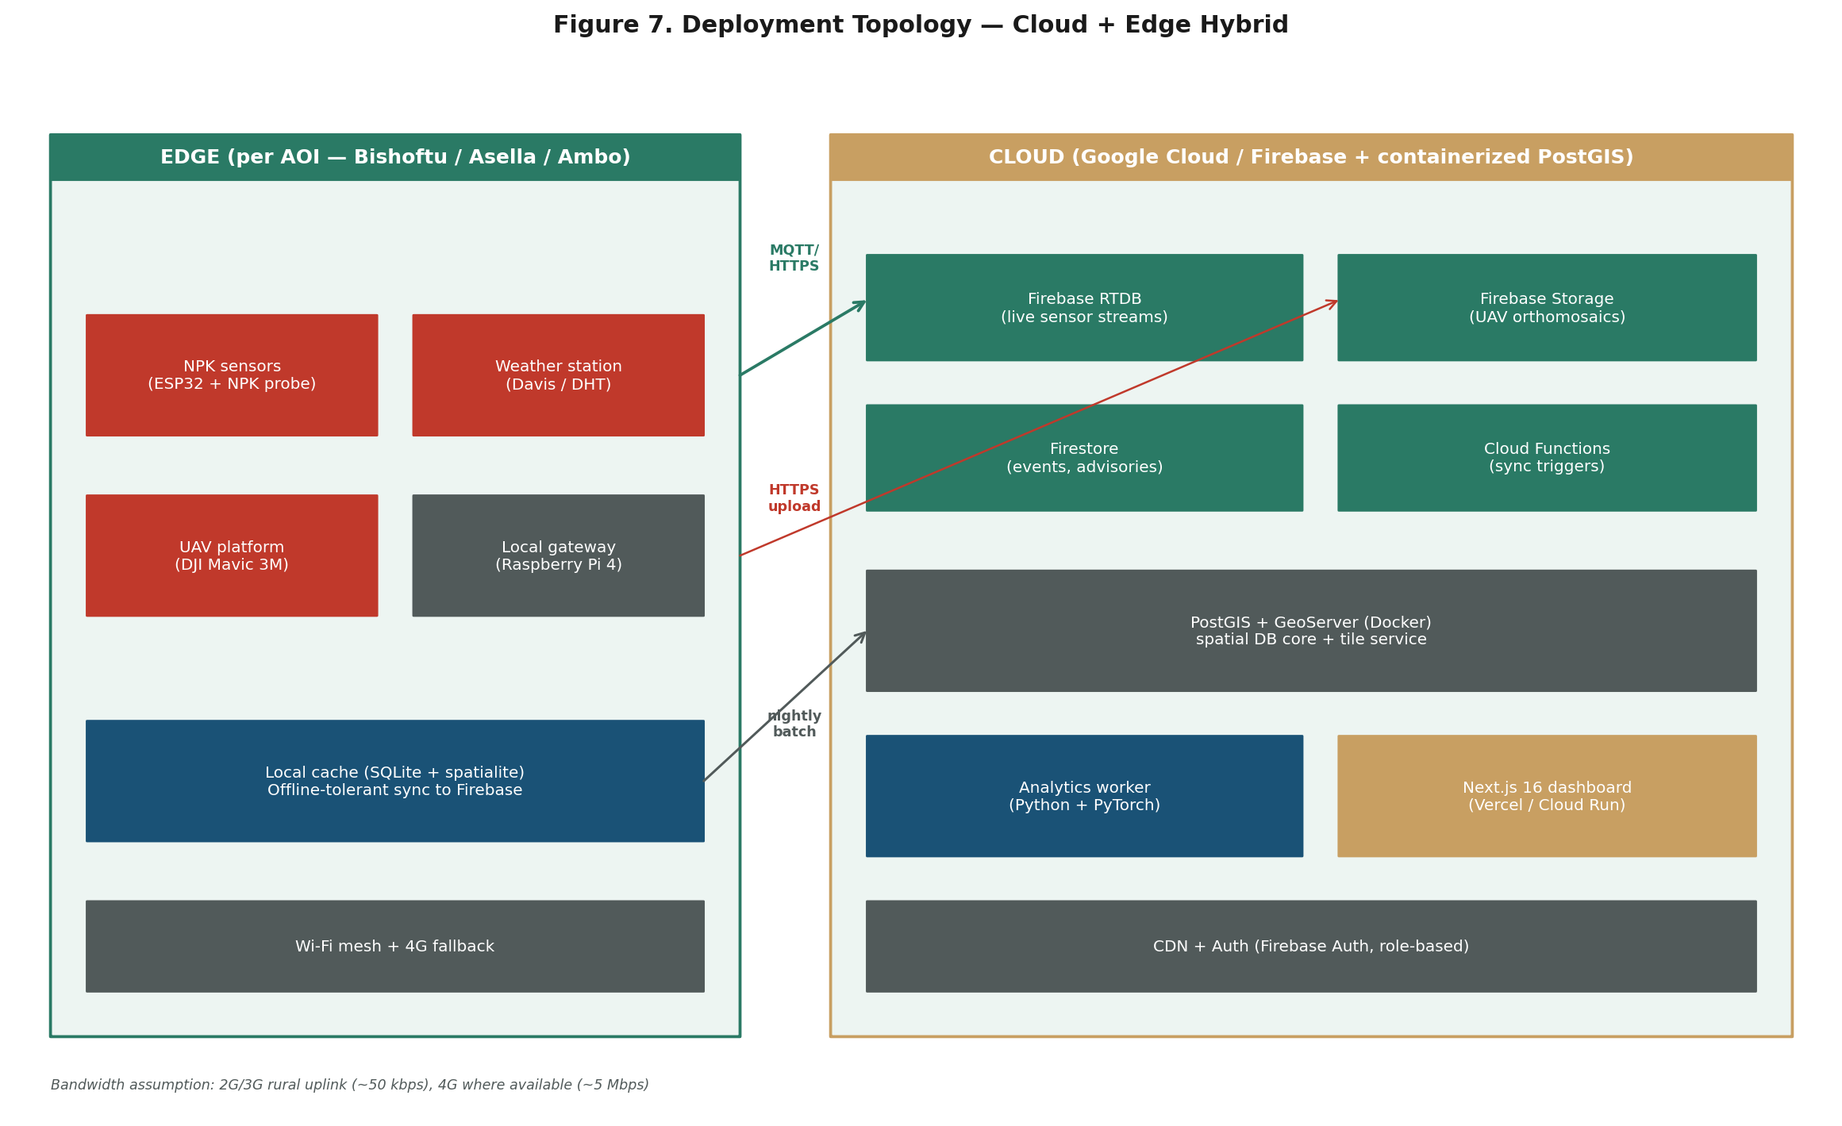
Figure 7. Deployment topology — edge (per AOI) and cloud (managed) zones. Arrows indicate ingestion paths: MQTT/HTTPS for sensor streams, HTTPS upload for UAV missions, nightly batch for local cache synchronization.

8. Repository Bootstrap and Project Setup

8.1 Source Repository
The project's source-of-truth codebase is hosted at https://github.com/DivergenTechnology/smartfarming-ecosystem on GitHub under the Divergen Technology organization. The repository is the canonical home for all six modules (M1 through M6), shared packages, infrastructure-as-code, documentation, and operational scripts. All project team members and EIAR technical staff commit to this repository via pull requests reviewed by at least one peer; the main branch is protected and requires passing CI before merge. At the time of this plan's v1.1 revision, the repository contains only an initial commit with the CC0 1.0 Universal license file; the project's first engineering work is therefore the bootstrap of the monorepo scaffold described in this chapter.

8.2 License and Governance
The repository is licensed under CC0 1.0 Universal (Public Domain Dedication) (Public Domain Dedication). This license choice supports the project's sustainability goal: any output of the project — source code, documentation, model weights, data schemas — can be freely reused by other Ethiopian agricultural research institutions, regional research consortia, or commercial integrators without legal encumbrance. Repository governance is layered: the project coordinator holds the maintainer role during the project lifetime, with a designated EIAR engineer granted co-maintainer rights from month 6 onward (during Phase 2). At project closure (month 18), governance transfers fully to EIAR, which becomes the canonical maintainer of record.

8.3 Planned Monorepo Structure
The repository is organized as a pnpm/npm workspace monorepo, with each module living in its own subdirectory. This structure isolates concerns, supports independent deployment of each service, and allows the shared packages directory to publish types and utilities across all modules. The dashboard is treated as an application (under apps/), the four Python-based analytics modules as services (under services/), and the spatial database schema as a service with Flyway-managed migrations (under services/spatial-db/migrations/). Figure 8 shows the complete planned folder layout.
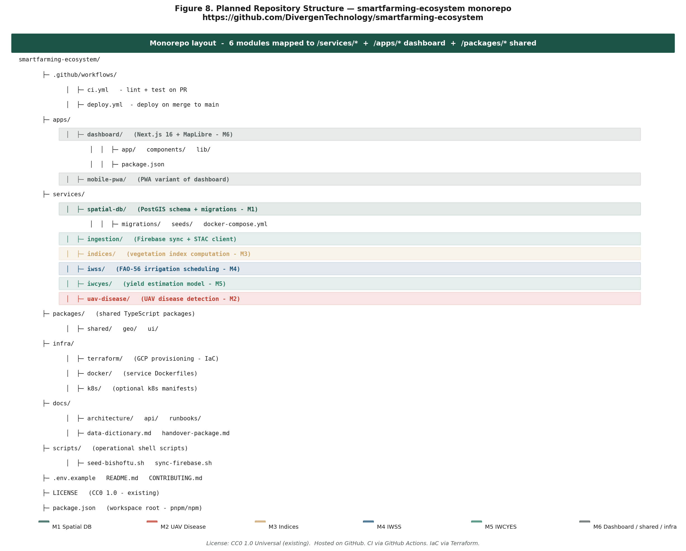
Figure 8. Planned repository structure — monorepo layout with 6 modules mapped to /services/* and /apps/*, plus shared packages, infrastructure-as-code, documentation, and operational scripts. Highlighted rows indicate module-level directories.

8.4 Bootstrap Activities (Month 1)
Before any module development begins, the repository must be bootstrapped with the foundational scaffolding. These activities are completed in the first two weeks of month 1 by the full-stack developer and GIS specialist, in parallel with procurement. The bootstrap deliverable is a runnable "hello world" monorepo — every service has a Dockerfile, every package has a package.json, CI runs on every pull request, and the dashboard can be started locally with mock data.
# | Bootstrap Activity | Owner | Output / Acceptance
B1 | Initialize pnpm/npm workspace root with package.json, .editorconfig, .gitignore, .env.example | Full-stack dev | Workspace install runs clean on a fresh clone
B2 | Create monorepo folder skeleton: apps/ services/ packages/ infra/ docs/ scripts/ | Full-stack dev | All folders created with .gitkeep
B3 | Set up CI via GitHub Actions (.github/workflows/ci.yml): lint + typecheck + test on PR | Full-stack dev | Green check on a sample PR
B4 | Set up deploy workflow (.github/workflows/deploy.yml): build + push images + deploy to Cloud Run on merge to main | Full-stack dev | Staging deploy succeeds end-to-end
B5 | Initialize Next.js 16 dashboard app (apps/dashboard) with Tailwind 4 + shadcn/ui + MapLibre | Full-stack dev | Dashboard renders a placeholder map at localhost:3000
B6 | Initialize PostGIS service (services/spatial-db) with docker-compose.yml + Flyway migrations dir | GIS specialist | docker compose up starts a PostGIS instance; migrations run clean
B7 | Initialize Python analytics services (services/indices, iwss, iwcyes, uav-disease) with shared pyproject.toml + ruff + pytest | ML engineer | pytest -q collects 0 tests, exits 0
B8 | Set up infra/terraform/ with GCP project scaffold (project, APIs, service accounts, IAM) | Full-stack dev | terraform plan succeeds against staging GCP project
B9 | Bootstrap docs/ with architecture/, api/, runbooks/ subdirectories and a README.md index | Project coordinator | Index page renders on GitHub Pages
B10 | Add CONTRIBUTING.md, CODE_OF_CONDUCT.md, SECURITY.md, README.md with project overview and quick-start | Project coordinator | All files committed; README renders on GitHub repo home
B11 | Provision Firebase project (Realtime DB, Firestore, Storage, Auth) and store config in GitHub Secrets | Full-stack dev | Service account JSON in secrets; dashboard can read a test node
B12 | Set up branch protection on main: require PR review + passing CI | Project coordinator | Direct push to main rejected

8.5 Repository Hygiene Standards
Throughout the project lifetime, the team maintains the following hygiene standards. Conventional commits (feat, fix, docs, refactor, chore, test) are used so that changelogs can be auto-generated. Each pull request is linked to a project issue (the project uses GitHub Issues for task tracking and GitHub Projects for sprint planning). Pre-commit hooks enforce lint and formatting on every commit. Dependabot is enabled for security updates. The repository is mirrored weekly to an EIAR-hosted Git server (Gitea or GitLab Community Edition) to ensure continued access in the event of GitHub service disruption — an important consideration given the project's institutional sustainability goal.

9. Pilot Site Implementation Strategy

9.1 Phasing Philosophy
The project adopts a pilot-then-scale strategy: a complete end-to-end build at Bishoftu first, followed by replication to Asella and Ambo, and finally stabilization, refinement, and handover. This sequencing is preferred over parallel builds at all three sites because it allows the team to learn from a single integration cycle and apply lessons learned — particularly around sensor calibration, model transferability, and dashboard UX — to the second and third deployments. The trade-off is that full multi-AOI coverage arrives later in the project (month 15 rather than month 9); this is acceptable given the eighteen-month duration and the higher reliability of the validated replication.

9.2 Phase 1 — Bishoftu Pilot Build (Months 1–9)
Phase 1 delivers a complete, validated system at Bishoftu ARC. The objective is end-to-end functionality: a parcel is selected, a shapefile is uploaded, sensors are registered, satellite imagery is fetched, vegetation indices are computed, FAO-56 advisories are generated, UAV missions are flown and disease severity is mapped, a yield forecast is produced, and all of this is visible on a live dashboard. The success criterion for Phase 1 is the demonstration of a complete advisory cycle for at least one wheat field at Bishoftu during a single wheat season.
Phase 1 deliverables include: the deployed PostGIS schema with Bishoftu shapefiles ingested; the dashboard MVP with mock-data integration followed by live Bishoftu data; the FAO-56 IWSS validated against tensiometer readings; the UAV disease detection model trained on at least 200 labeled UAV tiles per disease class; the XGBoost yield model trained on at least 50 parcel-yield ground-truth observations from the Bishoftu season.

9.3 Phase 2 — Replication to Asella and Ambo (Months 10–15)
Phase 2 replicates the validated stack to Asella and Ambo. The objective is to test agro-ecological transferability — does the disease model trained at Bishoftu generalize to Asella and Ambo, or does it require retraining? Does the FAO-56 Kc curve require AOI-specific calibration? The replication cycle at each site is compressed to two months per site (Bishoftu took six months for the full build; Asella and Ambo benefit from the existing codebase and training material).
Phase 2 deliverables include: shapefiles for both AOIs ingested; sensor and weather station installation complete; UAV missions flown at both sites; disease model evaluated for cross-site transferability (retraining if necessary); yield model retrained or fine-tuned per AOI; dashboard extended with multi-AOI view and attention-mechanism UI.

9.4 Phase 3 — Stabilization and Handover (Months 16–18)
Phase 3 is dedicated to three activities: model refinement based on a full second season of validation data, structured capacity building for EIAR staff (training of three to five technicians per AOI on operations, maintenance, and basic model retraining), and preparation of the handover package (source code, documentation, runbooks, infrastructure-as-code, and a sustainability plan).
Phase 3 deliverables include: final validation reports per AOI per module; trained EIAR operations team; handover documentation package; project closure report; and a sustainability roadmap identifying the institutional embedding (EIAR unit responsible for continued operation), funding path for years two and three, and a clear set of follow-on opportunities (national scale-up proposal).

9.5 Per-Site Deployment Checklist
Every site deployment follows a uniform checklist. This consistency is essential to allow the Asella and Ambo deployments to benefit directly from Bishoftu lessons learned.
# | Activity | Responsible | Duration
1 | Stakeholder kickoff at site — confirm access, identify pilot parcels | Project coordinator + site director | 1 week
2 | Procurement & shipping of NPK probes, weather station, edge gateway | Project logistics lead | 4–6 weeks
3 | Site survey — confirm 4G coverage, power availability, secure indoor location for gateway | Edge engineer | 1 week
4 | Install weather station + calibrate against WMO standards | Edge engineer + site technician | 1 week
5 | Install NPK probes on representative parcels (1 per parcel, up to 20 parcels per AOI) | Edge engineer + site technician | 2 weeks
6 | Edge gateway setup — install Raspberry Pi + local cache + sync to Firebase | Edge engineer | 1 week
7 | Shapefile collection & ingestion to PostGIS | GIS specialist | 1 week
8 | UAV mission planning — secure overflight permits, plan first mission | UAV pilot + ML engineer | 2 weeks
9 | First UAV mission flown, orthomosaic processed, indices computed | UAV pilot + analytics engineer | 1 week
10 | Field scouting campaign — weekly disease scoring on labeled parcels | Site agronomist | Ongoing (12 weeks)
11 | Dashboard go-live at site — first advisory pushed | Full-stack developer | 1 week
12 | Lessons-learned retrospective — feed back into Asella / Ambo plan | Project team | 1 week

10. Implementation Timeline and Milestones

10.1 18-Month Phased Schedule
Figure 4 presents the eighteen-month Gantt chart with module-level task bars across three phases. Phase boundaries are shown as background bands. Three milestone diamonds mark go/no-go decision gates: M1 Bishoftu Go-Live at month 9, M2 All-Three-AOIs Operational at month 15, and M3 Project Closure and Handover at month 18.
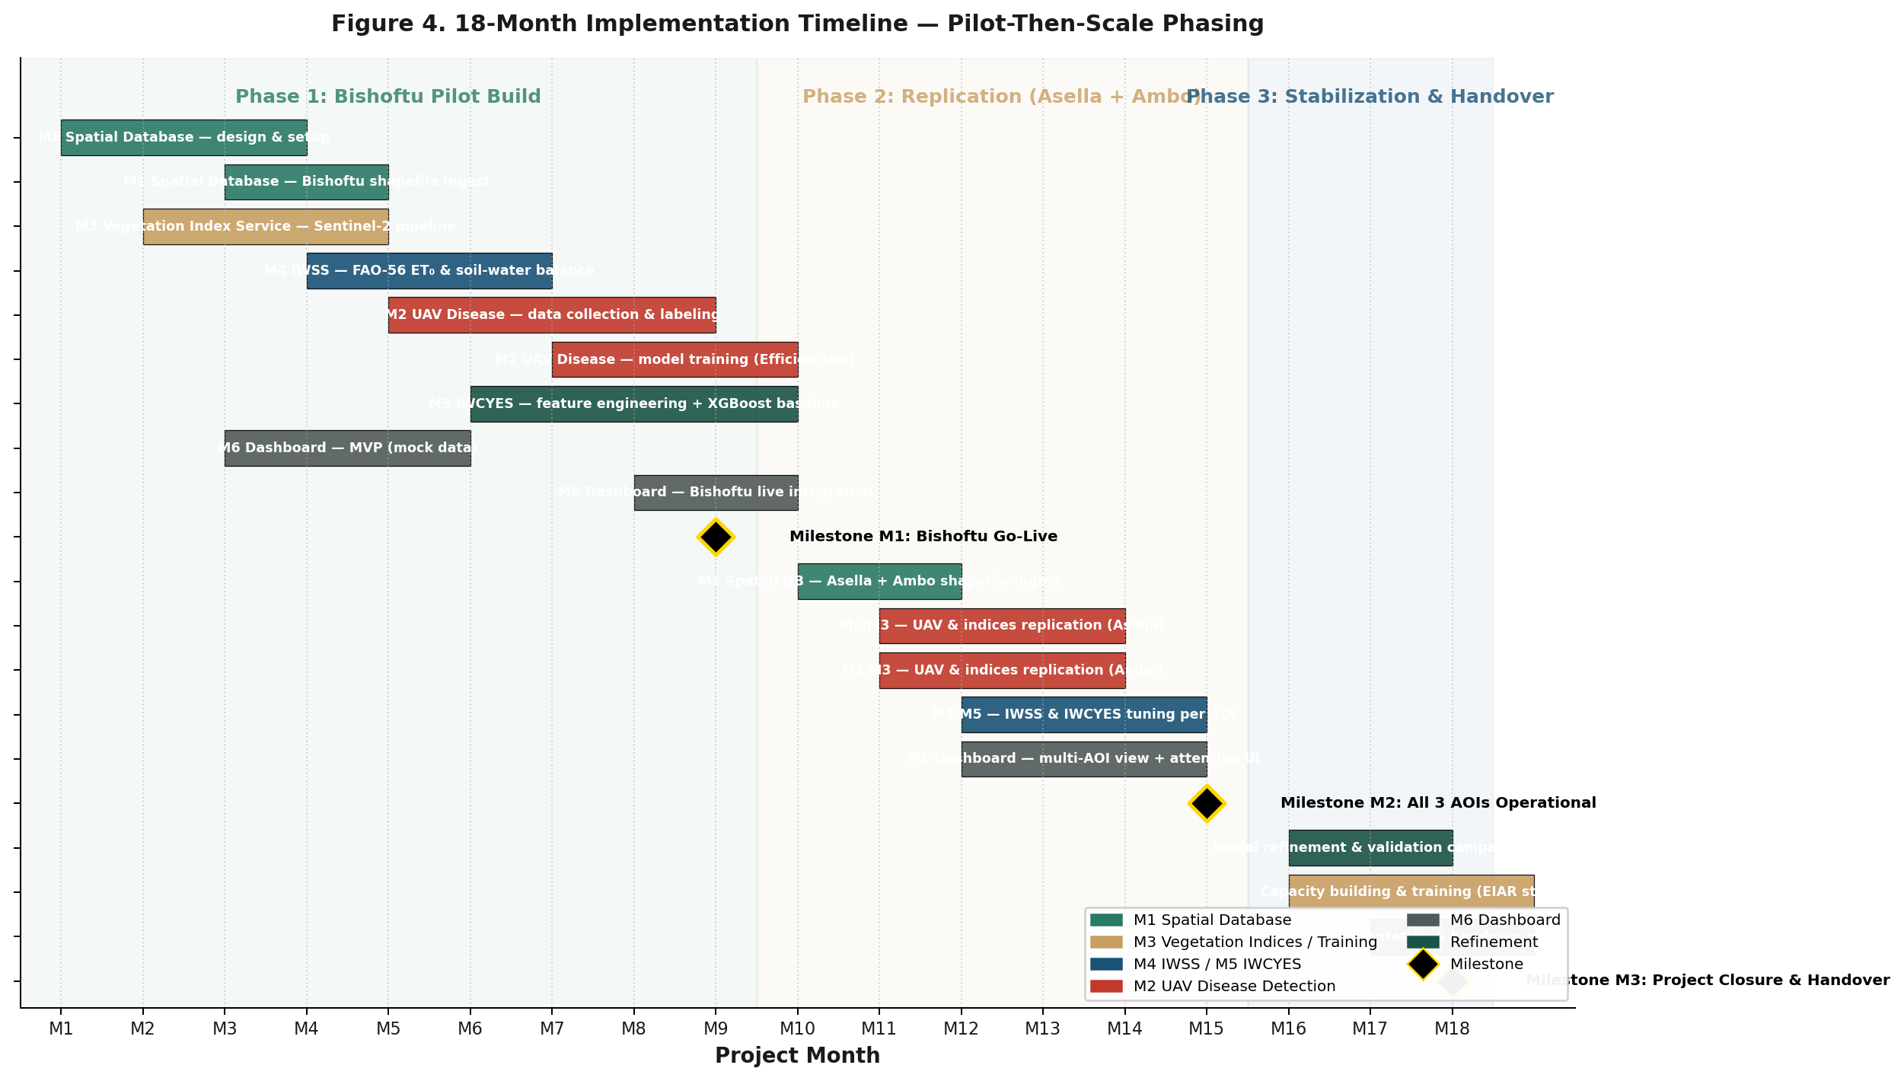
Figure 4. Eighteen-month implementation timeline. Phase 1 builds the complete system at Bishoftu (months 1–9). Phase 2 replicates to Asella and Ambo (months 10–15). Phase 3 stabilizes, refines, and hands over (months 16–18). Black diamonds mark milestone decision gates.

10.2 Milestone Decision Gates
Three milestone gates are explicitly defined. Each gate has measurable go/no-go criteria; failure to meet a gate triggers a structured replanning cycle rather than quiet slippage.
Gate | Month | Go-Criteria | No-Go Action
M1 | 9 | Bishoftu advisory cycle demonstrated end-to-end on ≥1 parcel; PostGIS schema deployed; dashboard MVP live; FAO-56 IWSS producing daily advisories; UAV disease model trained on ≥200 tiles/class with F1 ≥0.70 on held-out set; XGBoost yield model trained on ≥50 parcel-yield observations with MAE ≤0.5 t/ha. | Pause Phase 2; root-cause analysis; rebaseline Phase 1 with 4-week extension; reconsider scope.
M2 | 15 | Asella and Ambo both operational: shapefiles ingested, sensors live, ≥1 UAV mission flown per site, dashboard multi-AOI view live; cross-site transferability assessment of disease model completed (retrained if required); IWSS running at both sites with site-specific Kc calibration. | Treat Phase 3 scope as reduced: focus on stabilization of working sites; document transferability gaps; defer non-working site to follow-on.
M3 | 18 | Validation reports per AOI per module delivered; capacity-building training of ≥9 EIAR staff complete; handover package (source code, documentation, runbooks, infrastructure-as-code) accepted by EIAR; sustainability plan signed off. | Negotiate 3-month extension; prioritize documentation completeness; defer non-critical training.

10.3 Critical Path
The critical path runs through procurement (NPK probes and UAV platforms have 6–8 week lead times), ground-truth data accumulation (a single wheat season yields only one observation cycle), and model validation (cannot complete until harvest). Procurement must therefore begin in month 1, and the first UAV mission must fly no later than month 5 to leave sufficient season for ground-truth collection. Any delay to procurement compresses the entire downstream schedule.

11. Resource and Cost Plan

11.1 Budget Summary
The total indicative project budget is approximately USD 606,000 over eighteen months. Year-one expenditure (months 1–12) is approximately USD 401,000 and is capex-heavy — sensor procurement, UAV platforms, model training compute. Year-two expenditure (months 13–18) is approximately USD 205,000 and is opex-heavy — cloud services, replication travel, capacity-building training. All figures are indicative and should be finalized at procurement against actual vendor quotes.
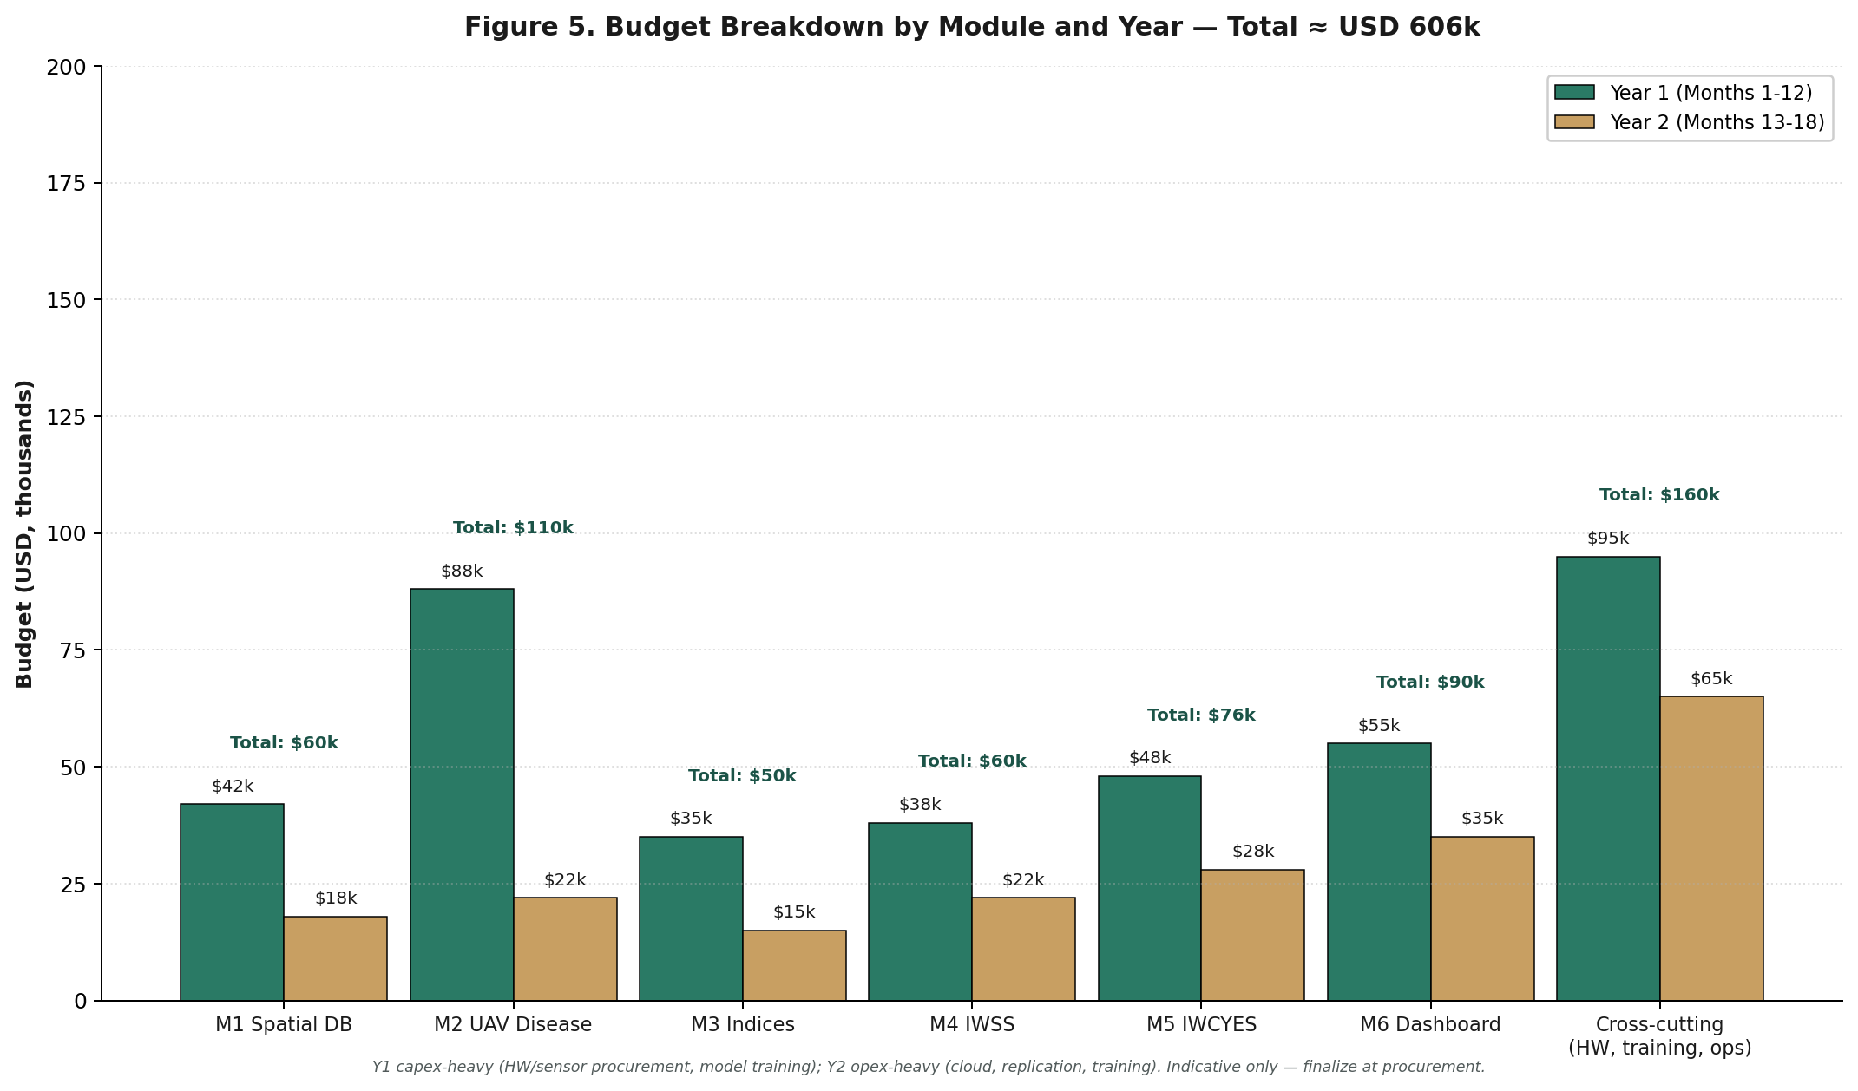
Figure 5. Budget breakdown by module and year. Year-one capex (procurement, training) dominates; year-two opex (cloud, travel, training) tapers as the system stabilizes.

11.2 Detailed Budget by Module
Table 6 details the budget by module and cost category. The cross-cutting row captures hardware shared across modules (sensors, UAVs), EIAR capacity building, project operations (travel, communications, M&E), and contingency.
Table 6. Detailed Budget by Module (USD thousands)
Module | Capex (HW + setup) | Opex (Cloud + Maintenance) | Personnel | Total
M1 Spatial Database | 8 | 12 | 40 | 60
M2 UAV Disease | 70 (UAV platform) | 10 | 30 | 110
M3 Vegetation Indices | 5 | 8 | 37 | 50
M4 IWSS | 8 | 10 | 42 | 60
M5 IWCYES | 5 | 8 | 63 | 76
M6 Dashboard | 5 | 10 | 75 | 90
Cross-cutting (sensors, training, ops, contingency) | 55 | 25 | 80 | 160
Total | 156 | 83 | 367 | 606
Personnel costs are the largest single category, reflecting the project's reliance on skilled GIS, ML, and full-stack engineering capacity. Hardware procurement is concentrated in M2 (UAV platforms) and the cross-cutting row (NPK probes, weather stations).

11.3 Cost Categories Explained
Category | Description | Typical Items
Capex — hardware | One-time procurement of physical equipment | UAV platforms (DJI Mavic 3M), NPK probes, weather stations, edge gateways, RAID storage for PostGIS
Capex — setup | One-time setup and configuration labor | Cloud project setup, schema deployment, dashboard scaffolding
Opex — cloud | Recurring cloud infrastructure | Google Cloud Run, Firebase (RTDB + Storage + Functions), GeoServer hosting
Opex — maintenance | Recurring maintenance and calibration | Sensor recalibration campaigns, UAV propeller/battery replacement, model retraining compute
Personnel | Project team labor costs | Project coordinator, GIS/RS specialist, ML engineer, full-stack developer, irrigation agronomist, M&E officer, edge engineer
Cross-cutting | Activities spanning multiple modules | Travel to AOIs, communications (4G data plans), training events, M&E validation campaigns, 10% contingency

11.4 Funding Path
The project is structured for co-financing. The principal funding source is assumed to be EIAR's allocated research and modernization budget, complemented by a donor grant (World Bank, FAO, or bilateral development partner) for the capex-heavy year-one procurement. The sustainability plan in Section 14 identifies EIAR operational budget as the funding source for years two and three, with the project's open-source design (CC0 license, repo at github.com/DivergenTechnology/smartfarming-ecosystem) keeping ongoing opex low (estimated USD 35,000 per year for cloud services and sensor maintenance).

12. Risk Management

12.1 Risk Identification Approach
Risks were identified through three lenses: technical (data quality, model performance, infrastructure), operational (sensor failure, staff turnover, connectivity), environmental (cloud cover, drought), and institutional (permits, data sharing, adoption). Each risk is rated on a five-point likelihood scale and a five-point impact scale, plotted on the heatmap in Figure 6, and paired with a concrete mitigation action and an owner.
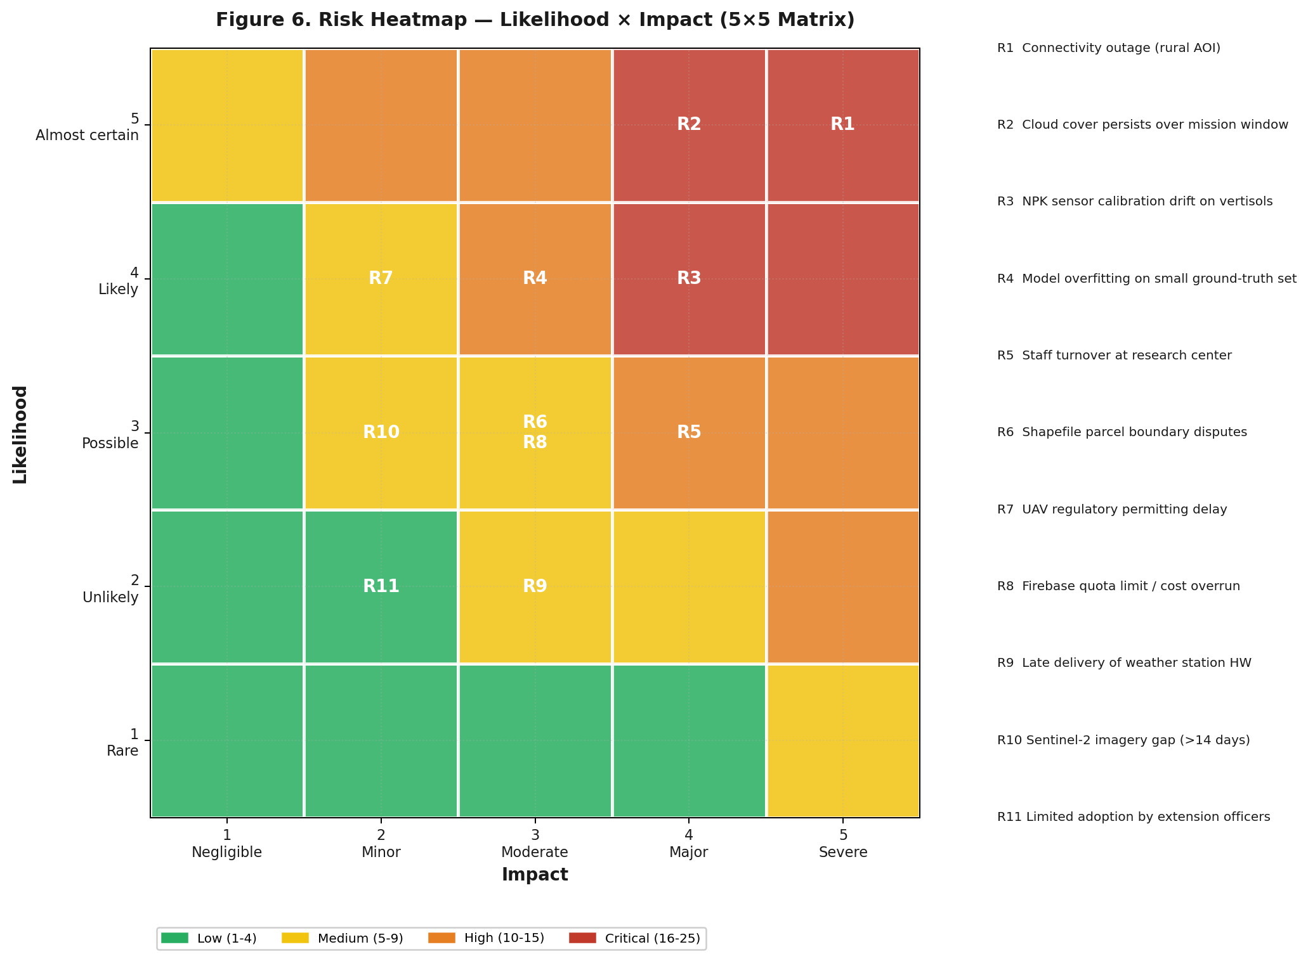
Figure 6. Risk heatmap. Risks in the red zone (R1: connectivity, R2: cloud cover) warrant explicit mitigation plans; risks in the orange zone (R3, R4, R5) require monitoring; risks in the yellow zone (R6–R11) are managed through normal project controls.

12.2 Risk Register
Table 7. Risk Register
ID | Risk | L | I | Score | Mitigation | Owner
R1 | Rural connectivity outage at AOI persists >48h | 5 | 5 | 25 | Edge gateway with 7-day local cache; 4G with 3G fallback; offline-tolerant Firebase sync; on-call rotation. | Edge engineer
R2 | Persistent cloud cover during UAV mission window | 4 | 5 | 20 | Augment with Sentinel-1 SAR; pre-book mission dates around seasonal clear-window climatology; supplement with proximal field scouting. | UAV pilot
R3 | NPK probe calibration drift on Ethiopian vertisols | 4 | 4 | 16 | Calibrate probes against lab soil samples per AOI; documented calibration curves; quarterly recalibration; cross-check against gravimetric samples. | Site agronomist
R4 | ML model overfitting on small ground-truth set | 4 | 3 | 12 | Use simple baselines first (XGBoost); strict cross-validation; leave-one-AOI-out protocol; documented performance bounds. | ML engineer
R5 | EIAR staff turnover during project | 3 | 4 | 12 | Three-person team per role minimum; documented runbooks; structured knowledge transfer in Phase 3; competitive compensation aligned with EIAR scales. | Project coordinator
R6 | Shapefile parcel boundary disputes (overlapping polygons, gaps) | 3 | 3 | 9 | Topology validation at ingestion; onsite field verification with site director; documented dispute-resolution protocol. | GIS specialist
R7 | UAV overflight permit delay (CAA Ethiopia) | 2 | 4 | 8 | Apply for permits in month 1; engage EIAR institutional liaison; have manual scouting fallback ready. | Project coordinator
R8 | Firebase quota exceeded or cost overrun | 3 | 3 | 9 | Set usage alerts; nightly archival to PostGIS to keep Firebase hot-store small; documented cost-monitoring dashboard. | Full-stack developer
R9 | Late delivery of weather station hardware | 2 | 3 | 6 | Order in month 1 from established vendor (Davis, Campbell); interim use of nearby EIAR climate station data. | Logistics lead
R10 | Sentinel-2 imagery gap >14 days over AOI | 2 | 3 | 6 | Augment with Landsat 8/9 (15 m panchromatic sharpened); use Sentinel-1 SAR where relevant; communicate advisory uncertainty to users. | GIS specialist
R11 | Limited adoption by extension officers | 2 | 2 | 4 | Co-design dashboard with extension officers from month 3; Amharic-language UX; training-of-trainers; track adoption metrics monthly. | Project coordinator
Likelihood (L) and Impact (I) on 1–5 scale. Score = L × I. Risks scoring ≥12 are reviewed monthly; risks scoring 6–11 reviewed quarterly; risks scoring ≤5 reviewed at phase boundaries.

12.3 Risk Governance
Risks are owned, monitored, and escalated through the project governance structure. The project coordinator reviews the red-zone risks monthly with the EIAR director of agricultural research. The M&E officer maintains the risk register as a living document, updating likelihood and impact scores as new information arrives (e.g., a successfully mitigated risk drops to a lower score; a realized risk is converted to an issue and tracked through closure).

13. Quality Assurance and KPIs

13.1 Quality Assurance Framework
Quality assurance operates at three levels. Module-level QA validates each module against its acceptance criteria (e.g., the IWCYES must achieve MAE ≤0.4 t/ha on held-out parcels). Integration-level QA validates end-to-end flows (e.g., a sensor reading must propagate from NPK probe through Firebase to a dashboard advisory in under five minutes during normal operating conditions). User-acceptance QA validates that decision-makers and extension officers can effectively use the system, measured through structured usability testing and adoption metrics.

13.2 Key Performance Indicators
Table 8 enumerates the project's principal KPIs, each with a baseline, target, and measurement method. KPIs are reviewed quarterly by the project coordinator and EIAR sponsor.
Table 8. Key Performance Indicators
KPI | Baseline | Target | Measurement Method
Spatial DB coverage (% of pilot-zone parcels ingested) | 0% | ≥95% | PostGIS count vs. AOI reference list
IWSS advisory accuracy (vs tensiometer) | — | MAE ≤25 mm soil-water depletion | Weekly comparison vs. installed tensiometers (3 per AOI)
IWSS advisory adoption (% of advisories acted on by farmer) | — | ≥60% | Field log + farmer survey
UAV disease detection F1 score (held-out) | — | F1 ≥0.75 macro-averaged | Stratified 5-fold CV; leave-one-AOI-out for transferability
UAV disease detection latency (mission → advisory) | — | ≤72 hours | Mission timestamp to advisory push timestamp
IWCYES yield MAE (t/ha, held-out) | — | ≤0.4 t/ha | Leave-one-AOI-out CV; validated against crop-cut yields
Vegetation index freshness (cloud-free obs ≤7 days old) | — | ≥80% of parcels | PostGIS query against index_timeseries
Dashboard uptime | — | ≥99.0% monthly | Synthetic monitoring from external probe
Dashboard response time (map tiles, p95) | — | ≤2.5 s | RUM (real user monitoring) via Vercel Analytics
Dashboard adoption (monthly active decision-makers) | 0 | ≥20 by month 18 | Firebase Auth login events
Capacity building (EIAR staff trained to operations level) | 0 | ≥9 (3 per AOI) | Certification assessment at end of training

13.3 Validation Campaigns
Three structured validation campaigns are conducted across the project lifetime. Campaign 1 (month 9, Bishoftu only) validates the Phase 1 system end-to-end. Campaign 2 (month 15, all three AOIs) validates Phase 2 replication. Campaign 3 (month 17, all three AOIs) is the final pre-handover validation. Each campaign follows a written protocol: pre-defined parcels, pre-defined observation windows, pre-defined metrics, and pre-defined go/no-go thresholds documented before the campaign begins.

14. Capacity Building and Sustainability

14.1 Capacity Building Plan
Capacity building is treated as a first-class deliverable, not a residual activity. Three EIAR staff per AOI (nine in total) are trained to operations level: they can run the system, troubleshoot common faults, retrain models with new data, and escalate to the project team for issues they cannot resolve. Training is structured into three tiers — operational user, technical operator, and system maintainer — so that staff with different backgrounds can be productively engaged at the appropriate tier.
Tier | Audience | Duration | Certification
1. Operational user | Site directors, extension officers, agronomists | 2 days | Certificate of completion
2. Technical operator | EIAR technicians, junior engineers | 5 days + 4-week shadowing | Operations-level certification
3. System maintainer | Senior EIAR engineers, IT staff | 10 days + 8-week shadowing | Maintainer-level certification

14.2 Knowledge Transfer Artifacts
The handover package comprises the following artifacts, all maintained in a project Git repository with public read access for the open-source components:
- Source code for all six modules with README per module.
- Infrastructure-as-code (Terraform / Docker Compose) for full environment reproducibility.
- Runbooks for the 20 most-likely operational issues (sensor offline, model drift, dashboard outage, etc.).
- Data dictionary documenting every PostGIS table and column with semantic meaning and units.
- API documentation (OpenAPI / Swagger) for all REST endpoints.
- Model cards for every ML model, documenting training data, performance, and limitations.
- Training material (slides, lab exercises, recorded sessions).
- Sustainability plan identifying EIAR unit, budget path, and three-year roadmap.

14.3 Sustainability Roadmap
Beyond the eighteen-month project lifetime, the system is designed to operate sustainably under EIAR ownership. Year two and three operational costs are estimated at USD 35,000 per year, covering cloud services, sensor maintenance and recalibration, and one part-time EIAR engineer dedicated to operations. The recommended sustainability path is:
- Year 1 (project lifetime): project team operates the system; EIAR staff shadow and train.
- Year 2 (post-handover): EIAR operations team runs day-to-day; project team available for paid consulting on escalations.
- Year 3 (steady state): EIAR fully self-sufficient; expansion to additional AOIs is a national-scale EIAR program.
The system's open-source design, documented infrastructure-as-code, and modular architecture make scaling to additional AOIs a deployment-and-calibration exercise rather than a re-engineering effort. The pilot-then-scale validation at three agro-ecologically distinct sites provides the evidence base to support a national scale-up proposal at the end of the project.

15. Conclusion and Next Steps

15.1 Summary
This implementation plan has specified a precision farming ecosystem for irrigated wheat in Ethiopia, structured around six modules — spatial database, UAV disease detection, vegetation-index service, irrigation water scheduling, yield estimation, and decision-support dashboard — and three pilot sites (Bishoftu, Asella, Ambo) chosen to span Ethiopia's principal wheat agro-ecologies. The plan adopts a pilot-then-scale phasing over eighteen months, a fully prescriptive open-source technology stack anchored on PostGIS, Firebase, and Next.js, and an indicative budget of approximately USD 606,000. Eleven identified risks have explicit mitigations, and eleven KPIs provide measurable acceptance criteria throughout.

15.2 Immediate Next Steps
To convert this plan into active project execution, the following immediate steps are recommended within the first four weeks:
- Project kickoff meeting with EIAR director-general and project sponsor to formally authorize the project and confirm budget allocation.
- Procurement initiated for NPK probes, weather stations, and DJI Mavic 3M UAV platform (long-lead items); target delivery within six weeks of kickoff.
- Project team mobilization — confirm project coordinator, GIS/RS specialist, ML engineer, full-stack developer, irrigation agronomist, M&E officer, and edge engineer.
- Repository bootstrap at github.com/DivergenTechnology/smartfarming-ecosystem — execute the B1–B12 bootstrap activities documented in Section 8.4 to deliver a runnable monorepo scaffold before module development begins.
- Stakeholder kickoff at Bishoftu ARC — confirm parcel access, secure indoor location for edge gateway, identify pilot parcels for Phase 1.
- Cloud project setup — provision Firebase project, Google Cloud Run services, PostGIS Docker container, and CI/CD pipeline (overlaps with bootstrap B11).
- Begin shapefile collection from Bishoftu ARC for initial ingestion to the spatial database.

15.3 Success Factors
Three success factors most strongly determine project outcome. First, timely procurement: the eighteen-month window is tight, and any delay to long-lead procurement compresses the entire schedule. Second, EIAR commitment to staff allocation: the project requires three to five qualified EIAR staff to be partially released from existing duties for the project duration. Third, agro-ecological transferability: the central scientific question is whether models trained at Bishoftu generalize to Asella and Ambo — the answer determines the project's national scale-up potential and is the principal scientific contribution of the work.

15.4 Contact
For follow-up, clarification, or revision requests regarding this implementation plan, please contact the project coordinator via the Ethiopian Institute of Agricultural Research. This document is maintained as version 1.1 (repo-anchored baseline) in the project document repository, with the canonical source codebase at github.com/DivergenTechnology/smartfarming-ecosystem. Subsequent revisions will be tracked in the revision history table at the front of this document.

