Screen 1:

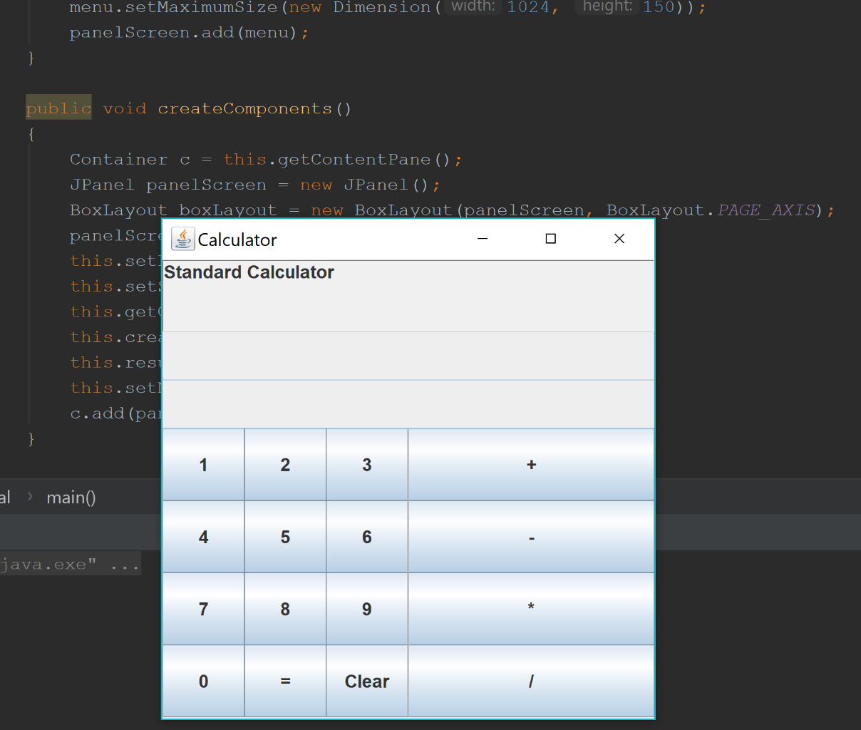

Screen 2: 1+3

2 text boxes are displayed on top as the original calculator displays the entered number on top after clicking on an operation symbol

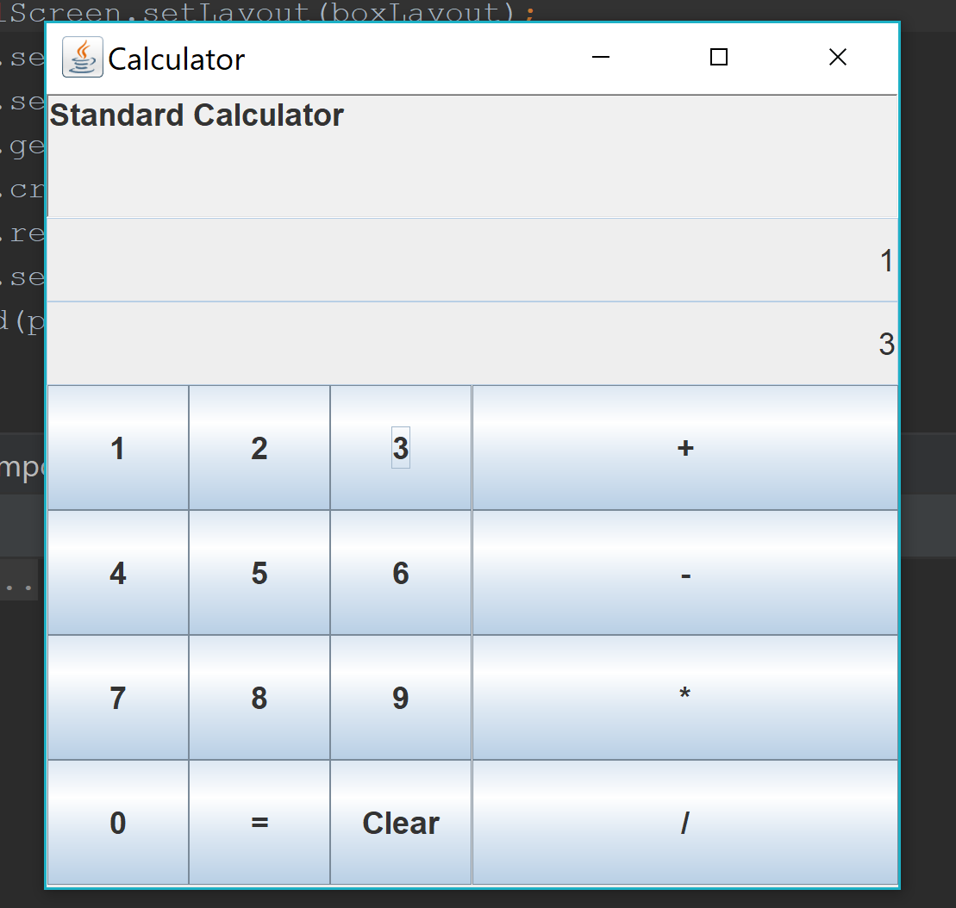

Screen 3: Result 4 being displayed

