Screen 1:

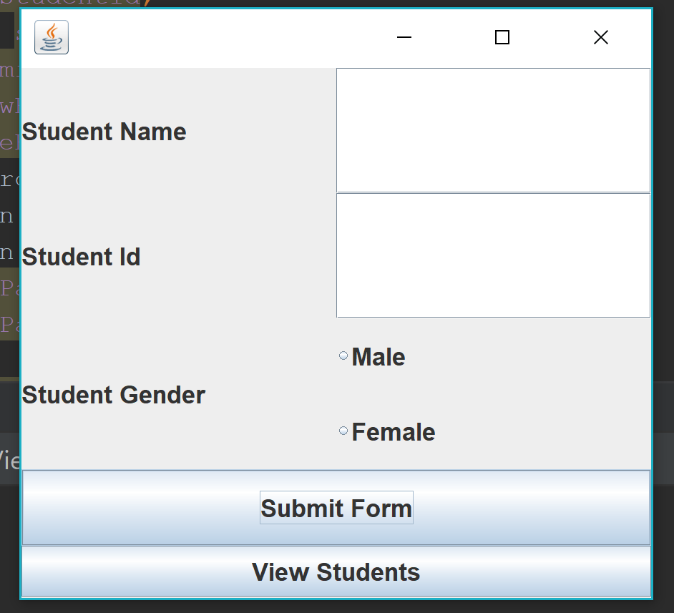

2. Entering details and clicking on Submit Form

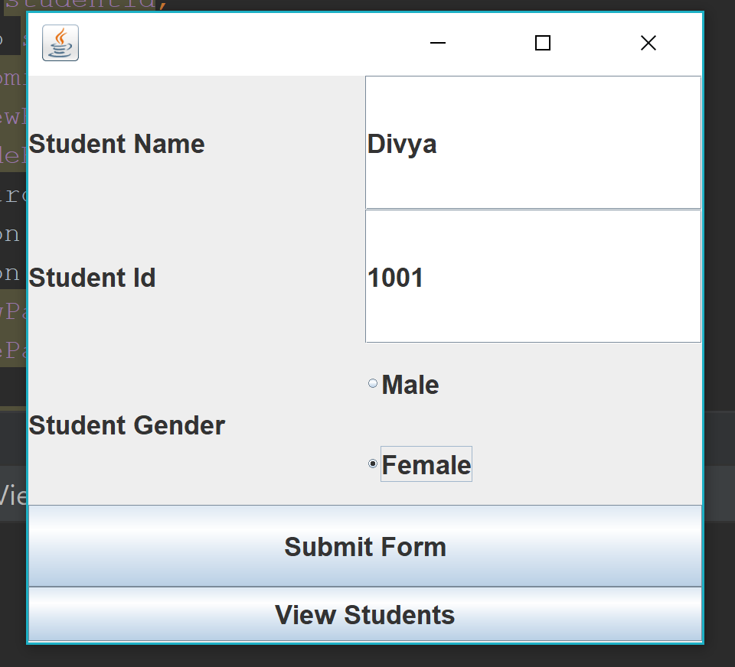

Screen 2: Clicking on View Students results in this screen

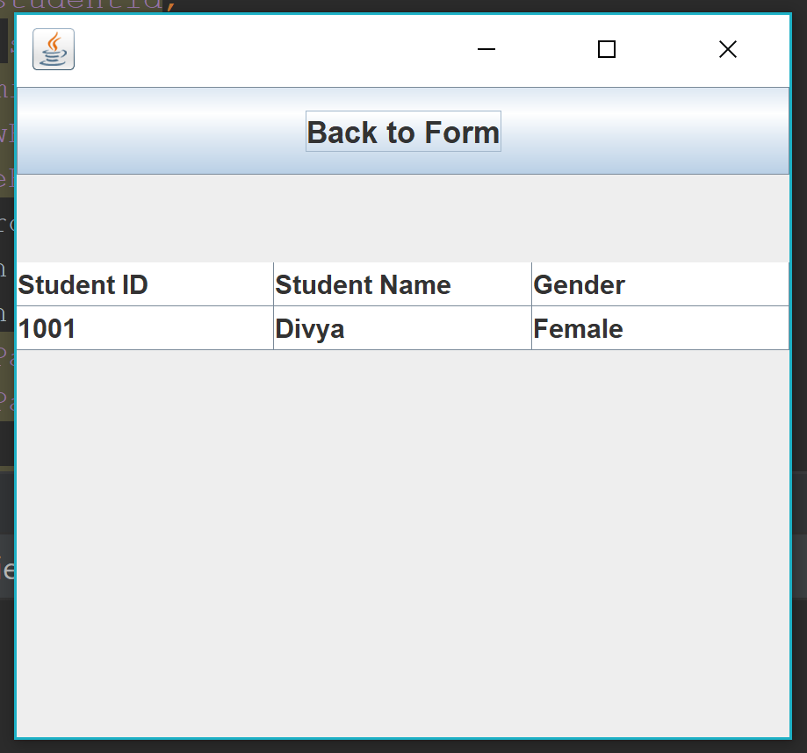

Screen 3: Clicking Back to Form results in this screen

