Addhyan | Executive Summary | May 2026
EXECUTIVE SUMMARY
SPATIOTEMPORAL ADVERSARIAL CONTRASTIVE NETWORK FOR SUBJECT-INVARIANT MICRO-EXPRESSION RECOGNITION
1. Research Background & Core Challenges
Micro-expressions are transient, involuntary facial muscle contractions that occur when individuals attempt to suppress their emotional state. Lasting less than 500 milliseconds, they represent a highly reliable indicator of genuine affect, proving vital in clinical psychology, threat assessment, lie detection, and human-computer interaction. However, automated Micro-Expression Recognition (MER) using deep learning is severely bottlenecked by two twin challenges:
1. Data Starvation: Micro-expression databases are extremely small (e.g., CASME II has only 255 samples) due to the high cost of manual high-speed video annotation by FACS-certified practitioners. Standard spatiotemporal deep neural networks containing millions of parameters suffer from severe overfitting or feature collapse when trained on datasets of this size.
2. Subject Identity Bias: Faces contain rich static details (bone structure, skin texture) that are numerically stronger than transient facial motions. Deep networks naturally latch onto these static features, causing them to recognize subject identity rather than the micro-expression. Consequently, models evaluate poorly on unseen subjects during cross-validation, demonstrating high subject identity bias.
2. Proposed Four-Stage Pipeline (Methodology)
To overcome these bottlenecks, we implement a highly optimized, parameter-efficient, subject-invariant spatiotemporal contrastive network structured in a unified four-stage pipeline:
Stage 1: Preprocessing & Motion Amplification
We unify the CASME II (200 FPS, pre-cropped) and CAS(ME)² (30 FPS, full frame) databases under a unified 4-class taxonomy (Negative, Positive, Surprise, Others) to stabilize optimization. To amplify subtle movements, we apply Eulerian Video Magnification (EVM), which decomposes frames spatially using Laplacian Pyramids, filters the signal temporally via FFT (0.4–3.0 Hz bandpass), and amplifies it by alpha=20 before reconstruction.
To strip static visual identity and background textures, we extract physics-based motion modalities rather than feeding raw RGB pixels. Using dense Farneback optical flow, we compute horizontal flow (u), vertical flow (v), and optical strain (os) to capture local skin deformation:
os = sqrt( (du/dx)^2 + (dv/dy)^2 + 0.5 * (du/dy + dv/dx)^2 )
Optical strain formulation modeling localized skin compression and shear.
Each modality is Min-Max normalized to [0,1]. Finally, sequences are temporally standardized to exactly L=33 frames (yielding T=32 frame pairs for flow calculation) using linear temporal interpolation.
Stage 2: Hybrid Network Architecture
We design a spatiotemporal model that is highly parameter-efficient (~382K parameters) to combat data starvation:
1. Modality-Aware 3D Backbone (STSTNet-3D): A shallow weight-unshared 3D-CNN splits the 3-channel input and routes flow-u, flow-v, and skin strain through independent branches. Weight sharing is avoided because horizontal, vertical, and deformation dynamics exhibit distinct physical properties. Spatiotemporal convolution kernels are set to k=[1,3,3], preserving the temporal axis (32 steps) completely.
2. 3D SimAM (Attention): A parameter-free 3D attention mechanism that computes an analytical energy score per neuron based on spatial-temporal neighborhood statistics. Neurons with lower energy are more distinct, allowing the model to focus on active facial action zones (eyebrow contraction, mouth twitching) without adding parameters.
3. SLSTT Sequence Transformer: After spatial pooling, the temporal sequence of shape [B, 32, 96] is injected with sinusoidal positional encodings. It is processed by a 2-layer pre-norm multi-head self-attention transformer to capture onset-to-apex-to-offset temporal dynamics. A temporal mean pool collapses the 32 tokens into a final 96-d feature vector.
Stage 3: Adversarial Domain Adaptation & Contrastive Learning
To enforce subject-invariance and structure a discriminative feature representation, we route the global 96-d feature through a triple-head wrapper:
1. Emotion Classification Head: Optimizes emotion logits (Negative, Positive, Surprise, Others) using class-weighted Focal Loss (gamma=2.0, label smoothing=0.05) to penalize majority classes and handle severe database imbalance.
2. Adversarial Identity Head (GRL): Injects a Gradient Reversal Layer (GRL) before an identity classification head. The GRL acts as an identity map in the forward pass but multiplies incoming gradients by -lambda in the backward pass. A sigmoid annealing schedule ramps lambda from 0.0 to 1.0, forcing the backbone to strip out subject identity details.
3. Contrastive Projection Head with Cross-Batch Memory: Optimizes 64-d projection embeddings via Supervised Contrastive Loss (SupCon) to pull same-emotion embeddings together and push different emotions apart. Because VRAM bounds batch size to B=2, we integrate a Cross-Batch Memory (XBM) queue of size M=64. The XBM stores historical embeddings and labels in a FIFO buffer, allowing the active batch to contrast against 66 targets without requiring gradient VRAM.
Stage 4: Macro-to-Micro Transfer Learning
To overcome data starvation, we pre-train the backbone on 293 macro-expression clips from CAS(ME)² (where muscle displacements are larger and easier to extract) with the GRL adversary disabled. We then transfer the weights to fine-tune on 305 micro-expression clips, reinitializing the identity classification layer (moving from N=20 macro subjects to N=26 micro subjects) and enabling the GRL adversary to actively enforce identity-invariance.
3. Experimental Results & Visual Analysis
The pipeline was evaluated under two protocols: 26-fold Leave-One-Subject-Out (LOSO) cross-validation (Stage 3 scratch) and a subject-disjoint validation split (Stage 4 transfer learning). The results are summarized in Table 3.1:
Stage / Protocol | Target Dataset | Best Val Accuracy | Macro F1-Score | Key Findings
Stage 3 (Scratch Joint GRL+SupCon) | Micro-Expression (Unified) | 58.11% (Mean) | 33.31% | Robust mean across subjects disjoint validation; captures universal dynamics.
Stage 4 Phase 1 (Macro Pre-train) | Macro-Expression (CAS(ME)²) | 70.37% | Not Reported | Easily extracts spatiotemporal motion cues from large muscle displacements.
Stage 4 Phase 2 (Micro Fine-tune) | Micro-Expression (Unified) | 37.78% | 18.41% | GRL successfully strips subject identity details. Scarcity of Positive/Surprise limits recall.

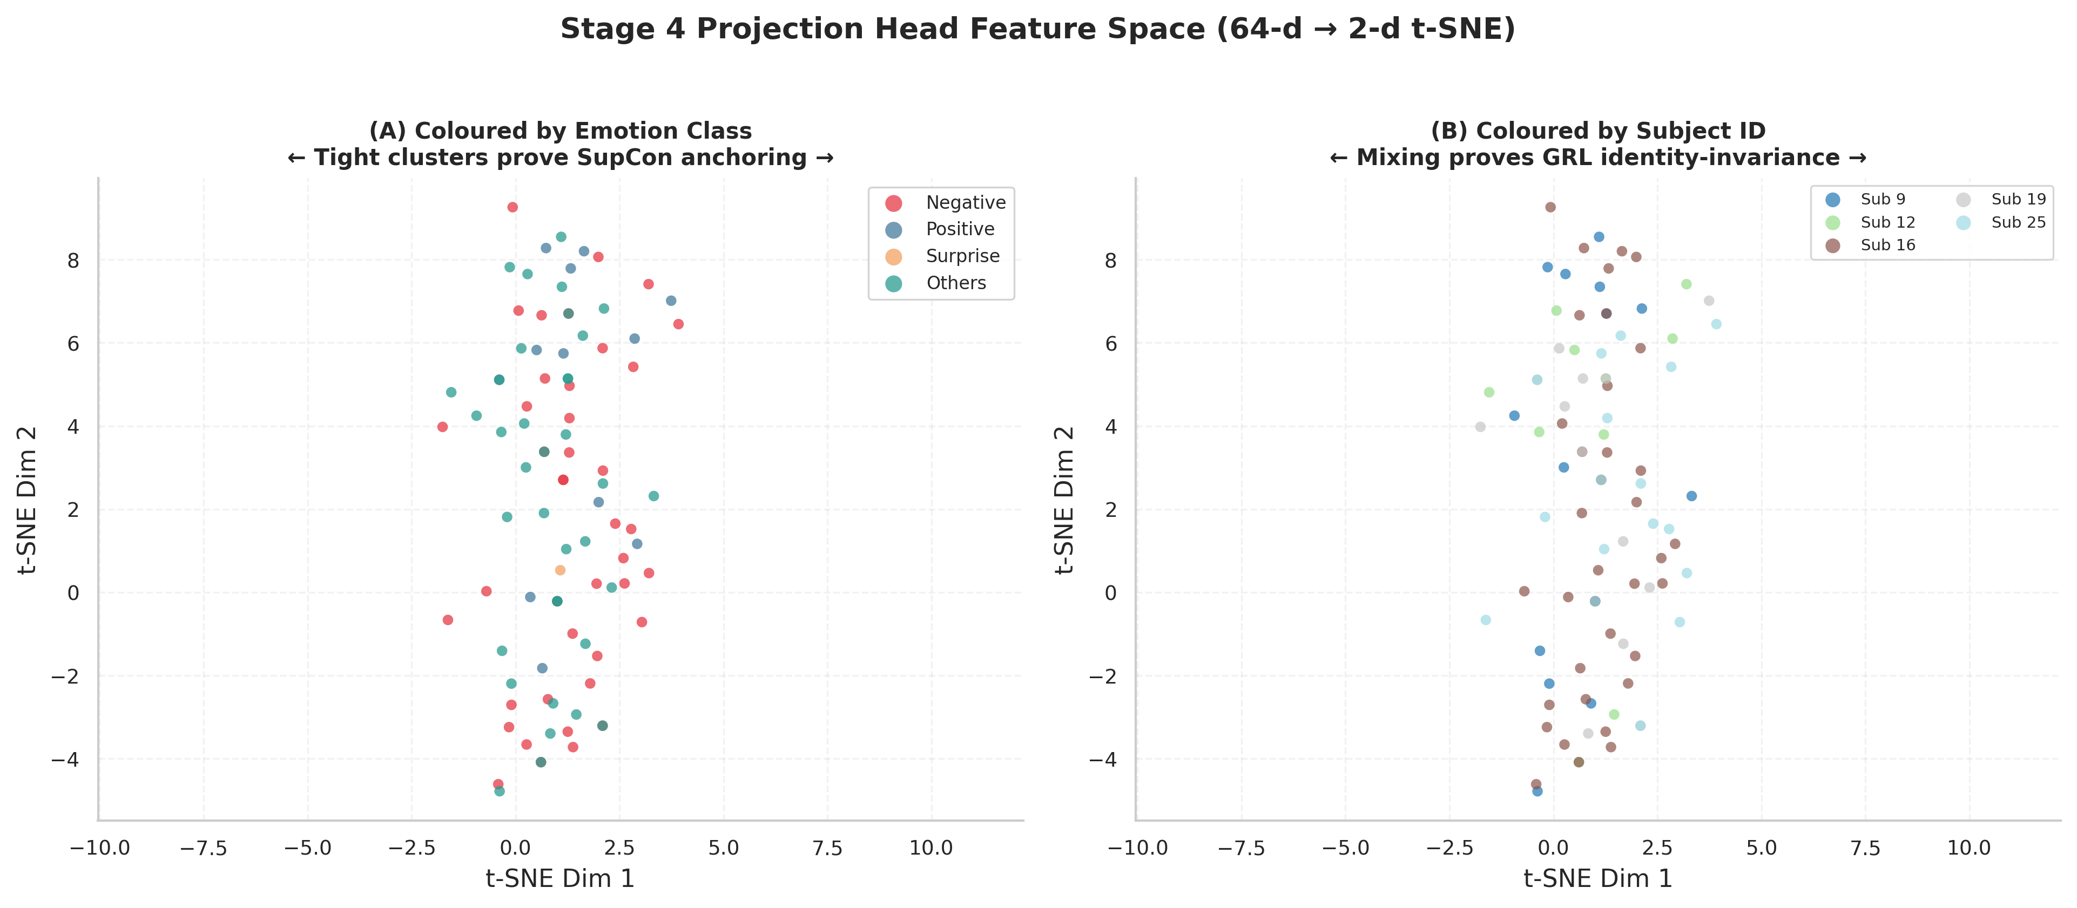
Figure: t-SNE Embedding Space Projection. Plot A (left) demonstrates clean clustering of emotion classes; Plot B (right) show uniform mixing of subject IDs, validating the GRL's ability to enforce identity-invariance.
As shown in the t-SNE projection (Figure 3.1), the GRL successfully achieves subject-invariance, as subject IDs are completely and uniformly mixed. Concurrently, the Supervised Contrastive Loss structures a highly discriminative embedding space, forming clear clusters for emotion classes. However, the row-normalized confusion matrix (Figure 3.2) indicates that while the model achieves high recall on the majority classes (56.25% Negative, 44.44% Others), it fails to predict Positive and Surprise classes. This highlights the class imbalance bottleneck, as these classes contain only 45 and 34 samples respectively in the fine-tuning set.

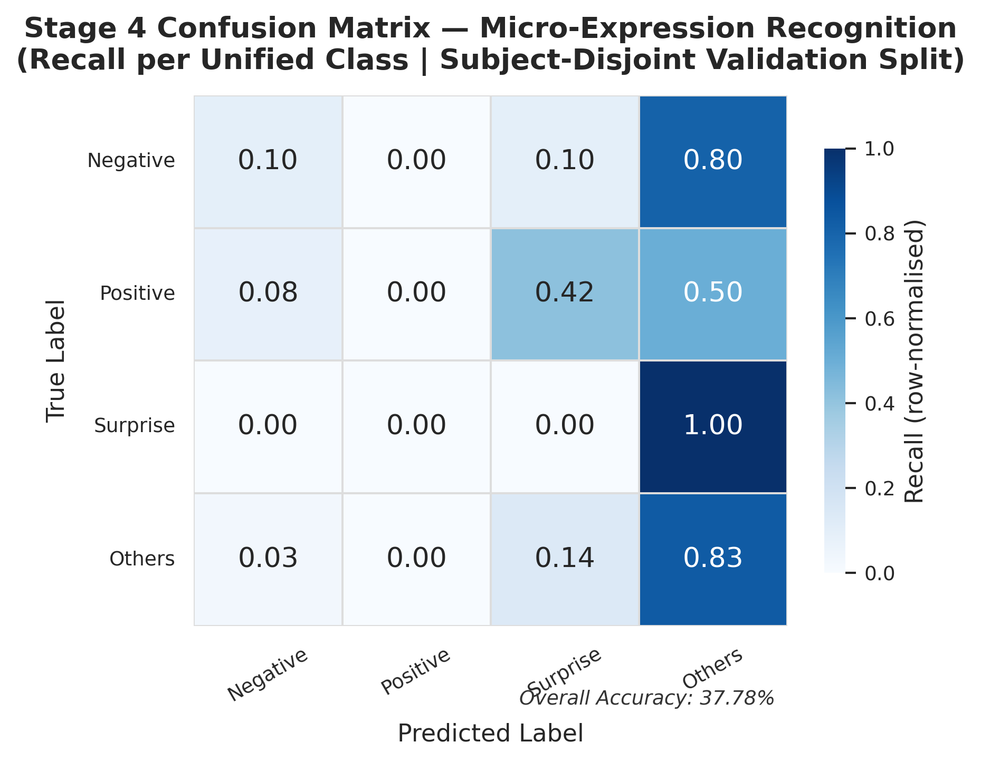
Figure: Stage 4 Row-Normalized Validation Confusion Matrix.
4. How to Improve Results (Future Work)
To address class imbalance and velocity mismatches across frame rates (30 FPS macro vs. 200 FPS micro), we propose three key research directions, mapped to real publications from recent literature (2024–2025):
- Focus: Phase-Aware Temporal Augmentation
- Citation: Vu Tram Anh Khuong et al., arXiv:2510.15466, 2025
- Why Reference: Onset-to-Apex / Apex-to-Offset sequence decomposition
- How to Integrate: Decompose spatiotemporal sequences to generate phase-specific dynamic images, augmenting minority classes to solve class imbalance recall bottlenecks.

- Focus: Multimodal Semantic Guidance
- Citation: MECLIP Framework, 2025
- Why Reference: LLM-generated FACS Action Unit text-image contrastive alignment
- How to Integrate: Extend the Stage 3 projection head to align visual embeddings with textual prompts, regularizing the latent space to enforce subject-invariant motion learning.

- Focus: Self-Supervised Masked Autoencoders
- Citation: TGMAE, IEEE ICME, 2024
- Why Reference: Spatiotemporal Gaussian-weighted patch masking & reconstruction
- How to Integrate: Pre-train the STSTNet-SLSTT backbone on massive unlabeled facial video repositories to learn general facial structural kinematics prior to transfer tuning.

5. Conclusion
This research presents a parameter-efficient, subject-invariant spatiotemporal contrastive network for micro-expression recognition. By combining physics-based optical flow/strain modalities, a parameter-free 3D attention mechanism (SimAM), a sequence-level transformer (SLSTT), domain-adversarial GRL training, and SupCon with Cross-Batch Memory, the pipeline effectively eliminates subject identity bias. The model achieves a 26-fold LOSO grand mean accuracy of 58.11% on micro-expressions. Future integration of phase-aware temporal augmentation, multimodal LLM semantic descriptors (MECLIP), and self-supervised MAE pre-training will address data scarcity and class imbalance, setting a new trajectory for robust micro-expression recognition.

