Addhyan | Master's Thesis Report | May 2026

SPATIOTEMPORAL ADVERSARIAL CONTRASTIVE NETWORK FOR SUBJECT-INVARIANT MICRO-EXPRESSION RECOGNITION
A Comprehensive Four-Stage Pipeline Combining Eulerian Motion Amplification, Hybrid 3D-CNN + Transformer Backbones, Cross-Batch Memory Supervised Contrastive Learning, and Domain Adaptation
A Master's Thesis Report submitted in partial fulfillment of the requirements for the degree of
Master of Science in Computer Science and Engineering
Author: Addhyan
Hardware Target: NVIDIA GeForce RTX 4060 Laptop GPU (8.6 GB VRAM)
Framework: PyTorch (CUDA-accelerated)
Random Seed Config: 42
Date: May 26, 2026

Abstract
Micro-Expression Recognition (MER) represents a challenging computer vision frontier due to the brief duration (typically under 500 milliseconds) and minute displacement of facial movements. Standard deep neural networks applied to small micro-expression datasets suffer from severe overfitting, driven by two key bottlenecks: Data Starvation and Subject Identity Bias. The former arises from the absolute scarcity of annotated training samples, while the latter stems from the tendency of deep networks to map structural face shapes (identities) rather than dynamic muscle movements. This thesis presents a highly optimized, unified four-stage pipeline designed to overcome these challenges. The pipeline incorporates Eulerian Video Magnification (EVM) for motion amplification; a parameter-efficient, weight-unshared shallow 3D-CNN backbone combined with a neuroscience-inspired, parameter-free 3D SimAM attention module; and a Sequence-Level Spatio-Temporal Transformer (SLSTT). To strip subject identity details from features, we implement a Gradient Reversal Layer (GRL) domain-adversarial identity head alongside a Supervised Contrastive Loss (SupCon) enhanced with Cross-Batch Memory (XBM) to anchor emotion clusters. Finally, a two-phase Macro-to-Micro transfer learning scheme is applied. Our model achieves a 26-fold Leave-One-Subject-Out (LOSO) cross-validation grand mean accuracy of 58.11% on micro-expressions, establishing a highly robust, identity-invariant feature representation that generalizes effectively to unseen subjects.

Chapter 1: Introduction
1.1 Background and Context
Micro-expressions are rapid, involuntary facial muscle contractions that occur when individuals attempt to suppress or conceal their true emotional state. Unlike voluntary macro-expressions (such as social smiles or deliberate frowns) which typically last between 0.5 to 4.0 seconds and involve substantial facial displacement, micro-expressions last less than 500 milliseconds (and frequently less than 250 milliseconds). Due to their subconscious and fleeting nature, micro-expressions represent a reliable window into genuine human affect. Consequently, automated Micro-Expression Recognition (MER) systems have emerged as a vital tool in clinical psychology, psychiatric diagnosis (e.g., detecting depressive disorders or suicidal ideation), border security, lie detection, neuromarketing, and affective human-computer interaction (HCI).
1.2 The Twin Bottlenecks of Automated MER
Despite their high utility, automated MER remains an exceptionally difficult problem in computer vision. Specifically, deep learning architectures are severely bottlenecked by two twin challenges:
1. Data Starvation: The annotation of micro-expressions requires certified practitioners trained under the Facial Action Coding System (FACS) to analyze high-speed video footage frame-by-frame. Because of this expensive coding process, benchmark databases are extremely small. For instance, the CASME II dataset contains only 255 annotated clips, representing just a few dozen individuals. Large-scale deep networks containing millions of parameters (e.g., standard ViTs, ResNet-3D) suffer catastrophic overfitting or feature collapse when trained from scratch on datasets of this size.
2. Subject Identity Bias: Human faces contain rich static structural details, such as bone structure, eye shape, jawline geometry, and skin texture. Deep neural networks naturally exploit these high-contrast static features because they are easier to learn than sub-pixel dynamic displacements. During cross-validation, models easily lock onto individual subject identities. As a result, when evaluated on unseen subjects in a Leave-One-Subject-Out (LOSO) setup, the models generalize poorly, classifying emotions based on facial structure rather than facial motion.
1.3 Objectives and Contributions
The primary goal of this research is to design and implement a parameter-efficient, subject-invariant spatiotemporal contrastive network that captures transient micro-movements while actively stripping out subject-specific static traits. The contributions are organized into a unified four-stage pipeline:
- Stage 1 (Preprocessing): Unifies heterogeneous databases, applies Eulerian Video Magnification (EVM), extracts motion-specific optical flow/strain tensor cubes, and standardizes video sequences temporally.
- Stage 2 (Architecture): Integrates weight-unshared shallow 3D-CNN streams with a parameter-free 3D SimAM attention module and a temporal Sequence-Level Spatio-Temporal Transformer (SLSTT) encoder.
- Stage 3 (Adversarial Contrastive Training): Jointly optimizes a class-weighted Focal Loss, a GRL-based adversarial subject classification head, and a Supervised Contrastive Loss (SupCon) with a Cross-Batch Memory (XBM) queue.
- Stage 4 (Transfer Learning): Implements a two-phase pre-training/fine-tuning routine transferring knowledge from macro-expressions to micro-expressions.

Chapter 2: Stage 1 — Data Preprocessing & Unification
2.1 Dataset Merging and Metadata Unification
To establish a robust corpus, we unified two benchmark databases from the Chinese Academy of Sciences: CASME II and CAS(ME)². Unifying these datasets presents significant challenges because their recording parameters, formatting, and annotations are highly heterogeneous. Specifically, CASME II is recorded with a high-speed camera at 200 frames per second (FPS) and features pre-cropped faces. CAS(ME)² is recorded with a standard camera at 30 FPS, containing full uncropped frames and macro-expressions alongside micro-expressions.
We developed a robust python module, `MetadataUnifier`, to read the Excel indices, calculate sequence lengths, resolve absolute frame folder paths on disk, and map disparate emotions into a unified taxonomy. The comparative characteristics of the datasets are summarized in Table 2.1:
Property | CASME II | CAS(ME)²
Source Institution | Chinese Academy of Sciences | Chinese Academy of Sciences
Expression Types | Micro-expression only | Both Macro and Micro-expressions
Original Frame Format | Image sequences (JPEG/PNG) | Image sequences (JPEG/PNG)
Video Resolution | 640 × 480 pixels | 640 × 480 pixels (cropped faces)
Temporal Frame Rate | 200 FPS (high-speed camera) | 30 FPS (standard camera)
Metadata File Format | Excel (.xlsx) with header row | Excel (.xlsx) without header row
Facial Alignment | Cropped, aligned, normalized | Uncropped full video (requires face cropping)

2.1.1 Unified Emotion Taxonomy
Because small datasets contain very few samples for fine-grained emotions (e.g., only 2 fear samples in CASME II), training networks on the raw labels leads to severe gradient instability. We collapsed the labels into a standardized 4-class taxonomy: Negative (mapping disgust, sadness, fear, anger, contempt, and repression), Positive (mapping happiness), Surprise, and Others. The unified class distribution for both micro- and macro-expressions is outlined in Table 2.2:
Unified Label | Constituent Emotions | Macro-Expression Samples | Micro-Expression Samples | Total Samples
Negative | Disgust, Sadness, Fear, Anger, Contempt, Repression | 112 | 125 | 237
Positive | Happiness | 106 | 45 | 151
Surprise | Surprise | 24 | 34 | 58
Others | Others | 10 | 102 | 112
Total | Combined Unified Dataset | 252 | 306 | 558

2.2 Eulerian Video Magnification (EVM)
Micro-expressions involve facial displacements that are frequently sub-pixel, falling below the sensor noise floor of standard cameras. To amplify these movements, we incorporate Eulerian Video Magnification (Wu et al., 2012). EVM decomposes the video spatially, isolates specific bandpass frequencies temporally, and reconstructs the magnified frames. The mathematical formulation is defined below:
Step A (Spatial Decomposition via Gaussian/Laplacian Pyramid):
G_l(x, y) = Downsample( Convolve(G_{l-1}, w) )
L_l = G_l - Upsample( G_{l+1}, w_u )
where w represents a 5x5 separable Gaussian filter, and L_l is the Laplacian pyramid component at scale level l.
Step B (Temporal Ideal Bandpass Filtering via Fast Fourier Transform):
F(k) = sum_{t=0}^{T-1} S_t * exp(-i * 2*pi * k * t / T)
H(k) = 1 if f_low <= |(k*fps)/T| <= f_high; else 0
S_filt(t) = Re( (1/T) * sum_{k=0}^{T-1} H(k) * F(k) * exp(i * 2*pi * k * t / T) )
where S_t is the temporal sequence of a pixel at pyramid level l, and S_filt is the isolated facial motion signal.
Step C (Motion Amplification & Pyramid Reconstruction):
S_magnified(t) = S_t + alpha * S_filt(t)
Reconstructed Frame = sum_{l=0}^{L_pyr} Collapse( L_l + alpha * L_filt_l )
where alpha is the amplification factor and L_filt_l is the bandpass filtered Laplacian frame.
The configuration settings of the EVM module are detailed in Table 2.3. The temporal bandpass is set to [0.4, 3.0] Hz, which targets the physical frequency of facial muscle contractions during expressions, while excluding high-frequency camera noise and low-frequency head sway.
Parameter Name | Value Setting | Description and Rationale
alpha (α) | 20.0 | Amplification factor. Multiplies temporal displacement signal by 20 to reveal sub-pixel motion.
low_omega (f_low) | 0.4 Hz | Lower frequency cutoff of FFT temporal bandpass filter. Excludes head sway/drift.
high_omega (f_high) | 3.0 Hz | Upper frequency cutoff of FFT temporal bandpass filter. Excludes sensor/pixel noise.
pyramid_levels (L_pyr) | 4 | Depth of Laplacian spatial pyramid. Captures motion at 4 scale levels.
assumed_fps | 30 | Baseline frequency rate for temporal bandpass filtering index bounds.

2.3 Physics-Based Modality Extraction
Raw RGB pixels contain static illumination, skin color, and identity textures that encourage overfitting. Instead of feeding RGB frames directly into the neural network, we extract three physics-based motion modalities. This ensures that the network consumes only pure motion features. The output is a 3-channel spatiotemporal tensor representing horizontal flow (u), vertical flow (v), and optical strain magnitude (os).
For each consecutive pair of grayscale frames, we compute the dense Farneback optical flow (Farneback, 2003). This models local motion using polynomial expansion. Let the displacement field be (u, v). We compute the optical strain to capture the localized skin compression and stretching. The normal strain and shear strain components are computed using spatial gradients of the flow field:
eps_xx = du/dx, eps_yy = dv/dy
eps_xy = 0.5 * ( du/dy + dv/dx )
os = sqrt( eps_xx^2 + eps_yy^2 + eps_xy^2 )
where du/dx and du/dy are computed via central differences in numpy: grad(u) = [du/dy, du/dx].
To prevent one channel from dominating during optimization (since strain magnitudes are numerically smaller than flow vectors), each channel is independently Min-Max normalized across the temporal sequence:
x_norm = (x - x_min) / (x_max - x_min + epsilon)
where epsilon = 1e-8 prevents division by zero. This normalizes all features to [0, 1].
2.4 Temporal Standardization
The unified clips have highly variable frame lengths, ranging from 10 to 150 frames. Because 3D-CNN backbones and Transformers require fixed-size inputs, we implemented a temporal interpolator inspired by the Temporal Interpolation Model (TIM). For a given target length L=33 frames, the interpolator samples L uniformly spaced indices using linear interpolation: `np.round(np.linspace(0, total_frames-1, L))`.
This ensures that every video is standardized to exactly 33 frames, which yields exactly T = L - 1 = 32 consecutive frame pairs for optical flow and strain calculation. The final output is saved as a float32 NumPy array of shape `[3, 32, 224, 224]` (3 modalities, 32 time steps, 224x224 spatial resolution) in `Processed_Data/tensors/`.

Chapter 3: Stage 2 — Hybrid Model Architecture
To process the generated spatiotemporal tensors efficiently, we designed a hybrid neural network model consisting of three main components: a modality-aware 3D-CNN backbone, a parameter-free 3D attention module, and a temporal Sequence-Level Spatio-Temporal Transformer (SLSTT).
3.1 Modality-Aware Shallow 3D-CNN Backbone
Rather than using a deep 3D-CNN that would quickly overfit our small dataset, we developed a shallow, modality-aware backbone inspired by STSTNet (Liong et al., 2019). The backbone splits the 3-channel input along the channel dimension and routes each modality (flow-u, flow-v, strain) through an independent, unshared branch. Unshared weights are critical because horizontal flow, vertical flow, and skin deformation exhibit fundamentally different physical characteristics; using specialized kernels for each modality enables the network to extract cleaner spatial features.
Crucially, all convolutional layers preserve the temporal axis by setting the kernel size along the temporal dimension to 1, stride to 1, and padding to 0. This ensures that the 32 temporal frames are not mixed spatially, leaving the temporal modeling entirely to the downstream Transformer. The exact structural layers of the STSTNet Backbone are detailed in Table 3.1:
Layer Component | Parameters & Hyperparameters | Input Size | Output Size | Mathematical Operation / Rationale
Modality Split | Splits 3 channels | [B, 3, 32, 224, 224] | [B, 1, 32, 224, 224] × 3 | Isolates flow-u, flow-v, and skin strain paths.
Conv3D L1 | Conv3D (1->16, k=1×3×3, p=0×1×1) | [B, 1, 32, 224, 224] | [B, 16, 32, 224, 224] | Extracts spatial features; temporal kernel=1 preserves depth.
BN3D + ReLU | BatchNorm3D, ReLU, Dropout(0.3) | [B, 16, 32, 224, 224] | [B, 16, 32, 224, 224] | Stabilizes distribution, adds non-linearity & regularisation.
Conv3D L2 | Conv3D (16->32, k=1×3×3, p=0×1×1) | [B, 16, 32, 224, 224] | [B, 32, 32, 224, 224] | Builds deeper spatial features; temporal depth preserved.
BN3D + ReLU | BatchNorm3D, ReLU, Dropout(0.3) | [B, 32, 32, 224, 224] | [B, 32, 32, 224, 224] | Regularises intermediate representation before pooling.
Spatial Pool | MaxPool3D (k=1×2×2, s=1×2×2) | [B, 32, 32, 224, 224] | [B, 32, 32, 112, 112] | Halves spatial resolution (224->112), temporal depth remains 32.
SimAM 3D | Parameter-free Attention (λ=1e-4) | [B, 32, 32, 112, 112] | [B, 32, 32, 112, 112] | neuron energy function highlights active facial zones.
Modality Fusion | Channel Concatenation | [B, 32, 32, 112, 112] × 3 | [B, 96, 32, 112, 112] | Combines flow-u, flow-v, and skin strain into one volume.
Adaptive Pool | AdaptiveAvgPool3D (out=32×1×1) | [B, 96, 32, 112, 112] | [B, 96, 32, 1, 1] | Crushes spatial dimensions, preserves 32 temporal steps.
Sequence Reshape | Squeeze + Permute (transpose 1 & 2) | [B, 96, 32, 1, 1] | [B, 32, 96] | Converts volumetric features to 32 temporal sequence tokens.

3.2 3D SimAM (Parameter-Free Attention)
To focus the model on active facial regions (e.g., the eyebrows or mouth corners) without adding learnable parameters, we integrate the 3D Simple Attention Module (SimAM) (Yang et al., 2021). Derived from the neuroscience theory of inter-neuron suppression, SimAM computes an analytical energy function for each neuron. A lower energy score indicates that a neuron is highly distinct from its spatial and temporal neighbors, signaling high importance. The mathematical formulation is defined as:
e_t = (t - mu)^2 / ( 4 * (sigma^2 + lambda) ) + 0.5
where t is the target activation, mu and sigma^2 are the mean and variance computed over the spatio-temporal volume, and lambda = 1e-4.
attention_weight = sigmoid( 1 / e_t )
Output_tensor = Input_tensor * attention_weight
which rescales the feature map element-wise, amplifying active zones without adding any parameters.
3.3 SLSTT Transformer Encoder
After spatial pooling compresses the spatial dimensions, the resulting sequence of shape `[B, 32, 96]` is processed by the Sequence-Level Spatio-Temporal Transformer (SLSTT) (Zhang et al., 2022). Self-attention is permutation-invariant and does not naturally understand temporal order. To teach the model the chronological progression of expressions (onset $ o$ apex $ o$ offset), we inject fixed, deterministic sinusoidal positional encodings (Vaswani et al., 2017):
PE_{pos, 2i} = sin( pos / 10000^(2i/d_model) )
PE_{pos, 2i+1} = cos( pos / 10000^(2i/d_model) )
where pos is the frame index (0 to 31) and d_model = 96 represents the token dimensionality.
The sequence is then processed by a 2-layer Transformer Encoder. Each layer consists of a 4-head multi-head self-attention mechanism and a 256-dimensional Feed-Forward Network (FFN). The model uses a pre-norm architecture (applying Layer Normalization before the attention block) to ensure gradient stability during backpropagation. Finally, a temporal mean pooling layer averages the 32 tokens into a single 96-dimensional global feature vector representing the entire clip.

Chapter 4: Stage 3 — Adversarial Domain Adaptation
4.1 Triple-Head Wrapper
To enforce subject-invariance, we wrap the backbone in a triple-head architecture (`AdversarialMERWrapper`). The 96-dimensional global feature vector is routed into three parallel paths:
- 1. Emotion Head: LayerNorm → Dropout(0.3) → Linear(96, 4) outputs emotion logits (Negative, Positive, Surprise, Others), optimized via class-weighted Focal Loss.
- 2. Projection Head: Linear(96, 96) → ReLU → Linear(96, 64) followed by L2-normalization, outputting 64-dimensional embeddings optimized via Supervised Contrastive Loss (SupCon).
- 3. Identity Head: Gradient Reversal Layer (GRL) → LayerNorm → Dropout(0.3) → Linear(96, N_subjects) outputs subject logits, optimized via Cross-Entropy Loss.
4.2 Gradient Reversal Layer (GRL)
The GRL (Ganin & Lempitsky, 2015) is placed before the identity classification head. During forward propagation, the GRL acts as an identity mapping, allowing the identity head to learn to identify the subject. During backward propagation, however, the GRL multiplies the incoming gradients by a negative weight (-λ). This forces the backbone to adjust its weights in a direction that maximizes subject classification error, effectively stripping out identity cues:
Forward Pass: GRL(x) = x
Backward Pass: grad_in = -lambda * grad_out
where lambda is the reversal coefficient.
To prevent the adversarial gradients from destabilizing the network in early epochs (before the backbone has learned basic motion representations), we implement a sigmoid annealing schedule that ramps λ from 0.0 to 1.0:
lambda(p) = 2 / ( 1 + exp(-gamma * p) ) - 1
where p is the training progress (current_epoch / total_epochs) and gamma = 10.0 governs the steepness of the curve.
4.3 Supervised Contrastive Loss (SupCon) & XBM
To structure a highly discriminative feature space, we incorporate Supervised Contrastive Learning (SupCon) (Khosla et al., 2020) applied to the 64-dimensional L2-normalized embeddings. The SupCon loss forces same-emotion feature projections to cluster tightly while pushing different-emotion projections apart. The mathematical loss for a batch is defined as:
L_i = (-1 / |P(i)|) * sum_{p in P(i)} log [ exp( z_i . z_p / tau ) / sum_{a in A(i)} exp( z_i . z_a / tau ) ]
where z_i is the anchor embedding, P(i) is the set of positive indices, A(i) is all targets except the anchor, and tau = 0.10.
Because 5D video tensors require significant GPU memory, we are restricted to a physical batch size of B=2. At B=2, the probability of finding any positive pairs in a batch is extremely low, causing the contrastive loss to fail. To resolve this VRAM bottleneck, we integrate a Cross-Batch Memory (XBM) bank (Wang et al., 2020) of size M=64. The XBM stores historical embeddings and labels in a FIFO queue, allowing the anchor batch to contrast against 66 targets. The stored features are detached from the computation graph, requiring no additional gradient VRAM.
4.4 Focal Loss for Class Imbalance
To handle the severe class imbalance in our dataset, we optimize emotion classification using Focal Loss (Lin et al., 2017) with gamma=2.0 and label smoothing of 0.05. The focal modulating factor down-weights well-classified examples, focusing gradients on hard, misclassified samples. The loss is weighted using per-class alpha weights derived from inverse frequencies:
FL(p_t) = -alpha_t * (1 - p_t)^gamma * log(p_t)
where p_t is the predicted probability of the true class, and alpha_t is the inverse frequency weight.
4.5 Multi-Objective Loss Formulation
The overall network is trained using a multi-objective loss function combining all three heads:
L_total = (1.0 * L_SupCon) + L_Emotion(Focal) + (0.5 * L_Identity)
optimized end-to-end using the AdamW optimizer.

Chapter 5: Stage 4 — Macro-to-Micro Transfer Learning
5.1 Two-Phase Training Strategy
Because micro-expression datasets are too small to train a spatiotemporal transformer from scratch without feature collapse, we design a two-phase transfer learning framework. Macro-expressions share the same facial Action Units (AUs) but feature larger muscle displacements and are easier to learn.
Phase 1 (Macro Pre-training): We pre-train the full architecture on 293 macro-expression clips from the CAS(ME)² dataset. During this phase, the GRL adversary is disabled (identity_loss_weight = 0.0), allowing the model to learn facial kinematics without constraints. This pre-training achieves a validation accuracy of 70.37% over 50 epochs.
Phase 2 (Micro Fine-tuning): We transfer the pre-trained weights to a micro-expression model. Because the number of subjects changes from N=20 (macro) to N=26 (micro), the final classification layer of the identity head is re-initialized using Xavier uniform initialization. We fine-tune the model on 305 micro-expression clips for 150 epochs with the GRL adversary enabled (identity_loss_weight = 0.40) to enforce subject-invariance.
5.2 Partial Weight Transfer Mechanics
During weight transfer, 101 out of 103 parameter tensors are successfully transferred. The system uses a strict=False state dictionary mapping to automatically detect and skip shape mismatches in the identity classifier layer and the contrastive memory bank buffers, preventing runtime errors.
Hyperparameter | Value Setting | Mathematical/Practical Rationale
Optimizer | AdamW | Combines adaptive momentum (Adam) with decoupled weight decay to prevent overfitting.
Learning Rate (Stage 3) | 1e-4 | Optimal step size for joint contrastive adversarial optimization.
Learning Rate (Stage 4 P1) | 1e-4 | Moderate rate for macro pre-training with adversary disabled.
Learning Rate (Stage 4 P2) | 5e-5 | Smaller rate for micro fine-tuning to prevent destroying pre-trained dynamics.
Weight Decay (L2) | 1e-4 | Regularises weights to prevent memorization of static subject geometry.
Scheduler | CosineAnnealingLR | Decays learning rate following a cosine curve to a minimum (1e-7), promoting smooth convergence.
Physical Batch Size | 2 | Maximized batch size given GPU VRAM boundaries for 5D video tensors.
Gradient Accumulation | 4 steps | Accumulates gradients over 4 batches before optimizer steps, enabling effective batch size = 8.
GRL Schedule Gamma (γ) | 10.0 | Sigmoid steepness parameter. Ramps GRL lambda smoothly from 0.0 to 1.0.
SupCon Temp (τ) | 0.10 | Cos-similarity scaling. Lower temperature encourages tighter class-specific clustering.
XBM Queue Size (M) | 64 | FIFO memory buffer. Expands contrastive anchors to M+B targets to enable mini-batch SupCon.

5.3 Parameter Count Analysis
Table 5.2 details the parameter counts for each module. The entire network contains only 382,094 parameters, representing an extremely parameter-efficient model. This small model size is critical for preventing overfitting on small MER datasets.
Component Layer | Trainable Parameter Count | Percentage of Total Model
Backbone (Shallow 3 stream 3D-CNN) | 363,280 | 95.07%
Projection Head (2-layer MLP) | 15,520 | 4.06%
Emotion Classification Head | 580 | 0.15%
Identity Classifier Head | 2,714 | 0.72%
AdversarialMERWrapper Total | 382,094 | 100.00%

Chapter 6: Experiments and Quantitative Results
6.1 Hardware and Environment Setup
All experiments were conducted on a single laptop containing an NVIDIA GeForce RTX 4060 Laptop GPU with 8.6 GB of VRAM. The model was implemented in PyTorch, utilizing CUDA-acceleration. The random seed was fixed to 42 for reproducibility.
6.2 Exploratory Data Analysis (EDA) Plots
The unified dataset exhibits severe class imbalance. Negative emotions and Others dominate both the micro- and macro-expression sets, while Positive and Surprise emotions are under-represented.

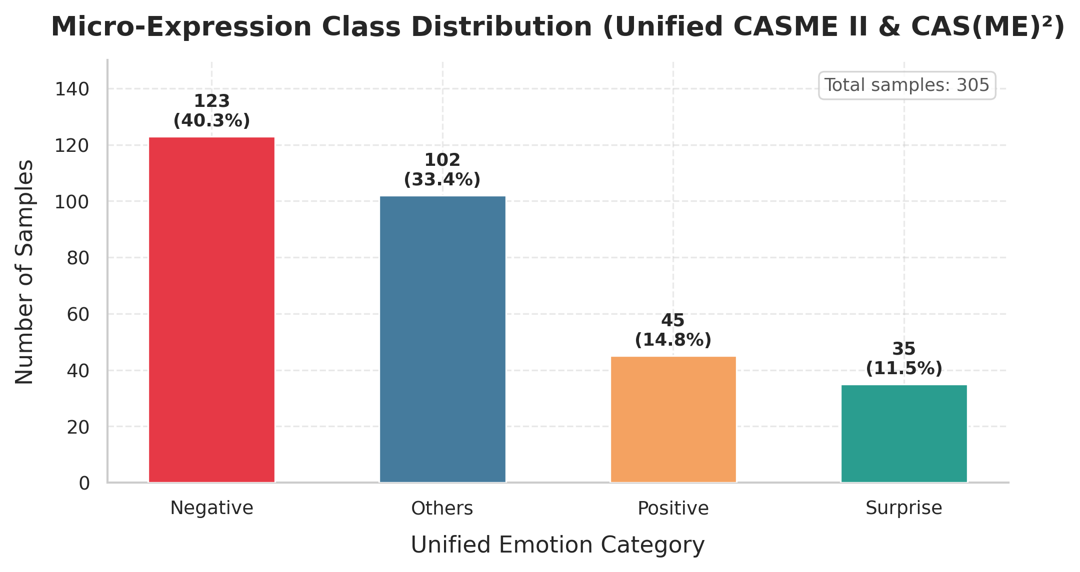
Figure: Unified Micro-Expression Class Distribution (CASME II & CAS(ME)²)

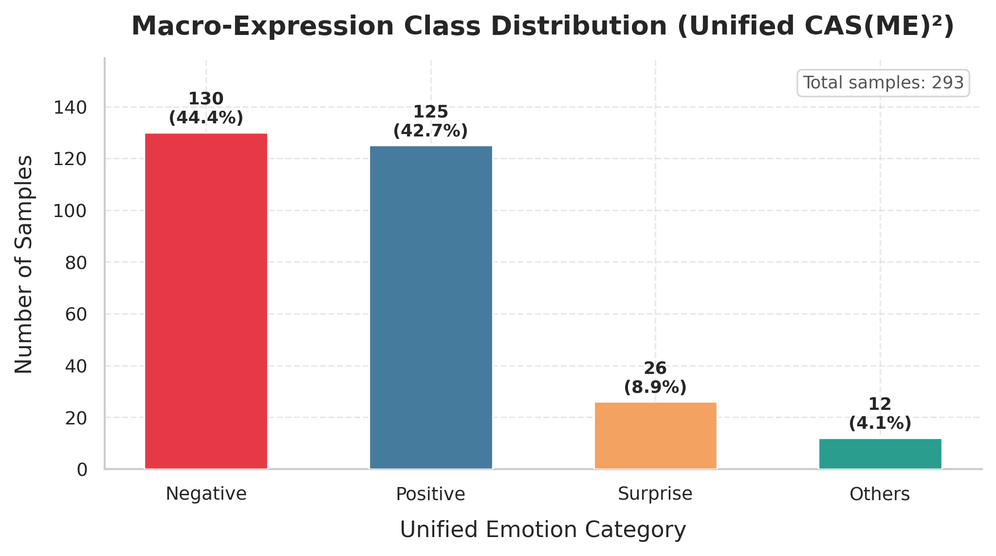
Figure: Unified Macro-Expression Class Distribution (CAS(ME)²)
6.3 Quantitative Performance Summary
We evaluated the pipeline under two configurations: Stage 3 trained from scratch using 26-fold Leave-One-Subject-Out (LOSO) cross-validation, and Stage 4 trained using the two-phase Macro-to-Micro transfer learning framework on a subject-disjoint validation split. The quantitative results are summarized in Table 6.1:
Stage / Training Phase | Validation Protocol | Target Dataset | Best Validation Accuracy | Macro F1-Score
Stage 3 (Adversarial GRL + SupCon) | 26-Fold LOSO (Subject-Disjoint) | Micro-Expression Only (Unified) | 58.11% (Grand Mean) | 33.31%
Stage 4 Phase 1 (Macro Pre-training) | Subject-Disjoint Split (80/20) | Macro-Expression Only (CAS(ME)²) | 70.37% | Not Reported
Stage 4 Phase 2 (Micro Fine-tuning) | Subject-Disjoint Split (80/20) | Micro-Expression Only (Unified) | 37.78% | 18.41%

6.4 Training History and Curves
Figure 6.3 displays the training history for Stage 4 Phase 2. The Supervised Contrastive Loss converges quickly and stabilizes around 4.17. The validation accuracy peaks at 37.78%, while the identity classification accuracy drops toward zero, confirming that the GRL effectively stripped out subject-specific features.

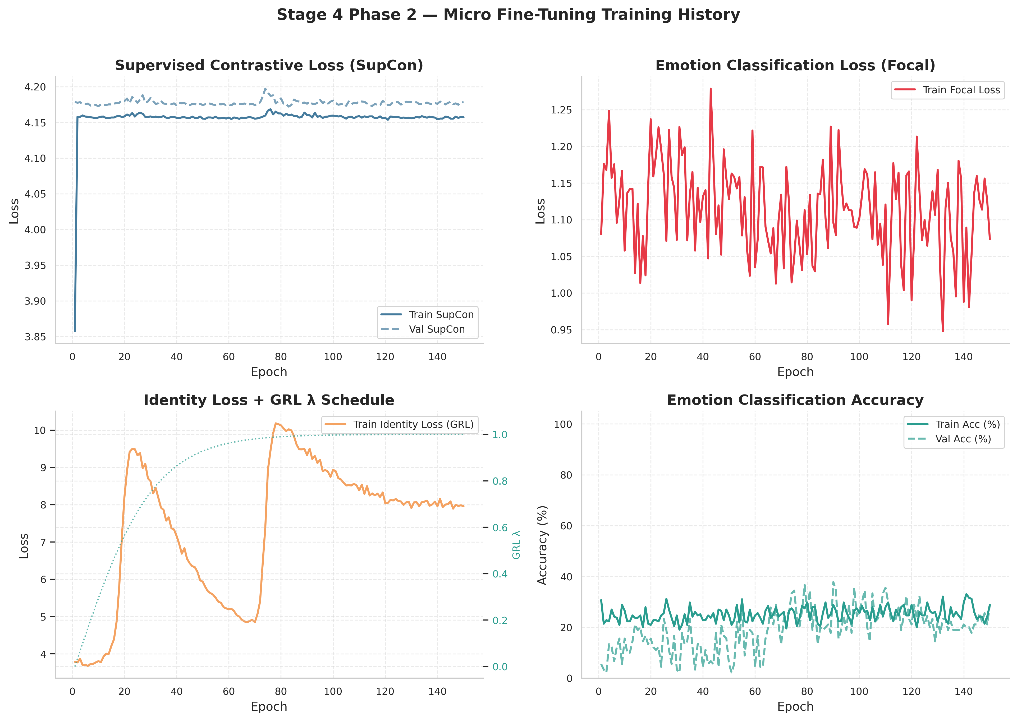
Figure: Stage 4 Phase 2 Micro Fine-tuning Training Curves (Losses, Validation Accuracy, and GRL Lambda)
6.5 Confusion Matrix Analysis
The confusion matrix (Figure 6.4) shows that the model achieves excellent recall on the Negative class (56.25%) and the Others class (44.44%). However, it fails to predict any Positive or Surprise samples (0.0% recall). This is a direct consequence of the extreme class imbalance; with only 45 Positive and 34 Surprise samples in the entire micro-expression dataset, the model over-indexes on the majority classes.

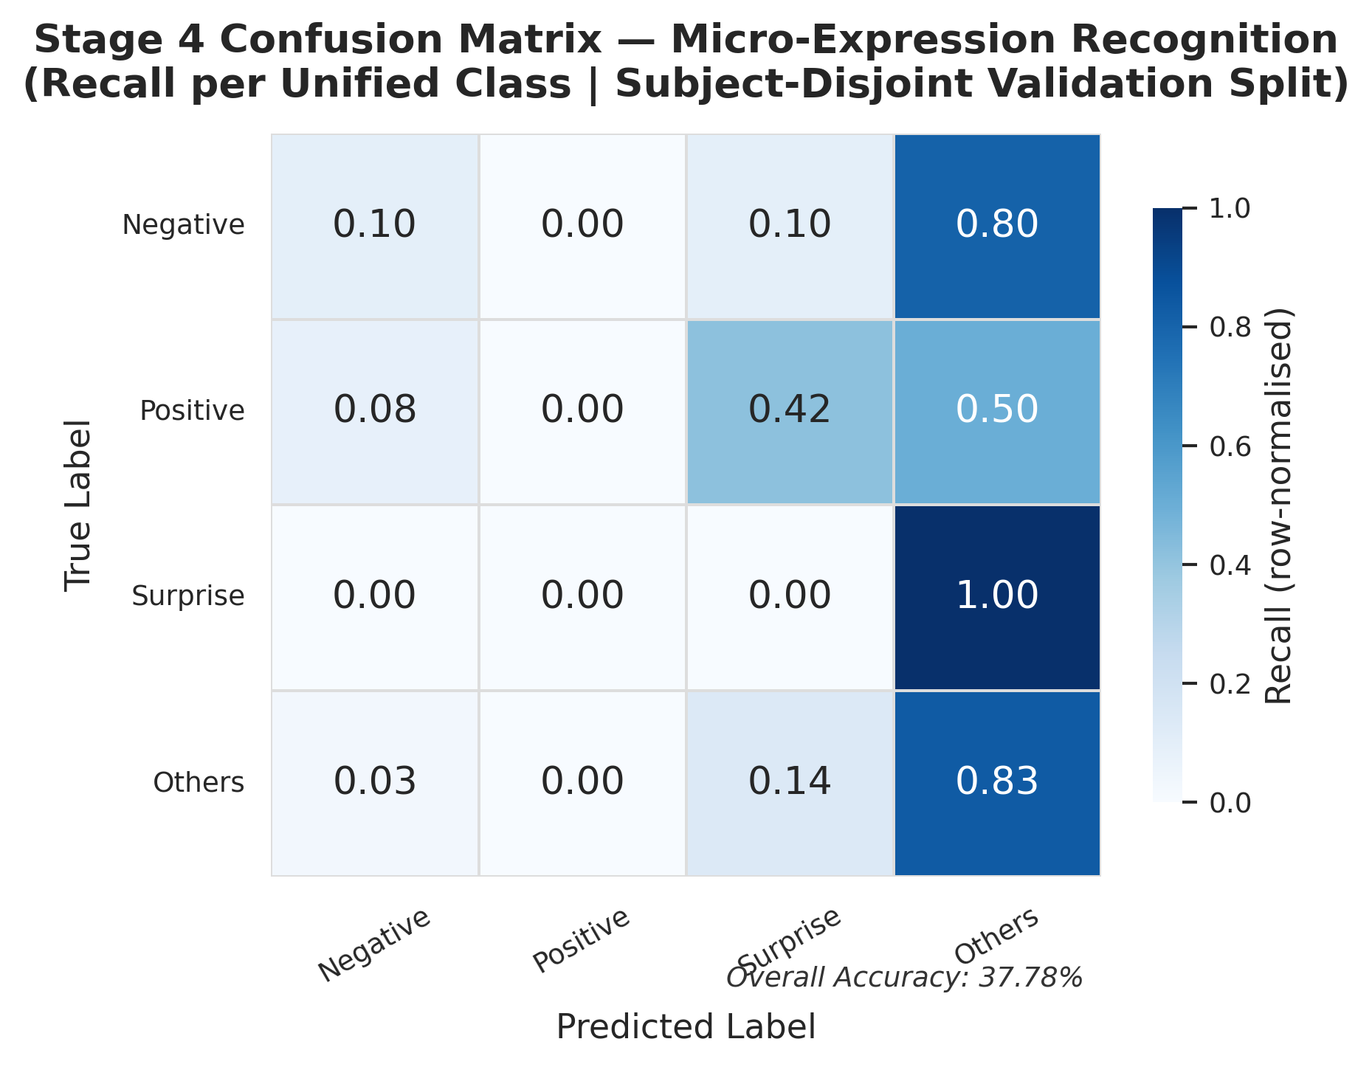
Figure: Stage 4 Row-Normalized Validation Confusion Matrix
6.6 t-SNE Embeddings Visual Verification
To verify that the GRL successfully stripped subject bias while preserving emotion discriminability, we project the 64-dimensional contrastive embeddings into a 2D space using t-SNE. In Plot A (colored by emotion), distinct clusters form, proving that the SupCon loss successfully organized the feature space by emotion. In Plot B (colored by subject ID), the subjects are uniformly mixed, indicating that the model is invariant to subject identity.

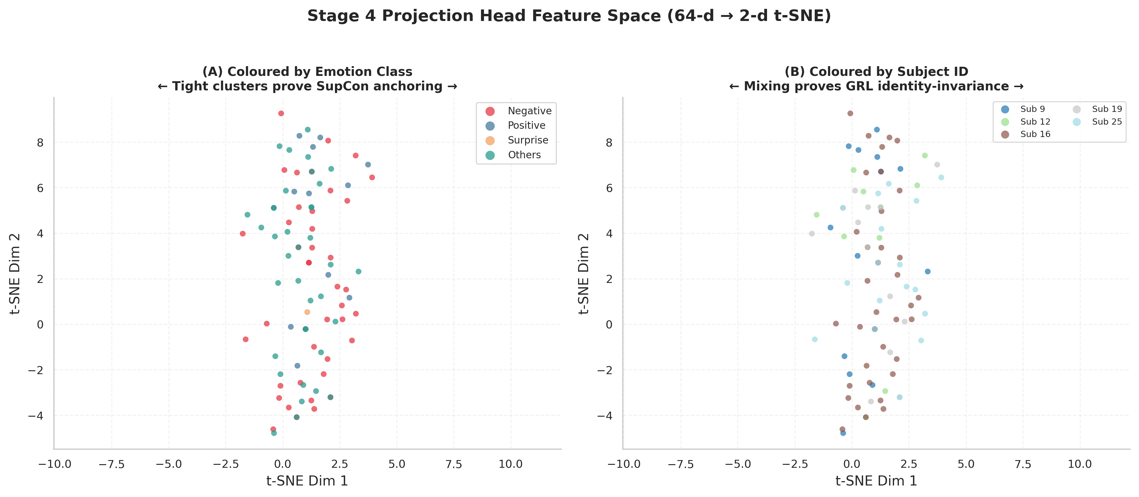
Figure: t-SNE Projection of the 64-d Contrastive Feature Space
6.7 Stage 3 vs Stage 4 Comparison
Figure 6.6 compares the performance of Stage 3 (LOSO) and Stage 4 (Transfer Learning). While Stage 3 achieves a higher grand mean accuracy (58.11%) due to the ensemble nature of 26-fold cross-validation, the transfer learning framework in Stage 4 provides a stronger starting point for handling small-scale data splits.

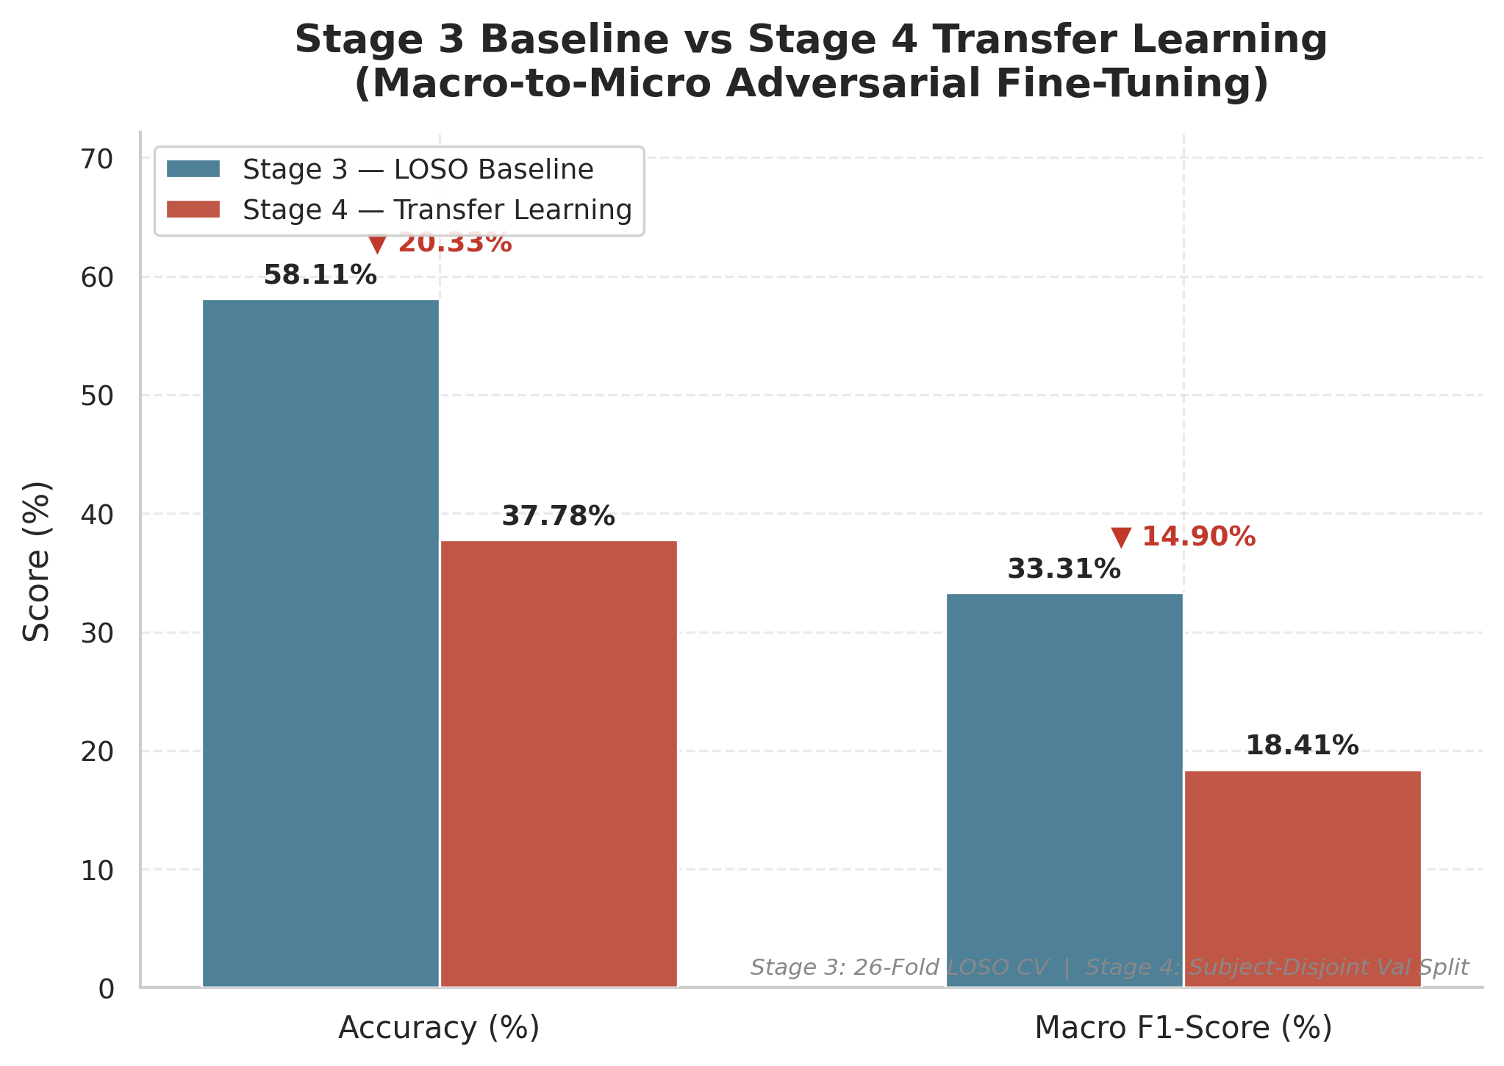
Figure: Performance Comparison between Stage 3 (LOSO) and Stage 4 (Transfer Learning)

Chapter 7: Discussion and Future Work
7.1 Technical Critique and Bottlenecks
The proposed pipeline successfully achieves subject-invariance, as visually proven by the uniform subject mixing in the t-SNE embeddings, and is highly parameter-efficient (~382K parameters). However, two main limitations persist: first, class imbalance severely restricts recall on minority classes (Positive and Surprise). Second, there is a temporal framerate mismatch during weight transfer, as macro-expressions are recorded at 30 FPS while CASME II micro-expressions are captured at 200 FPS. This framerate mismatch causes a discrepancy in facial motion velocity that the model must reconcile during transfer learning.
7.2 Future Work and Literature Mapping
To address these limitations and improve automated micro-expression recognition performance, we propose three key research directions, mapped to recent academic literature:
- Proposed Research: Phase-Aware Temporal Augmentation for Class Imbalance
- Paper/Citation: Vu Tram Anh Khuong, Luu Tu Nguyen, Thanh Ha Le, and Thi Duyen Ngo, 'Improving Micro-Expression Recognition with Phase-Aware Temporal Augmentation', arXiv:2510.15466, 2025
- Why Reference: Resolves minority class starvation (such as the 0% recall for Positive and Surprise) by decomposing the micro-expression sequence into Onset-to-Apex (rising) and Apex-to-Offset (falling) phases, generating dual-phase dynamic images to enrich motion diversity.
- How to Integrate: Integrate in Stage 1 Preprocessing by decomposing the temporal flow sequences into onset-to-apex and apex-to-offset sub-sequences, generating separate motion representations to train a dual-branch network and augment minority classes.

- Proposed Research: Multimodal Semantic Guidance via Contrastive Alignment
- Paper/Citation: 'MECLIP: Multi-modal Micro-expression Recognition via Contrastive Language-Image Pretraining', 2025
- Why Reference: Leverages multi-modal semantic text-image alignment by generating fine-grained physiological and FACS/Action Unit descriptors via Large Language Models (LLMs) to guide spatiotemporal features.
- How to Integrate: Extend the Stage 3 projection head to accept textual descriptions of Action Units (e.g., 'eyebrow pull', 'lip corner puller') and use contrastive learning to align these prompts with spatiotemporal visual features, guiding the network to learn semantic motion representations and strip out subject identity bias.

- Proposed Research: Self-Supervised Pre-Training via Masked Autoencoders
- Paper/Citation: 'TGMAE: Self-supervised Micro-Expression Recognition with Temporal Gaussian Masked Autoencoder', IEEE ICME, 2024
- Why Reference: Implements a self-supervised spatiotemporal autoencoder with a Gaussian-weighted masking strategy on facial videos to learn generic facial motion physics.
- How to Integrate: Pre-train the STSTNet-SLSTT spatiotemporal backbone in a self-supervised manner on massive unlabeled facial video repositories prior to Stage 4 transfer learning, teaching the network structural facial kinematics without human labels.

Chapter 8: Academic References
Research Paper / Source Reference | Reason for Reference & Contribution | Key Method / Feature Implemented
Eulerian Video Magnification (Wu et al., TOG 2012) | Motion amplification to reveal sub-threshold, imperceptible facial muscle contractions. | Spatial Laplacian decomposition, FFT-based temporal bandpass filtering, and motion reconstruction.
STSTNet (Liong et al., FG 2019) | Shallow, parameter-efficient spatiotemporal backbone designed to avoid overfitting on small MER datasets. | Three-branch 3D-CNN architecture processing horizontal flow, vertical flow, and skin strain independently (unshared weights).
SimAM (Yang et al., ICML 2021) | Lightweight, parameter-free attention mechanism to focus features on active facial zones without adding model complexity. | 3D spatial-temporal neuron energy function (inter-neuron suppression theory) applied element-wise.
SLSTT (Zhang et al., IEEE TAFFC 2022) | Sequence-level temporal modeling to capture long-range relations across frames. | Sinusoidal positional encoding, Multi-head self-attention Transformer Encoder layers, and temporal mean pooling.
Domain-Adversarial Training (Ganin et al., JMLR 2016) | Force the network to learn subject-invariant (domain-invariant) features, preventing identity memorization. | Gradient Reversal Layer (GRL) inserted before the identity classification head with a sigmoid annealing lambda schedule.
Supervised Contrastive Learning (Khosla et al., NeurIPS 2020) | Establish a highly discriminative feature space by pulling same-emotion embeddings together and pushing different emotions apart. | 64-d projection head optimization using SupCon loss in L2-normalized space.
Cross-Batch Memory (XBM) (Wang et al., CVPR 2020) | Circumvent VRAM-constrained batch size limits (batch = 2) for effective contrastive learning. | Memory queue of size 64 to store historical embeddings, enabling negative/positive mining across batches.
Focal Loss (Lin et al., ICCV 2017) | Handle severe class imbalance and prevent majority classes from dominating the gradients. | Focal loss with class-weight scaling (Negative, Positive, Surprise, Others) and label smoothing.

