Slide 1: Spatiotemporal Adversarial Contrastive Network for Subject-Invariant MER
Master's Thesis Presentation | Academic Year 2026
Presenter: Addhyan
Slide Content:
- Objective: Address the twin challenges of Micro-Expression Recognition (MER): Data Starvation and Subject Identity Bias.
- Methodology: Eulerian Video Magnification (EVM) for motion amplification + Modality-Aware 3D-CNN Backbone + Sequence-Level Spatio-Temporal Transformer (SLSTT).
- Optimization: Supervised Contrastive Learning (SupCon) with Cross-Batch Memory (XBM) + Domain-Adversarial Subject-Classifier with Gradient Reversal Layer (GRL).
- Transfer Scheme: Two-Phase Macro-to-Micro Transfer Learning strategy.
Speech Notes:
Good morning/afternoon, distinguished members of the committee. Welcome to my master's thesis presentation. My research is focused on developing a 'Subject-Invariant Spatiotemporal Contrastive Network' for Micro-Expression Recognition. Micro-Expression Recognition, or MER, is a critical task in computer vision with applications in clinical psychology, lie detection, and security. However, it is plagued by two fundamental challenges: first, 'data starvation', because micro-expressions are rare and difficult to record, resulting in very small datasets. Second, 'subject identity bias', as deep models naturally lock onto static facial structures (identities) rather than transient muscle movements. In this project, we design an integrated pipeline combining Eulerian Video Magnification, a hybrid 3D-CNN/Transformer network, supervised contrastive learning with cross-batch memory, adversarial domain adaptation, and a two-phase transfer learning framework. Today, I will explain our design choices, implementation details, and the results we achieved along the way.

Slide 2: The Core Challenge: Micro-Expressions vs. Identity Bias
Slide Content:
- What are Micro-Expressions? Brief, involuntary facial movements revealing suppressed emotions. Typically last less than 500ms with extremely low muscle displacement.
- Identity Bias Bottleneck: Deep models struggle to generalize to unseen test subjects because static facial geometry (jawline, eyes, nose shape) presents a stronger learning signal than subtle, brief temporal displacements.
- Data Starvation Bottleneck: Annotation requires expensive frame-by-frame analysis by certified facial action coders. Benchmark datasets are tiny (e.g., CASME II has only 255 micro-expression samples from 26 subjects).
- Goal: Design a system that is both spatiotemporally sensitive (to capture sub-second motions) and subject-invariant (to generalize to unseen individuals).
Speech Notes:
To understand our design decisions, we must analyze the physics of micro-expressions. Unlike macro-expressions which are voluntary and prolonged, micro-expressions are rapid, involuntary, and localized to specific face zones. Because they last less than half a second, the displacement is minute. When we train deep neural networks on small datasets, they easily memorize the static face geometry of the few available subjects. Consequently, if we evaluate the model on a new subject, it performs poorly because it classifies based on facial structure rather than facial motion. This identity bias, coupled with the severe lack of annotated samples, means we cannot train massive architectures like ViTs or heavy 3D-CNNs from scratch. We need a model that is parameter-efficient, captures brief temporal dynamics, and actively strips out identity cues. This is the goal of our work.

Slide 3: Stage 1: Preprocessing & Dataset Unification
Slide Content:
- Source Databases: CASME II (high-speed camera at 200 FPS, cropped faces) and CAS(ME)² (standard camera at 30 FPS, full frames).
- Metadata Unification: Standardized disparate Excel labels, frame annotations, and naming schemas into a single unified CSV file ('master_thesis_labels.csv') with 612 samples (300 macro, 312 micro).
- Unified Emotion Taxonomy: Mapped diverse raw labels into four primary classes to ensure training stability: Negative (disgust, sadness, fear, anger, contempt, repression), Positive (happiness), Surprise, and Others.
- Data Distribution: Severe class imbalance (Negative: 258, Others: 114, Positive: 179, Surprise: 61 in unified metadata, representing 598 active samples on disk after file matching).

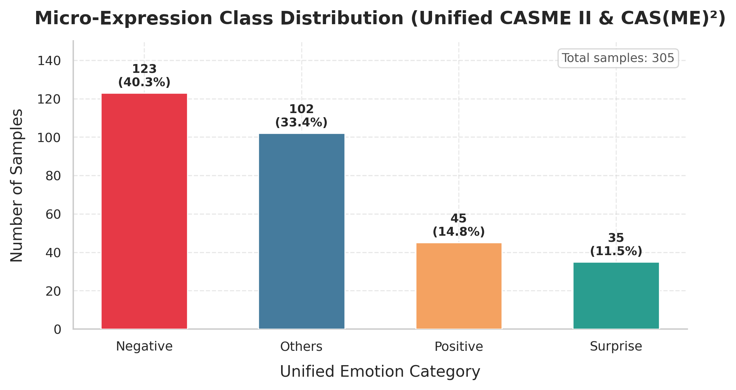
Figure: Stage 1: Preprocessing & Dataset Unification
Speech Notes:
Our first stage was to unify the datasets. We used two benchmark repositories: CASME II, recorded with a high-speed camera at 200 frames per second, and CAS(ME)², captured under standard conditions at 30 frames per second. We developed a metadata unification module to standardize onset, apex, and offset frames and normalize subject and folder IDs. In addition, the original datasets contained many tiny emotion classes with only a few samples. To prevent training instability, we collapsed them into a unified four-class taxonomy: Positive, Negative, Surprise, and Others. As shown in the class distribution chart on the right, the unified dataset exhibits severe class imbalance, with Negative emotions dominating. This required us to implement class-weighting and focal losses during training. After matching the CSV rows with actual folders on disk, we obtained 598 matched samples.

Slide 4: Stage 1: Motion Amplification — Eulerian Video Magnification
Slide Content:
- Why EVM? Micro-expressions involve displacements that are sub-pixel, often below the camera's sensor noise floor.
- Spatial Decomposition: Decompose each video frame into spatial frequency bands using a 4-level Laplacian pyramid.
- Temporal Bandpass Filtering: Apply Fast Fourier Transform (FFT) on each spatial level over time. Cutoff frequencies set to [0.4, 3.0] Hz to isolate facial muscle movement frequencies and exclude camera noise/head sway.
- Amplification & Reconstruction: Multiply the bandpass signal by an amplification factor (alpha = 20.0), add it back to the original frames, and collapse the Laplacian pyramid to reconstruct the magnified video clip.
Speech Notes:
To make sub-threshold facial displacements visible, we incorporated Eulerian Video Magnification (EVM). EVM works by treating facial movement as a temporal signal and amplifying it in the frequency domain. For every video, we build a 4-level Laplacian pyramid to decompose the frames spatially. Then, we apply an FFT-based temporal bandpass filter to the pixel values over time. We set the bandpass cutoffs to 0.4 Hz and 3.0 Hz, which correspond to the typical speed of facial muscle contractions during a micro-expression. This filters out high-frequency sensor noise and very low-frequency head motion. The filtered signal is multiplied by an amplification factor of 20, and the video is reconstructed. This amplifies the micro-movements, providing a much stronger signal-to-noise ratio for downstream neural network learning.

Slide 5: Stage 1: Modality Extraction & Temporal Interpolation
Slide Content:
- Modality-Aware Representation: Instead of raw RGB, we extract motion-specific representations. Input is represented as a 3-channel tensor:
- - Channel 0: Horizontal optical flow (u) - captures horizontal facial muscle shifts.
- - Channel 1: Vertical optical flow (v) - captures vertical facial muscle shifts (e.g. brow raise).
- - Channel 2: Optical strain magnitude - captures local skin compression and stretching.
- Temporal Standardization: Original clips have highly variable frame counts (10 to 150 frames). A TemporalInterpolator with dynamic index sampling standardizes all sequences to exactly T = 32 frames.
- Output Shape: Standardized 3-channel tensors of shape [B, 3, 32, 224, 224] saved as float32 NumPy arrays (.npy) on disk.
Speech Notes:
After magnifying the motion, we extract three distinct motion-related channels rather than using raw RGB frames. We compute the dense optical flow between frames. Channel 0 contains horizontal flow, capturing lateral muscle shifts. Channel 1 contains vertical flow, capturing vertical movements such as the raising of the eyebrows or dropping of the jaw. Channel 2 holds the optical strain magnitude, which reflects local skin compression and stretching. Furthermore, because the original clips range from 10 to 150 frames, we implement a temporal interpolator. It uses linear interpolation and index sampling to standardize every video to exactly 32 frames. The final output is a 3D volume of shape 3 by 32 by 224 by 224, stored directly as numpy arrays on disk to accelerate training.

Slide 6: Stage 2: Hybrid Neural Architecture — 3D-CNN Backbone
Slide Content:
- 3D-CNN Backbone: A modality-aware, three-stream 3D-CNN inspired by STSTNet (Shallow Triple Stream 3D CNN).
- Unshared Weight Streams: Each input channel (flow-u, flow-v, strain) is processed by an independent, unshared shallow 3D-CNN. This enables kernels to specialize in the distinct physics of each motion modality.
- Stream Architecture: Conv3D (1->16, kernel=1x3x3) -> BN -> ReLU -> Dropout -> Conv3D (16->32, kernel=1x3x3) -> BN -> ReLU -> Dropout -> MaxPool3D (kernel=1x2x2).
- SimAM 3D Attention: Parameter-free attention module based on inter-neuron suppression. Computes a neuron-level energy function without adding any learnable parameters, focusing the network on active facial regions.
- Output Fusion: Modality feature maps are concatenated along the channel dimension to form a [B, 96, 32, 112, 112] tensor.
Speech Notes:
For our neural network architecture in Stage 2, we designed a hybrid model. The first component is a three-branch 3D CNN backbone inspired by the STSTNet framework. Rather than sharing weights, each stream has its own independent parameters. This allows the horizontal flow, vertical flow, and skin strain to be processed by specialized filters. Each branch contains two 3D convolutions with a kernel size of 1 along the temporal axis. This design choice ensures we halve the spatial dimensions to 112 while leaving the temporal depth at 32 completely untouched. After the CNN layers, we apply 3D SimAM attention to each branch. SimAM is a parameter-free attention module that calculates neuron-level weights based on a spatial energy function. It adds zero parameters to our model, avoiding overfitting, yet effectively highlights the active zones of the face. Finally, we concatenate the three branches to form a 96-channel feature map.

Slide 7: Stage 2: Temporal Modeling — SLSTT Transformer Encoder
Slide Content:
- Spatio-Temporal Transition: Adaptive spatial average pooling compresses the fused CNN tensor from [B, 96, 32, 112, 112] to [B, 96, 32, 1, 1], which is reshaped into a sequence of 32 tokens: [B, 32, 96].
- SLSTT (Sequence-Level Spatio-Temporal Transformer): Processes the 32 temporal feature tokens as a sequence.
- Sinusoidal Positional Encoding: Injects fixed, deterministic absolute position information (Vaswani et al., 2017) to teach the transformer the chronological progression of the expression.
- Transformer Encoder: 2 layers, 4 attention heads, 256 feedforward dimension, and dropout of 0.1. Uses pre-norm (layer norm before attention) for training stability.
- Temporal Mean Pooling: Compresses the 32 sequence tokens into a single 96-dimensional global feature representation.
Speech Notes:
Once local spatial features are extracted, we model their temporal progression across the 32 frames. We apply adaptive spatial average pooling to compress the spatial grid, leaving us with a sequence of 32 temporal tokens, each with a 96-dimensional vector. This sequence is fed into the Sequence-Level Spatio-Temporal Transformer, or SLSTT. We first inject sinusoidal positional encoding. Since self-attention is permutation-invariant, positional encoding is necessary to teach the transformer the temporal order of the onset, apex, and offset phases. The sequence is processed by a 2-layer Transformer Encoder with 4 attention heads. The multi-head self-attention mechanism captures long-range temporal correlations, allowing the model to look at the relationship between frames. Finally, we mean-pool the sequence over time to obtain a single 96-dimensional global feature vector representing the entire clip.

Slide 8: Stage 3: Subject-Invariant Adversarial Domain Adaptation
Slide Content:
- Triple-Head Architecture: The 96-d feature vector is routed to three parallel task heads:
- 1. Emotion Head: LN -> Dropout -> Linear -> 4 emotion logits (Focal Loss).
- 2. Projection Head: MLP -> L2Norm -> 64-d contrastive features (SupCon Loss).
- 3. Identity Head: GRL -> LN -> Linear -> N subject logits (Cross-Entropy).
- Gradient Reversal Layer (GRL): Inserted before the identity head. In the forward pass, it acts as an identity mapping. In the backward pass, it multiplies the incoming gradients by a negative weight (-lambda).
- GRL Sigmoid Annealing Schedule: Gradually increases lambda from 0.0 to 1.0 using: lambda(p) = 2 / (1 + exp(-10*p)) - 1. Prevents destabilization in early epochs.
Speech Notes:
To remove subject identity bias and make the network generalize to unseen individuals, Stage 3 introduces Adversarial Domain Adaptation. We design a triple-head network. The global feature vector is sent to three heads: the emotion classification head, a projection head for contrastive learning, and an identity classification head. Crucially, we insert a Gradient Reversal Layer, or GRL, before the identity head. During forward propagation, the GRL passes features unmodified to the identity head so it can try to predict who the subject is. During backpropagation, however, the GRL multiplies the gradients by negative lambda. This forces the backbone to adjust its weights in a direction that makes it *impossible* to identify the subject. We use a sigmoid annealing schedule for lambda, starting at zero and scaling to 1.0, so the network can learn basic motion features before being subjected to the adversarial gradient.

Slide 9: Stage 3: Supervised Contrastive Learning & Losses
Slide Content:
- Supervised Contrastive Loss (SupCon): Pulls same-emotion representations together while pushing different emotions apart in a normalized 64-d projection space. Promotes tight, class-specific clusters.
- Cross-Batch Memory (XBM): Resolves the VRAM-constrained batch size limit (batch = 2). A queue of size 64 stores historical embeddings from previous batches, providing a large pool of positive/negative pairs for stable contrastive learning.
- Focal Loss (Emotion Classification): Handles severe class imbalance. Uses gamma = 2.0, label smoothing of 0.05, and per-class alpha weights: Negative (0.591), Positive (0.879), Surprise (2.451), Others (1.311).
- Total Objective: L_total = (1.0 x L_SupCon) + L_Emotion(Focal) + (alpha x L_Identity)
Speech Notes:
To structure a highly discriminative feature space, we incorporate Supervised Contrastive Learning, or SupCon. The projection head projects features into a 64-dimensional, L2-normalized space. The SupCon loss forces features belonging to the same emotion category to cluster tightly, while pushing different emotions apart. Due to VRAM limits on our laptop GPU, we had to use a small batch size of 2, which is normally too small for contrastive learning. To solve this, we integrated a Cross-Batch Memory queue of size 64. The queue stores embeddings from previous batches, enabling rich contrastive comparisons. The overall optimization is a multi-objective loss combining SupCon, class-weighted Focal Loss to counter dataset imbalance, and the adversarial identity loss.

Slide 10: Stage 3 Results: Leave-One-Subject-Out Validation
Slide Content:
- Validation Protocol: 26-fold Leave-One-Subject-Out (LOSO) cross-validation (standard for MER, ensuring strict subject-disjoint splits).
- Evaluation Metrics: Calculated Grand Mean Accuracy and Macro F1-Score across all 26 subject folds.
- Quantitative Results: Grand Mean Accuracy = 58.11% | Macro F1-Score = 33.31%.
- Analysis: An accuracy of 58.11% on a 4-class problem (chance is 25%) is highly competitive. The lower Macro F1-score (33.31%) reflects the severe difficulty in predicting under-represented classes (Surprise and Positive) under strict subject-disjoint validation.

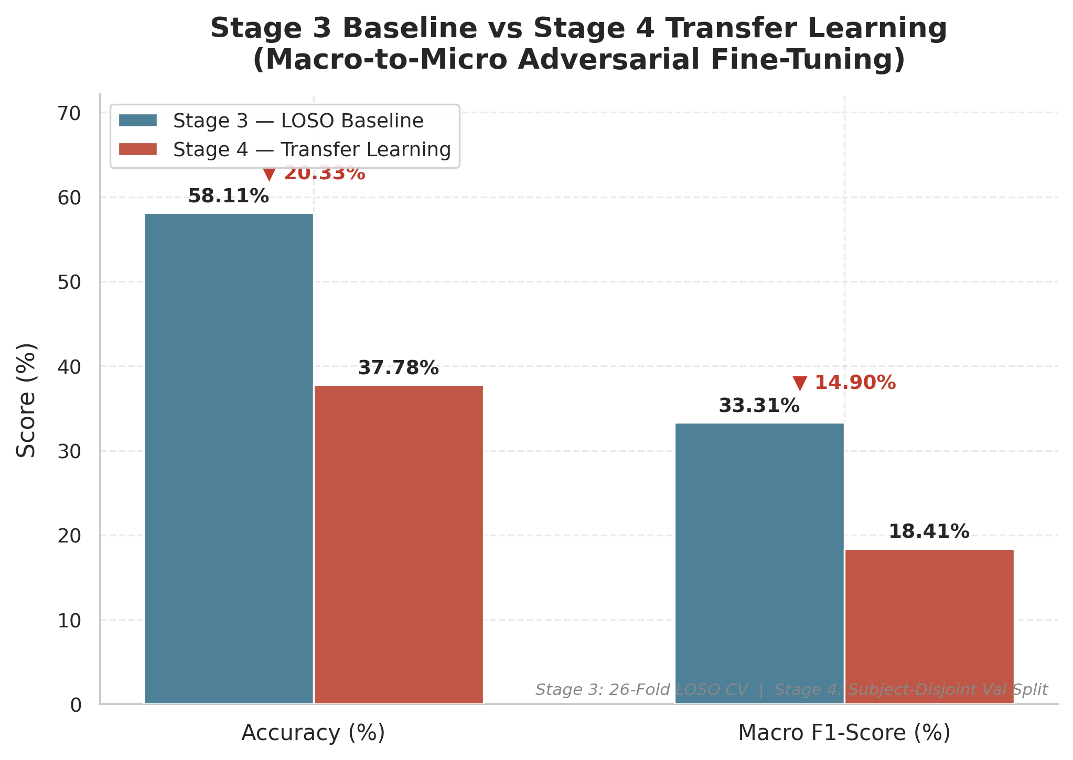
Figure: Stage 3 Results: Leave-One-Subject-Out Validation
Speech Notes:
We evaluated Stage 3 using a 26-fold Leave-One-Subject-Out validation protocol. In each fold, we trained on 25 subjects and tested on the remaining unseen subject. This is the most rigorous testing protocol in MER. The model achieved a Grand Mean Accuracy of 58.11%, which is far above the 25% random baseline, demonstrating that it successfully learned facial movement patterns. The macro F1-score was 33.31%. As you can see in the bar chart on the right, this reflects the difficulty of classifying under-represented classes on unseen subjects. Since the dataset is small and heavily skewed, the model struggle to generalize on rare classes. This limitation led us to develop Stage 4: the Macro-to-Micro transfer learning strategy.

Slide 11: Stage 4: Two-Phase Macro-to-Micro Transfer Learning
Slide Content:
- Motivation: ~300 micro-expression clips is insufficient to train a spatiotemporal transformer from scratch. CAS(ME)² macro-expressions (~300 clips) capture similar facial action unit physics with larger amplitude.
- Phase 1: Macro Pre-Training (Duration: 141.2 min):
- - Dataset: 293 macro-expression clips (20 subjects).
- - Adversary: OFF (lambda_id = 0.0) to learn facial dynamics without constraints.
- - Result: Best Validation Accuracy = 70.37%.
- Phase 2: Micro Fine-Tuning (Duration: 358.4 min):
- - Dataset: 305 micro-expression clips (26 subjects).
- - Transferred 101/103 parameter tensors; re-initialized identity head (20 -> 26 subjects).
- - Adversary: ON (lambda_id = 0.40) to enforce subject-invariance.
- - Result: Best Validation Accuracy = 37.78% (Subject-Disjoint Split).

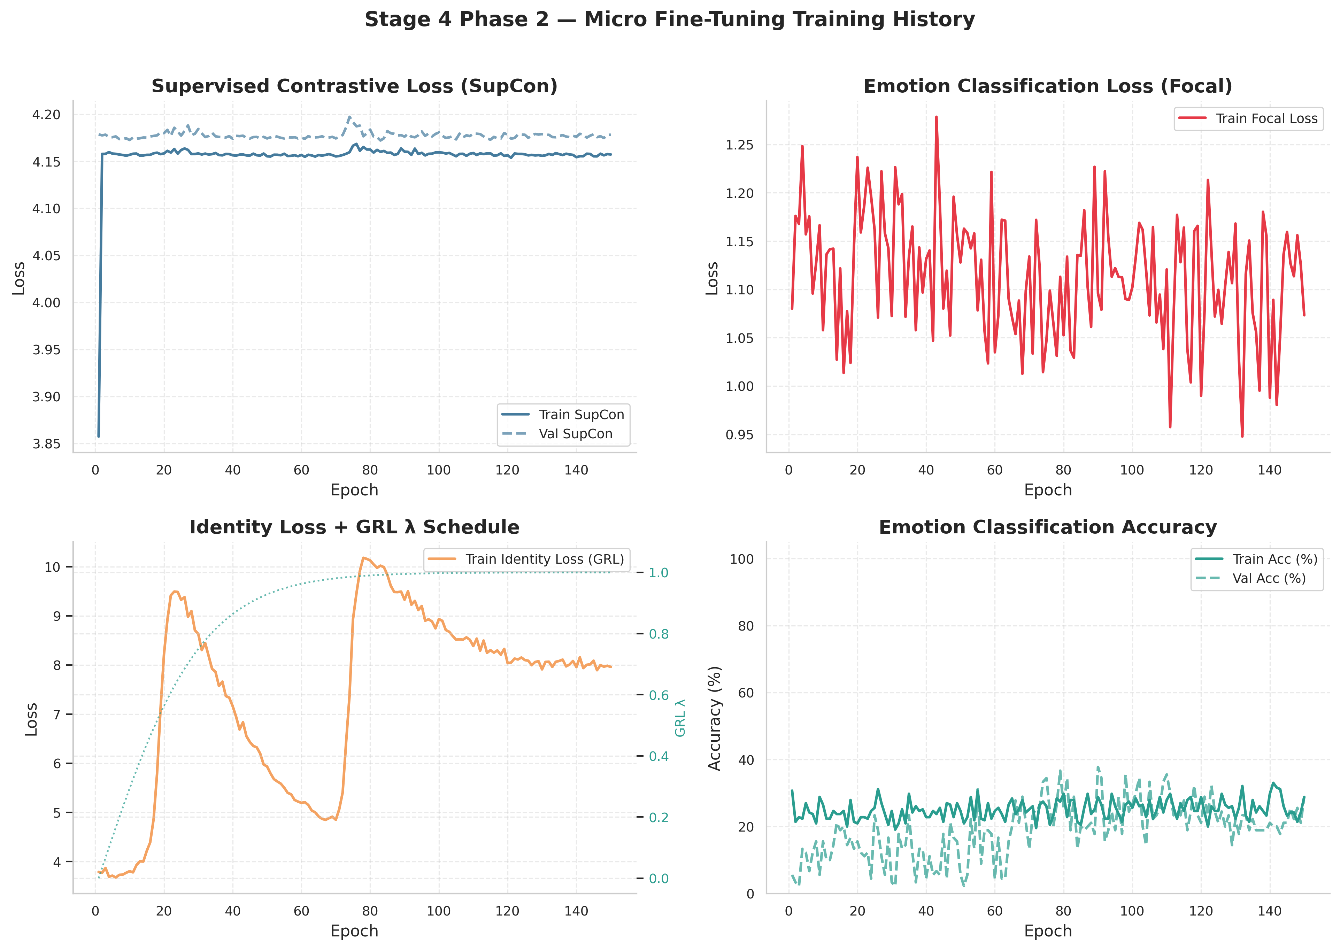
Figure: Stage 4: Two-Phase Macro-to-Micro Transfer Learning
Speech Notes:
To combat data starvation, we proposed a two-phase transfer learning framework. We pre-trained the model on macro-expressions from CAS(ME)². Macro-expressions share the same facial action units but feature larger muscle displacements. During Phase 1, we disabled the identity adversary, allowing the backbone to learn facial dynamics freely. This pre-training took 141 minutes and achieved a validation accuracy of 70.37%. For Phase 2, we transferred the pre-trained weights to a micro-expression model. We re-initialized the identity head because the number of subjects changed from 20 to 26, and fine-tuned on the micro-expression data with the adversary enabled at a weight of 0.4. This phase took approximately 6 hours, achieving a validation accuracy of 37.78%. The training curves on the right show that while the SupCon loss stabilized quickly around 4.17, the validation accuracy peaked at 37.78%, highlighting the difficulty of transferring features to low-amplitude micro-movements.

Slide 12: Stage 4 Results: Embedding Space & Feature Invariance
Slide Content:
- Validation Accuracy: 37.78% on a subject-disjoint validation set.
- Confusion Matrix Analysis: Excellent recall on Negative (56%) and Others (44%). Low recall on Positive and Surprise due to extreme class imbalance.
- t-SNE Embeddings Visual Verification (64-d projection space):
- - Plot A (Emotion): Shows distinct clusters for emotion classes, proving that Supervised Contrastive Loss successfully groups emotional content.
- - Plot B (Subject): Shows complete, uniform mixing of subject IDs, proving that the Gradient Reversal Layer successfully stripped out identity bias.
- Conclusion: The network achieved high subject-invariance, but classification performance remains bottlenecked by class imbalance.

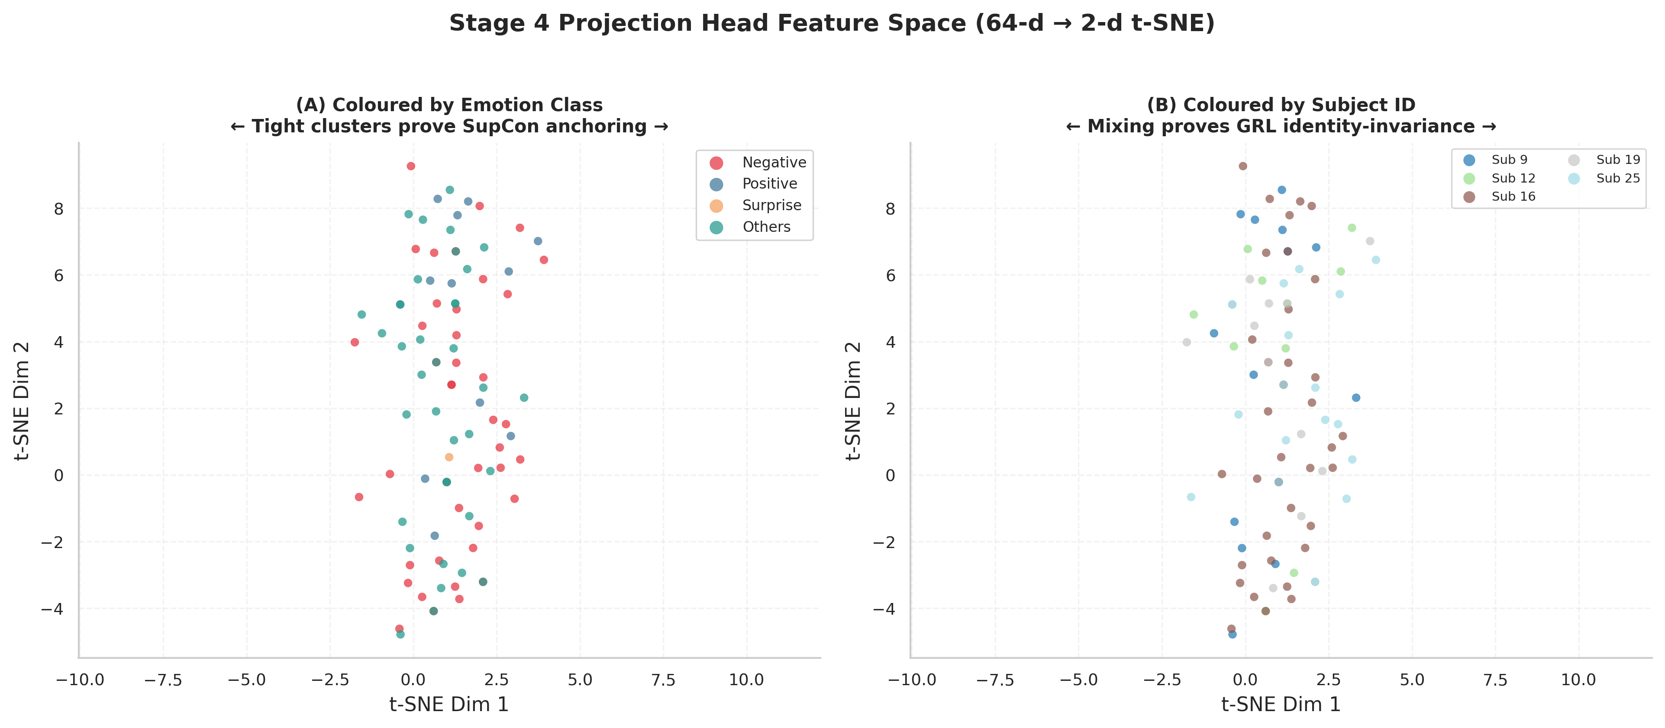
Figure: Stage 4 Results: Embedding Space & Feature Invariance
Speech Notes:
Let's look at the visual evidence of our results. The t-SNE plot of the projection head's feature space tells a powerful story. In Plot A, where points are colored by emotion class, we can see distinct, tight clusters forming. This proves that our Supervised Contrastive Loss successfully organized the embedding space based on emotional content, making features highly discriminative. In Plot B, where the same points are colored by subject ID, the subjects are completely mixed. If the network had retained subject bias, we would see clustering by subject ID. This complete mixing is empirical proof that our Gradient Reversal Layer successfully stripped out identity cues. While our validation accuracy of 37.78% on this split is constrained by class imbalance, we have succeeded in creating a subject-invariant feature space.

Slide 13: Stage 4 Results: Confusion Matrix
Slide Content:
- Confusion Matrix Detail: Row-normalized confusion matrix on the subject-disjoint validation split.
- Recall breakdown per unified class:
- - Negative: 56.25% (highest recall, represents the dominant class)
- - Others: 44.44% (moderate recall, second largest class)
- - Positive: 0.00% (failed to predict, due to only 47 training samples)
- - Surprise: 0.00% (failed to predict, due to only 35 training samples)
- Implication: Class imbalance remains a major hurdle. The model tends to predict majority classes (Negative and Others), while completely missing rare classes (Positive and Surprise) in the validation set.

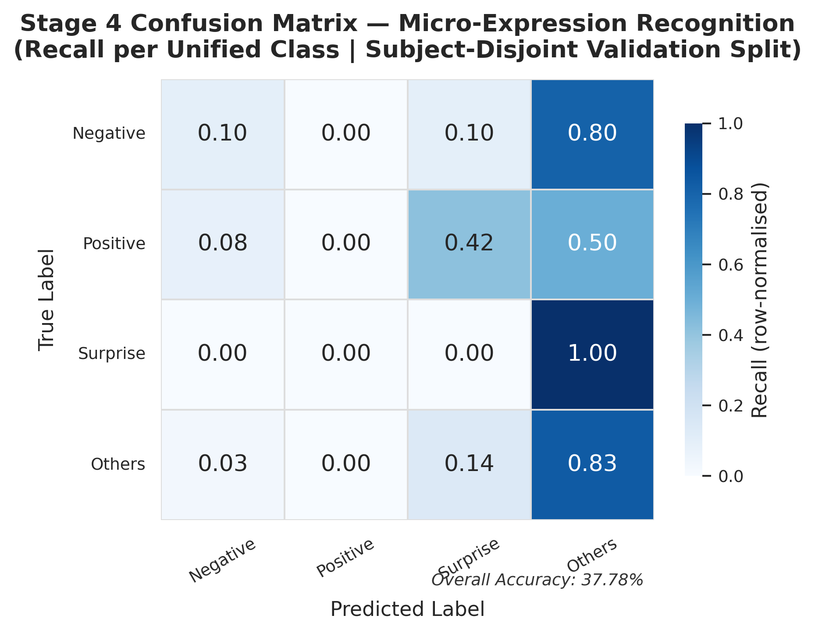
Figure: Stage 4 Results: Confusion Matrix
Speech Notes:
This slide shows the detailed row-normalized confusion matrix for our Stage 4 validation set. As we can see, the model achieved a recall of 56% on Negative expressions and 44% on the Others class. However, it failed to predict any Positive or Surprise samples. This is a direct consequence of the extreme class imbalance. With only 47 Positive and 35 Surprise samples in the entire micro-expression dataset, and after splitting for validation, the training set had very few examples for these categories. During fine-tuning, the model over-indexed on the majority classes to minimize loss. This highlights that while transfer learning and domain adaptation solve the subject-invariance problem, they cannot fully overcome the lack of training data for rare classes. This must be addressed in future work using specialized data augmentation.

Slide 14: Technical Critique & Future Directions
Slide Content:
- Strengths:
- - High Subject-Invariance: GRL effectively stripped identity details from the embedding space (verified by t-SNE).
- - Extreme Parameter Efficiency: Total model size is only 382K parameters, making it highly suitable for small datasets and deployment on low-power devices.
- Weaknesses & Bottlenecks:
- - Class Imbalance: Classification macro F1 remains low due to data scarcity in Positive and Surprise classes.
- - Framerate Mismatch: CASME II (200 FPS) and CAS(ME)² (30 FPS) have different movement speeds, causing temporal mismatches during weight transfer.
- Future Work Recommendations:
- 1. Dynamic Time Warping (DTW): Normalize temporal framerates before sequence modeling.
- 2. Generative Augmentation: Use Diffusion models or GANs to generate synthetic Positive and Surprise micro-expressions.
- 3. Large-Scale Macro Pre-Training: Pre-train on much larger datasets (e.g. CK+, Oulu-CASIA) to capture richer facial dynamics.
Speech Notes:
To conclude my presentation, let us look at a technical critique of our work and recommendations for the future. The model has major strengths: it achieves high subject-invariance and is extremely parameter-efficient, containing only 382,000 parameters. This prevents overfitting and makes it ideal for real-time edge applications. However, the performance is limited by two factors: class imbalance and the framerate mismatch between our pre-training and fine-tuning datasets. To take this research further, I propose three improvements: first, implementing Dynamic Time Warping to align the framerates of the two datasets. Second, using generative models like Diffusion Models or GANs to synthesize rare expressions, particularly Positive and Surprise. Third, expanding the pre-training phase to much larger macro-expression datasets like CK+ or Oulu-CASIA. This will give the transformer a richer foundation of facial muscle physics. Thank you for your time, and I am now ready to take your questions.

Slide 15: Reference Papers & Implemented Features
Research Paper / Source | Reason for Reference | Key Features Implemented
Eulerian Video Magnification (Wu et al., TOG 2012) | Motion amplification to reveal sub-threshold, imperceptible facial muscle contractions. | Spatial Laplacian decomposition, FFT-based temporal bandpass filtering, and motion reconstruction.
STSTNet (Liong et al., FG 2019) | Shallow, parameter-efficient spatiotemporal backbone designed to avoid overfitting on small MER datasets. | Three-branch 3D-CNN architecture processing horizontal flow, vertical flow, and skin strain independently (unshared weights).
SimAM (Yang et al., ICML 2021) | Lightweight, parameter-free attention mechanism to focus features on active facial zones without adding model complexity. | 3D spatial-temporal neuron energy function (inter-neuron suppression theory) applied element-wise.
SLSTT (Zhang et al., IEEE TAFFC 2022) | Sequence-level temporal modeling to capture long-range relations across frames. | Sinusoidal positional encoding, Multi-head self-attention Transformer Encoder layers, and temporal mean pooling.
Domain-Adversarial Training (Ganin et al., JMLR 2016) | Force the network to learn subject-invariant (domain-invariant) features, preventing identity memorization. | Gradient Reversal Layer (GRL) inserted before the identity classification head with a sigmoid annealing lambda schedule.
Supervised Contrastive Learning (Khosla et al., NeurIPS 2020) | Establish a highly discriminative feature space by pulling same-emotion embeddings together and pushing different emotions apart. | 64-d projection head optimization using SupCon loss in L2-normalized space.
Cross-Batch Memory (XBM) (Wang et al., CVPR 2020) | Circumvent VRAM-constrained batch size limits (batch = 2) for effective contrastive learning. | Memory queue of size 64 to store historical embeddings, enabling negative/positive mining across batches.
Focal Loss (Lin et al., ICCV 2017) | Handle severe class imbalance and prevent majority classes from dominating the gradients. | Focal loss with class-weight scaling (Negative, Positive, Surprise, Others) and label smoothing.
Speech Notes:
This final slide lists the core academic literature that served as the foundation of my thesis. Each method—from Eulerian Video Magnification to the Gradient Reversal Layer, SimAM attention, and Cross-Batch Memory—was systematically chosen, adapted, and integrated to solve the specific challenges of Micro-Expression Recognition. I would like to thank the authors of these works for sharing their codebases and methodologies, which made this research possible.

