CSCI 340:

Database Design

Spring 2024 Syllabus

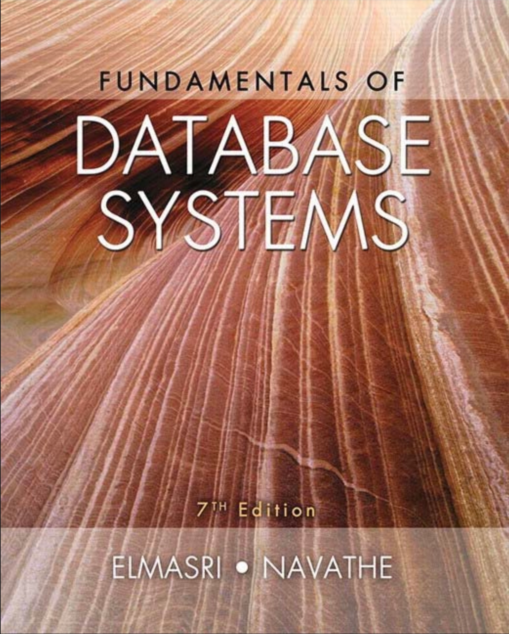

Databases are an essential and ubiquitous part of everyday life, and many of our day-to-day tasks involve the use of an underlying database in some form or another. As computer scientists, it is critical that we understand fundamental concepts of databases and database management systems (DBMS), including how they are designed, implemented, queried, and maintained. In this class, we will learn about data modeling, relational models, normal forms, file organization, index structures, SQL, and PHP. Throughout the course, students will work on a project that involves the design and implementation of a web-accessible database using PHP and MySQL.

## Administrative

*Instructor*: Addison Boyer | addison.boyer@umontana.edu | **TBD**

*Office hours*: By appointment only (**TBD**).

*Prerequisites*: CSCI 232. Prerequisites will be waived only for students that can demonstrate clear mastery of CSCI232, or in special circumstances those who are taking CSCI232 as a corequisite. Students taking this course without the prerequisite or corequisite course do so at their own risk, it is not the instructor’s responsibility to get you up to on the topics covered in that class.

*Textbook, Software and Course Material*: [Fundamentals of Database Systems Seventh Edition by Ramez Elmasri & Shamkant B. Navathe](https://www.amazon.com/Fundamentals-Database-Systems-Ramez-Elmasri/dp/0133970779/ref=tmm_hrd_swatch_0?_encoding=UTF8&dib_tag=se&dib=eyJ2IjoiMSJ9.osmN84SAp-z6ol-dE6uGQlHJd5Yu4-u97M5t_rU8HDnGjHj071QN20LucGBJIEps.IL8MYuOer0qC9iEveCcJfOp92MPFZuD8TAaRPn7dvtg&qid=1705580594&sr=8-5)

*Software:* For this course we will use a LAMP (Linux, Apache, MySQL, and PHP) stack to implement the semester long database project. Guide for installing LAMP stack locally using Ubuntu [here](https://www.digitalocean.com/community/tutorials/how-to-install-linux-apache-mysql-php-lamp-stack-on-ubuntu-22-04). Class lectures will be recorded using [Microsoft Teams](https://www.microsoft.com/en-us/microsoft-teams/download-app). Code and class exercises will be source controlled using [Git](https://www.git-scm.com/downloads) (please clone [this repository](https://github.com/addiboyer24/CSCI340_DatabaseDesign) on [GitHub](https://github.com/) to your local machine).

## Meeting Times and Places

*Lecture:* Tuesday and Thursday | 12:00 p.m. – 1:20 p.m. |Social Science 362 | *Attendance strongly encouraged*

*Final Exam:* Friday May 10th, 2024, | 8:00 a.m. – 10:00 a.m. | Social Science 362

## Learning Outcomes

# Upon successful completion of this class, students should be proficient with the following:

* Database system terminology, concepts, and architecture.
* Database design, including requirements specification, and ER modeling.
* Relational data model concepts, schemas, and constraints.
* Functional dependencies, and the process of normalization.
* Programming in SQL, PHP, and MySQL.
* File organizations, including single and multi-level indexing structures.

## Topics Covered (Tentative)

1. Databases and Database Users (January 18th - 25th).

2. Database System Concepts and Architecture (January 30th - February 1st).

3. Data Modeling Using the Entity–Relationship (ER) Model (February 6th - 15th).

4. The Enhanced Entity–Relationship (EER) Model (February 20th – 22nd).

5. Relational Data Model and Relational Database Constraints (February 27th).

6. Basic SQL (February 29th).

**Quiz 1 (February 29th in Class)**

7. More SQL: Complex Queries, Triggers, Views, and Schemas (March 5th - 7th).

8. The Relational Algebra and Relational (March 12th).

9. Relational Database Design by ER- and EER-to-Relational Mappings (March 14th - 28th).

10. Web Database Programming Using PHP (April 2nd - 4th).

11. Basics of Functional Dependencies and Normalization for Relational Databases(April 9th).

12. Relational Database Design Algorithms and Further Dependencies (April 11th).

**Quiz 2 (April 16th in Class)**

13. Disk Storage, Basic File Structures, Hashing, and Modern Storage Architectures (April 16th).

14. Indexing Structures for Files and Physical Database Design (April 18th).

15. Strategies for Query Processing (April 23rd).

16. Distributed Database Concepts (April 30th - May 2nd).

**Final Exam (Friday May 10th @ 8:00 a.m. – 10:00 a.m. Social Science 362)**

## Evaluation & Grading

Your grade for the course will be determined by the following elements (please Mark your calendars for dates in Quizzes and Final Exam sections respectively. I will not offer make up quizzes or exams (Except under very special circumstances).

### *Quizzes: (20%)*

* March 2nd, 2024 (In Class)
* April 16th, 2024 (In Class)

### *Chapter Exercises: (20%)*

### *Final Exam: (15%)*

* Friday May 10th, 2024 @ 8:00 a.m. – 10:00 a.m. Social Science 362

### *Semester Long Project (4 Parts): (45%)*

Please note that, as indicated in the course catalog, this course may be taken for a traditional letter grade only.

**Late Submissions**

**Always** - a 10-minute grace period. Don't forget to turn things in.

**First late assignment** - 10 percentage point deduction.

**Second late assignment** - 30 percentage point deduction.

**Third or more late assignments** - a grade of 0 percent will be assigned.

**How late can late be?** - assignments can be turned in late until the next assignment is due. After that, they will not be accepted and a grade of 0 assigned.

Exceptions to this policy will be rare.

## Academic Dishonesty

All students must practice academic honesty. Academic misconduct is subject to an academic penalty by the course instructor and/or a disciplinary sanction by the University. All students need to be familiar with the Student Conduct Code. The Code is available for review online at <http://www.umt.edu/student-affairs/community-standards/default.php>.

In other words,...

I expect all work handed in to be a representation of what you have learned, and not that of others...

## Additional class policies and information:

* If you miss a class, you and you alone are responsible for the material covered. This includes handouts, schedule changes, and lecture notes.
* Our campus has its [COVID policies online](https://www.umt.edu/coronavirus/).
* Be aware of important dates and [deadlines related to classes,](https://www.umt.edu/registrar/calendar/spring.php) especially regarding drop or withdrawing from courses.
* Also in the University catalog, review the policy on **incompletes**. Note that incompletes can only be assigned when the student has “been in attendance and doing passing work up to three weeks before the end of the semester.” Incompletes will not be issued simply to prevent a failing grade.
* Students with disabilities will receive reasonable modifications in this course. Your responsibilities are to request them from me with sufficient advance notice, and to be prepared to provide verification of disability and its impact from the Office for Disability Equity. Please speak with me after class or during my office hours to discuss the details. For more information, visit the [Office for Disability Equity](https://www.umt.edu/disability/).