Chapter 1 & 2 Exercises

1. What is the informal or general definition of a database?

Collection of related data (facts about the real world)?

1. Give a more formal definition of a database (include the three key implicit properties we discussed in class)?

* Logically Coherent.
* My database needs to have a purpose.
* Representative of the real world.

1. What is a Database Management System (DBMS)?

Piece of software that helps us administrate our data.

1. What four main actions does the Database Management System (DBMS) help us to facilitate in relation to the database (please complete the actions below as well as providing a short description)?
   1. **D –** Define – data types, attribute names, entities (schema) in the database catalog (meta data).
   2. **C** **–** Construct – file structures, disk, etc... how we represent our data (attributes make the majority of this).
   3. **M –** Manipulate – Query, update, etc... on my database (modifying the state of the database). SQL – DML (Data Manipulation Language).
   4. **S** **–** Need to make the database available to multiple users (multiuser vs. single user systems).
2. What two other actions does the Database Management System (DBMS) help us facilitate in relation to the database (please complete the words below ?
   1. **P –** Protection, implements RBAC (what is this?).
   2. **M** **–** Maintain – apply updates to the DBMS software, indexing maintenance, etc...
3. In the database approach, data types, constraints, and locations of the data are stored where?

Database Catalog (Meta data)

1. This mechanism of storing data (see question 6) separately from the data types, constraints, and locations of the data facilitates this type of data independence or abstraction?

Program data independence.

1. What are the two main properties of a transaction (give a short description of each)?

Isolation – as an end user, I need the system to appear as if I’m the only user.

Atomicity – shouldn’t have partial success in manipulation of my database (all pass, or all fail).

1. What is the name for the combination of the primary database and secondary DBMS & related software?

The database system.

1. The class of users who require access to the database for querying, updating, and generating reports to do their jobs?

End Users.

1. Name three different types of users from the class of users described in question 10 (give a short description for each)?

* Casual (you know the rest)
* Naïve (Least about the database management system)
* Sophisticated (Most about the database management system)
  + DBA (Database Admin)
    - Database Designer
    - Software Engineer
    - System Engineer, etc...
* Standalone

1. What are three benefits of using a Database Management System (DBMS) over a file-based system?

Control data redundancy – each user group might have same representation of student.

* Leads to data inconsistency.
* DOE (Duplication of Effort)

Security – implement more granular access i.e., RBAC, etc...

Ensure data abstraction – i.e., program data independence, method data independence.

1. When might you choose to use a file based-based system over a Database Management System (DBMS)?

Single user system, overhead cost, short timeline.

1. What law predicts that the number of transistors on a microchip will double every two years?

Moore’s law

1. Describe the difference of horizontal and vertical scalability?

Vertical scalability increasing the storage medium space, ram, etc.., horizontal scalability – creating more instances of my databases programs (API).

1. The module that typically handles user interaction and provides the user-friendly interfaces such as apps for mobile devices, or forms or menu-based GUIs (graphical user interfaces) for PCs.

Client Module

1. The module that typically handles data storage, access, search, and other functions.

Server Module

1. What is the suppression of details of data organization and storage referred to as (in general)?

Data abstraction

1. What is the collection of concepts that can be used to describe the structure of a database referred to as?

Data Model

1. What are the three types of general data models (name, and give a short description for each)?

Conceptual

Representational

Physical

1. What are the three general components of the *Conceptual Data Model* (name and give a short description for each)?

Entities, attributes, relationships.

1. This is referred to as the “description of the database”, is specified during database design, and is not expected to change frequently?

Database Schema

1. What is the data in a database at a particular moment in time referred to as?

Database snapshot, database state

1. What is the state of the database called that corresponds to when it satisfies the structure and constraints specified in the schema?

Valid state, business rules (business logic) – can’t be enforced by the DBMS.

1. Changes occasionally need to be applied to the schema as the application requirements change, this is referred to as what?

Schema Evolution

1. What are the three levels of the three-schema architecture (name, and give a short description for each)?

External

Conceptual

Physical

1. What level of the three-schema architecture is the actual data stored at?

Physical

1. What is the process of transforming requests and results between levels of the three-schema architecture?

Mapping

1. What is data independence (in relation to the three-schema architecture)?

The ability to alter one level of the schema, without having to make changes to the other.

1. Define the two types of data independence?

Logical data independence – Conceptual + External

Physical data independence – (Physical + (Conceptual + External)).

1. Which type of data independence is harder to achieve and why?

Logical data independence – Conceptual + External

1. The high-level DML (Data Manipulation Language) used in a standalone interactive manner is referred to as what?

Query language

1. This type of language is used by the DBA and database designers to define the schema.

DDL (Data Definition Language)

1. Name the three remaining criteria we use to classify a given Database Management System (DBMS) (I’ve given you the first one to get you started)?
   1. we classify a given DBMS by the data model it’s based upon.
      1. Relational data model referred to as SQL systems.
      2. Object data model referred to as NOSQL systems.
   2. Number of users
      1. Single users
      2. Multi users
   3. Cost
      1. Open sourced (Free*)
      2. Proprietary (Expensive)
   4. Number of sites
      1. Single – centralized.
      2. Multiple – distributed.
   5. DBMS Software
      1. Single – Homogenous (MYSQL)
      2. Multiple – Heterogenous (MYSQL, Cosmos DB, Oracle)

*Please complete sections 1 – 3 for the course on Java programming on Code Academy* [*here*](https://www.codecademy.com/learn/learn-java) *(see screenshot below). Please include screenshots proving you’ve completed these three modules in your submission.*

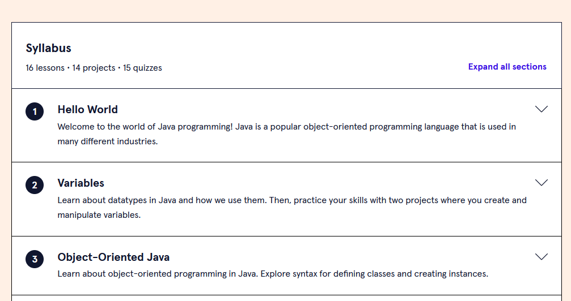

*Please include screenshots here (below):*