Chapter 3 & 4 Exercises

1. Defined as a concisely written set of users’ requirements, and should be specified in as detailed and complete a form as possible?
2. Requirements that are user operations or transactions that will be applied to the database and may include both retrievals and updates.
3. This class of design is usually easier to communicate to non-technical users because it doesn’t contain implementation details.
4. This class of design is often referred to as the implementation data model.
5. This class of design includes the internal storage structures, file organizations, indexes, and access paths.
6. What are the two types of existence for entities in the Entity Relationship (ER) model (give an example of each type)?
7. These become a major part of the data stored in the database and describe each entity.
8. These types of attributes are helpful to model an address when the user needs to refer to each part of the address independently (i.e., state, city, zip code, etc...).
9. How do we specify the type of attribute from question 8 on an entity relationship (ER) diagram?
10. With these types of attributes, the value can be determined by one or many other related attributes, or entities.
11. How do we specify the type of attribute from question 10 on an entity relationship (ER) diagram?
12. Give two cases in which we may use the special “NULL” value?
13. These types of attributes have distinct values for each given entity set of an entity type E.
14. How many such entity sets are there for an entity type E with N entity instances (please explain your answer)?
15. Please model the following logical data requirements using the Entity Relationship (ER) model (use only Entities and Attributes)*

**PLACE LOGICAL DATA REQUIREMENTS HERE...**

1. When an attribute of one entity type refers to another entity type, what generally exists?
2. The following is defined as the number of participating entity types in a relationship type R.
3. When the same entity type participates more than once in a relationship type (in different roles), this is referred to as what kind of relationship?
4. The general term for the combination of cardinality and participation constraints on a relationship type R.
5. How many possible cardinality ratios are there for binary relationships (list them)?
6. This constraint specifies the minimum number of relationship instances that each entity can participate in and is sometimes called the minimum cardinality constraint?
7. What are the two types of the constraint from question 21 (explain what each type means regarding a relationship type R, and two participating entity types E and D)?
8. Regarding attributes on relationship types, which cardinality ratio (of a binary relationship R from question 20) prevents me from migrating to either participating entity type in the relationship type R?
9. Entity types that don’t have key attributes of their own are referred to as what?
10. How do we specify the type of entity from question 24 on an entity relationship (ER) diagram?
11. The type of relationship that relates the entity type from question 24 to its owner entity type?
12. How do we specify the type of relationship from question 26 on an entity relationship (ER) diagram?
13. What is true about the participation of the entity type from question 24 in the relationship type from question 26?
14. True or false, entity types in an entity relationship (ER) diagram should be plural?
15. True or false, attribute names in an entity relationship (ER) diagram should have their first letter capitalized?
16. This notation allows us to combine both cardinality and participation constraints into one.
17. Give an example of this notation where an entity type has total participation.
18. The process of defining a set of subclasses of an entity type is referred to as what?
19. What are the two constraints we must specify on a subclass / superclass relationship?

For questions 35 – 38 refer to the following diagrams...

**A**

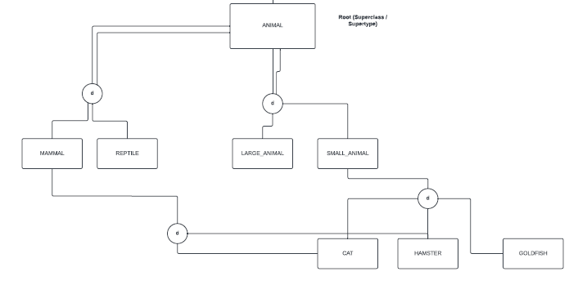

**\*\*\*\*\*\*\*\*\*\*\*\*\*\*\*\*\*\*\*\*\*\*\*\*\*\*\*\*\*\*\*\*\*\*\*\*\*\*\*\*\*\*\*\*\*\*\*\*\*\*\*\*\*\*\*\*\*\*\*\*\*\*\*\*\*\*\*\*\*\*\*\*\*\*\*\*\*\*\*\*\*\*\*\*\***

**B**

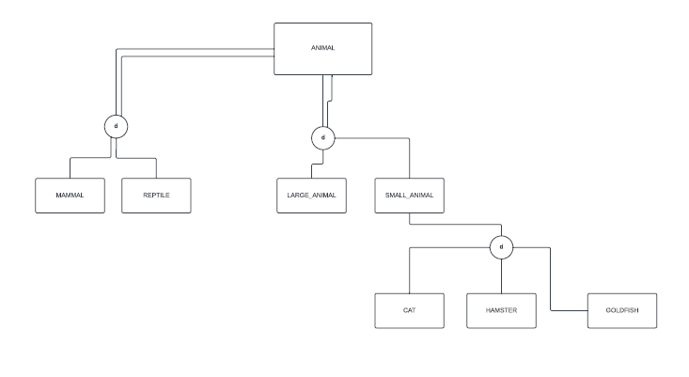

1. Which diagram represents an inheritance hierarchy?
2. Which diagram represents an inheritance lattice?
3. Which diagram represents multiple inheritance?
4. Which diagram represents single inheritance?
5. What is a leaf node in relation to an inheritance lattice or hierarchy?