**Database Dialect**

100 - Term used to describe the combination of the DBMS and the database.

Answer: Database System.

200 - The following property of transaction ensures that all manipulation of the database must be successful, or else no changes will be applied.

Answer: Atomicity.

300 - A function of the Database Management System (DBMS) that includes functions such as querying the database to retrieve specific data, updating the database to reflect changes in the mini world, and generating reports form the data.

Answer: Manipulating.

400 - Is sometimes referred to as the "intension" of the database.

Answer: Schema.

500 - When we define a new database, we specify its database schema only to the DBMS. At this point, the corresponding database is in this state.

Answer: Empty State.

**Database Users**

100 - People whose jobs require access to the database for querying,  
updating, and generating reports; the database primarily exists for their use.

Answer: Database Users.

200 - Of the different classes of end users, this class requires the most knowledge of the DBMS.

Answer: Sophisticated Users.

300 - Duplication of effort is one of many downsides in not controlling this, or storing the same data multiple times.

Answer: Data Redundancy.

400 - "every section record must be related to a course record" is an example of this type of constraint.

Answer: Referential Integrity.

500 - Some constraints can be specified to the DBMS and automatically enforced. Other constraints may have to be checked by update programs or at the time of data entry. For typical large applications, it is customary to call such constraints by this name.

Answer: Business Rules (Logic)

**Cardinality**

100 - 1:1, 1:N, N:1, N:M are all cardinality ratios of these class of relationships.

Answer: Binary Relationships.

200 - This participation, also referred to as the "existence dependency" is represented as a double solid line from an entity type E to a relationship type R on an ER diagram.

Answer: Total Participation.

300 - The total number of subsets of an entity set {e1, e2, ..., en} with n entity instances.

Answer: 2^n.

400 – Daily Double (Which entity type can I move the attribute “StartDate” to)?

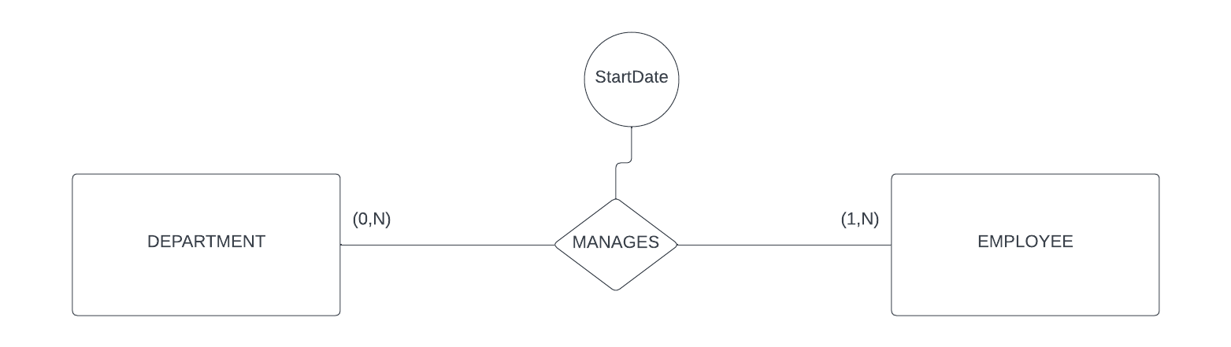

Answer: You cannot move the StartDate to any of the entity types because the cardinality of the relationship type is M:N.

500 - The cardinality combined with the participation constraint(s) are referred to as this.

Answer: Structural Constraints.

**ER Eureka**

100 - This type of attribute is represented on an ER diagram with a solid oval.

Answer: Simple Attribute, Single Valued Attribute.

200 - This type of attribute is represented on an ER diagram with a dotted oval.

Answer: Derived Attribute.

300 - This type of attribute is represented on an ER diagram with double ovals.

Answer: Multivalued attribute.

400 - This type of relationship is represented on an ER diagram with a double diamond.

Answer: Identifying Relationship.

500 - This type of entity cannot be uniquely identified by itself and has this type of key attribute.

Answer: Entity Type.

**E-ER Eureka**

100 - DAILY DOUBLE (If you draw the ER diagram in the order 1, 2, 3 what process was followed)

200 - The process of defining a set of subclasses of an entity type.

Answer: Generalization.

300 - When an entity can be a member of at most one of the subclasses of the specialization, they are this.

Answer: Disjoint.

400 - The second constraint on specialization, which may be total or partial.

Answer: Completeness.

500 - When a shared subclass directly inherits attributes and relationships from multiple super classes.

Answer: Multiple Inheritance.