*CSCI 340 Database Design – Quiz 1*

*Name:*

*Student Id:*

**Databases and Database Users**

1. Is most generally referred to as a collection of related data?

**Database**

1. A computerized system that enables users to create and maintain a database is referred to as (please write out the entire name, not just the acronym)?

**Database Management System (DBMS)**

1. The answers to questions 1 & 2 together are referred to as this?

**Database System**

*For questions 4 – 7 please fill in the blank(s) with the function(s) of the DBMS described.*

1. **Constructing** the database is the process of storing the data on some storage medium that is controlled by the DBMS.
2. **Manipulating** a database includes functions such as querying the database to retrieve specific data, updating the database to reflect changes in the mini world, and generating reports from the data.
3. **Defining** a database involves specifying the data types, structures, and constraints of the data to be stored in the database. The database definition or descriptive information is also stored by the DBMS in the form of a database **catalog** or dictionary; it is also referred to as **meta-data**.
4. **Sharing** a database allows multiple users and programs to access the data simultaneously.
5. What are the two properties of a transaction, give a short definition of each?

**Isolation – it appears as if I’m the only user, atomicity – all manipulations to the database are successful, or none are.**

1. These users (give the role name) are responsible for authorizing access to databases as well as coordinating and monitoring their use?

**Database Administrators**

1. These users (give the role name) are responsible for identifying the data to be stored, as well as choosing the appropriate structures to represent and store the data?

**Database Designers**

1. Rank the following types of end users from 1 (needs to know most about the DBMS) to 3 (needs to know least about the DBMS).

|  |  |
| --- | --- |
| **User Type** | **Rank** |
| Casual | **2** |
| Naïve | **3** |
| Sophisticated | **1** |

1. These type of end users are generally characterized by their use of personal databases.

**Standalone users**

1. Name one possible downside of not controlling data redundancy (give one of the downsides we discussed in class)?

**Data inconsistency, unnecessary cost (storage), duplication of effort (maintainability)**

1. Which of the following is are **advantages** of using the DBMS approach?
   1. Restricting Unauthorized Access.
   2. Providing Persistent Storage for Program Objects.
   3. Controlling Redundancy.
   4. **All are advantages of using the DBMS approach.**
   5. None are advantages of using the DBMS approach.
2. Why might an organization choose **not** to use a DBMS (give one of the reasons we discussed in class)?

**Single user systems, unnecessary overhead cost, short timeline.**

**Database System Concepts and Architecture**

1. Which law predicts that the number of transistors on a microchip will double every two years?

**Moore’s Law**

1. Increasing the amount of CPU from 1GB to 2GB on a single database server is an example of which of the following types of scaling?
   1. **Vertical Scaling**
   2. Horizontal Scaling
   3. None of the above
2. This module is typically composed of application programs and user interfaces that access the database.

**Client module (phone, computer, etc...)**

1. This module is typically responsible for handling data storage, access, search, and other functions.

**Server module (API, Database Server, etc...)**

1. The description of the database is referred to as this.

**Schema**

1. True or **false**, the state of a database that satisfies the structure and constraints specified in the schema is referred to as the “contrary state” (valid state)?

*For questions 22 – 27 please refer to Figure 2.2 (The three-schema architecture) below.*

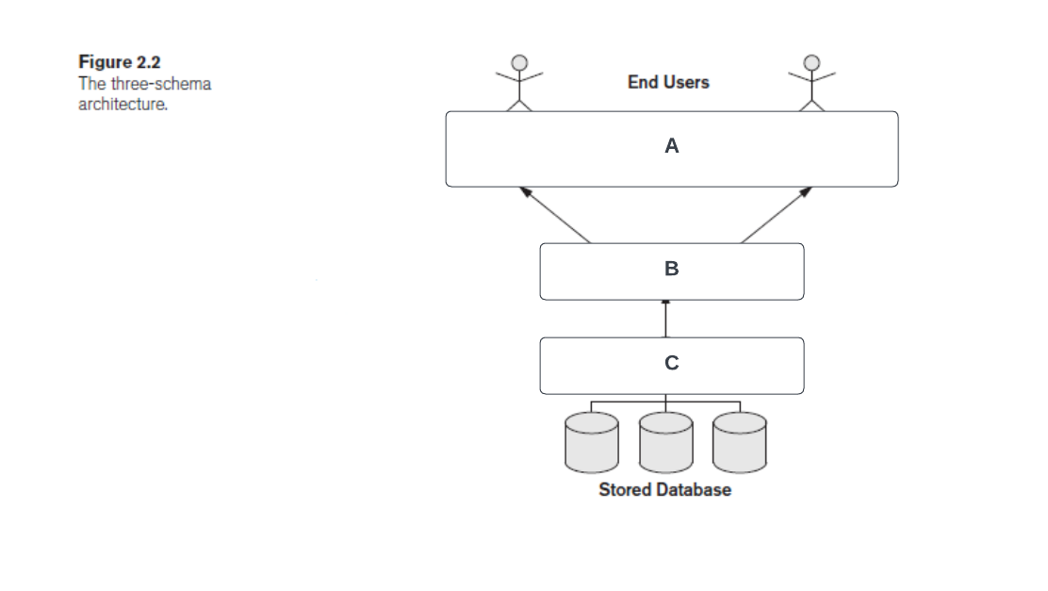

1. What is the level of the three-schema architecture labeled “**C”** (above) referred to as?

**Internal level (Physical)**

1. What is the level of the three-schema architecture labeled “**A”** (above) referred to as?

**External level**

1. What is the level of the three-schema architecture labeled “**B”** (above) referred to as?

**Conceptual level**

1. Describe logical data independence. In your answer, please include the levels of the three-schema architecture involved.

**The ability to make changes to the conceptual level (B) without having to make changes to the external level (A).**

1. Describe physical data independence. In your answer, please include the levels of the three-schema architecture involved.

**The ability to make changes to the internal level (C) without having to make changes to the conceptual level (B) or by association the external level (A).**

1. At what level of the three-schema architecture is the actual data stored in (give the name, not just the letter)?

**Internal (C)**

1. True or **false**, in general physical data independence is harder to achieve?

**Logical data independence is harder to achieve, less data abstraction between conceptual level and external level.**

1. What are four characteristics that are generally used to classify a Database Management System?

**Cost (open sourced vs. proprietary), # of sites (centralized vs. distributed), # of users (single user vs. multiuser), Data model (Relational Model, Object Model)**

1. Name a fifth (for extra credit).

**# of DBMS software (heterogenous vs. homogenous)**

**Data Modeling Using the Entity – Relationship (ER) Model**

1. These types of requirements are defined as user-defined operations (or transactions) that will be applied to the database, including both retrievals and updates.

**Functional requirements**

1. What are the three basic components of the ER Model?

**Entities, Attributes, Relationships**

1. Which of the three (from question 32) makes up most of the data stored in a database?

**Attributes**

1. Given the following ER Diagram (below), which entity type could I move the “Start_date” attribute of the MANAGES relationship type to?

**EMPLOYEE**

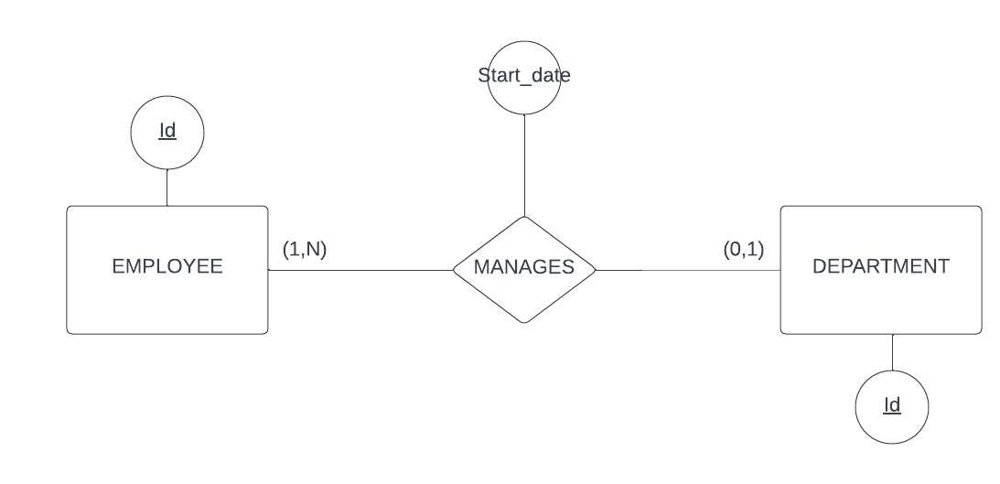

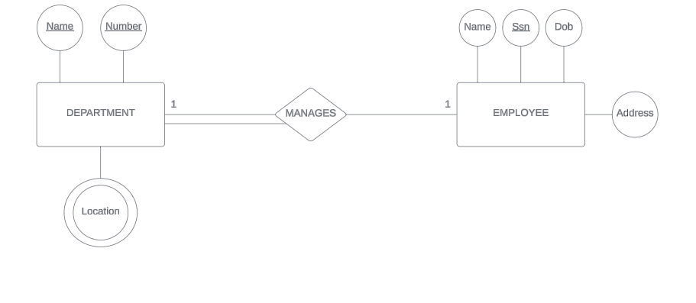*For questions 34 – 41 please refer to the Entity Relationship (ER) diagram below.*

1. What type of attribute is “Location” on the DEPARTMENT entity type?

**Multivalued (stored)**

1. What type(s) of attribute is “Ssn” on the EMPLOYEE entity type (hint: there is more than one type)?

**Key attribute, simple attribute, stored attribute**

1. Model a new attribute “Age” on the EMPLOYEE entity type which is *derived* from the Dob attribute, and the current date.

**Solid line from EMPLOYEE entity type with dotted oval (with Age inside dotted oval)**

1. Model the “Address” attribute, which is *composed* of “City”, “State”, and “Zip” (assume the end users are interested in accessing the *atomic* parts of the Address, as well as the Address as a whole).

**City, State, and Zip attached to Address with solid ovals for each.**

1. What *degree* is the “MANAGES” relationship type?

**2**

1. What is the formal name for relationship types of this degree (from question 39)?

**Binary**

1. Model the “MANAGES” relationship type using “min-max” notation (please include the participating entity types).

**Went over in class (add the diagram here).**

1. Model the following data requirements (assume that a dependent cannot be uniquely identified apart from its relationship with an employee).

*Logical Data Requirements:*

* The database will keep track of the dependents of each employee for insurance purposes, including each dependent’s first name, sex, birth date, and relationship to the employee.

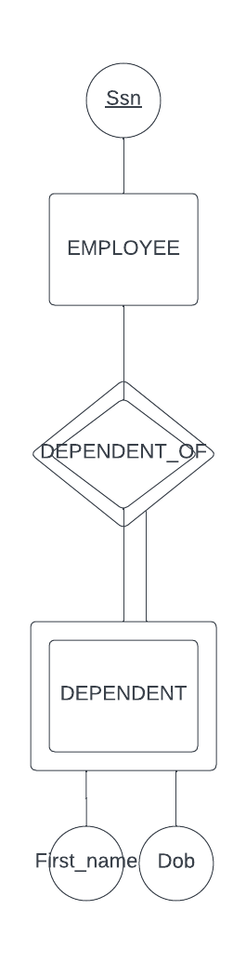

Identifying relationship (1/2 point)

Total participation (1/2 point)

Weak entity type, double rectangle (1/2 point)

these should have dotted underlines for partial key (1/2 point)

1. **True** or false, there are 2n possible entity sets for an Entity Type E with n entity instances { e1, e2, ..., en }.

Explanation: there are n entity instances, choose whether to include it or not (decision) there are two choices y/n, n decisions (they are independent)*

1. What is the special value for the empty entity set, or { }?

**NULL**

1. Give two possible meanings for that special value (question 44).

**Missing, doesn’t exist.**

1. True or false, in the ER Model, an entity type E is only allowed to have a single key attribute?

**False**

**The Enhanced Entity – Relationship (EER) Model**

1. **True** or false, an entity cannot exist in the database merely by being a member of a subclass; it must also be a member of the superclass.
2. Assuming the following EER diagram was drawn in the order 1, 2, 3. Which process was followed, **Specialization** or Generalization?

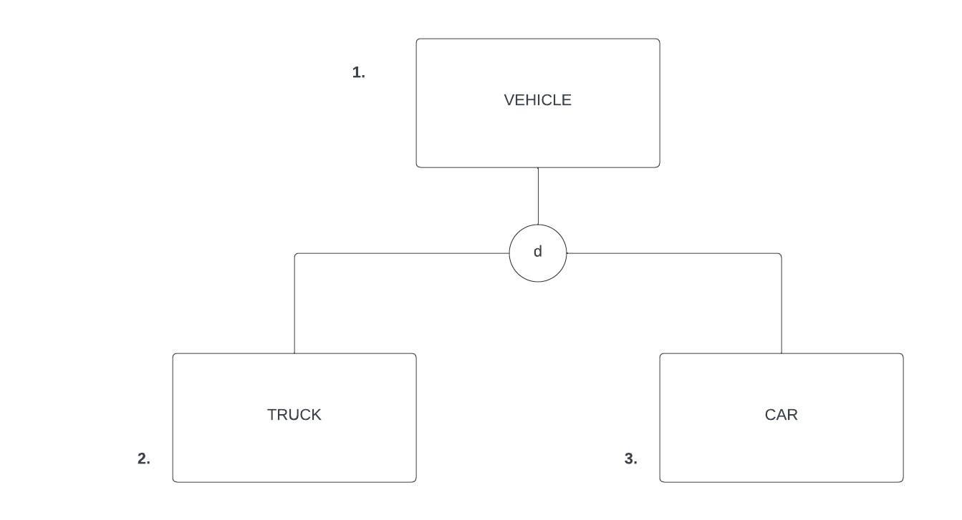

1. Circle a “leaf node” on the following EER diagram or “inheritance hierarchy”.
2. 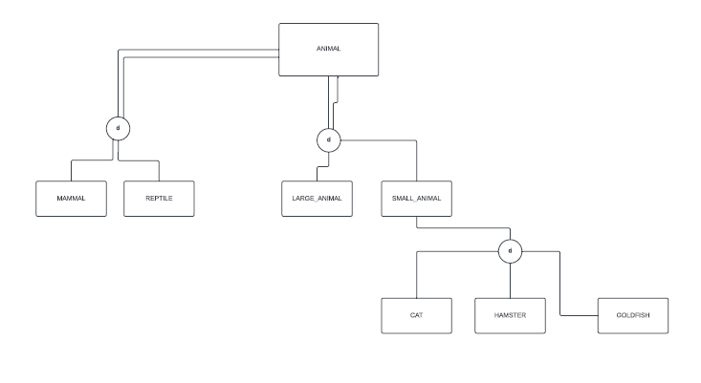Name the two constraints that are represented in the class / subclass relationships in the inheritance hierarchy above (from question 49).

Disjointness, completeness

**SCRATCH PAPER**