*CSCI 340 Database Design – Quiz 2*

*Name:*

*Student Id:*

"Embrace the challenge, for within every question lies the opportunity to succeed. Trust in your preparation, stay focused, and let your knowledge shine. You've got this! 🌟"

**The Relational Data Model and Relational Database Constraints (28 Points)**

*For questions 1 – 4 please fill in the blank with the component(s) of the relational model described.*

1. The logical definition of a ___________ includes its *name*, *data type*, *format*, and in some special cases *unit of measurement.*
2. A ___________, or row is often written as *t = < v1, v2, ...., vn >.*
3. In the following denotation of the relation schema for a student;

*STUDENT(NetId, Name, DateOfBirth, Sex)* the number of ___________ or *arity* is *4*. This is also referred to as the ___________ of the STUDENT relation.

1. In the relational model entities and relationships alike are simply referred to as ___________.
2. Is *constantly changing* and is denoted as *r(R) = { t1, t2, ...., tm }*.
3. Is *relatively static* and is denoted as *R( A1, A2, ...., An )*.
4. Give the name for the general category of constraints that refers to *constraints that can be directly expressed in the schemas of the data model, typically by specifying them in the data definition language (DDL)*.
5. Give the name for the general category of *constraints that cannot be directly expressed in the schemas of the data model, hence they must be expressed and enforced by the application programs or in some other way*.
6. Give the name for the general category of *constraints that are characterized by being inherent in the data model*.
7. For a subset of attributes *SK* in a relation schema *R*, for any two distinct tuples *t1* and *t2* in any relation schema *r(R)*, what invariant must hold for *SK* to be considered a *superkey* of *R*?
8. What is a superkey (by default) of any relation *R( A1, A2, ...., An )*?
9. If an attribute *A* is removed from a *superkey* *SK* resulting in the invariant (from question 10) to no longer hold for SK-A (i.e., SK-A is not a *superkey* of R), *SK* is referred to as what, also known as a *minimal superkey* of R?
10. Which integrity constraint, from the general category of constraints described in question 7, states that all tuples in a relation must be distinct?
11. What does the *entity integrity constraint* state about tuples within a relation?

**Basic SQL (32 Points)**

1. What does SQL stand for?
2. The *CREATE TABLE* statement in SQL would be an example of this type of DBMS language.
3. The *INSERT, UPDATE, AND DELETE* statements in SQL are examples of this type of DBMS language.
4. Put the following *components* into the correct **Order** (*1, 2, or 3*) in which they should be defined in the *CREATE TABLE* statement (below).

|  |  |
| --- | --- |
| **Order** | **Component(s)** |
|  | *Constraint(s)* |
|  | *Data type* |
|  | *Column name* |

*CREATE TABLE SCHEMANAME.TABLENAME*

*(*

*1 2 3*

*);*

1. If the schema name *SCHEMANAME.* is omitted from the *CREATE TABLE* statement from question 15 (above). What schema will the table *TABLENAME* be created in (include the name, and what that schemas abbreviation stands for)?
2. Describe the difference between the CHAR and VARCHAR data types in SQL.

*For floating point numbers, especially currency, the decimal data type is most often used to protect against rounding error(s). In general, this is denoted as DECIMAL( i , j ) in SQL.*

1. If the *precision* of a column with a DECIMAL data type is defined as 4, and the *scale* of that same column is defined as 2, which of the following would be valid values for that column (circle all that apply)?

* 12.1234
* 1234.12
* 12.34
* 1.234

1. Fill in the blanks (below) with the correct concrete values for i and j given the scale and precision defined in the previous question (18).

*DECIMAL ( _ , _ )*

1. True or false, a NOT NULL constraint is *implicitly* specified for the attributes that are part of the primary key for each relation?
2. What keyword is used to define a uniqueness constraint for one or many attributes which make up a candidate key?
3. What is the default referential triggered action in SQL i.e., actions that are triggered when referential integrity is violated?
4. Which of the following operations have the potential to result in the violation of a referential integrity constraint (circle all that apply)?

* Deleting an existing tuple from a relation.
* Inserting a new tuple into a relation.
* Updating an attributes value that is neither a foreign nor primary key.

1. True or false, in SQL the same name can be used for two (or more) attributes within the same table?
2. Which constraint in SQL is used to ensure that an attribute does not have NULL values?
3. Who typically has the authorization to create schemas and schema elements in SQL (give the type of end user and the role they are likely performing these duties in)?
4. Describe the difference between base tables and virtual relations in SQL.

**Relational Database Design by ER- and EER-to-Relational Mapping (40 Points)**

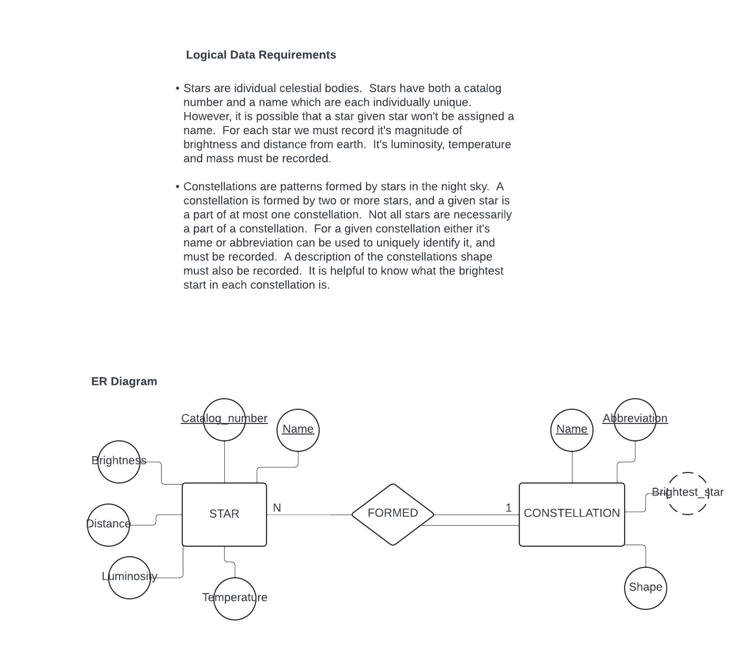*Use the following Logical Data Requirements and ER Diagram to produce the relational schema for question 31 (below).*

1. *Produce the relational schema corresponding to the logical data requirements and ER diagram (above) by completing parts A, B, and C (be sure to denote all integrity constraints in your relational schema, as well as giving names to each relation).*
2. Map the *strong entity type* **STAR** to the relational model i.e., perform the first step of data model mapping on the ER diagram above (hint: use the logical data requirements to help you specify integrity constraints).
3. Map the *strong entity type* **CONSTELLATION** to the relational model i.e., perform the first step of data model mapping (hint: use the logical data requirements to help you specify integrity constraints).
4. Map the *binary 1:N relationship type* **FORMED** to the relational model i.e., perform the fourth step of the data model mapping (hint: use the logical data requirements to help you pick the correct approach on mapping the relationship type).

**Relational Schema (your solution to question 31 goes here, or on SCRATCH PAPER on the last page of this quiz):**

*Use the following Extended Logical Data Requirements and ER Diagram for questions 32 – 36 (below).*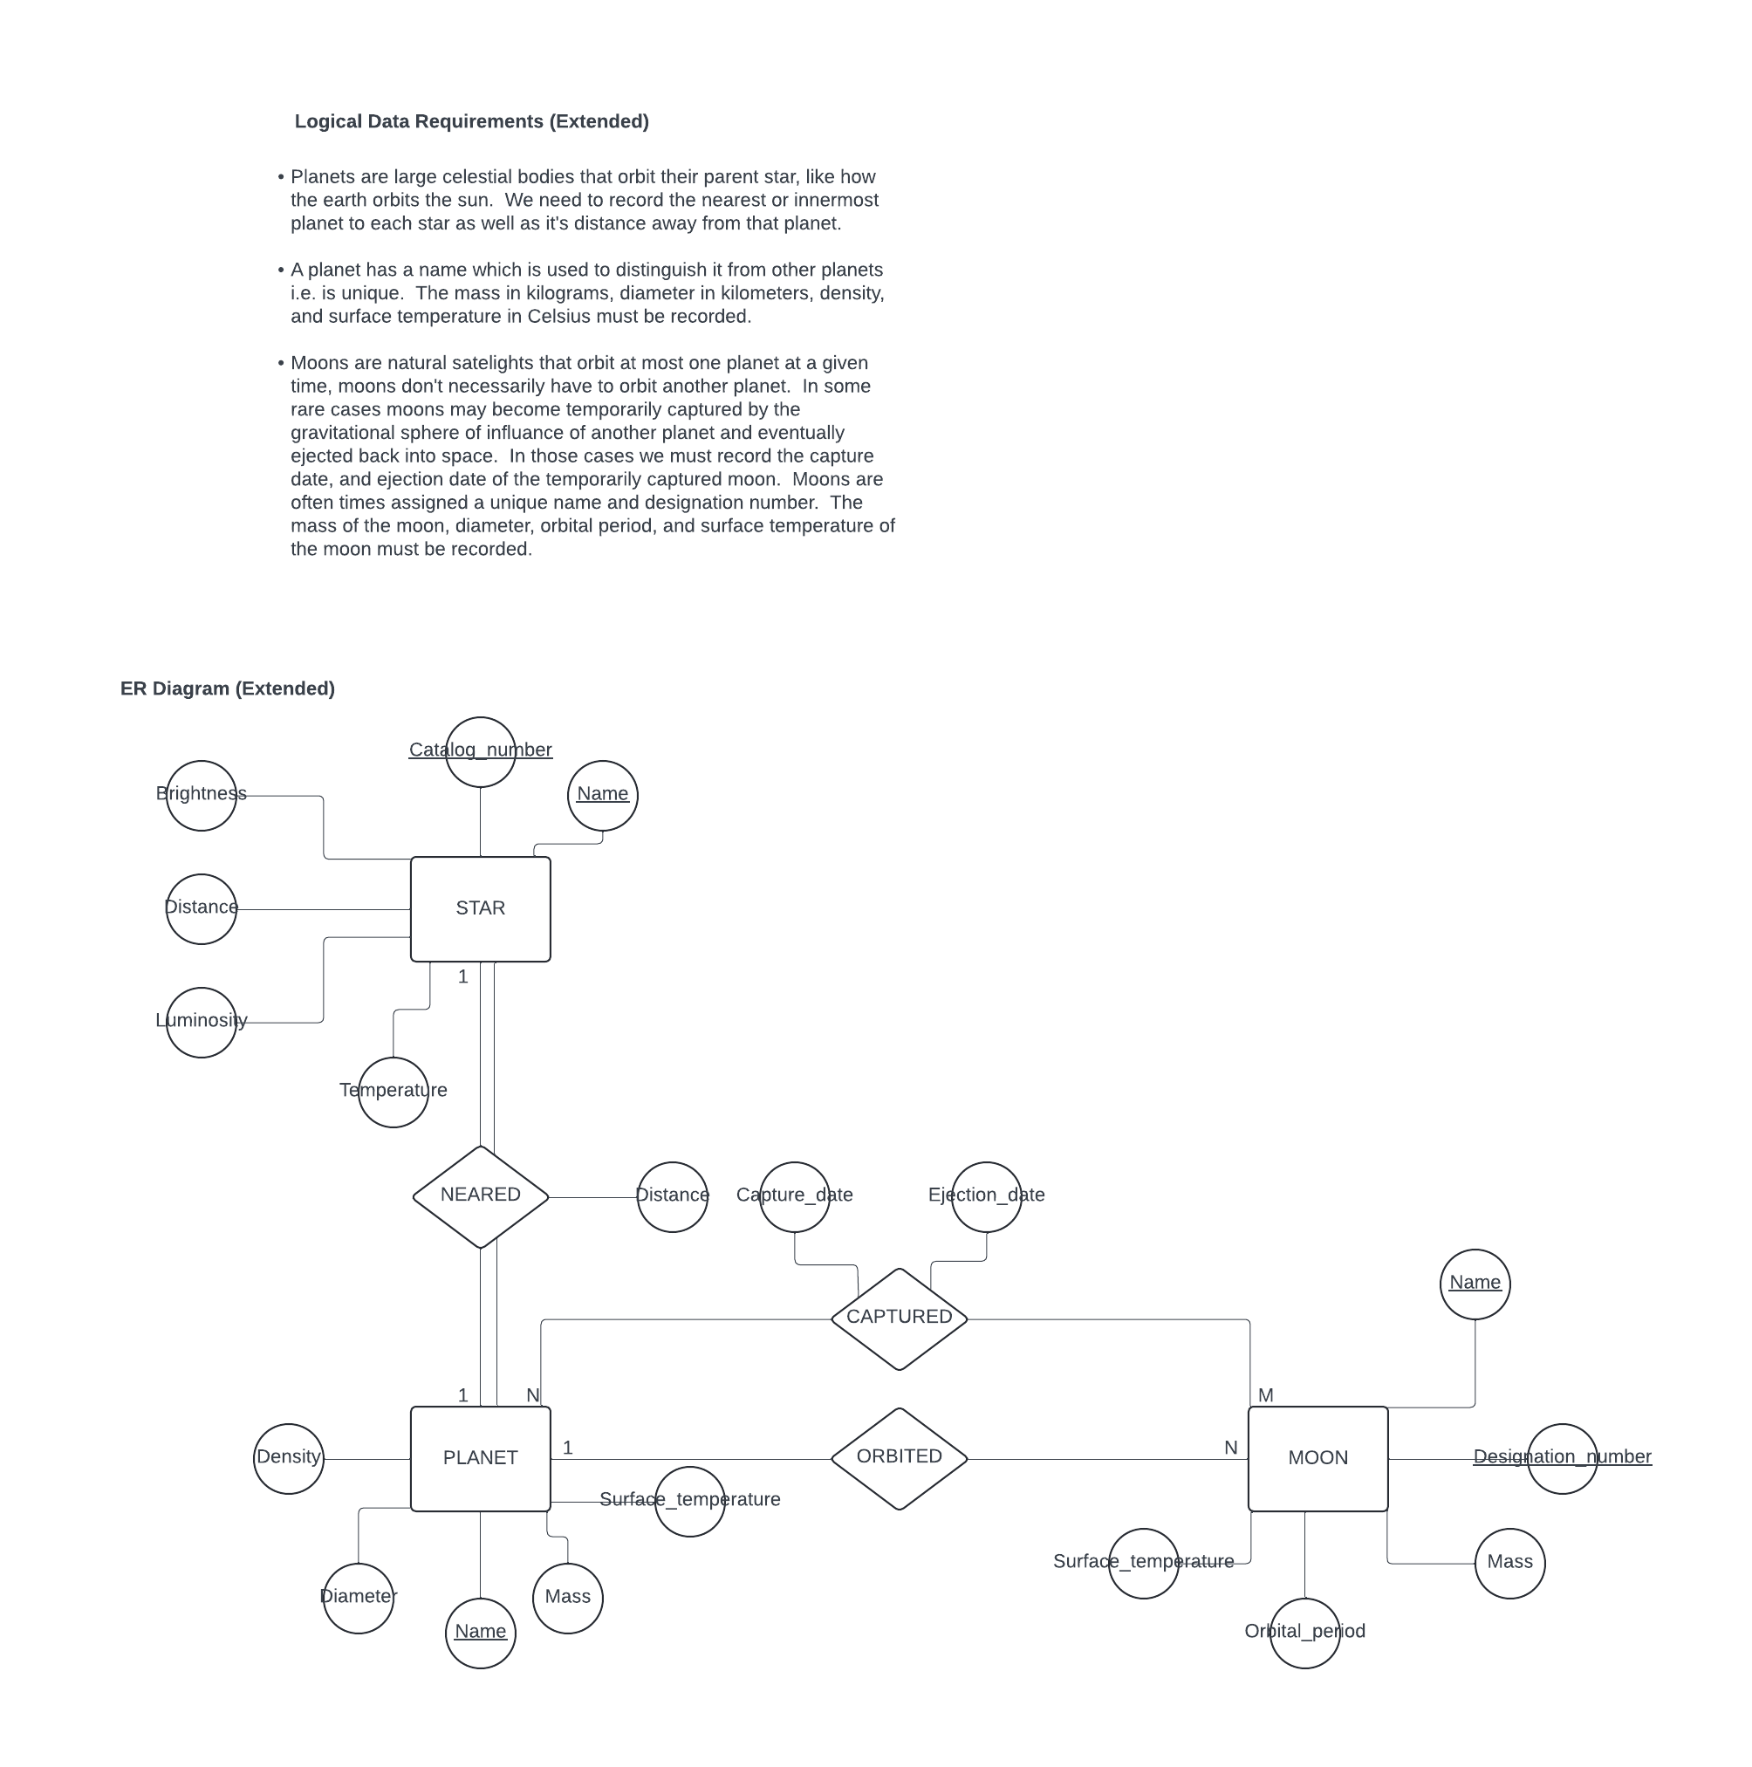

1. When performing the data model mapping for the *strong entity type* **MOON** we must specify a key constraint as the primary key in the relational schema. What criteria should we consider when selecting the attribute to become the primary key?
2. When performing the data model mapping for the *binary 1:1 relationship type* **NEARED** what is the preferred approach for mapping this relationship type?
3. What are the other viable approaches for mapping the *binary 1:1 relationship type* **NEARED**, and which approach would be a preferred alternative over the other based upon the extent to which the **STAR** and **PLANET** *strong entity types* are *participating* in the **NEARED** *relationship type* (please justify your answer)?
4. When performing the data model mapping for the *binary 1:N relationship type* **ORBITED** we may consider using an alternative approach than what is generally preferred based upon the extent to which the **PLANET** and **MOON** *strong entity types* are *participating* in the ORBITED *relationship type* (please justify your answer)?
5. When performing the data model mapping for the *binary N:M relationship type* **CAPTURED** what is the preferred approach for mapping this relationship type?

*Use the following Logical Data Requirements and ER Diagram to produce the relational schema for question 37 (below).*

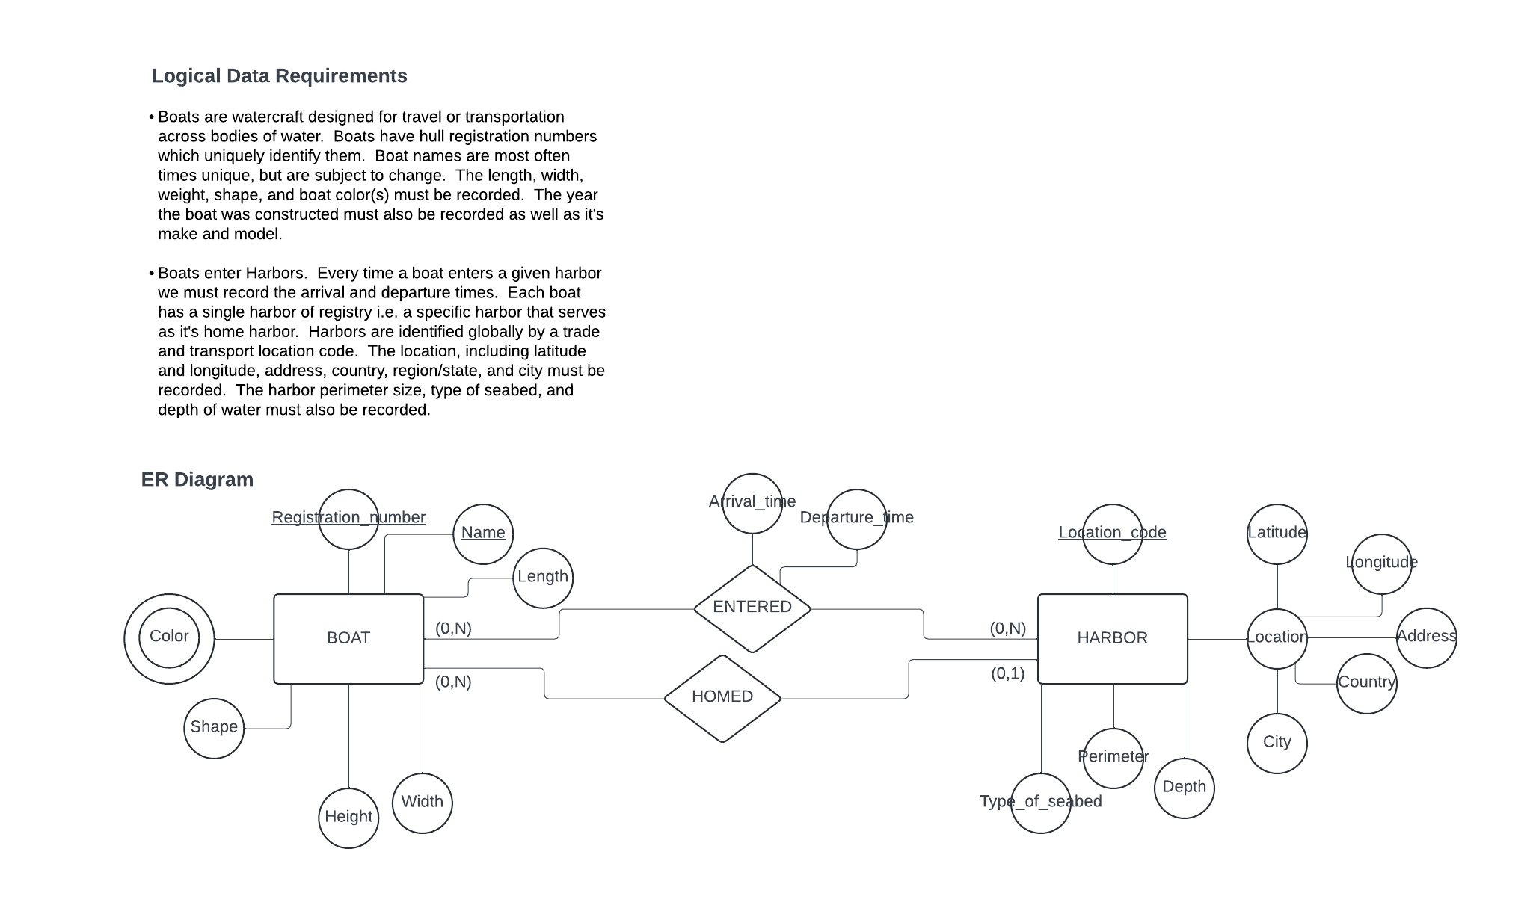

1. *Produce the relational schema corresponding to the logical data requirements and ER diagram (above) by completing parts A, B, C, D, and E (be sure to denote all integrity constraints in your relational schema, as well as giving names to each relation).*
2. Map the *strong entity type* **BOAT** to the relational model i.e., perform the first step of data model mapping on the ER diagram above (hint: use the logical data requirements to help you specify integrity constraints).
3. Map the *strong entity type* **HARBOR** to the relational model i.e., perform the first step of data model mapping (hint: use the logical data requirements to help you specify integrity constraints).
4. Map the *binary 1:N relationship type* **HOMED** to the relational model i.e., perform the fourth step of the data model mapping (hint: use the logical data requirements and/or participation constraints to help you pick the correct approach on mapping the relationship type).
5. Map the *binary N:M relationship type* **ENTERED** to the relational model i.e., perform the fifth step of the data model mapping.
6. Map the *multivalued attribute* ***Color*** to the relational model i.e., perform the sixth step of data model mapping (hint: the relation formed by this mapping will have a composite primary key).

**Relational Schema (your solution to question 37 goes here, or on SCRATCH PAPER on the last page of this quiz):**

**SCRATCH PAPER (31)**

**SCRATCH PAPER (37)**