*CSCI 340 Database Design – Quiz 2 (Key)*

*Name:*

*Student Id:*

"Embrace the challenge, for within every question lies the opportunity to succeed. Trust in your preparation, stay focused, and let your knowledge shine. You've got this! 🌟"

**The Relational Data Model and Relational Database Constraints (28 Points)**

*For questions 1 – 4 please fill in the blank with the component(s) of the relational model described.*

1. The logical definition of a **domain** includes its *name*, *data type*, *format*, and in some special cases *unit of measurement.*
2. A **tuple**, or row is often written as *t = < v1, v2, ...., vn >.*
3. In the following denotation of the relation schema for a student;

*STUDENT(NetId, Name, DateOfBirth, Sex)* the number of **attributes** or *arity* is *4*. This is also referred to as the **degree** of the STUDENT relation.

1. In the relational model entities and relationships alike are simply referred to as **relations**.
2. Is *constantly changing* and is denoted as *r(R) = { t1, t2, ...., tm }*.

**Relation State**

1. Is *relatively static* and is denoted as *R( A1, A2, ...., An )*.

**Relation Schema**

1. Give the name for the general category of constraints that refers to *constraints that can be directly expressed in the schemas of the data model, typically by specifying them in the data definition language (DDL)*.

**Explicit or Schema-Based Constraints**

1. Give the name for the general category of *constraints that cannot be directly expressed in the schemas of the data model, hence they must be expressed and enforced by the application programs or in some other way*.

**Semantic or Application-Based Constraints (Business Rules)**

1. Give the name for the general category of *constraints that are characterized by being inherent in the data model*.

**Implicit or Model-Based Constraints**

1. For a subset of attributes *SK* in a relation schema *R*, for any two distinct tuples *t1* and *t2* in any relation schema *r(R)*, what invariant must hold for *SK* to be considered a *superkey* of *R*?

**t1[SK] != t2[SK]**

1. What is a superkey (by default) of any relation *R( A1, A2, ...., An )*?

**The set of all attributes A1, A2, ...., An**

1. If an attribute *A* is removed from a *superkey* *SK* resulting in the invariant (from question 10) to no longer hold for SK-A (i.e., SK-A is not a *superkey* of R), *SK* is referred to as what, also known as a *minimal superkey* of R?

**Key**

1. Which integrity constraint, from the general category of constraints described in question 7, states that all tuples in a relation must be distinct?

**Key Constraint**

1. What does the *entity integrity constraint* state about tuples within a relation?

**The primary key attribute(s) cannot have null values.**

**Basic SQL (32 Points)**

1. What does SQL stand for?

**Structured Query Language**

1. The *CREATE TABLE* statement in SQL would be an example of this type of DBMS language.

**DDL (Data Definition Language)**

1. The *INSERT, UPDATE, AND DELETE* statements in SQL are examples of this type of DBMS language.

**DML (Data Manipulation Language)**

1. Put the following *components* into the correct **Order** (*1, 2, or 3*) in which they should be defined in the *CREATE TABLE* statement (below).

|  |  |
| --- | --- |
| **Order** | **Component(s)** |
| **3** | *Constraint(s)* |
| **2** | *Data type* |
| **1** | *Column name* |

*CREATE TABLE SCHEMANAME.TABLENAME*

*(*

*1 2 3*

*);*

1. If the schema name *SCHEMANAME.* is omitted from the *CREATE TABLE* statement from question 15 (above). What schema will the table *TABLENAME* be created in (include the name, and what that schemas abbreviation stands for)?

**dbo (Database Owner)**

1. Describe the difference between the CHAR and VARCHAR data types in SQL.

**CHAR – fixed length, remaining characters padded with blank space. VARCHAR – variable length, no padding with blank space.**

*For floating point numbers, especially currency, the decimal data type is most often used to protect against rounding error(s). In general, this is denoted as DECIMAL( i , j ) in SQL.*

1. If the *precision* of a column with a DECIMAL data type is defined as 4, and the *scale* of that same column is defined as 2, which of the following would be valid values for that column (circle all that apply)?

* 12.1234
* 1234.12
* 12.34
* 1.234

1. Fill in the blanks (below) with the correct concrete values for i and j given the scale and precision defined in the previous question (18).

*DECIMAL (* ***4*** *,* ***2*** *)*

1. True or false, a NOT NULL constraint is *implicitly* specified for the attributes that are part of the primary key for each relation?

**True**

1. What keyword is used to define a uniqueness constraint for one or many attributes which make up a candidate key?

**UNIQUE (Also accepted PRIMARY KEY)**

1. What is the default referential triggered action in SQL i.e., actions that are triggered when referential integrity is violated?

**RESTRICT**

1. Which of the following operations have the potential to result in the violation of a referential integrity constraint (circle all that apply)?

* Deleting an existing tuple from a relation.
* Inserting a new tuple into a relation.
* Updating an attributes value that is neither a foreign nor primary key.

1. True or false, in SQL the same name can be used for two (or more) attributes within the same table?

**False**

1. Which constraint in SQL is used to ensure that an attribute does not have NULL values?

**NOT NULL**

1. Who typically has the authorization to create schemas and schema elements in SQL (give the type of end user and the role they are likely performing these duties in)?

**Sophisticated User, Database Administrator**

1. Describe the difference between base tables and virtual relations in SQL.

**Base tables are physically stored as a file on disk, virtual relations may or may not be stored as a file on disk.**

**Relational Database Design by ER- and EER-to-Relational Mapping (40 Points)**

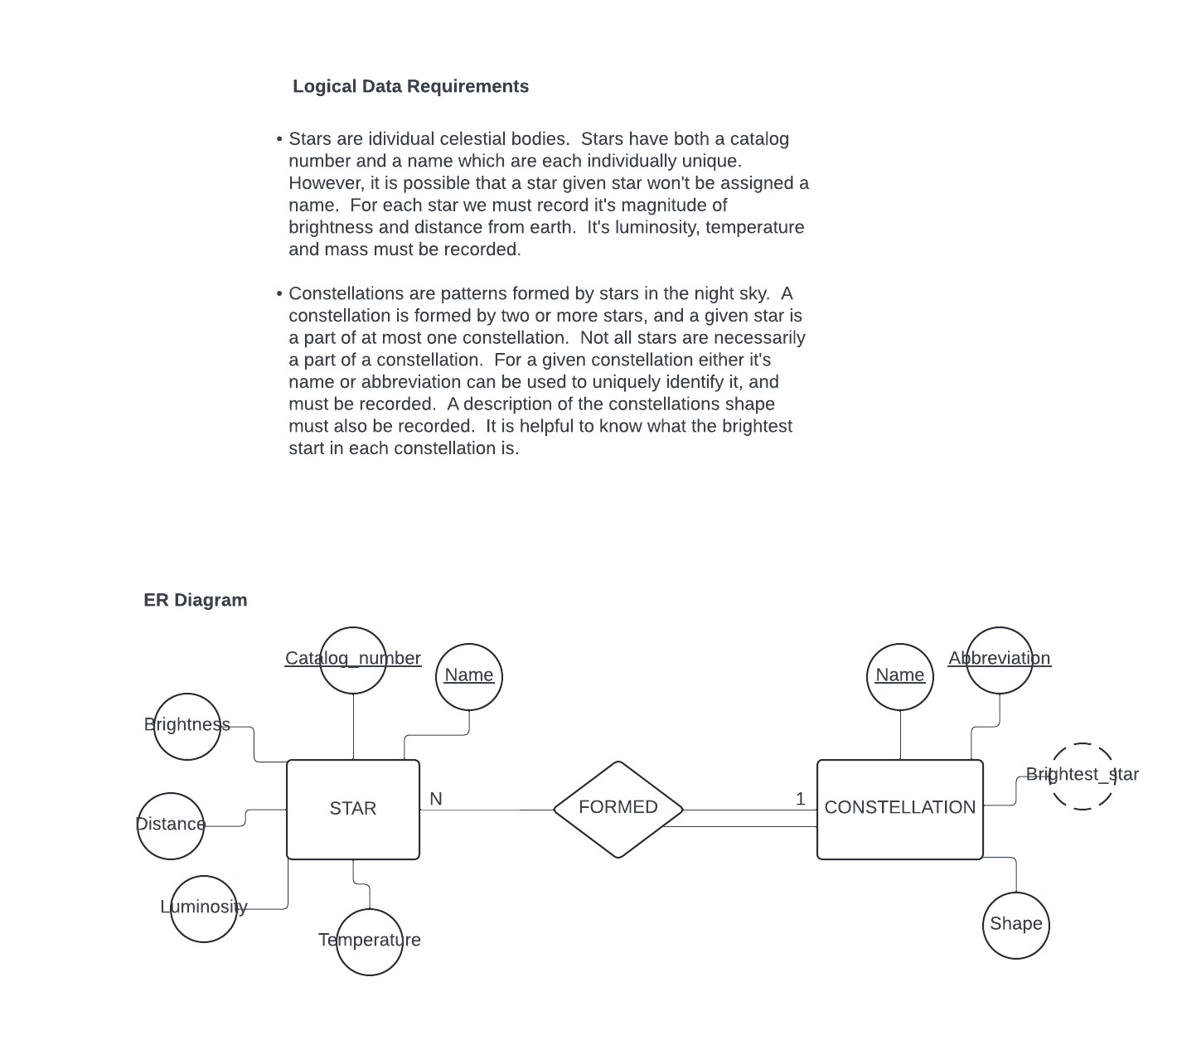*Use the following Logical Data Requirements and ER Diagram to produce the relational schema for question 31 (below).*

1. *Produce the relational schema corresponding to the logical data requirements and ER diagram (above) by completing parts A, B, and C (be sure to denote all integrity constraints in your relational schema, as well as giving names to each relation).*
2. Map the *strong entity type* **STAR** to the relational model i.e., perform the first step of data model mapping on the ER diagram above (hint: use the logical data requirements to help you specify integrity constraints).
3. Map the *strong entity type* **CONSTELLATION** to the relational model i.e., perform the first step of data model mapping (hint: use the logical data requirements to help you specify integrity constraints).
4. Map the *binary 1:N relationship type* **FORMED** to the relational model i.e., perform the fourth step of the data model mapping (hint: use the logical data requirements to help you pick the correct approach on mapping the relationship type).

**Relational Schema (your solution to question 31 goes here, or on SCRATCH PAPER on the last page of this quiz):**

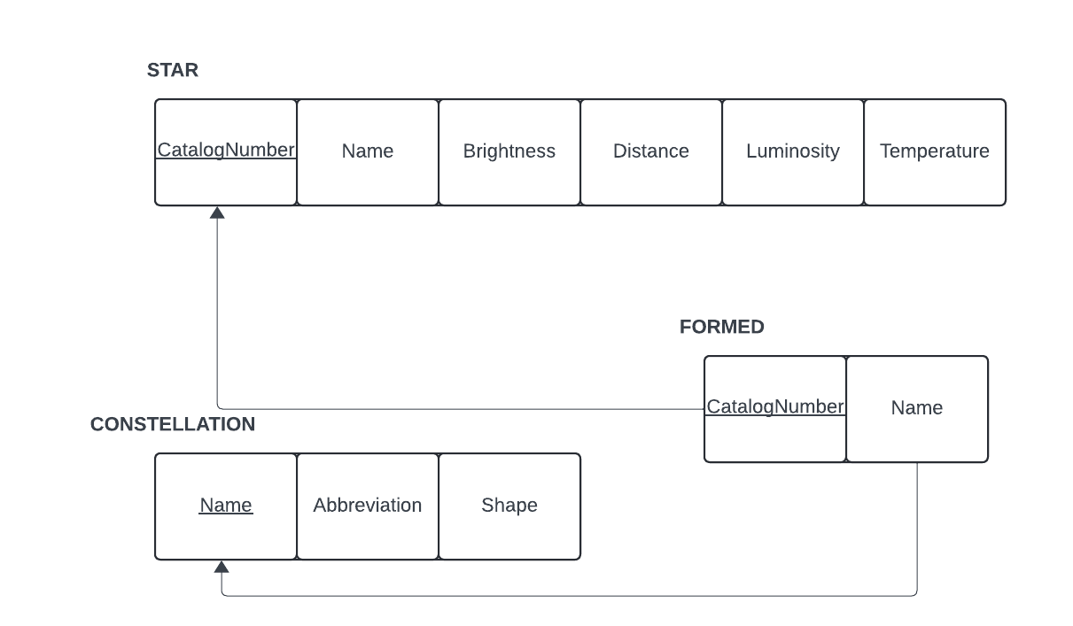

**Or**

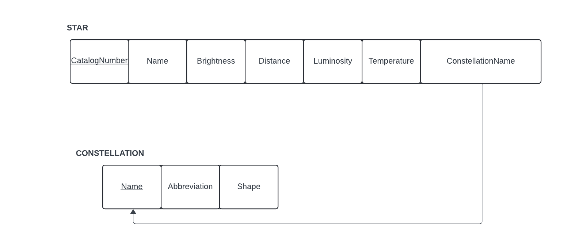

*Use the following Extended Logical Data Requirements and ER Diagram for questions 32 – 36 (below).*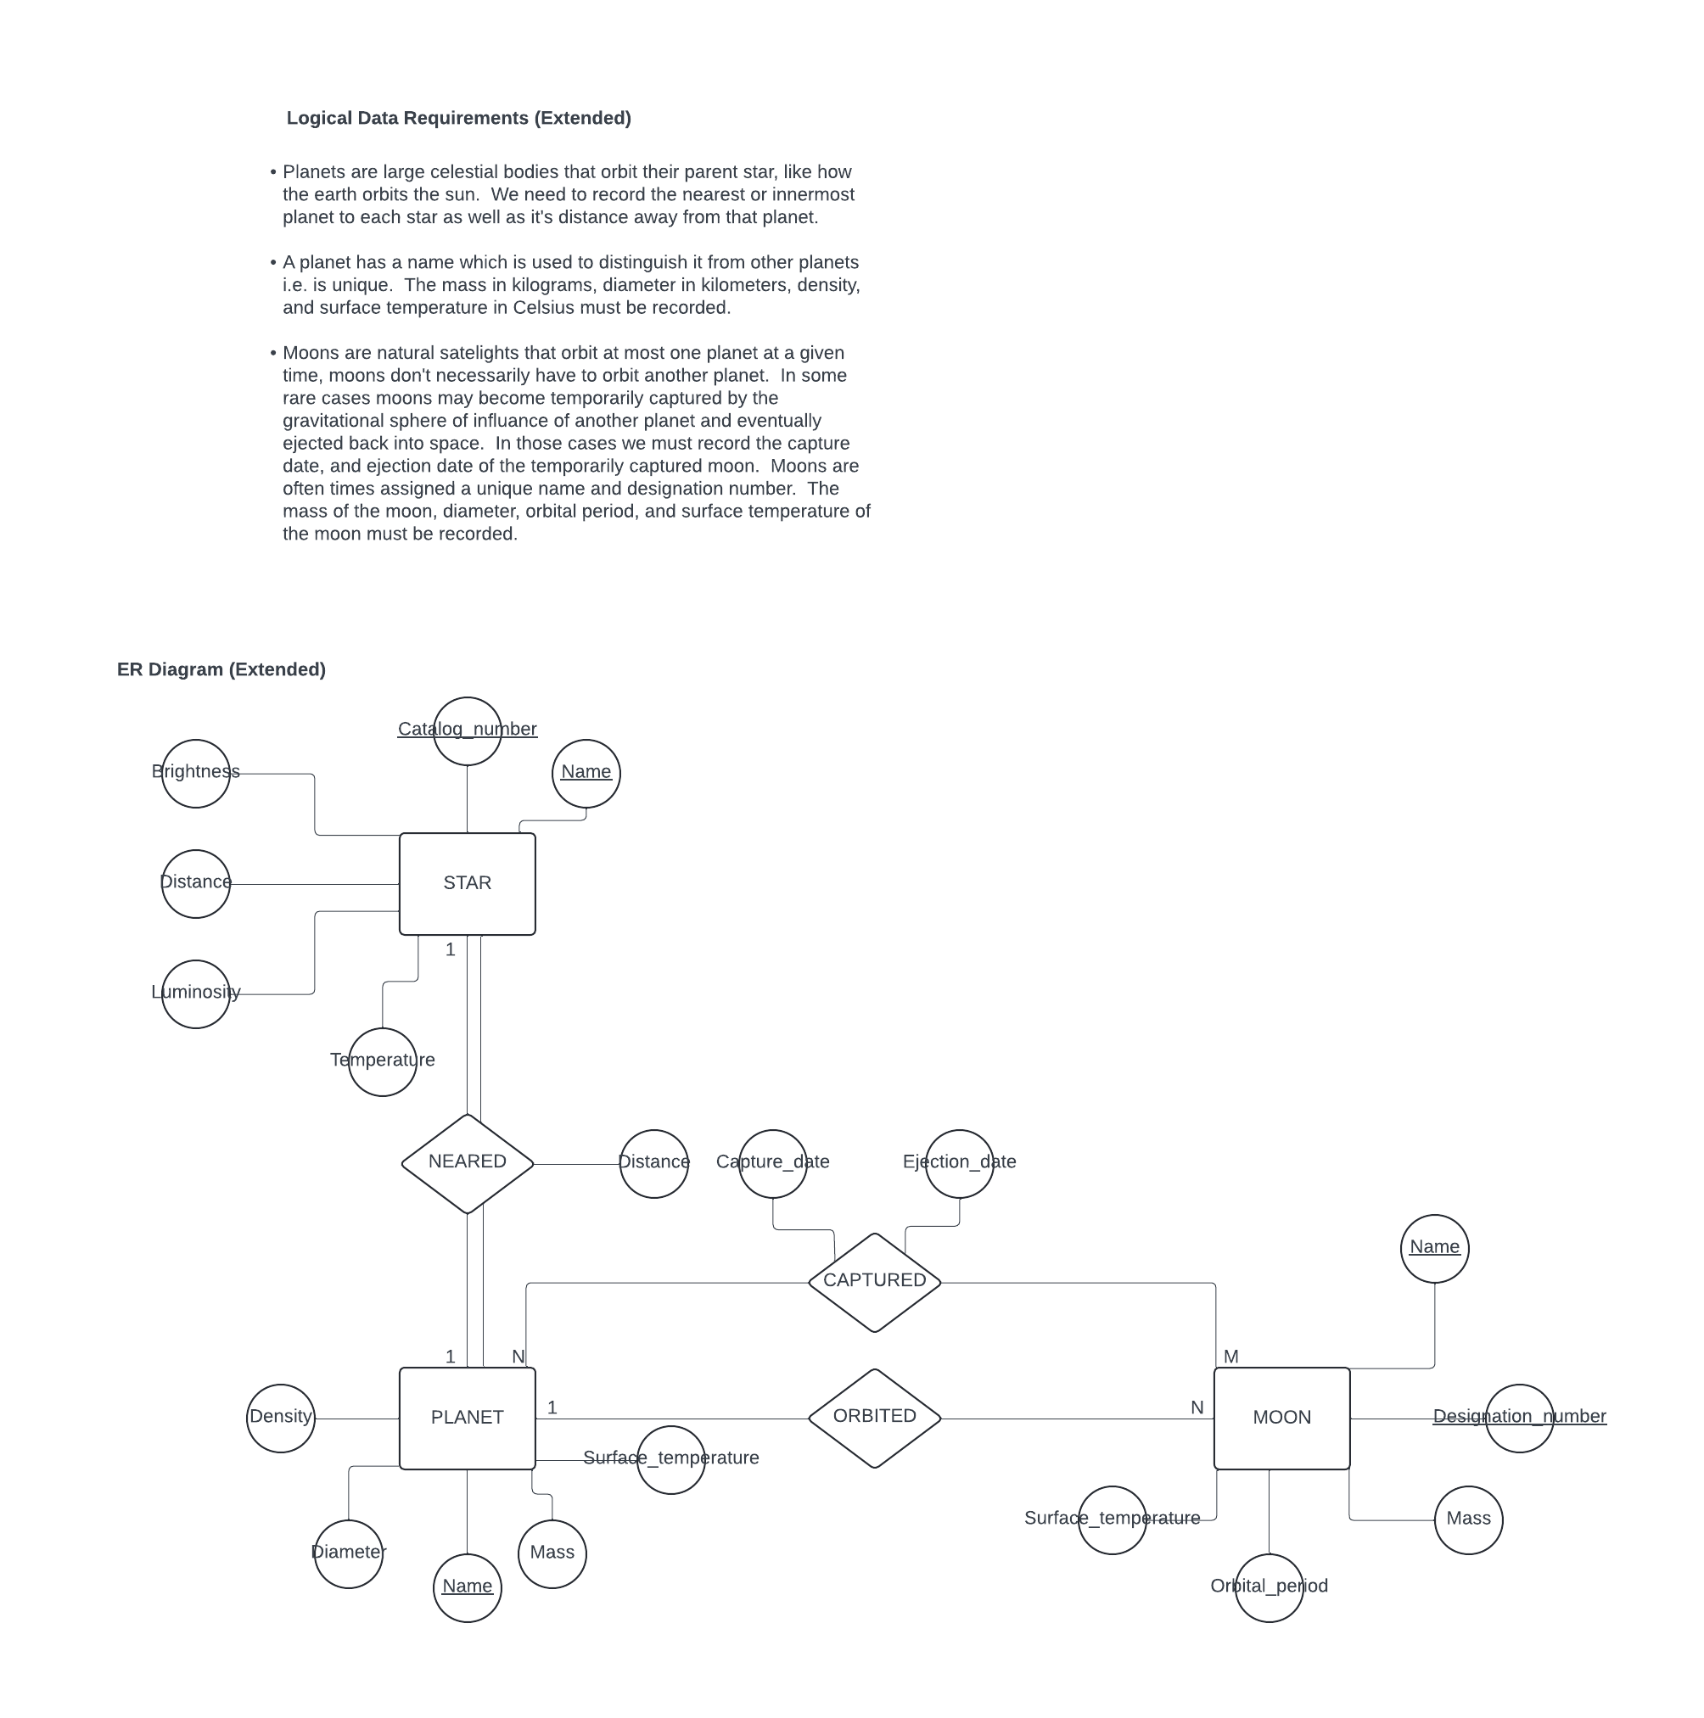

1. When performing the data model mapping for the *strong entity type* **MOON** we must specify a key constraint as the primary key in the relational schema. What criteria should we consider when selecting the attribute to become the primary key?

**The primary key should be “time invariant” i.e., not likely to change and/or be missing a value.**

1. When performing the data model mapping for the *binary 1:1 relationship type* **NEARED** what is the preferred approach for mapping this relationship type?

**The preferred approach is always the Foreign Key approach.**

1. What are the other viable approaches for mapping the *binary 1:1 relationship type* **NEARED**, and which approach would be a preferred alternative over the other based upon the extent to which the **STAR** and **PLANET** *strong entity types* are *participating* in the **NEARED** *relationship type* (please justify your answer)?

**The merged relation and cross-referenced relation approaches are alternatives to the preferred approach (both can be justified).**

1. When performing the data model mapping for the *binary 1:N relationship type* **ORBITED** we may consider using an alternative approach than what is generally preferred based upon the extent to which the **PLANET** and **MOON** *strong entity types* are *participating* in the ORBITED *relationship type* (please justify your answer)?

**The cross-referenced relation approach or the foreign key approach (both can be justified).**

1. When performing the data model mapping for the *binary N:M relationship type* **CAPTURED** what is the preferred approach for mapping this relationship type?

**The cross-referenced relation approach is the only approach for mapping binary N:M relationship types.**

*Use the following Logical Data Requirements and ER Diagram to produce the relational schema for question 37 (below).*

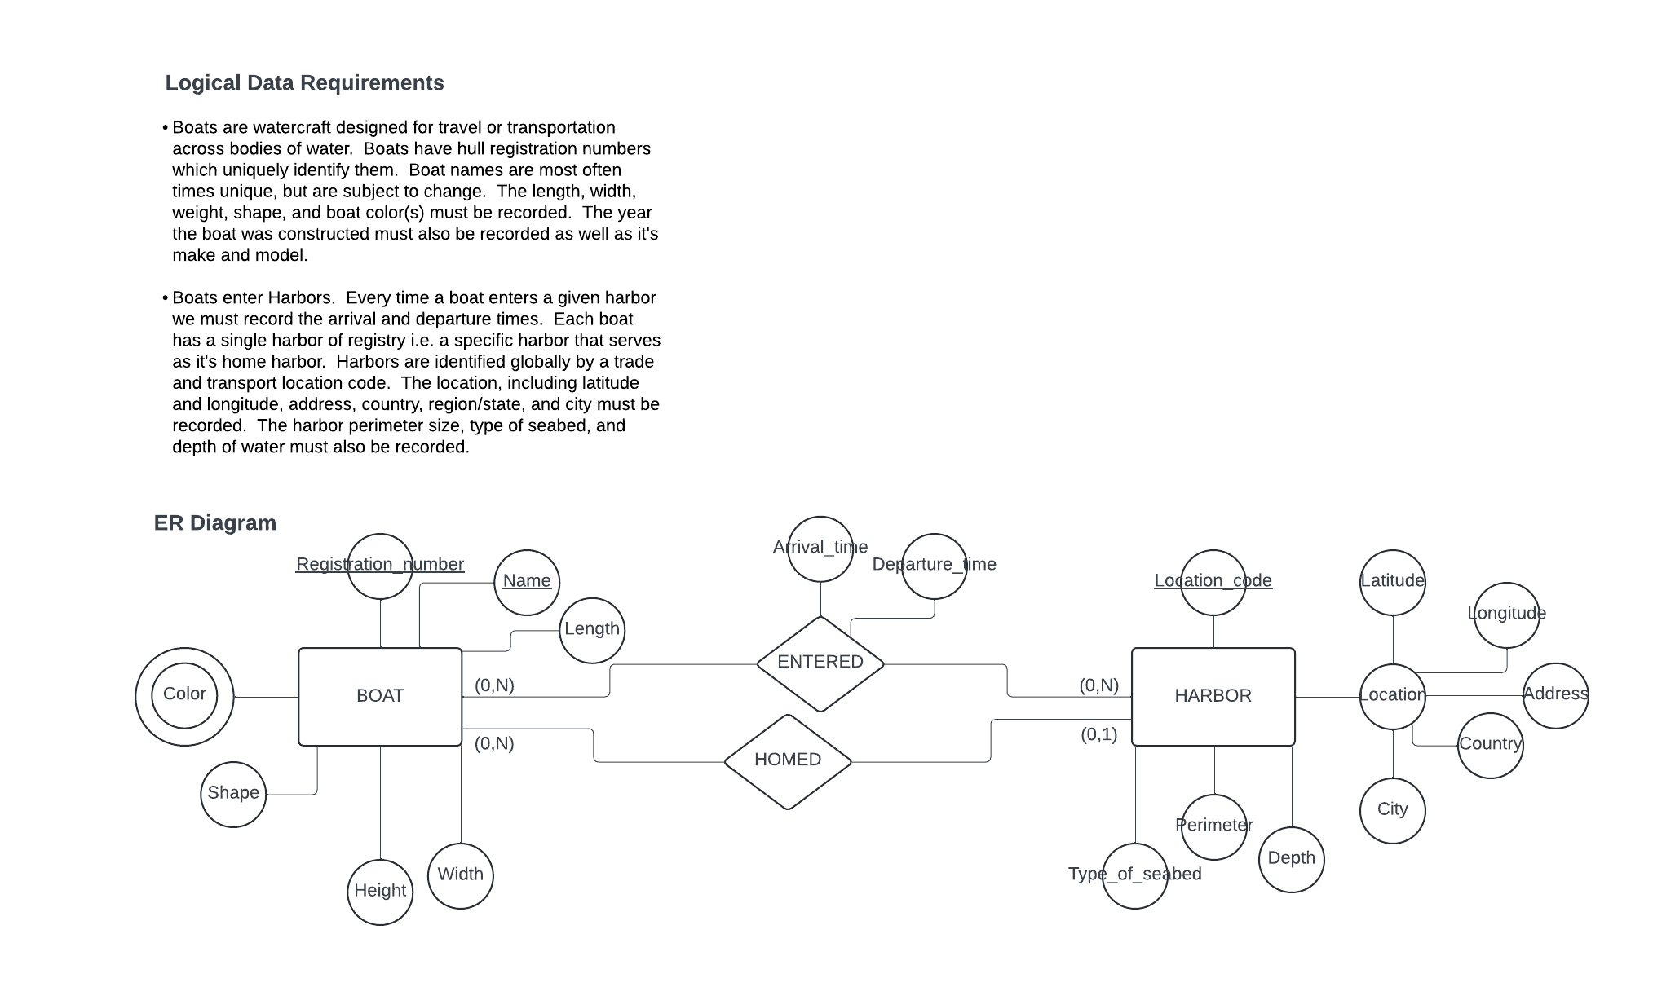

1. *Produce the relational schema corresponding to the logical data requirements and ER diagram (above) by completing parts A, B, C, D, and E (be sure to denote all integrity constraints in your relational schema, as well as giving names to each relation).*
2. Map the *strong entity type* **BOAT** to the relational model i.e., perform the first step of data model mapping on the ER diagram above (hint: use the logical data requirements to help you specify integrity constraints).
3. Map the *strong entity type* **HARBOR** to the relational model i.e., perform the first step of data model mapping (hint: use the logical data requirements to help you specify integrity constraints).
4. Map the *binary 1:N relationship type* **HOMED** to the relational model i.e., perform the fourth step of the data model mapping (hint: use the logical data requirements and/or participation constraints to help you pick the correct approach on mapping the relationship type).
5. Map the *binary N:M relationship type* **ENTERED** to the relational model i.e., perform the fifth step of the data model mapping.
6. Map the *multivalued attribute* ***Color*** to the relational model i.e., perform the sixth step of data model mapping (hint: the relation formed by this mapping will have a composite primary key).

**Relational Schema (your solution to question 37 goes here, or on SCRATCH PAPER on the last page of this quiz):**

**THIS QUESTION WAS OMITTED FROM GRADING (i.e., everyone got 15 free points)\***

**SCRATCH PAPER (31)**

**SCRATCH PAPER (37)**