Midterm Exam 1 Review Jeopardy (Key): Link [here](https://jeopardylabs.com/play/midterm-exam-1-review-3).

**DBMS-ing:**

100 – Allows multiple users and programs to access the data simultaneously (*Sharing*).

200 – Specifying the data types, structures, and constraints of the data to be stored in the database (*Defining*).

300 – The process of storing the data on some storage medium that is controlled by the DBMS (*Constructing*).

400 – Includes functions such as querying the database to retrieve specific data, updating the database to reflect changes in the mini world, and generating reports from the data (*Manipulating*).

500 (DAILY DOUBLE) – Allowing the system to evolve as requirements change over time (*Maintaining*).

**Identify that User:**

100 – This type of end user needs to know the least about the DBMS (*Naïve*).

200 – This type of end user needs to know the most about the DBMS (*Sophisticated*).

300 – Responsible for identifying the data to be stored, as well as choosing the appropriate structures to represent and store the data (*Database Designers*).

400 – Responsible for authorizing access to databases as well as coordinating and monitoring their use (*Database Administrators*).

500 – Determine the requirements of end users, especially naive and parametric end users, and develop specifications for standard canned transactions that meet these requirements (*System Analysts*).

**A10E is for Architecture:**

100 – The description of the database (*Schema*).

200 – The external, conceptual, and internal levels make up this popular DBMS architecture (*Three-Schema*).

300 – the capacity to change the schema at one level of a database system without having to change the schema at the next higher level (*Data Independence*).

400 – Satisfies the structure and constraints specified in the schema (*Valid State*).

500 – The classification of a DBMS by cost that also means free (*Open Source*).

**Looks like an Attribute:**

100 – Can be divided into smaller sub parts, which represent more basic attributes with independent meanings (*Composite Attributes*).

200 – Its values are distinct for each individual entity in the entity set (*Key Attributes*).

300 – Modeled using a dotted oval on an ER diagram (*Derived Attributes*).

400 – Modeled using a double solid lined oval on an ER diagram (*Multi-valued Attributes*).

500 (DAILY DOUBLE) – Given the following ER Diagram (below), which entity type could I move the “Start_date” attribute of the MANAGES relationship type to (*DEPARTMENT*)?

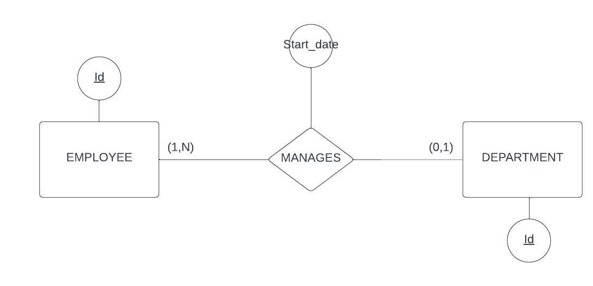

**Models are Wrong (Some are Useful):**

100 – Entities, Attributes, and Relationships are the main components of this model (*ER Model*).

200 – The number of participating entity types in a relationship type R (*Degree*).

300 – This type of participation is implied by the following structural constraints written in min-max notation (1,N) (*Total Participation*).

400 – The name for this entity type, which cannot be uniquely identified by itself (*Weak Entity Type*).

500 – The name for this constraint, which determines if a super class must be included in at least one of its sub classes for a given super class / sub class relationship. (*Completeness Constraint*).

**Final Jeopardy:**

Model the following logical data requirements with the ER modeling techniques (and best practices).

Projects are uniquely identified by a project id. Each project has many tasks, and a given task can be associated to at most one project. A task cannot be uniquely identified apart from the project it is associated to. Each task has a task identifier which starts at 1 and increases with each successive task on the project (hence the task identifier is not unique across projects). Lastly, we must also record the due date of each task that is associated to a project.

