Chapter 1 & 2 Exercises

1. What is the informal or general definition of a database?
2. Give a more formal definition of a database (include the three key implicit properties we discussed in class)?
3. What is a Database Management System (DBMS)?
4. What four main actions does the Database Management System (DBMS) help us to facilitate in relation to the database (please complete the actions below as well as providing a short description)?
   1. **D –**
   2. **C** **–**
   3. **M –**
   4. **S** **–**
5. What two other actions does the Database Management System (DBMS) help us facilitate in relation to the database (please complete the words below)?
   1. **P –**
   2. **M** **–**
6. In the database approach, data types, constraints, and locations of the data are stored where?
7. This mechanism of storing data (see question 6) separately from the data types, constraints, and locations of the data facilitates this type of data independence or abstraction?
8. What are the two main properties of a transaction (give a short description of each)?
9. What is the name for the combination of the primary database and secondary DBMS & related software?
10. The class of users who require access to the database for querying, updating, and generating reports to do their jobs?
11. Name four different types of users from the class of users described in question 10 (give a short description for each)?
12. What are three benefits of using a Database Management System (DBMS) over a file-based system?
13. When might you choose to use a file based-based system over a Database Management System (DBMS)?
14. What law predicts that the number of transistors on a microchip will double every two years?
15. Describe the difference of horizontal and vertical scalability?
16. The module that typically handles user interaction and provides the user-friendly interfaces such as apps for mobile devices, or forms or menu-based GUIs (graphical user interfaces) for PCs.
17. The module that typically handles data storage, access, search, and other functions.
18. What is the suppression of details of data organization and storage referred to as (in general)?
19. What is the collection of concepts that can be used to describe the structure of a database referred to as?
20. What are the three types of general data models (name, and give a short description for each)?
21. What are the three general components of the *Conceptual Data Model* (name and give a short description for each)?
22. This is referred to as the “description of the database”, is specified during database design, and is not expected to change frequently?
23. What is the data in a database at a particular moment in time referred to as?
24. What is the state of the database called that corresponds to when it satisfies the structure and constraints specified in the schema?
25. Changes occasionally need to be applied to the schema as the application requirements change, this is referred to as what?
26. What are the three levels of the three-schema architecture (name, and give a short description for each)?
27. What level of the three-schema architecture is the actual data stored at?
28. What is the process of transforming requests and results between levels of the three-schema architecture?
29. What is data independence (in relation to the three-schema architecture)?
30. Define the two types of data independence?
31. Which type of data independence is harder to achieve and why?
32. The high-level DML (Data Manipulation Language) used in a standalone interactive manner is referred to as what?
33. This type of language is used by the DBA and database designers to define the schema.
34. Name the three remaining criteria we use to classify a given Database Management System (DBMS) (I’ve given you the first one to get you started)?
    1. we classify a given DBMS by the data model it’s based upon.
       1. Relational data model referred to as SQL systems.
       2. Object data model referred to as NOSQL systems.

*Please complete sections 1 – 3 for the course on Java programming on Code Academy* [*here*](https://www.codecademy.com/learn/learn-java) *(see screenshot below). Please include screenshots proving you’ve completed these three modules in your submission.*

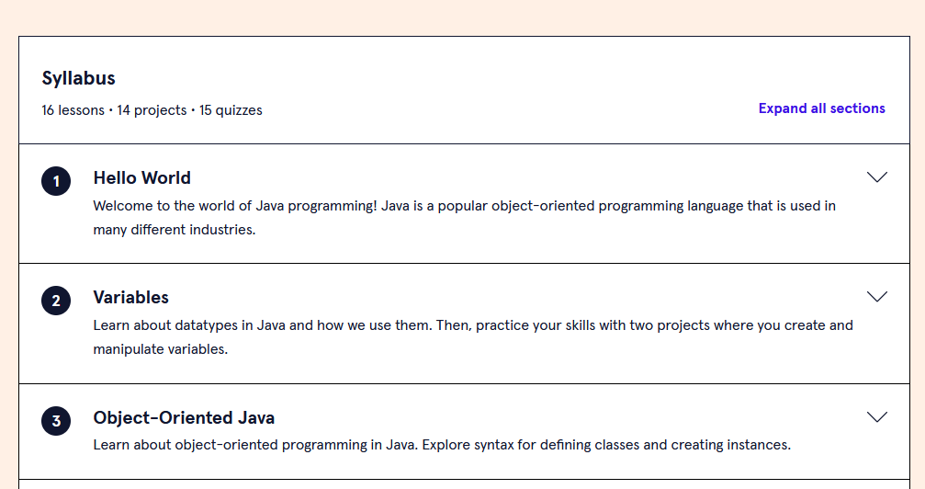

*Please include screenshots here (below):*