*CSCI 340 Database Design – Midterm Exam 1*

*Name:*

*Student Id:*

**Databases and Database Users**

1. Is most generally referred to as a collection of related data?

Database

1. A computerized system that enables users to create and maintain a database is referred to as (please write out the entire name, not just the acronym)?

Database Management System (DBMS)

1. The answers to questions 1 & 2 together are referred to as this?

Database System

*For questions 4 – 7 please fill in the blank(s) with the function(s) of the DBMS described.*

1. *Constructing* the database is the process of storing the data on some storage medium that is controlled by the DBMS.
2. *Manipulating* a database includes functions such as querying the database to retrieve specific data, updating the database to reflect changes in the mini world, and generating reports from the data.
3. *Defining* a database involves specifying the data types, structures, and constraints of the data to be stored in the database. The database definition or descriptive information is also stored by the DBMS in the form of a database *catalog* or dictionary; it is also referred to as *meta-data*.
4. *Sharing* a database allows multiple users and programs to access the data simultaneously.
5. Explain how the application program (below) violatesprogram-data independence. How does the DBMS solve this problem?

public static List<Student> getStudents() throws FileNotFoundException{

File studentFile = new File("./08_29_2024/src/Student.txt");

Scanner myScanner = new Scanner(studentFile);

myScanner.nextLine(); // Skip data member names.

ArrayList<Student> myStudents = new ArrayList<Student>();

// Read students from file until there are no more.

while(myScanner.hasNextLine()){

String myLine = myScanner.nextLine().replaceAll("\n","");

String[] tokens = myLine.split(",");

int id = Integer.parseInt(tokens[0]);

String name = tokens[1];

int age = Integer.parseInt(tokens[2]);

String email = tokens[3];

Student myStudent = new Student(id, name, age, email);

myStudents.add(myStudent);

}

return myStudents;

}

1. These users (give the role name) are responsible for authorizing access to databases as well as coordinating and monitoring their use?

Database Administrator

1. These users (give the role name) are responsible for identifying the data to be stored, as well as choosing the appropriate structures to represent and store the data?

Database Designer

1. Rank the following types of end users from 1 (needs to know the most about the DBMS) to 3 (needs to know the least about the DBMS).

|  |  |
| --- | --- |
| **User Type** | **Rank** |
| Casual | 2 |
| Naïve | 3 |
| Sophisticated | 1 |

1. These type of end users are generally characterized by their use of personal databases.

Standalone (End Users)

1. Name one possible downside of not controlling data redundancy (give one of the downsides we discussed in class)?

* Data Inconsistencies
* Duplication of Effort
* Wasted Storage Space (Cost)

1. Which of the following is *not* an **advantage** of using the DBMS approach?
   1. Restricting Unauthorized Access.
   2. Providing Persistent Storage for Program Objects.
   3. Controlling Redundancy.
   4. All (a, b, and c) are advantages of using the DBMS approach.
2. Why might an organization choose **not** to use a DBMS (give one of the reasons we discussed in class)?

* Embedded Systems (Storage Limitations)
* Short Timelines
* Small Project Scope
* Low Budget

**Database System Concepts and Architecture**

1. The module typically composed of application programs and user interfaces that access the database.

Client Module

1. The module typically responsible for handling data storage, access, search, and other functions.

Server Module

1. The “description of the database” also referred to as this, is specified during database design, and is not expected to change frequently?

Schema

1. The data in a database at a particular moment in time.

Database State (Snapshot)

1. This type of language is used by the DBA and database designers to define the schema.

DDL (Data Definition Language) – SQL

1. This architecture adds an intermediate layer between the client and the database server (see figure below).

Three-tier Architecture

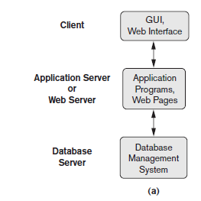

*For questions 22 – 27 please refer to Figure 2.2 (below).*

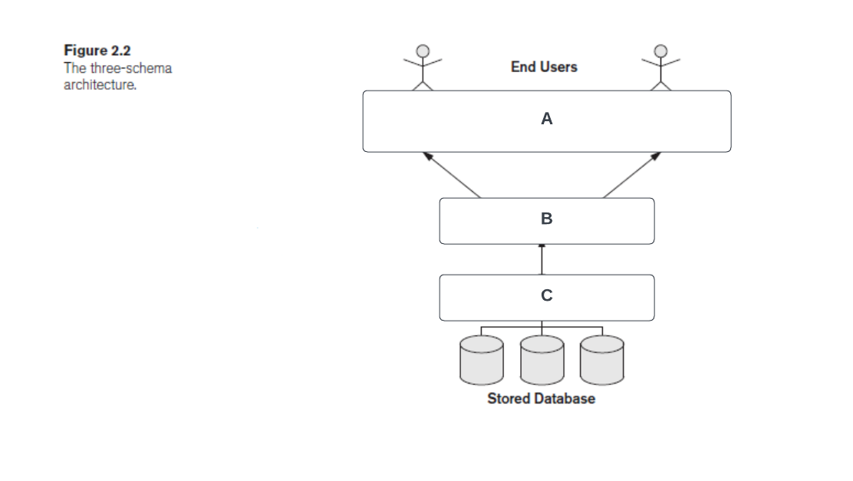

1. What is the level of the three-schema architecture labeled “**C”** (above) referred to as?

Internal Schema (Physical)

1. What is the level of the three-schema architecture labeled “**A”** (above) referred to as?

External Schema

1. What is the level of the three-schema architecture labeled “**B”** (above) referred to as?

Conceptual Schema

1. Describe logical data independence. In your answer, please include the levels of the three-schema architecture involved.

Ability to make changes to the Conceptual Level without having to change the External Level or Application Programs.

1. Describe physical data independence. In your answer, please include the levels of the three-schema architecture involved.

Ability to make changes to the Internal Level without having to change the Conceptual Level (External Level).

1. At what level of the three-schema architecture is the actual data stored in (give the name, not just the letter)?

Internal Schema (Physical)

1. True or false, in general physical data independence is harder to achieve?

False

1. What are four characteristics that are generally used to classify a Database Management System?

* Cost (Open Source vs. Proprietary)
* Data Model
* Number of Users (Single User vs. Multiuser)
* Number of Sites (Centralized vs. Distributed)

1. Name a fifth (for extra credit).

The number of different DBMS software across sites (Heterogenous vs. Homogenous)

**Data Modeling Using the Entity – Relationship (ER) Model**

1. These types of requirements are defined as a concisely written set of users’ requirements, and should be specified in as detailed and complete a form as possible?

Logical Data Requirements

1. What are the three basic components of the ER Model?

Entities, Attributes, Relationships

1. Which of the three (from question 32) makes up most of the data stored in a database?

Attributes

*For questions 34 – 35 please refer to the Entity Relationship (ER) diagram below.*

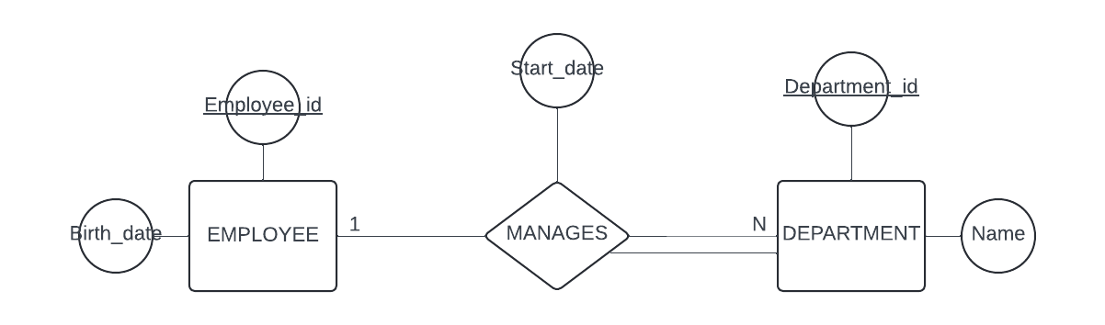

1. Which entity type could the “Start_date” attribute of the MANAGES relationship type be migrated to?

DEPARTMENT

1. Model the “MANAGES” relationship type using “min-max” notation (please include the participating entity types in your answer).

*For questions 36 – 41 please refer to and/or extend the Entity Relationship (ER) diagram below.*

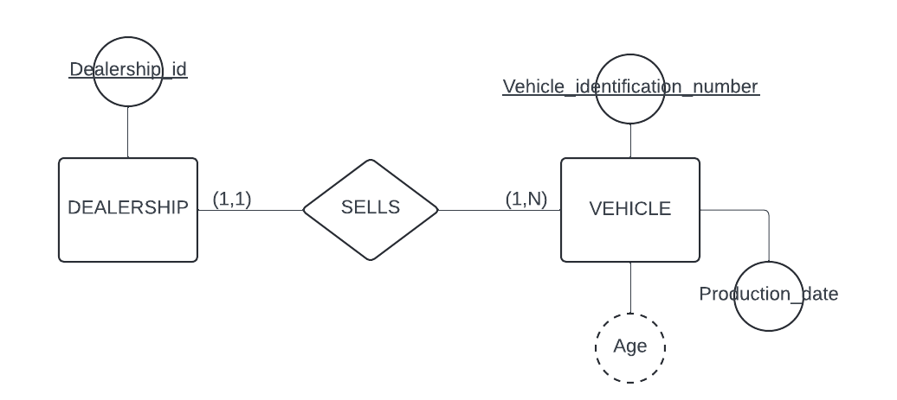

1. What type of attribute is “Age” on the VEHICLE entity type?

Derived Attribute

1. What type of attribute is “Dealership_id” on the DEALERSHIP entity type (hint: there is more than one)?

Key Attribute, Stored Attribute, Simple Attribute, Single Valued Attribute

1. Model a new attribute “Colors” on the VEHICLE entity type (assume a single vehicle can be “two-toned” or have *multiple* colors ).

(Multi-valued attribute) Double Ellipse from Vehicle

1. Model a new attribute “Address”, which is *composed* of “City”, “State”, and “Zip” on the DEALERSHIP entity type (assume the end users are interested in accessing the *atomic* parts of the Address, as well as the Address as a whole).

Address (Single Ellipse) with City, State and Zip from Address (Also Single Ellipse)

1. What *degree* is the “SELLS” relationship type?

2

1. What is the formal name for relationship types of this degree (from question 40)?

Binary Relationship Types (1:N, 1:1, N:1, N:M)

1. The cardinality ratio and participation constraints, taken together, are referred to as what?

Structural Constraints (min-max)

1. Produce the ER Model (below) for the following data requirements (*assume that a dependent cannot be uniquely identified apart from its relationship with an employee*).

* The database will keep track of employees. Employees are uniquely identified by their Ssn. The name of the employee must also be recorded in the database.
* The database will keep track of the dependents of each employee for insurance purposes, including each dependent’s first name, sex, and birth date.

1. How many total entity sets (without ordering) are there for an entity type E with 3 entity instances (please explain your answer)?

8

1. True or false, in the ER Model, an entity type E is only allowed to have a single key attribute?

False

1. When the same entity type participates more than once in a relationship type (in different roles), what kind of relationship exists?

Recursive or Self-Referencing Relationship

**The Enhanced Entity – Relationship (EER) Model**

1. True or false, an entity cannot exist in the database merely by being a member of a subclass; it must also be a member of the superclass?

True

*For questions 48 – 50 please refer to the Extended Entity Relationship (EER) diagram below.*

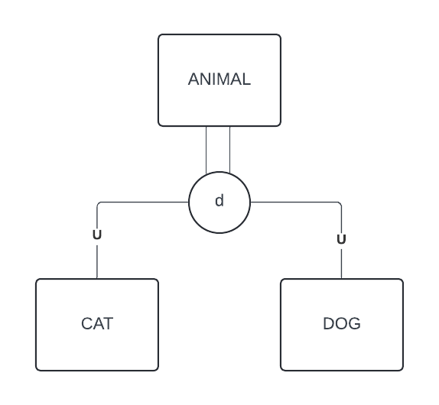

1. Assuming the entity types of the superclass / subclass relationship were modeled in the following order: ANIMAL, CAT, DOG. What process was followed (Generalization or Specialization)?

Specialization

1. Does the EER diagram (above) represent an inheritance hierarchy or an inheritance lattice?

Hierarchy

1. Name the two structural constraints of a Superclass / Subclass relationship and label them on the EER diagram (above).

Disjointness Constraint – oval with d

Completeness Constraint – double solid line between d and animal.

**SCRATCH PAPER**