CSCI 340 – Database Design Syllabus

Autumn Semester 2024

# General Course Information

## Course Information

|  |  |
| --- | --- |
| School name: | University of Montana |
| Course number: | CSCI 340 |
| Letter designation: | N/A |
| Section number: | 01 |
| Course title: | Database Design |
| Number of credits: | 3 |
| Prerequisite(s) or corequisite(s): | CSCI 232. Prerequisites will be waived only for students that can demonstrate clear mastery of CSCI232, or in special circumstances those who are taking CSCI232 as a corequisite. Students taking this course without the prerequisite or corequisite course do so at their own risk, it is not the instructor’s responsibility to get you up to on the topics covered in that class. |

## Instructor Information

|  |  |
| --- | --- |
| Name of instructor: | Addison Boyer |
| Email: | Addison.Boyer@UMontana.edu |
| Office Location: | Social Science 406 |
| Office Hours: | Tuesday & Thursday 10 a.m. - 11:00 a.m., or by appointment (Schedule via Microsoft Teams) |
| Teaching Assistant(s): | N/A |

## Class Times & Location

Lecture: Tuesday & Thursday 11 a.m. – 12:20 p.m. (Social Science 362). *Attendance is strongly encouraged.*

Virtual Classroom on [Microsoft Teams](https://teams.microsoft.com/l/meetup-join/19%3ameeting_NzAwNmQ3YjktODM5OC00Y2IzLTk1N2QtMjk1NTU0MzhiYTgw%40thread.v2/0?context=%7b%22Tid%22%3a%2268407ce5-03da-49ff-af0a-724be0d37c9d%22%2c%22Oid%22%3a%2200d88027-4dc3-405d-bb7f-1070c807deec%22%7d).

# Course Information

## Course Description & Objectives

Databases are an essential and ubiquitous part of everyday life, and many of our day-to-day tasks involve the use of an underlying database in some form or another. As computer scientists, it is critical that we understand fundamental concepts of databases and database management systems (DBMS), including how they are designed, implemented, queried, and maintained. In this class, we will learn about data modeling, relational models, normal forms, file organization, index structures, SQL, and Java Spring Boot API’s. Throughout the course, students will work on a project that involves the design and implementation of a web-accessible database and API using Java Spring Boot and MSSQL.

## Student Learning Outcomes

# Upon successful completion of this class, students should be proficient with the following:

* Database system terminology, concepts, and architecture.
* Database design, including requirements specification, and ER modeling.
* Relational data model concepts, schemas, and constraints.
* Functional dependencies, and the process of normalization.
* Programming in SQL, Java Spring Boot, and MSSQL.
* File organizations, including single and multi-level indexing structures.

## Course Format

## The course will primarily be delivered through lectures based on the textbook. Students will work independently on a semester-long project that aligns closely with the content covered in the lectures. Evaluation will be based on homework assignments that assess comprehension of the textbook and lecture material. Additionally, two midterm exams will be administered to gauge overall understanding of the material presented in lectures and the textbook. Students are expected to complete the required readings before class and are encouraged to ask questions if any topics from the readings are unclear. Most of the grade in this class is the semester long project, starting on this project early is highly encouraged so that students don’t get behind.

## Materials

Textbook: [Fundamentals of Database Systems Seventh Edition by Ramez Elmasri & Shamkant B. Navathe](https://www.amazon.com/Fundamentals-Database-Systems-Ramez-Elmasri/dp/0133970779/ref=tmm_hrd_swatch_0?_encoding=UTF8&dib_tag=se&dib=eyJ2IjoiMSJ9.osmN84SAp-z6ol-dE6uGQlHJd5Yu4-u97M5t_rU8HDnGjHj071QN20LucGBJIEps.IL8MYuOer0qC9iEveCcJfOp92MPFZuD8TAaRPn7dvtg&qid=1705580594&sr=8-5).

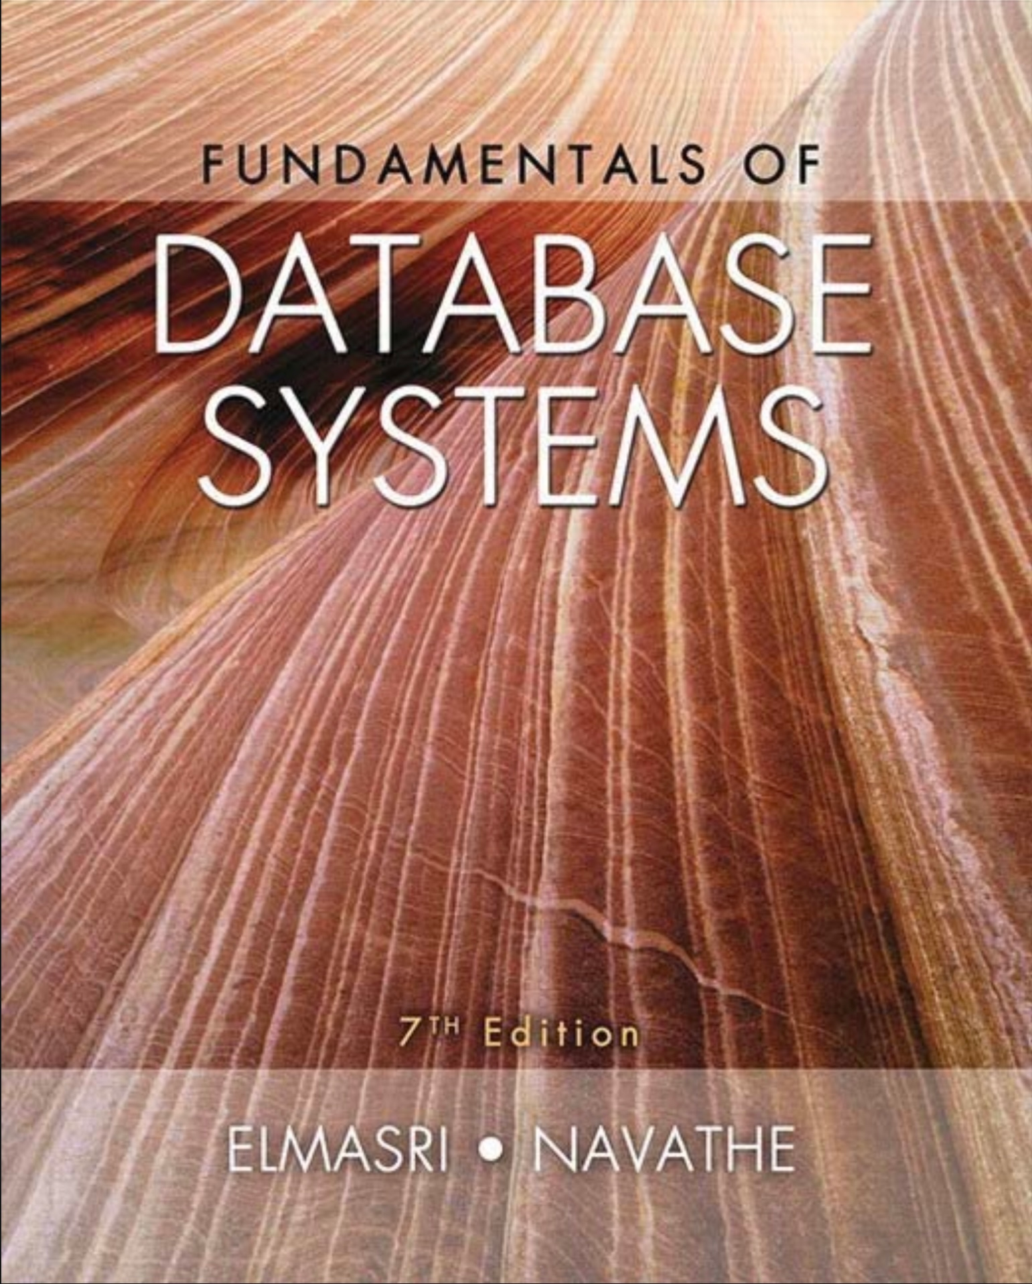

GitHub (Source Control): <https://github.com/addiboyer24/CSCI340_DatabaseDesign_Autumn2024> (I will upload lecture materials and assignment documents here).

Lucid Chart (Diagramming Tool): <https://lucid.app/>

Microsoft Teams (Meeting Software): <https://teams.microsoft.com/l/meetup-join/19%3ameeting_NzAwNmQ3YjktODM5OC00Y2IzLTk1N2QtMjk1NTU0MzhiYTgw%40thread.v2/0?context=%7b%22Tid%22%3a%2268407ce5-03da-49ff-af0a-724be0d37c9d%22%2c%22Oid%22%3a%2200d88027-4dc3-405d-bb7f-1070c807deec%22%7d> (Lectures will be recorded and available for download here).

IntelliJ Idea Community (IDE for Java Development): <https://www.jetbrains.com/idea/download/?section=windows> (The are supported versions of this IDE for MacOS and Linux respectively).

Azure Data Studio (Data Management and Development):

<https://learn.microsoft.com/en-us/azure-data-studio/download-azure-data-studio?view=sql-server-ver16&tabs=win-install%2Cwin-user-install%2Credhat-install%2Cwindows-uninstall%2Credhat-uninstall>

Microsoft Azure Portal (Cloud Hosted Databases):

<https://portal.azure.com/> (you can login with your university email, and you will be redirected to the University of Montana NetId login page).

## Course Calendar

**Important Dates:**

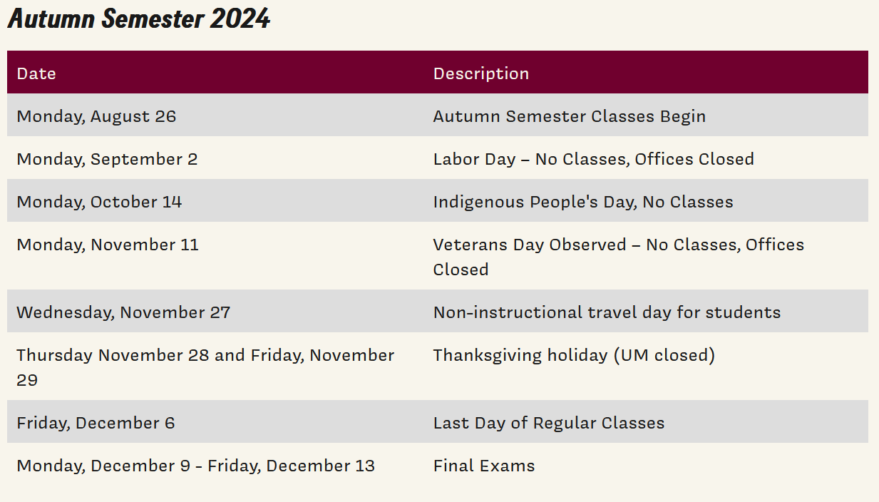

**Course Schedule (Tentative and Subject to Change*):**

|  |  |  |
| --- | --- | --- |
| Week/Dates | Topics | Assessments |
| 1 | Databases and Database Users |  |
| 2 – 3 | Database System Concepts and Architecture |  |
| 4 – 5 | Data Modeling Using the Entity–Relationship (ER) Model |  |
| 5 – 6 | The Enhanced Entity–Relationship (EER) Model | Midterm Exam 1 *(Thursday October 3rd, 2024).* |
| 7 – 8 | The Relational Data Model and Relational Database Constraints |  |
| 9 | Basic SQL |  |
| 10 – 12 | Relational Database Design by ER- and EER-to-Relational Mapping |  |
| 13 - 14 | Web Database Programming Using Java Spring |  |
| 15 | More SQL: Complex Queries, Triggers, Views, and Schema Modification | Midterm Exam 2 *(Tuesday December 3rd, 2024).* |
| 16 | Final Exam / Project Presentations | Final Exam / Project Presentations *(Friday December 13th, 2024, 10:10 a.m. – 12:10 p.m.).* |

# Grading Information

Your grade for the course will be determined by the following elements (please mark your calendars for dates in Midterm Exams and Final Exam sections respectively. I will not offer make up exams (except under very special circumstances).

## Grading Criteria

Midterm Exams: (20%)

Chapter Exercises: (20%)

Final Exam: (15%)

Semester Long Project (45%)

## Grading Scale

|  |  |
| --- | --- |
| **Letter Grade** | **Percentage Range** |
| A | 93 – 100 |
| A- | 90 – 93 |
| B+ | 87 – 90 |
| B | 83 – 87 |
| B- | 80 – 83 |
| C+ | 77 – 80 |
| C | 73 – 77 |
| C- | 70 – 73 |
| D+ | 67 – 70 |
| D | 63 – 67 |
| D- | 60 – 63 |
| F | 0 – 60 |

# Course Expectations & Policies

## Attendance Policy

Attendance to lectures is highly encouraged (but not required). *Midterm and final exams will be administered in class, and attendance will be required on those days (****please mark your calendars****).*

## Late Submissions

**Always** - a 10-minute grace period. Don't forget to turn things in.

**First late assignment** - 10 percentage point deduction.

**Second late assignment** - 30 percentage point deduction.

**Third or more late assignments** - a grade of 0 percent will be assigned.

**How late can late be?** - assignments can be turned in late until the next assignment is due. After that, they will not be accepted and a grade of 0 assigned.

*Exceptions to this poli**cy will be rare.*

## Course Workload

For a three-credit course, students are generally expected to spend about **6 to 9 hours** per week outside of class. This estimate is based on the commonly accepted guideline that for each credit hour of a course, students should spend approximately 2 to 3 hours per week outside of class on coursework, study, and other academic activities.

## Communication Expectations

Participation in class is highly encouraged. I will often call upon students in the class to answer questions related to the assigned readings (so please come to class prepared to discuss the content covered in the reading for that week). If you need additional help, please come to office hours prior to class (see times above), or schedule a meeting with me through Microsoft teams or email.

## Academic Misconduct and the Student Conduct Code

The [Student Conduct Code](https://www.umt.edu/campus-life/community-standards/um_student_code_of_conduct.pdf) at the University of Montana embodies and promotes honesty, integrity, accountability, rights, and responsibilities associated with constructive citizenship in our academic community. This Code describes expected standards of behavior for all students, including academic conduct and general conduct, and it outlines students' rights, responsibilities, and the campus processes for adjudicating alleged violations.

## ODE Accommodations

The University of Montana assures equal access to instruction through collaboration between students with disabilities, instructors, and the Office for Disability Equity (ODE). If you anticipate or experience barriers based on disability, please contact the ODE at 406-243-2243 or [ode@umontana.edu](mailto:dss@umontana.edu), or visit [Office of Disability Equity website.](http://www.umt.edu/disability) for more information. Retroactive accommodation requests will not be honored, so please, do not delay. As your instructor, I will work with you and the ODE to implement an effective accommodation, and you are welcome to contact me privately if you wish.

## Health and Safety Policies (if applicable)

If you are feeling unwell, please let me know via Microsoft teams or email (especially if you will potentially miss a scheduled lecture or exam).

# Information for Students

## Land Acknowledgement

The University of Montana acknowledges that we are in the aboriginal territories of the Salish and Kalispel people. Today, we honor the path they have always shown us in caring for this place for the generations to come.

## Inclusion Policies

The University of Montana values leadership, engagement, **diversity**, and sustainability, because our institution is committed to respecting, welcoming, encouraging, and celebrating the differences among us.

As members of the University of Montana community, we aspire to:

* Respect the dignity and rights of all persons.
* Practice honesty, trustworthiness, and academic integrity.
* Promote justice, learning, individual success, and service.
* Act as good stewards of institutional resources.
* Respect the natural environment.

## Cultural Leave Policy

Cultural or ceremonial leave allows excused absences for cultural, religious, and ceremonial purposes to meet the student's customs and traditions or to participate in related activities. To receive an authorized absence for a cultural, religious, or ceremonial event the student or their advisor (proxy) must submit a formal written request to the instructor. This must include a brief description (with inclusive dates) of the cultural event or ceremony and the importance of the student's attendance or participation. Authorization for the absence is subject to approval by the instructor. Appeals may be made to the Chair, Dean or Provost. The excused absence or leave may not exceed five academic calendar days (not including weekends or holidays). Students remain responsible for completion or make-up of assignments as defined in the syllabus, at the discretion of the instructor.

## Food & Housing Insecurity

Any student who faces challenges securing food or housing and believes that this could affect their performance in this course, is urged to contact any or all the following campuses resources.

Food Pantry Program

UM offers a food pantry that students can access for emergency food. The pantry is open on Tuesdays from 12 to 5 PM and Fridays from 10 AM to 5 PM. The pantry is in UC 119 (in the former ASUM Childcare offices). Pantry staff operate several satellite food cupboards on campus (including one at Missoula College). For more information about this program, email [umpantry@mso.umt.edu](mailto:umpantry@mso.umt.edu), visit the [UM Food Pantry website](https://www.umt.edu/asum/agencies/food-pantry/default.php) or contact the pantry on social media (@pantryUm on twitter, @UMPantry on Facebook, um_pantry on Instagram).

ASUM Renter Center

The Renter Center has compiled a [list of resources](https://medium.com/griz-renter-blog/basic-needs-insecurity-on-college-campuses-a-growing-issue-9775f6d721d2) (<https://medium.com/griz-renter-blog>) for UM students at risk of homelessness or food insecurity. Students can schedule an appointment with Renter Center staff to discuss their situation and receive information, support, and referrals.

TRiO Student Support Services

TRiO serves UM students who are low-income, first-generation college students or have documented disabilities. TRiO services include a textbook loan program, scholarships and financial aid help, academic advising, coaching, and tutoring.  
   
Students can [check their eligibility](http://www.umt.edu/triosss/apply.php) (www.umt.edu/triosss/apply.php) for TRiO services online. If you are comfortable, please come see members of the teaching team. We will do our best to help connect you with additional resources.

The Writing and Public Speaking Center

[The Writing and Public Speaking Center](http://www.umt.edu/writingcenter) provides a collaborative learning environment for all members of the University of Montana community. Professional tutors support undergraduates, graduate students, alumni, faculty, and staff working on a wide variety of academic, professional, and creative writing tasks.

Online and in-person appointments are available six days a week. Same-day appointments are often available!

The Math Learning Center

[The Math Learning Center](https://www.umt.edu/math/undergraduate/all-students/free-tutoring.php) has in-person, drop-in tutoring to help students with homework and test preparation needs. Check their website for drop-in hours and location.

UM Information Technology

Get the technology, tools, and services you need. Visit the [UM IT webpage](https://www.umt.edu/it/default.php) for services and self-help articles, or contact the help desk directly by calling 406.243.HELP (4357) or emailing [ithelpdesk@umontana.edu](mailto:ithelpdesk@umontana.edu). The Help Desk is open **Monday through Friday, 8 AM - 5 PM Mountain Time** (excluding University holidays).

Supporting Mental Well-Being of Students at UM

At UM, we value every student’s wellbeing and believe that taking care of yourself is imperative to your success as a student. College students often experience issues that may interfere with academic success such as academic stress, sleep problems, juggling responsibilities, life events, relationship concerns, or feelings of anxiety, hopelessness, or depression. If you or a friend is struggling, we strongly encourage seeking support. Helpful, effective resources are available on campus.

* If you are struggling with this class, please visit during office hours or contact me by email.
* Check-in with your academic advisor if you are struggling in multiple classes, unsure  
   whether you are making the most of your time at the University of Montana.
* Reach out for Counseling Support at Curry Health Center Counseling. To make a counseling appointment call 406-243-4712 or go online to the Curry Health Portal to schedule an appointment.
* If you feel you need accommodations for a mental health concern, reach out to the Office of Disability Equity (ODE) at 406-243-2243.
* If you feel that you would benefit from general wellness skills to support your overall stress reach out to CHC-Wellness at 406-243-2809.
* If you have experienced sexual assault, relationship violence, bullying, intimidation, or discrimination contact the Student Advocacy Resource Center (SARC) 406-243-4429 *24/7 support line 406-243-6559.
* If you are experiencing a mental health crisis and seeking immediate help, call 911, go to the nearest hospital emergency room or call Campus Safety at 406-243-4000.