[**CSCI 391 – ST: Microservices Midterm Exam 1 Review Jeopardy**](https://jeopardylabs.com/play/csci-391-st-microservices-midterm-exam-1-review)

**Microservice Fundamentals**

100 – This advantage of microservices allows us to pick the right tool for each job rather than taking a standardized, one-size-fits-all approach?

What is Technology Heterogeneity.

200 – This disadvantage of microservices results from breaking up the monolithic database schema? What is Reporting.

300 – Often referred to as a single unit of deployment, it may be characterized as single process, modular, or distributed?

What is a Monolith or Monolithic.

400 – To have a true microservices architecture, this core concept must be achieved for each microservice.

What is Independent Deployability.

500 – Implementation of this enabling technology is strongly advocated as a prerequisite to adopting a microservice architecture.

What is Log Aggregation & Tracing.

**Coupling & Cohesion**

100 –The lowest, loosest, or most desirable form of coupling.

What is Domain Coupling.

200 – DAILY DOUBLE (question about time for parallel calls vs. sequential calls).

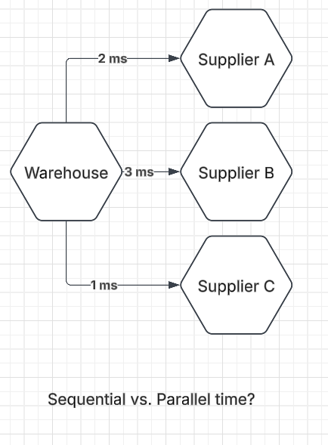

300 – This law states that a structure is stable if cohesion is strong, and coupling is low.

What is Constantine’s Law.

400 – This type of coupling is sometimes acceptable in situations where you have static reference data.

What is Common Coupling.

500 – Another name for content coupling due to it being the highest, tightest, or least desirable form of coupling.

What is Pathological Coupling.

**Microservice Communication**

100 – This communication pattern is used when one microservice puts data into a defined location, and another microservice (or potentially multiple microservices) then makes use of the data.

What is Communication through Common Data.

200 – This communication pattern makes perfect sense for any situation in which the result of a request is needed before further processing can take place.

What is Request-response communication.

300 – DAILY DOUBLE. Something happened too late (you didn’t get it in time), or something happened too early!

What is Timing Failure.

400 – The medium by which we transmit a request, response, or event payload?

What is a Message.

500 – This communication pattern is advantageous when trying to reduce the amount of temporal coupling within your systems?

What is Event-driven communication.

**Implementation Details**

100 – Frameworks that allow for local method calls to be invoked on a remote process.

What are Remote Procedure Calls.

200 – An obvious choice for a synchronous request-response interface if you are looking

to allow access from as wide a variety of clients as possible.

What is REST or REST over HTTP.

300 – An obvious fit for mobile devices given their constraints in terms of their limited ability to surface data to the end user and the nature of mobile networks.

What is GraphQL.

400 – These serialization formats give clients a lot of flexibility in how they consume resources.

What are Textual Formats.

500 – One or many microservice instances that work together to process messages from a message broker, such as Kafka, RabbitMQ, or others.

What is a Consumer Group.

**Microservice Decomposition**

100 – Refers to the idea that we should strive to use the same terms in our code as the users use.

What is Ubiquitous Language.

200 – A collection of objects that are managed as a single entity, typically referring to real-world concepts.

What is an Aggregate.

300 – A decomposition strategy in which we identify parts of the system that experience more frequent change and extract those functionalities into separate services.

What is Volatility.

400 – Puts the business domain at the heart of the software we are building.

What is Domain Driven Design.

500 – This concept represents a larger organizational boundary and is typically the starting point for defining microservice boundaries.

What is a Bounded Context.

**Final Jeopardy:**

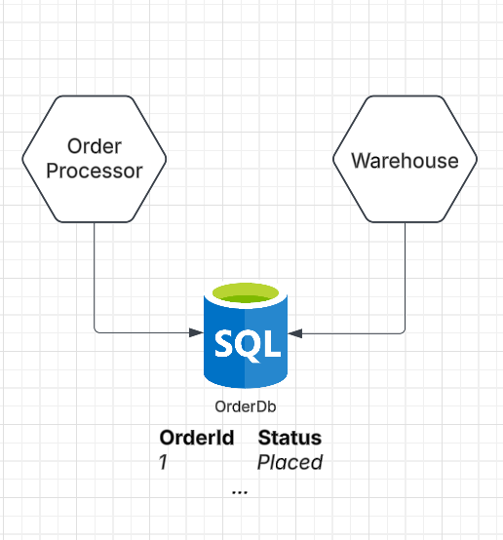

*What type of coupling is shown above? What can we do to reduce this type of coupling, does this introduce any other forms of coupling, what forms of coupling. Please produce the end state architectural diagram and explain your solution.*