**CSCI 391 – ST: Microservices, Quiz 2 – How to Model Microservices.**

Name: **Key**

Student Id: **Key**

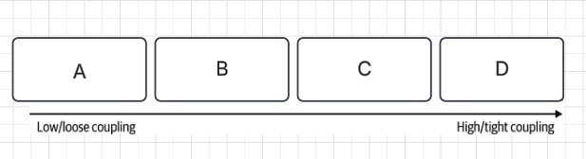

*Figure 2-1. The different types of coupling, from loose (low) to tight (high)*

***For questions 1 – 4 identify the correct position; A, B, C, or D (in Figure 2-1) for each type of coupling.***

1. Pass-through

**B**

1. Content

**D (i.e., Pathological Coupling)**

1. Common

**C**

1. Domain

**A**

*Extra Credit: Name a fifth type of coupling (that we covered in class).*

**Temporal Coupling**

***For questions 5 – 8 identify the correct definition for each type of coupling from questions 1 – 4.***

1. Describes a situation in which one microservice needs to interact with another microservice, because the first microservice needs to make use of the functionality that the other microservice provides.

**Domain Coupling**

1. Occurs when two or more microservices make use of a common set of data.

**Common Coupling**

1. Describes a situation in which an upstream service reaches into the internals of a downstream service and changes its internal state.

**Content Coupling**

1. Describes a situation in which one microservice passes data to another microservice purely because the data is needed by some other microservice further downstream.

**Pass-through Coupling**