**CSCI 391 – ST: Microservices, Quiz 3 – Microservices Communication Styles.**

Name:

Student Id:

***For the following scenarios, determine whether they best describe In-process or Inter-process communication.***

1. Data must be serialized into some form that can be transmitted over a network.
2. In-process
3. Inter-process
4. The act of rolling out changes is straightforward, and in many cases an IDE automatically applies changes for you.
   1. In-process
   2. Inter-process
5. The errors are either expected and easy to handle, or they are catastrophic to the point that we just propagate the error up the call stack. Errors, overall, are deterministic.
6. In-process
7. Inter-process

***For the following statements, determine whether they best describe Synchronous blocking or Asynchronous nonblocking communication.***

1. Its main disadvantage is the inherent temporal coupling that occurs.
   1. Synchronous blocking
   2. Asynchronous nonblocking
2. Its main disadvantage is level of complexity and range of choice.
   1. Synchronous blocking
   2. Asynchronous nonblocking

***For the following scenarios, determine whether Synchronous blocking or Asynchronous nonblocking communication would be the best choice.***

1. Simple microservices architectures.
   1. Synchronous blocking
   2. Asynchronous nonblocking
2. Long running processes.
   1. Synchronous blocking
   2. Asynchronous nonblocking

*Extra Credit (complete the diagram below):* 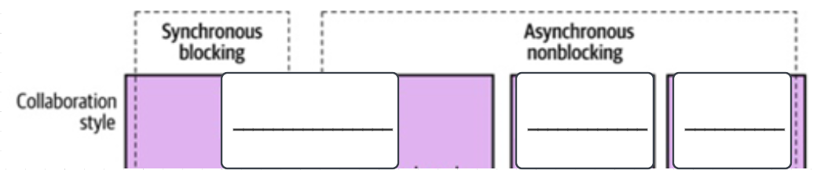

Left to right – Request-response, event driven, common data