**CSCI 391 – ST: Microservices, Quiz 6 – Testing.**

Name:

Student Id:

*For questions 1 – 4 (A – D) complete Marick’s quadrant (below) for “types of testing” i.e., please select one of the following for* ***A****,* ***B****,* ***C****, and* ***D (1-4)****;* ***Business facing, Technology facing, Support programming,*** *or* ***Critique product.***

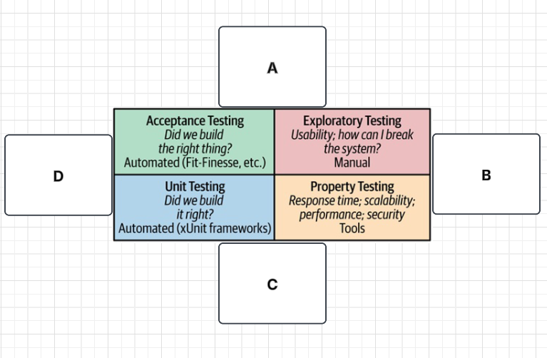

1. (**A**)

Business facing

1. (**B**)

Critique product

1. (**C**)

Technology facing

1. (**D**)

Support programming

*For questions 5 – 8 Please complete the test pyramid (below) for “scope of testing” i.e., please match the following to either position* ***A*** *or* ***B*** *on the test pyramid…*

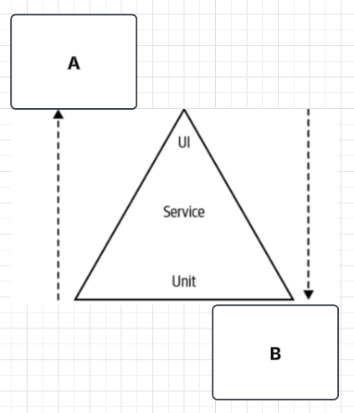

1. Increasing Scope.

A

1. Faster.

B

1. Better isolation.

B

1. More confidence.

A

*Extra Credit:*

A common antipattern where the overall distribution of your tests reflects the inverted test pyramid. Test snow cone antipattern.