**CSCI 391 – ST: Microservices, Quiz 7 – Security.**

Name:

Student Id:

1. Which of the following is **NOT** one of the five core functions of cybersecurity?
   1. Identify
   2. Secure
   3. Protect
   4. Respond

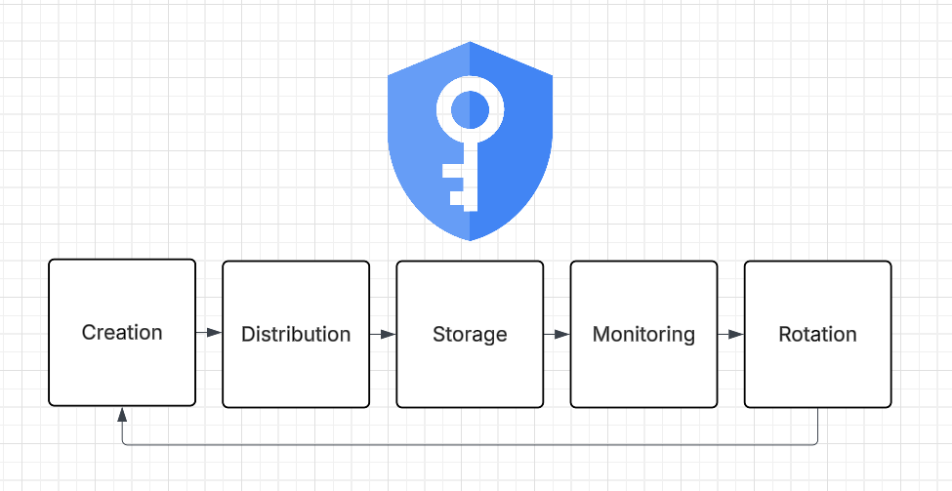

*For questions 2 & 3 identify the step in the “lifecycle of a secret” (above) described…*

1. Knowing how the secret is being used.

Monitoring

1. Making sure the secret gets to the right place (and only the right place).

Distribution

*For questions 4 & 5 decide whether the scenario describes implicit trust or zero trust…*

1. Assume that any calls to a service within our security perimeter are trusted.

Implicit Trust

1. Assume that the environment is already compromised that is being operated in.

Zero Trust

*Extra Credit:*

This is a backup that may or may not actually be a backup (give the name).

Schrodinger Backup