**CSCI 391 – ST: Microservices Syllabus**

**Spring Semester 2025**

**General Course Information**

**Course Information**

* **School Name**: University of Montana
* **Course Number**: CSCI 391
* **Course Title**: ST: Microservices
* **Number of Credits**: 3
* **Prerequisite(s)**: CSCI 258 (Web Application Development) or equivalent.  
  Prerequisites will be waived only for students with demonstrated proficiency in software architecture and development.
* **Section Number**: 01

**Instructor Information**

* **Instructor**: Addison Boyer
* **Email**: addison.boyer@umontana.edu
* **Office Location**: Social Science 406
* **Office Hours**: Monday and Wednesday 11:00 a.m. – 12:00 p.m., or by appointment
* **Teaching Assistant(s)**: N/A

**Class Times & Location**

* **Lecture**: Monday, Wednesday, Friday 10:00 a.m. – 10:50 a.m. (Social Science 362)
* **Virtual Classroom**: Microsoft Teams
* **Attendance**: Regular attendance is strongly encouraged for in-person sessions.

**Course Description & Objectives**

This course provides a deep dive into the principles and practices of microservices architecture, enabling students to design and build scalable, maintainable, and resilient systems. Through theoretical and practical learning, students will explore the fundamentals of microservices, including service decomposition, database management, API design, and deployment strategies. The course is based on **Sam Newman's *Building Microservices: Designing Fine-Grained Systems (2nd Edition)***, and students will engage in hands-on labs and assignments to apply these concepts in real-world scenarios. Topics include service communication, data management, inter-service communication, security, cloud-based deployment, and monitoring of microservices.

**Student Learning Outcomes**

*Upon successful completion of this class, students should be proficient with the following:*

* Understanding the fundamentals of microservices architecture and its components.
* Designing, building, and maintaining microservices based systems.
* Managing service communication and implementing inter-service data consistency.
* Implementing API Gateway, security measures, and deployment strategies.
* Using tools like Docker and Kubernetes to deploy and scale microservices.
* Evaluating real-world microservices architectures through case studies.

**Course Format**

* The course will include **lectures** based on the textbook and external resources.
* Active participation in **discussions** is encouraged to facilitate knowledge sharing.
* **Hands-on labs and assignments** will be provided to reinforce concepts.
* Two **midterm exams** will evaluate students' grasp of the theoretical concepts.
* **Quizzes** will be given throughout the semester to evaluate students’ comprehension of the assigned readings.
* Students should complete readings **before class** and come prepared to discuss.

**Materials**

Textbook: [Building Microservices: Designing Fine-Grained Systems 2nd Edition by Sam Newman](https://www.bkstr.com/gogrizstore/course-materials-results?shopBy=course&divisionDisplayName=&departmentDisplayName=CSCI&courseDisplayName=391&sectionDisplayName=01&programId=5244&termId=100086530)

(Available in the bookstore).



GitHub (Source Control): <https://github.com/addiboyer24/CSCI391_Microservices_Spring2025>

[Links to an external site.](https://github.com/addiboyer24/CSCI391_Microservices_Spring2025) (I will upload lecture materials and assignment documents here).

Lucid Chart (Diagramming Tool): <https://lucid.app/>

Microsoft Teams (Meeting Software): <https://www.microsoft.com/en-us/microsoft-teams/download-app> (Lectures will be recorded and available for download here).

IntelliJ Idea Community (IDE for Java Development): <https://www.jetbrains.com/idea/download/?section=windows>(There are supported versions of this IDE for MacOS and Linux respectively).

Docker Desktop (Containerization Solution): [https://docs.docker.com/get-started/get-docker/](https://docs.docker.com/get-started/get-docker/%20)

**Course Schedule**

**Important Dates:**

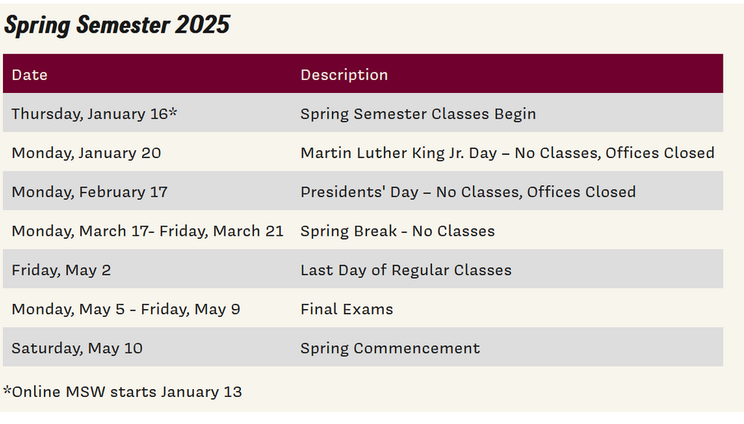

**Friday, April 25                                                   No Class**

**Course Schedule (Tentative and Subject to Change*):**

|  |  |  |
| --- | --- | --- |
| ****Week/Dates**** | ****Topics**** | ****Assessments**** |
| 1 | What are Microservices? |  |
| 2 | How to Model Microservices. |  |
| 3 - 4 | Microservice Communication Styles. |  |
| 5 | Implementing Microservice Communication. |  |
| 6 | Testing. | Midterm Exam 1 (***Friday February 28th, 2025***). |
| 7 - 8 | Security. |  |
| 9 | Resiliency. |  |
| 10 | User Interfaces. |  |
| 11 - 12 | From Monitoring to Observability. |  |
| 13 | Scaling. | Midterm Exam 2 (***Wednesday April 23rd, 2025***). |
| 14 | Build. |  |
| 15 | Deployment. |  |
| 16 | Final Exam. | Final Exam (***Friday May 9th, 2025 @ 10:10 a.m. - 12:10 p.m.***). |

**Grading Information**

Your grade for the course will be determined by the following elements (please mark your calendars for dates in Midterm Exams and Final Exam sections respectively.  I will not offer make up exams (*except under very special circumstances*).

|  |  |
| --- | --- |
| Category | Percentage Weight |
| Labs & Assignments | 40 |
| Midterm Exams (2) | 25 |
| Final Exam | 20 |
| Quizzes | 15 |

**Grading Scale**

|  |  |
| --- | --- |
| Letter Grade | Percentage Range |
| A | 93 – 100 |
| A- | 90 – 93 |
| B+ | 87 – 90 |
| B | 83 – 87 |
| B- | 80 – 83 |
| C+ | 77 – 80 |
| C | 73 – 77 |
| C- | 70 – 73 |
| D+ | 67 – 70 |
| D | 63 – 67 |
| D- | 60 – 63 |
| F | 0 – 60 |

**Course Expectations & Policies**

**Attendance Policy**

Attendance to lectures is highly encouraged (but not required).  *Quizzes, midterms, and final exams will be administered in class, and attendance will be required on those days (****please mark your calendars****).*

**Late Submissions**

**Always** - a 10-minute grace period. Don't forget to turn things in.

**First late assignment** - 10 percentage point deduction.

**Second late assignment** - 30 percentage point deduction.

**Third or more late assignments** - a grade of 0 percent will be assigned.

**How late can late be?** - assignments can be turned in late until the next assignment is due. After that, they will not be accepted and a grade of 0 assigned.

*Exceptions to this policy will be rare.*

**Course Workload**

Students are expected to spend 6–9 hours per week outside of class on coursework and project work.

**Communication**

Participation in class is highly encouraged.  I will often call upon students in the class to answer questions related to the assigned readings (so please come to class prepared to discuss the content covered in the reading for that week).  If you need additional help, please come to office hours after class (see times above) or schedule a meeting with me through Microsoft teams or email.

**Academic Misconduct**

The [Student Conduct Code](https://www.umt.edu/campus-life/community-standards/um_student_code_of_conduct.pdf) at the University of Montana embodies and promotes honesty, integrity, accountability, rights, and responsibilities associated with constructive citizenship in our academic community. This Code describes expected standards of behavior for all students, including academic conduct and general conduct, and it outlines students' rights, responsibilities, and the campus processes for adjudicating alleged violations.

**ODE Accommodations**

The University of Montana assures equal access to instruction through collaboration between students with disabilities, instructors, and the Office for Disability Equity (ODE). If you anticipate or experience barriers based on disability, please contact the ODE at 406-243-2243 or [ode@umontana.edu](mailto:dss@umontana.edu), or visit [Office of Disability Equity website.](http://www.umt.edu/disability) for more information. Retroactive accommodation requests will not be honored, so please, do not delay. As your instructor, I will work with you and the ODE to implement an effective accommodation, and you are welcome to contact me privately if you wish.

**Information for Students**

**Land Acknowledgement**

The University of Montana acknowledges that we are in the aboriginal territories of the Salish and Kalispel people. Today, we honor the path they have always shown us in caring for this place for the generations to come.

**Inclusion Policies**

We are committed to an inclusive and respectful learning environment for all students.