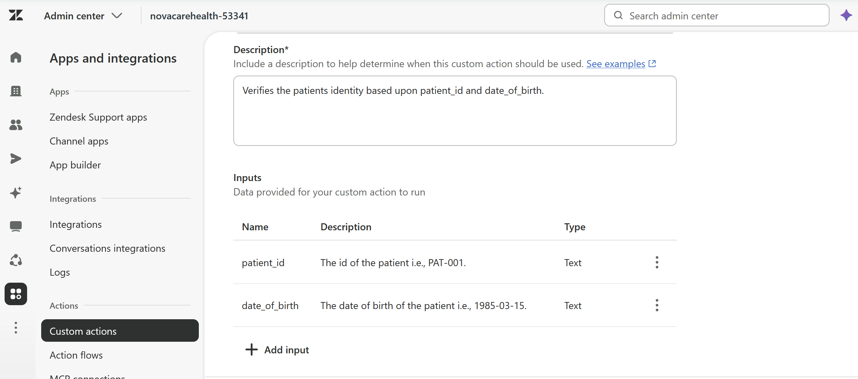

Will use the supplied default value in the description of the parameter. Class of bugs for LLMs.

