1. *Linear model*

Volume = 1459.4 + 12423.8* Types+ 166116.7*DestinationAkademiskahus-3066.3 * DestinationE-huset+ 6831.1* DestinationFysik +13374.9*DestinationMaskin + 4809* DestinationSB3+ 33626.8* CommodityClothes +22256.7* CommodityDailynecessities + 5233.9* CommodityElectronicproduct -642.5* CommodityITinfrastructure+ 11199.2 * CommodityLaboratoryequipment -7089.3* CommodityMachinary -30579.6* (DestinationMaskin*CommodityElectronicProduct )+39250.1*(DestinationSB3*CommodtyElectronicProduct)+ 24586.5* (DestinationE-huset*CommodityITinfrastructure) -163398.7* (DestinationAkademiskahus*CommodityMachinary)+ 18371.8*(DestinationFysik*CommodityMachinary)

* 1. Linear Model analysis

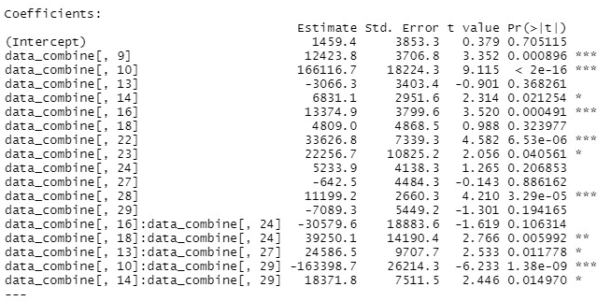

Residual standard error: 18130 on 333 degrees of freedom

Multiple R-squared: 0.3784, Adjusted R-squared: 0.3467

F-statistic: 11.93 on 17 and 333 DF, p-value: < 2.2e-16

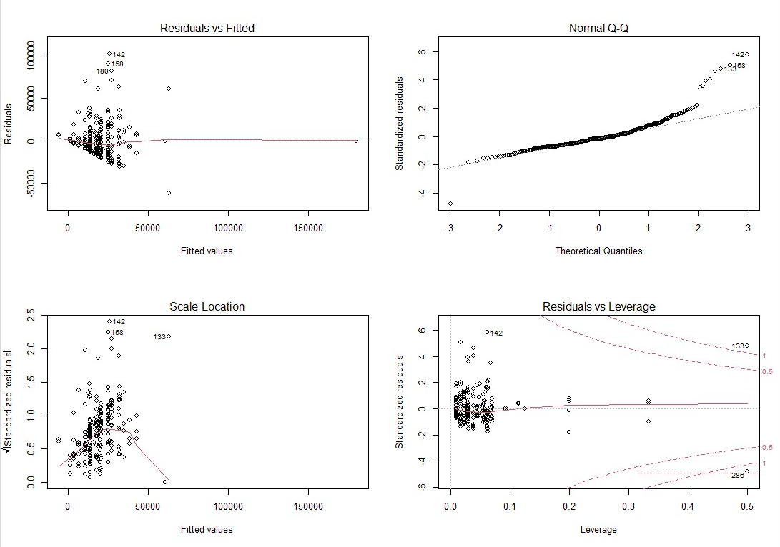1.2 Residuals analysis

1. *Decision Tree Regression*

* 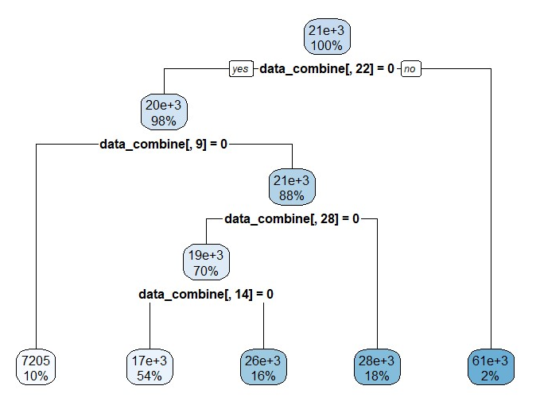data_combine[,22] – commodity clothes
* data_combine[,9] – types
* data_combine[,28] – commodity laboratory equipment
* data_combine[,14] – destination Fysik

* 1. Analysis of Decision Tree Regression

10-fold cross validation :

NMSE for training set: 0.990945557136904

NMSE for validation set: 0.970835486064974

Conclusion: Normalized mean square error indicates the model is underfitted.

1. 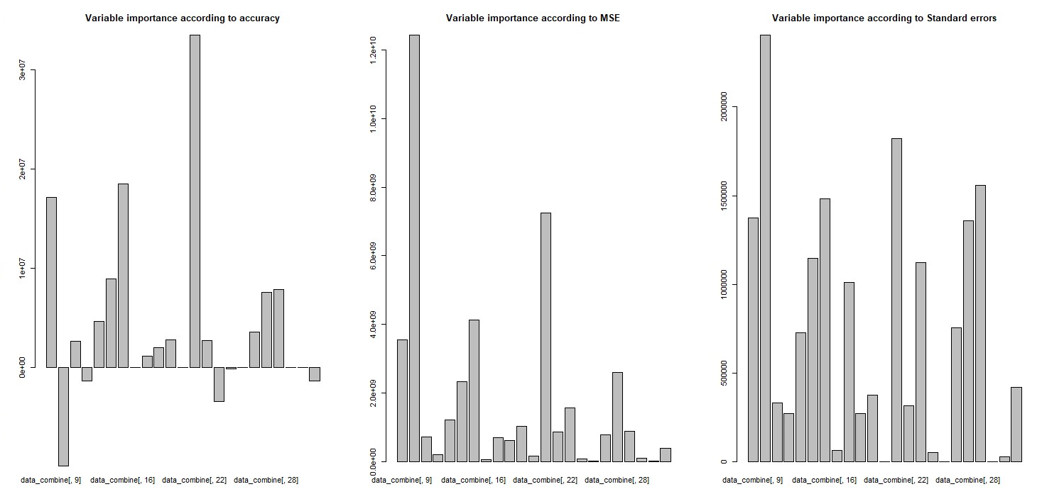Random Forest
   1. Analysis of Decision Tree Regression

NMSE for training set: 0.979605058028845

NMSE for validation set: 0.96465612611189

Conclusion: Normalized mean square error indicates the model is underfitted.

1. GLM model with Gamma family
2. 