Title: Randomly Generated Document

Horizontal Line

Emoji 🌺

Date Smart Chip: 2024-09-18 12:15 AM GMT-12

Drop Down:

Not Started

Blocked

In Progress

Completed

# H1: Bullet Points examples

**Example 1:**

* Level 1
  + Level 2
    - Level 3
      * Level 4
  + Level 2
    - Level 3
      * Level 4
    - Level 3
  + Level 2
* Level 1
  + Level 2
    - Level 3
      * Level 4
        + Level 5

**Example 2:**

1. Level 1
   * Level 2
     + Level 3
       - Level 4
     + Level 3
       - Level 4
   * Level 2
     + Level 3
       - Level 4
       - Level 4
   * Level 2
2. Level 1
   * Level 2
     + Level 3
       - Level 4
         * Level 5

**Example 3:**

(a) Level 1

(i) Level 2

(1) Level 3

(A) Level 4

(2) Level 3

(A) Level 4

(B) Level 4

(ii) Level 2

(1) Level 3

(A) Level 4

(2) Level 3

(A) Level 4

(b) Level 1

(i) Level 2

(1) Level 3

(A) Level 4

(i) Level 5

**Image 1:**



**Table 1:**

| **Feature** | **Value** |
| --- | --- |
| Name | Random Cat |
| Age | 3 years old |
| Breed | Domestic shorthair |

**Heading 1:**Nested Heading

**Code Block with the native Google Doc element:**

def fibonacci(n):

sequence = [0, 1]

while len(sequence) < n:

sequence.append(sequence[-1] + sequence[-2])

return sequence

# Print the first 10 Fibonacci numbers

fib_sequence = fibonacci(10)

for number in fib_sequence:

print(number)



**Code Block Formatted with the** [**code blocks extension**](https://workspace.google.com/u/1/marketplace/app/code_blocks/100740430168)**:**

| **def fibonacci(n):  sequence = [0, 1]  while len(sequence) < n:  sequence.append(sequence[-1] + sequence[-2])  return sequence  # Print the first 10 Fibonacci numbers fib_sequence = fibonacci(10) for number in fib_sequence:  print(number)** |
| --- |

# Heading 1 example

## Heading 2: Nested Heading

**Table 2:**

| **Month** | **Rainfall (inches)** |
| --- | --- |
| January | 1.5 |
| February | 2.0 |
| March | 2.5 |

**Image 3:**

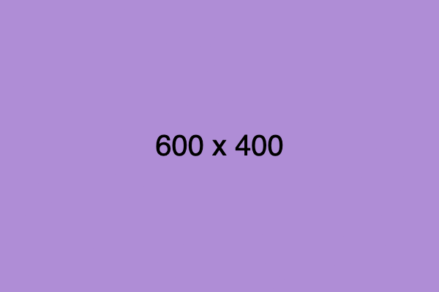

### Heading 3: Nested Heading

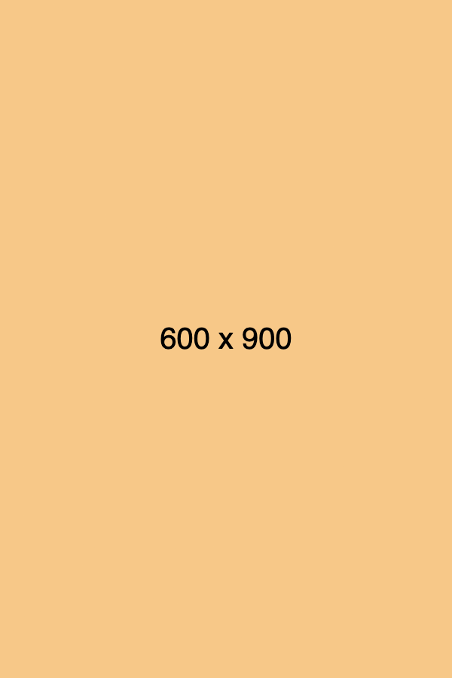

**Heading 4:**Nested Heading

**Table 3:**

| **Country** | **Population** |
| --- | --- |
| China | 1.4 billion |
| India | 1.3 billion |
| United States | 330 million |

**Image 5:**



##### Heading 5: Nested Heading

*Italic*

***Bold Italic***

Undeline

~~strike~~