115學年度分科測驗物理科
高一必修＋高二選修物理I、II範圍精選卷｜13題・50分
班級 | ____________ | 姓名 | ____________
座號 | ______ | 得分 | ____／50
篩題說明｜納入高一必修物理與高二選修物理I、II；依解題所需最高先備課程排除高三選修物理III、IV。 本卷保留原題號與原配分，共13題50分。
作答提醒：單選題每題只有一個答案；多選題可複選；非選題須寫出計算或理由。
壹、單選題（原題1–5、10；共18分）
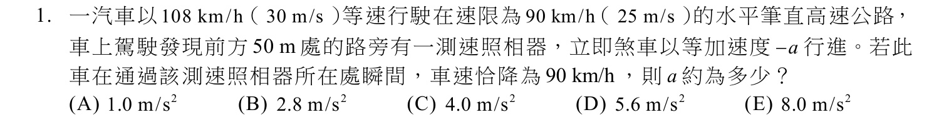
作答：________________________________________________________________
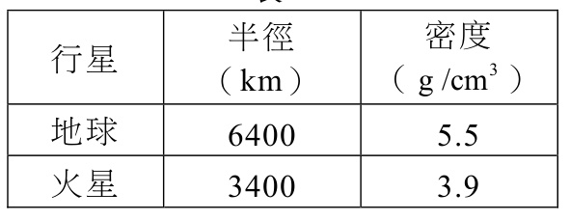
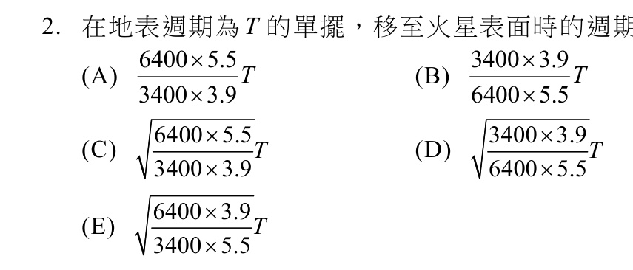
作答：________________________________________________________________
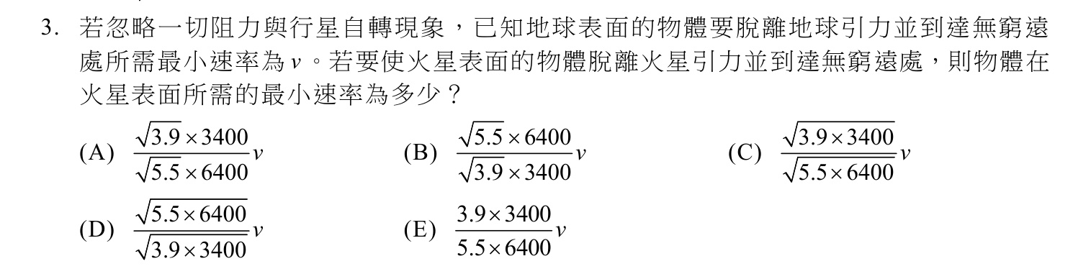
作答：________________________________________________________________

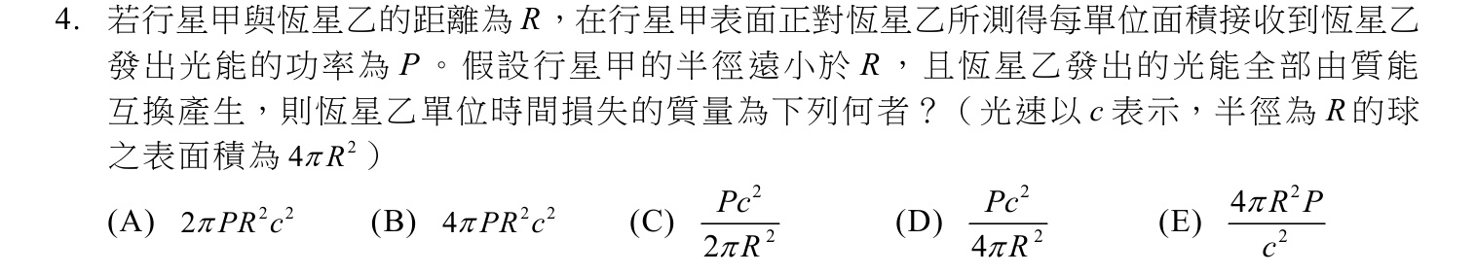
作答：________________________________________________________________
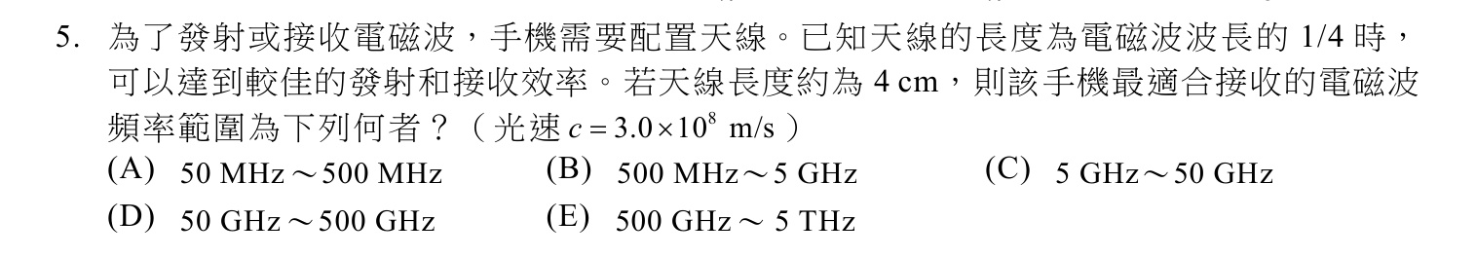
作答：________________________________________________________________
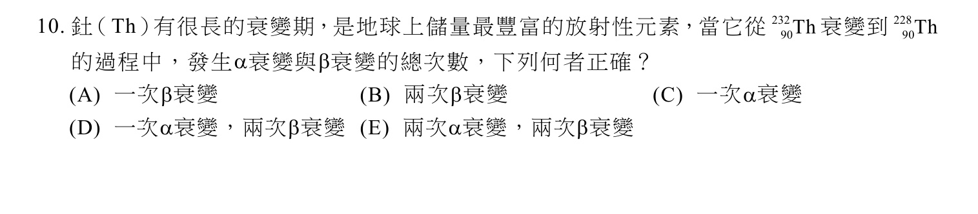
作答：________________________________________________________________

貳、多選題（原題12–14；共15分）
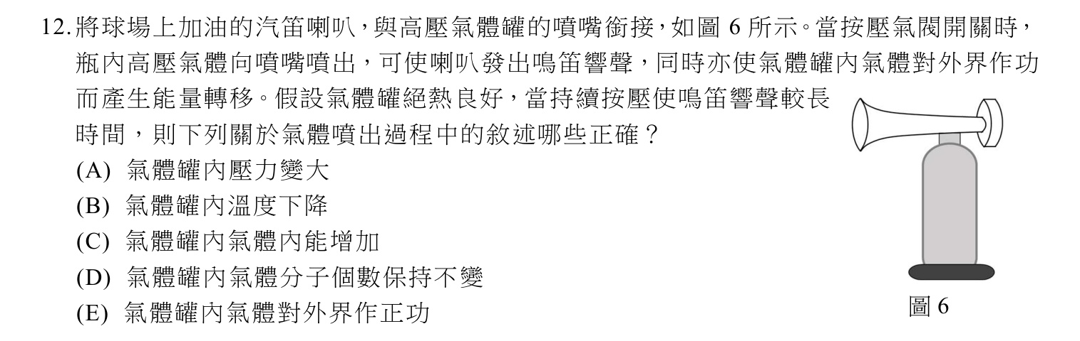
複選：________________________________________________________________
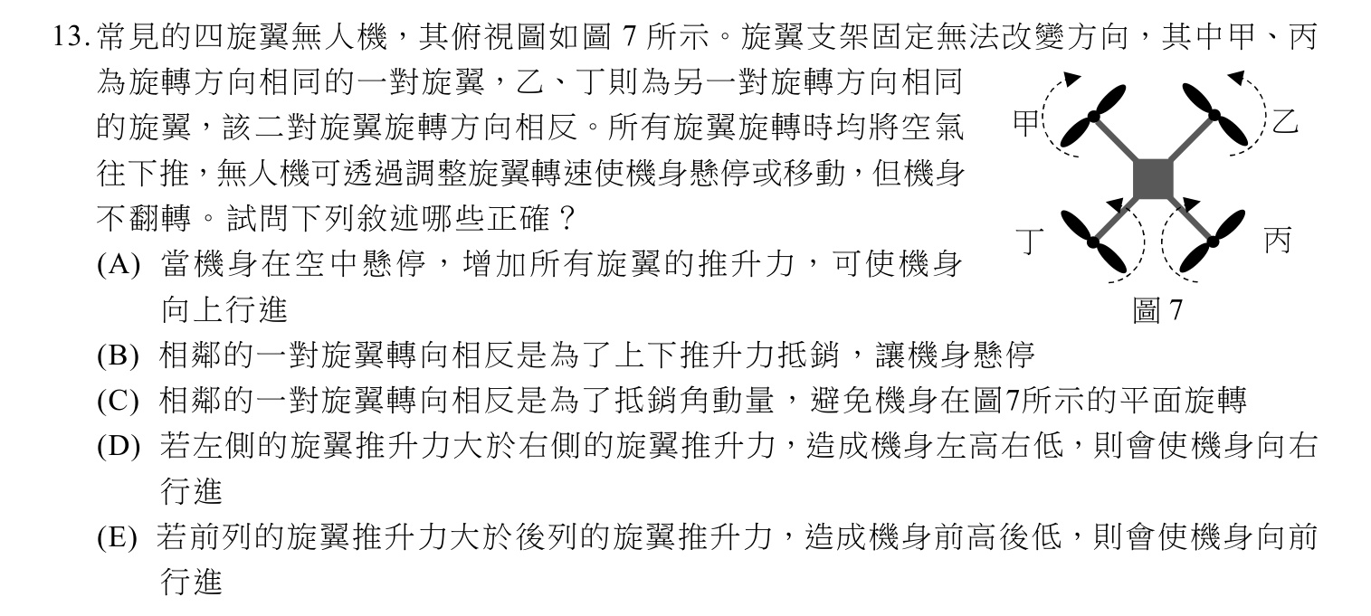
複選：________________________________________________________________

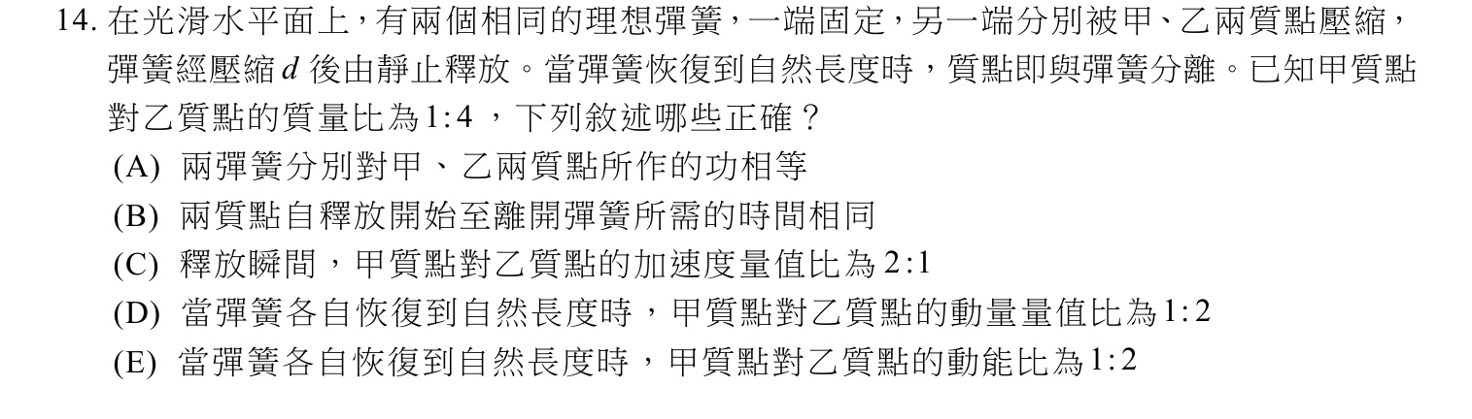
複選：________________________________________________________________
參、混合題或非選擇題（原題18–20、23；共17分）
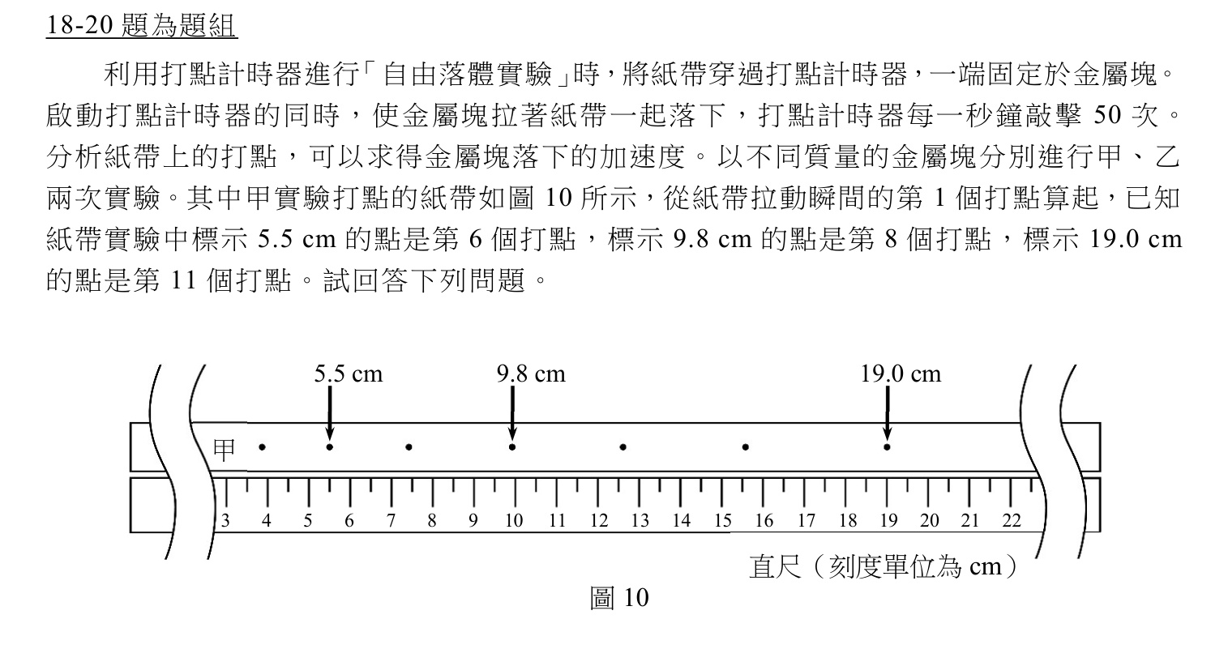
________________________________________________________________________________
________________________________________________________________________________
________________________________________________________________________________
________________________________________________________________________________
作答：________________________________________________________________

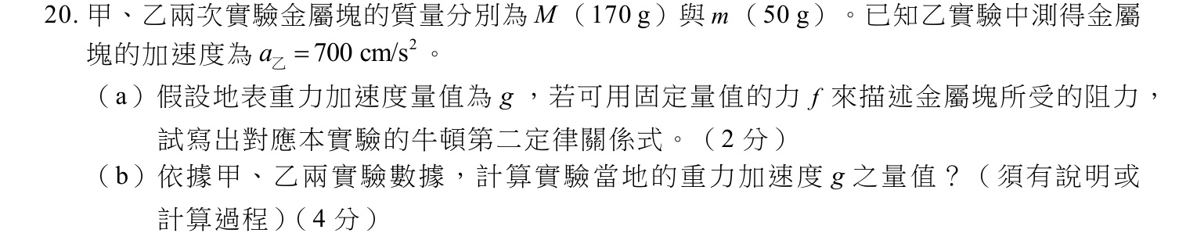
________________________________________________________________________________
________________________________________________________________________________
________________________________________________________________________________
________________________________________________________________________________
________________________________________________________________________________
________________________________________________________________________________
________________________________________________________________________________
________________________________________________________________________________
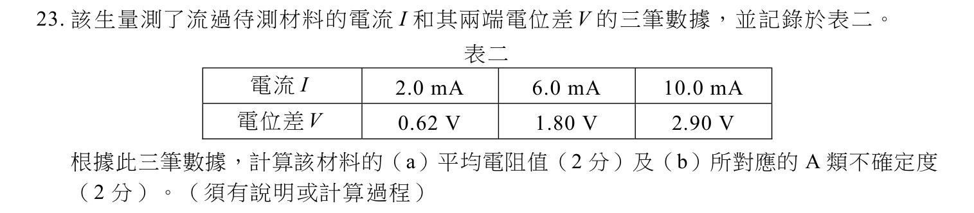
________________________________________________________________________________
________________________________________________________________________________
________________________________________________________________________________
________________________________________________________________________________
________________________________________________________________________________
________________________________________________________________________________
— 試題結束，請檢查作答 —

