Latthe education society’s polytechnic, sangli

Department of computer engineering

An

Micro project report

On

**Object Oriented Programming**

Submitted by

|  |  |
| --- | --- |
| ROLL NO | STUDENT NAME |
| 182324 | **Aditya Gujar** |
| 182325 | **Swapnil Gunke** |

1. **Rational:**

The project is on super market billing system .Super market is the place where customer comes to purchase their daily Product and pat for that ,so there is need to calculate how many product are sold and to generate the bill for the customer .

**Super Market billing system** aims at developing software that helps to calculate the bill and tacking order etc. The main advantage of this project is to convert all the manual work which is time consuming and error prone to fully automated system which helps in eliminating all paper work, savage of time and improves customer services.

In this project c++ language is used to maintain all the data, it provides many features like file handling data can be easily maintained and many features required while doing project

**2.0 Course outcome:**

* Develop c++ program using classes and objects
* Develop c++ programs using File handling

**3.0 Literature review:**

Reference: <https://www.tutorialspoint.com/cplusplus/cpp_files_streams.htm>

The functions which are used in project

* Void create():
* Void show_product():
* Void write_product():
* Void display_all():
* Void displaysr():
* Void update_product():
* Void delete_record():
* Void place_order():
* ✓Void intro():
* Void admin_menu():

By using these functions we implemented the project

**4.0 Actual methodology: Tools menu consist of following menu**

* Create a new product
* Display all product menu
* Query
* Update product
* Delete Product
* View all product menu
* Back to main menu

**Enter choice**

* When we choose a create new product option we need to enter name,price,discount to create a product
* When we choose second option display all, all product then one by one name price and discount displayed on monitor
* If we choose third option i.e. query then you have enter the the product no and it will display all the info. of that product
* 4th option i.e. update product used to modify the product by inserting a new product no or price or discount of that product
* When we choose 5th option we have to mention a product no to delete a product
* If 6th option will be selected then all the product list with product no, name ,price will be displayed
* Exit menu used to back to main menu

**5.0 Resources used**

|  |  |  |  |  |
| --- | --- | --- | --- | --- |
| Sr.no | Name and resources used | Specifications | Oty | Remark |
| 1 | Operating system | Windows | -- | -- |
| 2 | Application Software | Turbo c++,MS word | -- | -- |
| 3 | Hard disc | 32GB | 1 |  |
| 4 | Ram | 4GB | -- |  |
| 5 | Processor | Intel core 2duo cpu 2.93 GHZ 4GB RAM | -- |  |

**Coding of program:**

#include<iostream.h>

#include<conio.h>

#include<dos.h>

#include<stdio.h>

#include<process.h>

#include<fstream.h>

Class product

{

int pno;

char name[50];

float price,qty,tax,dis;

public:

void create_product()

{

cout<<"\n Enter The Product No. of the Product ";

cin>>pno;

cout<<"\n Enter The Name of the Product ";

gets(name);

cout<<"\n Enter The Price of the Product ";

cin>>price;

cout<<"\n Please Enter the Discount (%) ";

cin>>dis;

}

void show_product()

{

cout<<"\nThe Product No. of the Product:"<<pno;

cout<<"\nThe Name of the Product:"<<name;

cout<<"\nThe Price of The Product:"<<price;

cout<<"\nDiscount:"<<dis;

}

int retpno()

{

return pno;

}

float retprice()

{

return price;

}

char* retname()

{

return name;

}

int retdis()

{

return dis;

}

};

fstream fp;

product pr;

void write_product()

{

fp.open("Shop.dat",ios::out|ios::app);

pr.create_product();

fp.write((char*)&pr,sizeof(product));

fp.close();

cout<<"\n\nThe Product Has Been Created ";

getch();

}

void display_all()

{

clrscr();

cout<<"\n\n\n\t\t DISPLAY ALL RECORD !!!\n\n";

fp.open("Shop.dat",ios::in);

while(fp.read((char*)&pr,sizeof(product)))

{

pr.show_product();

cout<<"\n\n====================================\n";

getch();

}

fp.close();

getch();

}

void display_sr(int n)

{

int flag=1;

fp.open("Shop.dat",ios::in);

while(fp.read((char*)&pr,sizeof(product)))

{

if(pr.retpno()==n)

{

clrscr();

pr.show_product();

flag=0 ;

}

}

fp.close();

if(flag==1)

{

cout<<"\n\n record not exist";

}

getch();

}

void update_product()

{

int no,pos,found=0;

clrscr();

cout<<"\n\n\t To Update";

cout<<"\n\n\t Please Enter The Product No. of The Product";

cin>>no;

fp.open("Shop.dat",ios::in|ios::out);

while(fp.read((char*)&pr,sizeof(product)) && found==0)

{

if(pr.retpno()==no)

{

pr.show_product();

cout<<"\nPlease Enter The New Details of Product"<<endl;

pr.create_product();

pos=-1*sizeof(pr);

fp.seekp(pos,ios::cur);

fp.write((char*)&pr,sizeof(product));

cout<<"\n\n\t Record Updated";

found=1;

}

}

fp.close();

if(found==0)

cout<<"\n\n Record Not Found ";

getch();

}

void delete_product()

{

int no;

clrscr();

cout<<"\n\n\n\t Delete Record";

cout<<"\n\n Please Enter The product no. of The Product You Want To Delete";

cin>>no;

fp.open("Shop.dat",ios::in|ios::out);

fstream fp2;

fp2.open("Temp.dat",ios::out);

fp.seekg(0,ios::beg);

while(fp.read((char*)&pr,sizeof(product)))

{

if(pr.retpno()!=no)

{

fp2.write((char*)&pr,sizeof(product));

}}

fp2.close();

fp.close();

remove("Shop.dat");

rename("Temp.dat","Shop.dat");

delay(500);

cout<<"\n\n\tRecord Deleted ..";

getch();

}

void allproduct()

{

clrscr();

fp.open("Shop.dat",ios::in);

if(!fp)

{

cout<<"ERROR!!! FILE COULD NOT BE OPEN\n\n\n Go To Admin Menu to createFile";

cout<<"\n\n\n Program is closing ....";

getch();

exit(0);

}

cout<<"\n\n\t\tProduct MENU\n\n";

cout<<"====================================================\n";

cout<<"P.NO.\t\tNAME\t\tPRICE\n";

cout<<"====================================================\n";

while(fp.read((char*)&pr,sizeof(product)))

{

cout<<pr.retpno()<<"\t\t"<<pr.retname()<<"\t\t"<<pr.retprice()<<endl;

}

fp.close();

}

void place_order()

{

allproduct();

int order_arr[50],quan[50],i=0;

float amt,damt,total=0;

char ch='Y';

cout<<"\n============================";

cout<<"\n PLACE YOUR ORDER";

cout<<"\n=============================\n";

do

{

cout<<"\n\nEnter The Product No. Of The Product : ";

cin>>order_arr[i];

cout<<"\n Quantity in number:";

cin>>quan[i];

i++;

cout<<"\n Do You Want To Order Another Product ? (y/n)";

cin>>ch;

}

while(ch=='y' ||ch=='Y');

cout<<"\n\nThank You For Placing The Order";

getch();

clrscr();

cout<<"\n\n********************************PAYMENT DETAILS************************\n";

delay(2000);

cout<<"\nPr No.\tPr Name\tQuantity \tPrice \tAmount \t Amount After Discount\n";

for(int x=0;x<=i;x++)

{

fp.open("Shop.dat",ios::in);

fp.read((char*)&pr,sizeof(product));

while(!fp.eof())

{

if(pr.retpno()==order_arr[x])

{

amt=pr.retprice()*quan[x];

damt=amt-(amt*pr.retdis()/100);

cout<<"\n"<<order_arr[x]<<"\t"<<pr.retname()<<"\t"<<quan[x]<<"\t\t"<<pr.retprice()<<"\t"<<amt<<"\t\t"<<damt;

total+=damt;

}

fp.read((char*)&pr,sizeof(product));

}

fp.close();

}

delay(1500);

cout<<"\n\n\t\t\t\t\t\t\tTOTAL = "<<total;

delay(1000);

cout<<"\n*************************************************************************";

delay(1000);

cout<<"\n\n\t\t THANK YOU";

getch();

}

void Intro()

{

clrscr();

gotoxy(31,9);

cout<<"...SUPER MARKET...";

gotoxy(34,10);

delay(1000);

cout<<"...BILLING...";

gotoxy(37,11);

delay(1000);

cout<<"...SYASTEM...";

gotoxy(16,4);delay(1000);

cout<<"\n================================================================================";

cout<<"....WEL-COME TO SUPER MARKET BILLING SYSTEM (GG MALL)....";

cout<<"\n================================================================================";

gotoxy(28,14);

delay(1000);cout<<"\n________________________________________________________________________________";

delay(1000);

cout<<"\n PROJECT MADE BY : 1] Aditya Gujar \t\t Rollno=182324";

delay(1000);

cout<<"\t\t\t\t\t 2]Swapnil Gunke \t\t Rollno=182325" ;

cout<<"\n_________________________________________________________________________________";

delay(1000);

cout<<"\n\t COLLAGE NAME : LATTHE EDUCATIONS SOCIETYS POLYTECHNIQUE SANGLI";

textcolor(YELLOW+BLINK);

gotoxy(55,13);

cprintf("\n PRESS ANY KEY");

getch();

}

void admin_menu()

{

clrscr();

char ch2;

gotoxy(30,3);

cout<<"\n\n\n\t ADMIN MENU";

cout<<"\n\n\t1.CREATE A NEW PRODUCT";

cout<<"\n\n\t2.DISPLAY ALL THE PRODUCTS";

cout<<"\n\n\t3.QUERY ";

cout<<"\n\n\t4.UPDATE PRODUCT";

cout<<"\n\n\t5.DELETE PRODUCT";

cout<<"\n\n\t6.VIEW PRODUCT MENU";

cout<<"\n\n\t7.BACK TO MAIN MENU";

cout<<"\n\n\t PLEASE ENTER YOUR CHOISE FROM (1-7) ";

ch2=getch();

switch(ch2)

{

case'1': clrscr();

write_product();

break;

case'2':

display_all();

break;

case'3':

int num;

clrscr();

cout<<"\n\n\tPlease Enter The Product No. ";

cin>>num;

display_sr(num);

break;

case'4':

update_product();

break;

case'5':

delete_product();

break;

case'6':

allproduct();

getch();

case'7': break;

default:cout<<"\a";admin_menu();

}

}

void main()

{

char ch;

Intro();

do

{

clrscr();

textbackground(BLACK);

cout<<"\n\n\n\t MAIN MENU";

cout<<"\n\n\t01. PLACE YOUR ORDER";

cout<<"\n\n\t02. TOOLS";

cout<<"\n\n\t03. EXIT";

cout<<"\n\n\tPlease Select Your Option (1-3) ";

ch=getche();

switch(ch)

{

case'1': clrscr();

place_order();

getch();

break;

case'2': admin_menu();

break;

case'3':exit(0);

default :cout<<"\a";

}

}while(ch!='3');

}

6.0 Output of project

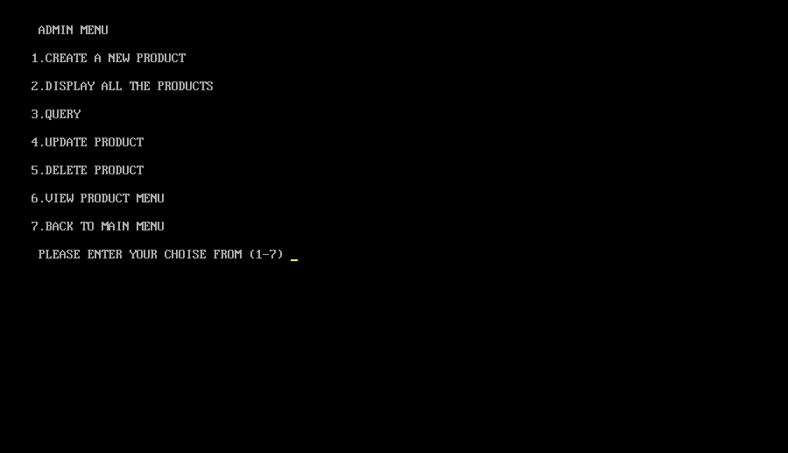

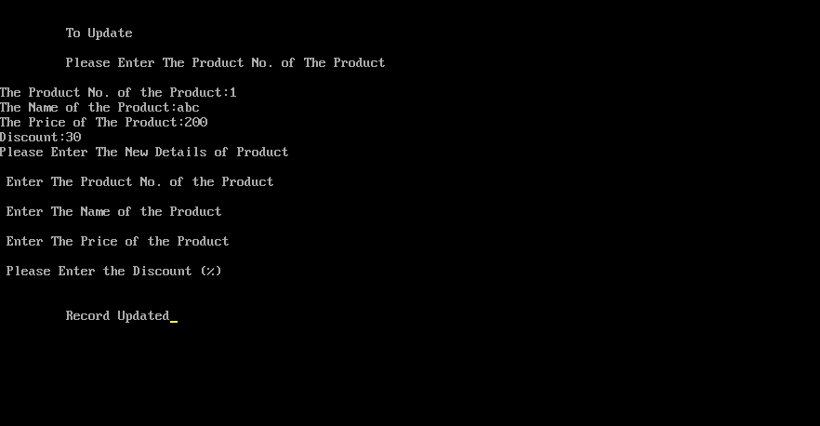

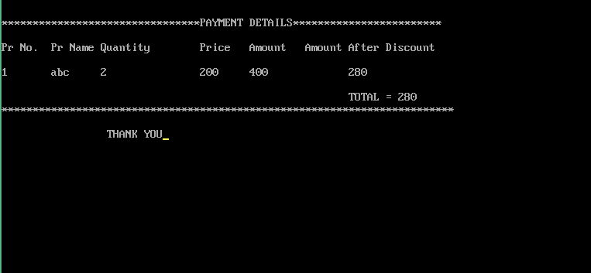

**7.0 Skill development:**

* We learned the file handling different file handling modes writing and reading files
* We learned the classes and objects and functions

**8.0 Application used in micro project:**

* The super market billing system used in the different shops to reduce the the paper work and make the calculation fast

**9.0 Future scope of this project:**

* We can implement this project in different languages such as c,java,python etc.
* This project enables the owner of shop to maintain the data of customer