Viewing the document at fullscreen at 1080*1920.
1200px BREAKPOINT
HEADER
Terracotta Catering and contact info do not align at the top.
Email contact info missing padding/ margin to the right hand side.
Main header letter spacing is too large.
Tagline letter spacing not enough.
“Book Now” button is a double line button not a single line button.
Navigation bar letter spacing seems smaller than the reference image. There is also white space above the navigation bar. (Figure 1)

Figure 1
FOOTER
Book now description text box is not the same width as the reference image.
Book Now button is two lines, and is not uppercase or aligned correctly.
The CONTACT US, SECTIONS, and FOLLOW US sections in the footer are aligned differently to the reference image. The reference image appears to have them in equally sized boxes, so that each one has empty space to the right, including FOLLOW US, meaning that its right content edge does not line up to the right of the webpages content right hand edge.
FOLLOW US list items are missing height padding to separate them.
Copyright line has less top padding/margin than the reference image. Copyright line is not uppercase. This is also missing bottom margin/padding.
Zooming in or out of the window breaks the layout of the header and footer. This is due to pixel margins/paddings being used primarily to align content. (Figure 2, and 3)
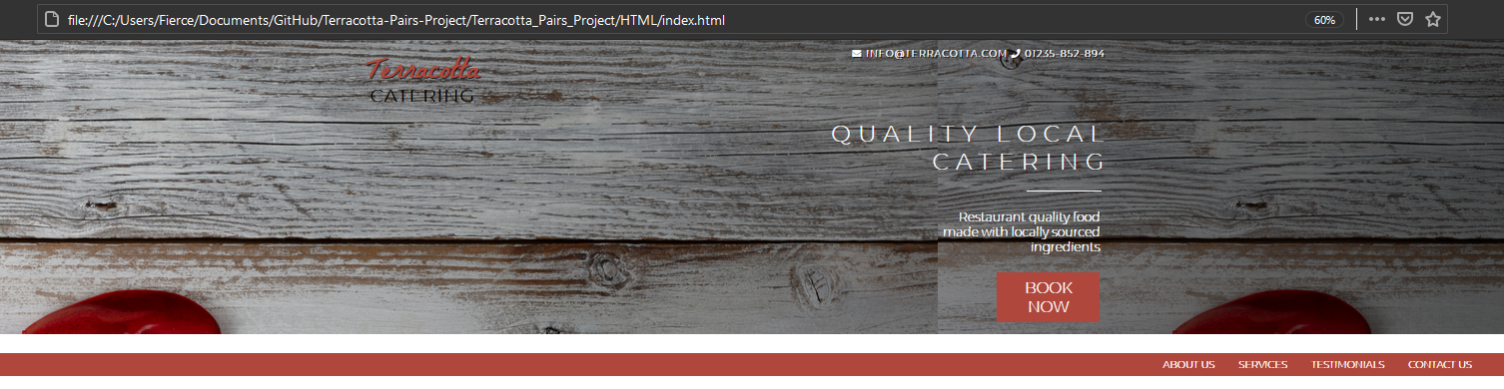
Figure 2
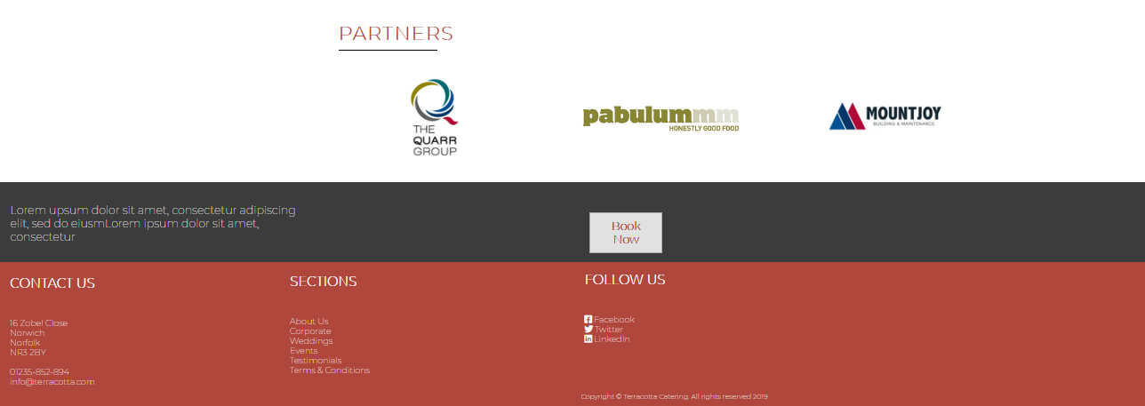
Figure 3
975px BREAKPOINT
HEADER
Header content is too thin and doesn’t match the rest of the homepage content.
Book Now button padding seems minimal and could need increasing.
FOOTER
Book Now description and button are misaligned. (Figure 4)

Figure 4
CONTACT US, SECTIONS, and FOLLOW US seem misaligned but this could be preference based.
Footer content seems too far aligned to the left, compared to the homepage content.
750px BREAKPOINT
Header content is too narrow.
Footer content seems misaligned to the left hand side.
MOBILE
ABOUT US in the navigation bar, has white space above it.
Info and Email are misaligned at the top of the page with the phone icon not being on the same line as the phone number.
Copyright line is misaligned to the rest of the footer content. (Figure 5).
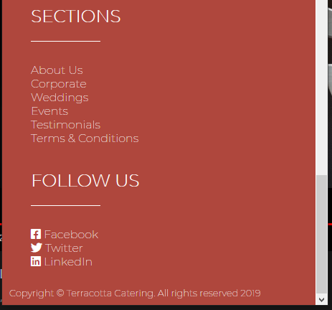
Figure 5

