**CEPH:**

**Object Storage**

Ceph’s software libraries provide client applications with direct access to the RADOS object-based storage system, and also provide a foundation for some of Ceph’s advanced features, including RADOS Block Device (RBD), RADOS Gateway, and the Ceph File System.

**Librados**

The Ceph librados software libraries enable applications written in C, C++, Java, Python and PHP to access Ceph’s object storage system using native APIs. The librados libraries provide advanced features, including:

* partial or complete reads and writes
* snapshots
* atomic transactions with features like append, truncate and clone range
* object level key-value mappings

**REST Gateway**

RADOS Gateway provides Amazon S3 and OpenStack Swift compatible interfaces to the RADOS object store.

**Block Storage**

Ceph’s object storage system isn’t limited to native binding or RESTful APIs. You can mount Ceph as a thinly provisioned block device! When you write data to Ceph using a block device, Ceph automatically stripes and replicates the data across the cluster. Ceph’s RADOS Block Device (RBD) also integrates with Kernel Virtual Machines (KVMs), bringing Ceph’s virtually unlimited storage to KVMs running on your Ceph clients.

**How it Works**

Ceph RBD interfaces with the same Ceph object storage system that provides the librados interface and the Ceph FS file system, and it stores block device images as objects. Since RBD is built on top of librados, RBD inherits librados capabilites, including read-only snapshots and revert to snapshot. By striping images across the cluster, Ceph improves read access performance for large block device images.

**Benefits**

* Thinly provisioned
* Resizable images
* Image import/export
* Image copy or rename
* Read-only snapshots
* Revert to snapshots
* Ability to mount with Linux or QEMU KVM clients!

**File System**

Ceph’s object storage system offers a significant feature compared to many object storage systems available today: Ceph provides a traditional file system interface with POSIX semantics. Object storage systems are a significant innovation, but they complement rather than replace traditional file systems. As storage requirements grow for legacy applications, organizations can configure their legacy applications to use the Ceph file system too! This means you can run one storage cluster for object, block and file-based data storage.

**How it Works**

Ceph’s file system runs on top of the same object storage system that provides object storage and block device interfaces. The Ceph metadata server cluster provides a service that maps the directories and file names of the file system to objects stored within RADOS clusters. The metadata server cluster can expand or contract, and it can rebalance the file system dynamically to distribute data evenly among cluster hosts. This ensures high performance and prevents heavy loads on specific hosts within the cluster.

**Benefits**

The Ceph file system provides numerous benefits:

* It provides stronger data safety for mission-critical applications.
* It provides virtually unlimited storage to file systems.
* Applications that use file systems can use Ceph FS with POSIX semantics. No integration or customization required!
* Ceph automatically balances the file system to deliver maximum performance.

**FAQ:**

**Is Ceph Production-Quality?**

Ceph’s object store (RADOS) is production ready. Large-scale storage systems (i.e., petabytes of data) use Ceph’s RESTful Object Gateway (RGW), which provides APIs compatible with Amazon’s S3 and OpenStack’s Swift. Many deployments also use the Ceph Block Device (RBD), including deployments of OpenStack and CloudStack. [Inktank](http://inktank.com/" \o "http://inktank.com" \t "_blank) provides commercial support for the Ceph object store, Object Gateway, block devices and CephFS with running a single metadata server.

The CephFS POSIX-compliant filesystem is functionally complete and has been evaluated by a large community of users. There are production systems using CephFS with a single metadata server. The Ceph community is actively testing clusters with multiple metadata servers for quality assurance. Once CephFS passes QA muster when running with multiple metadata servers, [Inktank](http://inktank.com/" \o "http://inktank.com" \t "_blank) will provide commercial support for CephFS with multiple metadata servers, too.

**Can Ceph Export a Filesystem via NFS or Samba/CIFS?**

Ceph doesn’t export CephFS via NFS or Samba. However, you can use a gateway to serve a CephFS filesystem to NFS or Samba clients.

**Does Ceph Support ISCSI?**

[**http://www.hastexo.com/resources/hints-and-kinks/turning-ceph-rbd-images-san-storage-devices**](http://www.hastexo.com/resources/hints-and-kinks/turning-ceph-rbd-images-san-storage-devices)

[**http://ceph.com/dev-notes/adding-support-for-rbd-to-stgt/**](http://ceph.com/dev-notes/adding-support-for-rbd-to-stgt/)

[**http://ceph.com/dev-notes/updates-to-ceph-tgt-iscsi-support/**](http://ceph.com/dev-notes/updates-to-ceph-tgt-iscsi-support/)

**Can Ceph Support Multiple Data Centers?**

A RADOS cluster can theoretically span multiple data centers, with safeguards to ensure data safety.  However, replication between Ceph OSDs is synchronous and may lead to low write and recovery performance.  When a client writes data to Ceph the primary OSD will not acknowledge the write to the client until the secondary OSDs have written the replicas. See [How Ceph Scales](http://ceph.com/docs/master/architecture#how-ceph-scales) for details.

 The Ceph community is working to ensure that OSD/monitor heartbeats and peering processes operate effectively with the additional latency that may occur when deploying hardware in different geographic locations. See [Monitor/OSD Interaction](http://ceph.com/docs/master/rados/configuration/mon-osd-interaction) for details.

 If your data centers have dedicated bandwidth and low latency, you can distribute your cluster across data centers easily. If you use a WAN over the Internet, you may need to configure Ceph to ensure effective peering, heartbeat acknowledgement and writes to ensure the cluster performs well with additional WAN latency.

 For those who are using the Ceph Object Gateway (RGW) to store objects using the S3 or Swift protocol, there are a sophisticated set of functions and capabilities that allow an administrator to create flexible multi-site topologies by linking, or federating, RGWs.  See [Configuring Federated Gateways](http://ceph.com/docs/master/radosgw/federated-config/) for details.

 For those using the Ceph Block Device (RBD), a snapshot capability allows the administrator to create a copy of a volume at a given point in time. This snapshot can be exported as a file or image that can then be imported into a separate Ceph cluster in a different location.  See [Snapshots](http://ceph.com/docs/master/rbd/rbd-snapshot/) for details.

**What Underlying Filesystem Do You recommend?**

Currently, we recommend using XFS as the underlying filesystem for OSD drives. We think btrfs will become the optimal filesystem. However, we still encounter enough issues that we do not recommend it for production systems yet. See [Filesystem Recommendations](http://ceph.com/docs/master/rados/configuration/filesystem-recommendations" \o "http://ceph.com/docs/master/rados/configuration/filesystem-recommendations" \t "_blank) for details.

# **Intro to Ceph**

Whether you want to provide [Ceph Object Storage](http://ceph.com/docs/master/glossary/#term-ceph-object-storage) and/or [Ceph Block Device](http://ceph.com/docs/master/glossary/#term-ceph-block-device) services to [Cloud Platforms](http://ceph.com/docs/master/glossary/#term-cloud-platforms), deploy a [Ceph Filesystem](http://ceph.com/docs/master/glossary/#term-ceph-filesystem) or use Ceph for another purpose, all [Ceph Storage Cluster](http://ceph.com/docs/master/glossary/#term-ceph-storage-cluster) deployments begin with setting up each [Ceph Node](http://ceph.com/docs/master/glossary/#term-ceph-node), your network and the Ceph Storage Cluster. A Ceph Storage Cluster requires at least one Ceph Monitor and at least two Ceph OSD Daemons. The Ceph Metadata Server is essential when running Ceph Filesystem clients.

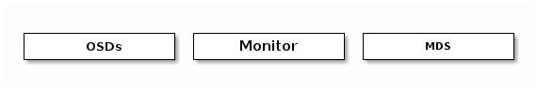

* **Ceph OSDs**: A [Ceph OSD Daemon](http://ceph.com/docs/master/glossary/#term-ceph-osd-daemon) (Ceph OSD) stores data, handles data replication, recovery, backfilling, rebalancing, and provides some monitoring information to Ceph Monitors by checking other Ceph OSD Daemons for a heartbeat. A Ceph Storage Cluster requires at least two Ceph OSD Daemons to achieve an active + clean state when the cluster makes two copies of your data (Ceph makes 2 copies by default, but you can adjust it).
* **Monitors**: A [Ceph Monitor](http://ceph.com/docs/master/glossary/#term-ceph-monitor) maintains maps of the cluster state, including the monitor map, the OSD map, the Placement Group (PG) map, and the CRUSH map. Ceph maintains a history (called an “epoch”) of each state change in the Ceph Monitors, Ceph OSD Daemons, and PGs.
* **MDSs**: A [Ceph Metadata Server](http://ceph.com/docs/master/glossary/#term-ceph-metadata-server) (MDS) stores metadata on behalf of the [Ceph Filesystem](http://ceph.com/docs/master/glossary/#term-ceph-filesystem) (i.e., Ceph Block Devices and Ceph Object Storage do not use MDS). Ceph Metadata Servers make it feasible for POSIX file system users to execute basic commands like ls, find, etc. without placing an enormous burden on the Ceph Storage Cluster.

Ceph stores a client’s data as objects within storage pools. Using the CRUSH algorithm, Ceph calculates which placement group should contain the object, and further calculates which Ceph OSD Daemon should store the placement group. The CRUSH algorithm enables the Ceph Storage Cluster to scale, rebalance, and recover dynamically.

|  |  |
| --- | --- |
| Recommendations To begin using Ceph in production, you should review our hardware recommendations and operating system recommendations.   * [Hardware Recommendations](http://ceph.com/docs/master/start/hardware-recommendations/)   + [CPU](http://ceph.com/docs/master/start/hardware-recommendations/#cpu)   + [RAM](http://ceph.com/docs/master/start/hardware-recommendations/#ram)   + [Data Storage](http://ceph.com/docs/master/start/hardware-recommendations/#data-storage)   + [Networks](http://ceph.com/docs/master/start/hardware-recommendations/#networks)   + [Failure Domains](http://ceph.com/docs/master/start/hardware-recommendations/#failure-domains)   + [Minimum Hardware Recommendations](http://ceph.com/docs/master/start/hardware-recommendations/#minimum-hardware-recommendations)   + [Production Cluster Examples](http://ceph.com/docs/master/start/hardware-recommendations/#production-cluster-examples) * [OS Recommendations](http://ceph.com/docs/master/start/os-recommendations/)   + [Ceph Dependencies](http://ceph.com/docs/master/start/os-recommendations/#ceph-dependencies)   + [Platforms](http://ceph.com/docs/master/start/os-recommendations/#platforms) | Get Involved You can avail yourself of help or contribute documentation, source code or bugs by getting involved in the Ceph community.   * [Get Involved in the Ceph Community!](http://ceph.com/docs/master/start/get-involved/) * [Documenting Ceph](http://ceph.com/docs/master/start/documenting-ceph/)   + [Making Contributions](http://ceph.com/docs/master/start/documenting-ceph/#making-contributions)   + [Documentation Style Guide](http://ceph.com/docs/master/start/documenting-ceph/#documentation-style-guide) |

# **Architecture**

[Ceph](http://ceph.com/docs/master/glossary/#term-ceph) uniquely delivers **object, block, and file storage** in one unified system. Ceph is highly reliable, easy to manage, and free. The power of Ceph can transform your company’s IT infrastructure and your ability to manage vast amounts of data. Ceph delivers extraordinary scalability–thousands of clients accessing petabytes to exabytes of data. A [Ceph Node](http://ceph.com/docs/master/glossary/#term-ceph-node) leverages commodity hardware and intelligent daemons, and a [Ceph Storage Cluster](http://ceph.com/docs/master/glossary/#term-ceph-storage-cluster) accommodates large numbers of nodes, which communicate with each other to replicate and redistribute data dynamically.

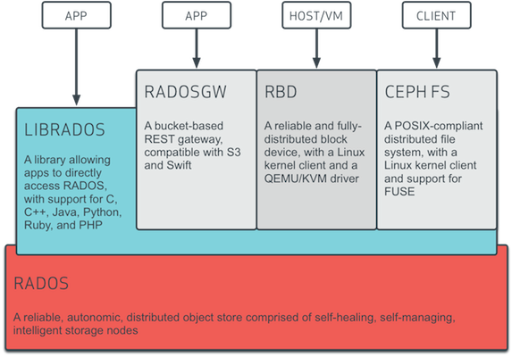

## The Ceph Storage Cluster

Ceph provides an infinitely scalable [Ceph Storage Cluster](http://ceph.com/docs/master/glossary/#term-ceph-storage-cluster) based upon RADOS, which you can read about in [RADOS - A Scalable, Reliable Storage Service for Petabyte-scale Storage Clusters](http://ceph.com/papers/weil-rados-pdsw07.pdf).

A Ceph Storage Cluster consists of two types of daemons:

* [Ceph Monitor](http://ceph.com/docs/master/glossary/#term-ceph-monitor)
* [Ceph OSD Daemon](http://ceph.com/docs/master/glossary/#term-ceph-osd-daemon)

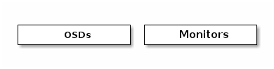

A Ceph Monitor maintains a master copy of the cluster map. A cluster of Ceph monitors ensures high availability should a monitor daemon fail. Storage cluster clients retrieve a copy of the cluster map from the Ceph Monitor.

A Ceph OSD Daemon checks its own state and the state of other OSDs and reports back to monitors.

Storage cluster clients and each [Ceph OSD Daemon](http://ceph.com/docs/master/glossary/#term-ceph-osd-daemon) use the CRUSH algorithm to efficiently compute information about data location, instead of having to depend on a central lookup table. Ceph’s high-level features include providing a native interface to the Ceph Storage Cluster via librados, and a number of service interfaces built on top of librados.

### Storing Data

The Ceph Storage Cluster receives data from [Ceph Clients](http://ceph.com/docs/master/glossary/#term-ceph-clients)–whether it comes through a [Ceph Block Device](http://ceph.com/docs/master/glossary/#term-ceph-block-device), [Ceph Object Storage](http://ceph.com/docs/master/glossary/#term-ceph-object-storage), the [Ceph Filesystem](http://ceph.com/docs/master/glossary/#term-ceph-filesystem) or a custom implementation you create using librados–and it stores the data as objects. Each object corresponds to a file in a filesystem, which is stored on an [Object Storage Device](http://ceph.com/docs/master/glossary/#term-object-storage-device). Ceph OSD Daemons handle the read/write operations on the storage disks.

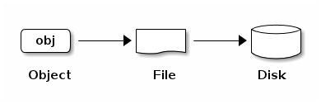

Ceph OSD Daemons store all data as objects in a flat namespace (e.g., no hierarchy of directories). An object has an identifier, binary data, and metadata consisting of a set of name/value pairs. The semantics are completely up to [Ceph Clients](http://ceph.com/docs/master/glossary/#term-ceph-clients). For example, CephFS uses metadata to store file attributes such as the file owner, created date, last modified date, and so forth.

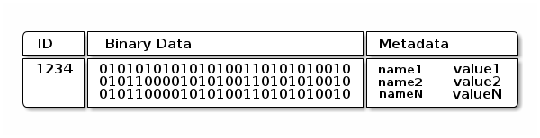

Note

An object ID is unique across the entire cluster, not just the local filesystem.

### Scalability and High Availability

In traditional architectures, clients talk to a centralized component (e.g., a gateway, broker, API, facade, etc.), which acts as a single point of entry to a complex subsystem. This imposes a limit to both performance and scalability, while introducing a single point of failure (i.e., if the centralized component goes down, the whole system goes down, too).

Ceph eliminates the centralized gateway to enable clients to interact with Ceph OSD Daemons directly. Ceph OSD Daemons create object replicas on other Ceph Nodes to ensure data safety and high availability. Ceph also uses a cluster of monitors to ensure high availability. To eliminate centralization, Ceph uses an algorithm called CRUSH.

#### CRUSH Introduction

Ceph Clients and Ceph OSD Daemons both use the CRUSH algorithm to efficiently compute information about object location, instead of having to depend on a central lookup table. CRUSH provides a better data management mechanism compared to older approaches, and enables massive scale by cleanly distributing the work to all the clients and OSD daemons in the cluster. CRUSH uses intelligent data replication to ensure resiliency, which is better suited to hyper-scale storage. The following sections provide additional details on how CRUSH works. For a detailed discussion of CRUSH, see [CRUSH - Controlled, Scalable, Decentralized Placement of Replicated Data](http://ceph.com/papers/weil-crush-sc06.pdf).

#### Cluster Map

Ceph depends upon Ceph Clients and Ceph OSD Daemons having knowledge of the cluster topology, which is inclusive of 5 maps collectively referred to as the “Cluster Map”:

1. **The Monitor Map:** Contains the cluster fsid, the position, name address and port of each monitor. It also indicates the current epoch, when the map was created, and the last time it changed. To view a monitor map, execute ceph mon dump.
2. **The OSD Map:** Contains the cluster fsid, when the map was created and last modified, a list of pools, replica sizes, PG numbers, a list of OSDs and their status (e.g., up, in). To view an OSD map, execute ceph osd dump.
3. **The PG Map:** Contains the PG version, its time stamp, the last OSD map epoch, the full ratios, and details on each placement group such as the PG ID, the Up Set, the Acting Set, the state of the PG (e.g., active + clean), and data usage statistics for each pool.
4. **The CRUSH Map:** Contains a list of storage devices, the failure domain hierarchy (e.g., device, host, rack, row, room, etc.), and rules for traversing the hierarchy when storing data. To view a CRUSH map, execute ceph osd getcrushmap -o {filename}; then, decompile it by executing crushtool -d {comp-crushmap-filename} -o {decomp-crushmap-filename}. You can view the decompiled map in a text editor or with cat.
5. **The MDS Map:** Contains the current MDS map epoch, when the map was created, and the last time it changed. It also contains the pool for storing metadata, a list of metadata servers, and which metadata servers are up and in. To view an MDS map, execute ceph mds dump.

Each map maintains an iterative history of its operating state changes. Ceph Monitors maintain a master copy of the cluster map including the cluster members, state, changes, and the overall health of the Ceph Storage Cluster.

#### High Availability Monitors

Before Ceph Clients can read or write data, they must contact a Ceph Monitor to obtain the most recent copy of the cluster map. A Ceph Storage Cluster can operate with a single monitor; however, this introduces a single point of failure (i.e., if the monitor goes down, Ceph Clients cannot read or write data).

For added reliability and fault tolerance, Ceph supports a cluster of monitors. In a cluster of monitors, latency and other faults can cause one or more monitors to fall behind the current state of the cluster. For this reason, Ceph must have agreement among various monitor instances regarding the state of the cluster. Ceph always uses a majority of monitors (e.g., 1, 2:3, 3:5, 4:6, etc.) and the [Paxos](http://en.wikipedia.org/wiki/Paxos_%28computer_science%29) algorithm to establish a consensus among the monitors about the current state of the cluster.

For details on configuring monitors, see the [Monitor Config Reference](http://ceph.com/docs/master/rados/configuration/mon-config-ref).

#### High Availability Authentication

To identify users and protect against man-in-the-middle attacks, Ceph provides its cephx authentication system to authenticate users and daemons.

Note

The cephx protocol does not address data encryption in transport (e.g., SSL/TLS) or encryption at rest.

Cephx uses shared secret keys for authentication, meaning both the client and the monitor cluster have a copy of the client’s secret key. The authentication protocol is such that both parties are able to prove to each other they have a copy of the key without actually revealing it. This provides mutual authentication, which means the cluster is sure the user possesses the secret key, and the user is sure that the cluster has a copy of the secret key.

A key scalability feature of Ceph is to avoid a centralized interface to the Ceph object store, which means that Ceph clients must be able to interact with OSDs directly. To protect data, Ceph provides its cephx authentication system, which authenticates users operating Ceph clients. The cephx protocol operates in a manner with behavior similar to [Kerberos](http://en.wikipedia.org/wiki/Kerberos_%28protocol%29).

A user/actor invokes a Ceph client to contact a monitor. Unlike Kerberos, each monitor can authenticate users and distribute keys, so there is no single point of failure or bottleneck when using cephx. The monitor returns an authentication data structure similar to a Kerberos ticket that contains a session key for use in obtaining Ceph services. This session key is itself encrypted with the user’s permanent secret key, so that only the user can request services from the Ceph monitor(s). The client then uses the session key to request its desired services from the monitor, and the monitor provides the client with a ticket that will authenticate the client to the OSDs that actually handle data. Ceph monitors and OSDs share a secret, so the client can use the ticket provided by the monitor with any OSD or metadata server in the cluster. Like Kerberos, cephx tickets expire, so an attacker cannot use an expired ticket or session key obtained surreptitiously. This form of authentication will prevent attackers with access to the communications medium from either creating bogus messages under another user’s identity or altering another user’s legitimate messages, as long as the user’s secret key is not divulged before it expires.

To use cephx, an administrator must set up users first. In the following diagram, the client.admin user invokes ceph auth get-or-create-key from the command line to generate a username and secret key. Ceph’s auth subsystem generates the username and key, stores a copy with the monitor(s) and transmits the user’s secret back to the client.admin user. This means that the client and the monitor share a secret key.

Note

The client.admin user must provide the user ID and secret key to the user in a secure manner.

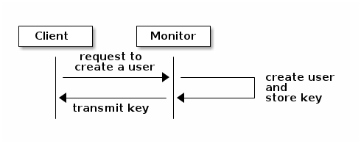

To authenticate with the monitor, the client passes in the user name to the monitor, and the monitor generates a session key and encrypts it with the secret key associated to the user name. Then, the monitor transmits the encrypted ticket back to the client. The client then decrypts the payload with the shared secret key to retrieve the session key. The session key identifies the user for the current session. The client then requests a ticket on behalf of the user signed by the session key. The monitor generates a ticket, encrypts it with the user’s secret key and transmits it back to the client. The client decrypts the ticket and uses it to sign requests to OSDs and metadata servers throughout the cluster.

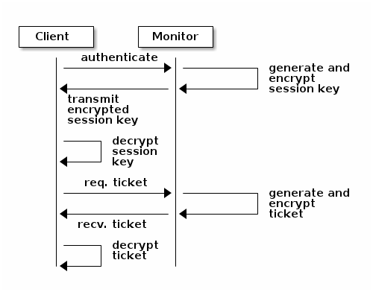

The cephx protocol authenticates ongoing communications between the client machine and the Ceph servers. Each message sent between a client and server, subsequent to the initial authentication, is signed using a ticket that the monitors, OSDs and metadata servers can verify with their shared secret.

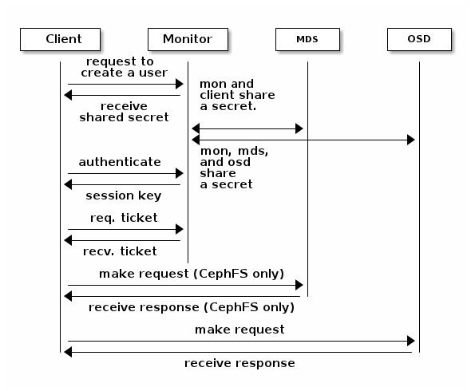

The protection offered by this authentication is between the Ceph client and the Ceph server hosts. The authentication is not extended beyond the Ceph client. If the user accesses the Ceph client from a remote host, Ceph authentication is not applied to the connection between the user’s host and the client host.

For configuration details, see [Cephx Config Guide](http://ceph.com/docs/master/rados/configuration/auth-config-ref). For user management details, see [User Management](http://ceph.com/docs/master/rados/operations/user-management).

#### Smart Daemons Enable Hyperscale

In many clustered architectures, the primary purpose of cluster membership is so that a centralized interface knows which nodes it can access. Then the centralized interface provides services to the client through a double dispatch–which is a **huge** bottleneck at the petabyte-to-exabyte scale.

Ceph eliminates the bottleneck: Ceph’s OSD Daemons AND Ceph Clients are cluster aware. Like Ceph clients, each Ceph OSD Daemon knows about other Ceph OSD Daemons in the cluster. This enables Ceph OSD Daemons to interact directly with other Ceph OSD Daemons and Ceph monitors. Additionally, it enables Ceph Clients to interact directly with Ceph OSD Daemons.

The ability of Ceph Clients, Ceph Monitors and Ceph OSD Daemons to interact with each other means that Ceph OSD Daemons can utilize the CPU and RAM of the Ceph nodes to easily perform tasks that would bog down a centralized server. The ability to leverage this computing power leads to several major benefits:

1. **OSDs Service Clients Directly:** Since any network device has a limit to the number of concurrent connections it can support, a centralized system has a low physical limit at high scales. By enabling Ceph Clients to contact Ceph OSD Daemons directly, Ceph increases both performance and total system capacity simultaneously, while removing a single point of failure. Ceph Clients can maintain a session when they need to, and with a particular Ceph OSD Daemon instead of a centralized server.
2. **OSD Membership and Status**: Ceph OSD Daemons join a cluster and report on their status. At the lowest level, the Ceph OSD Daemon status is up or down reflecting whether or not it is running and able to service Ceph Client requests. If a Ceph OSD Daemon is down and in the Ceph Storage Cluster, this status may indicate the failure of the Ceph OSD Daemon. If a Ceph OSD Daemon is not running (e.g., it crashes), the Ceph OSD Daemon cannot notify the Ceph Monitor that it is down. The Ceph Monitor can ping a Ceph OSD Daemon periodically to ensure that it is running. However, Ceph also empowers Ceph OSD Daemons to determine if a neighboring OSD is down, to update the cluster map and to report it to the Ceph monitor(s). This means that Ceph monitors can remain light weight processes. See [Monitoring OSDs](http://ceph.com/docs/master/rados/operations/monitoring-osd-pg/#monitoring-osds) and [Heartbeats](http://ceph.com/docs/master/rados/configuration/mon-osd-interaction) for additional details.
3. **Data Scrubbing:** As part of maintaining data consistency and cleanliness, Ceph OSD Daemons can scrub objects within placement groups. That is, Ceph OSD Daemons can compare object metadata in one placement group with its replicas in placement groups stored on other OSDs. Scrubbing (usually performed daily) catches bugs or filesystem errors. Ceph OSD Daemons also perform deeper scrubbing by comparing data in objects bit-for-bit. Deep scrubbing (usually performed weekly) finds bad sectors on a drive that weren’t apparent in a light scrub. See [Data Scrubbing](http://ceph.com/docs/master/rados/configuration/osd-config-ref#scrubbing) for details on configuring scrubbing.
4. **Replication:** Like Ceph Clients, Ceph OSD Daemons use the CRUSH algorithm, but the Ceph OSD Daemon uses it to compute where replicas of objects should be stored (and for rebalancing). In a typical write scenario, a client uses the CRUSH algorithm to compute where to store an object, maps the object to a pool and placement group, then looks at the CRUSH map to identify the primary OSD for the placement group.

The client writes the object to the identified placement group in the primary OSD. Then, the primary OSD with its own copy of the CRUSH map identifies the secondary and tertiary OSDs for replication purposes, and replicates the object to the appropriate placement groups in the secondary and tertiary OSDs (as many OSDs as additional replicas), and responds to the client once it has confirmed the object was stored successfully.

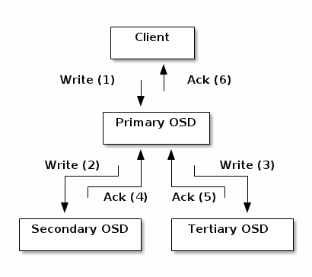

With the ability to perform data replication, Ceph OSD Daemons relieve Ceph clients from that duty, while ensuring high data availability and data safety.

### Dynamic Cluster Management

In the [Scalability and High Availability](http://ceph.com/docs/master/architecture/#scalability-and-high-availability) section, we explained how Ceph uses CRUSH, cluster awareness and intelligent daemons to scale and maintain high availability. Key to Ceph’s design is the autonomous, self-healing, and intelligent Ceph OSD Daemon. Let’s take a deeper look at how CRUSH works to enable modern cloud storage infrastructures to place data, rebalance the cluster and recover from faults dynamically.

#### About Pools

The Ceph storage system supports the notion of ‘Pools’, which are logical partitions for storing objects.

Ceph Clients retrieve a [Cluster Map](http://ceph.com/docs/master/architecture/#cluster-map) from a Ceph Monitor, and write objects to pools. The pool’s size or number of replicas, the CRUSH ruleset and the number of placement groups determine how Ceph will place the data.

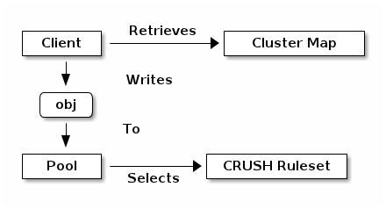

Pools set at least the following parameters:

* Ownership/Access to Objects
* The Number of Placement Groups, and
* The CRUSH Ruleset to Use.

See [Set Pool Values](http://ceph.com/docs/master/rados/operations/pools#set-pool-values) for details.

#### Mapping PGs to OSDs

Each pool has a number of placement groups. CRUSH maps PGs to OSDs dynamically. When a Ceph Client stores objects, CRUSH will map each object to a placement group.

Mapping objects to placement groups creates a layer of indirection between the Ceph OSD Daemon and the Ceph Client. The Ceph Storage Cluster must be able to grow (or shrink) and rebalance where it stores objects dynamically. If the Ceph Client “knew” which Ceph OSD Daemon had which object, that would create a tight coupling between the Ceph Client and the Ceph OSD Daemon. Instead, the CRUSH algorithm maps each object to a placement group and then maps each placement group to one or more Ceph OSD Daemons. This layer of indirection allows Ceph to rebalance dynamically when new Ceph OSD Daemons and the underlying OSD devices come online. The following diagram depicts how CRUSH maps objects to placement groups, and placement groups to OSDs.

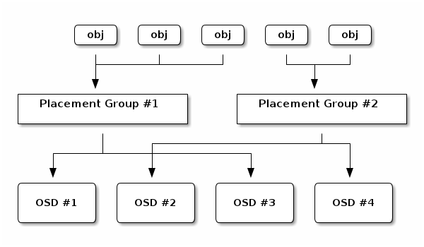

With a copy of the cluster map and the CRUSH algorithm, the client can compute exactly which OSD to use when reading or writing a particular object.

#### Calculating PG IDs

When a Ceph Client binds to a Ceph Monitor, it retrieves the latest copy of the [Cluster Map](http://ceph.com/docs/master/architecture/#cluster-map). With the cluster map, the client knows about all of the monitors, OSDs, and metadata servers in the cluster. **However, it doesn’t know anything about object locations.**

Object locations get computed.

The only input required by the client is the object ID and the pool. It’s simple: Ceph stores data in named pools (e.g., “liverpool”). When a client wants to store a named object (e.g., “john,” “paul,” “george,” “ringo”, etc.) it calculates a placement group using the object name, a hash code, the number of PGs in the pool and the pool name. Ceph clients use the following steps to compute PG IDs.

1. The client inputs the pool ID and the object ID. (e.g., pool = “liverpool” and object-id = “john”)
2. Ceph takes the object ID and hashes it.
3. Ceph calculates the hash modulo the number of PGs. (e.g., 58) to get a PG ID.
4. Ceph gets the pool ID given the pool name (e.g., “liverpool” = 4)
5. Ceph prepends the pool ID to the PG ID (e.g., 4.58).

Computing object locations is much faster than performing object location query over a chatty session. The CRUSH algorithm allows a client to compute where objects should be stored, and enables the client to contact the primary OSD to store or retrieve the objects.

#### Peering and Sets

In previous sections, we noted that Ceph OSD Daemons check each others heartbeats and report back to the Ceph Monitor. Another thing Ceph OSD daemons do is called ‘peering’, which is the process of bringing all of the OSDs that store a Placement Group (PG) into agreement about the state of all of the objects (and their metadata) in that PG. In fact, Ceph OSD Daemons [Report Peering Failure](http://ceph.com/docs/master/rados/configuration/mon-osd-interaction#osds-report-peering-failure) to the Ceph Monitors. Peering issues usually resolve themselves; however, if the problem persists, you may need to refer to the [Troubleshooting Peering Failure](http://ceph.com/docs/master/rados/troubleshooting/troubleshooting-pg#placement-group-down-peering-failure) section.

Note

Agreeing on the state does not mean that the PGs have the latest contents.

The Ceph Storage Cluster was designed to store at least two copies of an object (i.e., size = 2), which is the minimum requirement for data safety. For high availability, a Ceph Storage Cluster should store more than two copies of an object (e.g., size = 3 and min size = 2) so that it can continue to run in a degraded state while maintaining data safety.

Referring back to the diagram in [Smart Daemons Enable Hyperscale](http://ceph.com/docs/master/architecture/#smart-daemons-enable-hyperscale), we do not name the Ceph OSD Daemons specifically (e.g., osd.0, osd.1, etc.), but rather refer to them as Primary, Secondary, and so forth. By convention, the Primary is the first OSD in the Acting Set, and is responsible for coordinating the peering process for each placement group where it acts as the Primary, and is the **ONLY** OSD that that will accept client-initiated writes to objects for a given placement group where it acts as the Primary.

When a series of OSDs are responsible for a placement group, that series of OSDs, we refer to them as an Acting Set. An Acting Set may refer to the Ceph OSD Daemons that are currently responsible for the placement group, or the Ceph OSD Daemons that were responsible for a particular placement group as of some epoch.

The Ceph OSD daemons that are part of an Acting Set may not always be up. When an OSD in the Acting Set is up, it is part of the Up Set. The Up Set is an important distinction, because Ceph can remap PGs to other Ceph OSD Daemons when an OSD fails.

Note

In an Acting Set for a PG containing osd.25, osd.32 and osd.61, the first OSD, osd.25, is the Primary. If that OSD fails, the Secondary, osd.32, becomes the Primary, and osd.25 will be removed from the Up Set.

#### Rebalancing

When you add a Ceph OSD Daemon to a Ceph Storage Cluster, the cluster map gets updated with the new OSD. Referring back to [Calculating PG IDs](http://ceph.com/docs/master/architecture/#calculating-pg-ids), this changes the cluster map. Consequently, it changes object placement, because it changes an input for the calculations. The following diagram depicts the rebalancing process (albeit rather crudely, since it is substantially less impactful with large clusters) where some, but not all of the PGs migrate from existing OSDs (OSD 1, and OSD 2) to the new OSD (OSD 3). Even when rebalancing, CRUSH is stable. Many of the placement groups remain in their original configuration, and each OSD gets some added capacity, so there are no load spikes on the new OSD after rebalancing is complete.

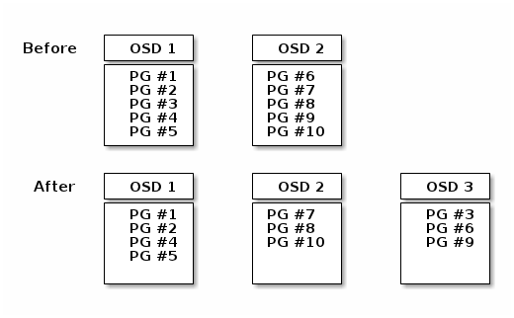

#### Data Consistency

As part of maintaining data consistency and cleanliness, Ceph OSDs can also scrub objects within placement groups. That is, Ceph OSDs can compare object metadata in one placement group with its replicas in placement groups stored in other OSDs. Scrubbing (usually performed daily) catches OSD bugs or filesystem errors. OSDs can also perform deeper scrubbing by comparing data in objects bit-for-bit. Deep scrubbing (usually performed weekly) finds bad sectors on a disk that weren’t apparent in a light scrub.

See [Data Scrubbing](http://ceph.com/docs/master/rados/configuration/osd-config-ref#scrubbing) for details on configuring scrubbing.

### Erasure Coding

An erasure coded pool stores each object as K+M chunks. It is divided into K data chunks and M coding chunks. The pool is configured to have a size of K+M so that each chunk is stored in an OSD in the acting set. The rank of the chunk is stored as an attribute of the object.

For instance an erasure coded pool is created to use five OSDs (K+M = 5) and sustain the loss of two of them (M = 2).

#### Reading and Writing Encoded Chunks

When the object **NYAN** containing ABCDEFGHI is written to the pool, the erasure encoding function splits the content into three data chunks simply by dividing the content in three: the first contains ABC, the second DEF and the last GHI. The content will be padded if the content length is not a multiple of K. The function also creates two coding chunks: the fourth with YXY and the fifth with GQC. Each chunk is stored in an OSD in the acting set. The chunks are stored in objects that have the same name (**NYAN**) but reside on different OSDs. The order in which the chunks were created must be preserved and is stored as an attribute of the object (shard\_t), in addition to its name. Chunk 1 contains ABC and is stored on **OSD5** while chunk 4 contains YXY and is stored on **OSD3**.

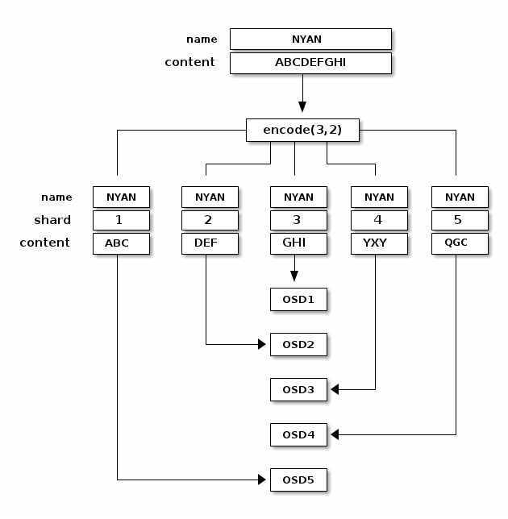

When the object **NYAN** is read from the erasure coded pool, the decoding function reads three chunks: chunk 1 containing ABC, chunk 3 containing GHI and chunk 4 containing YXY. Then, it rebuilds the original content of the object ABCDEFGHI. The decoding function is informed that the chunks 2 and 5 are missing (they are called ‘erasures’). The chunk 5 could not be read because the **OSD4** is out. The decoding function can be called as soon as three chunks are read: **OSD2** was the slowest and its chunk was not taken into account.

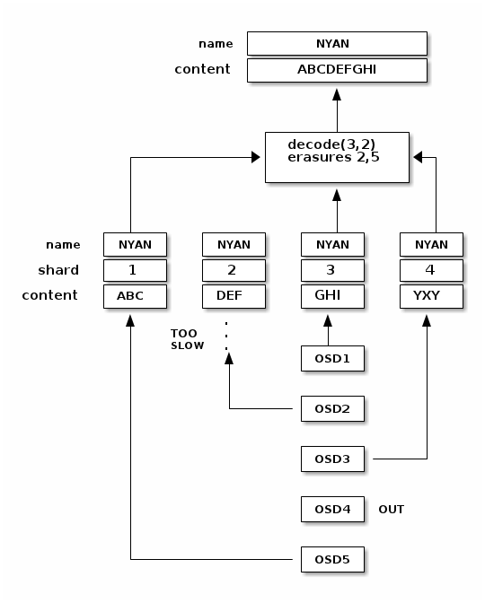

#### Interrupted Full Writes

In an erasure coded pool, the primary OSD in the up set receives all write operations. It is responsible for encoding the payload into K+M chunks and sends them to the other OSDs. It is also responsible for maintaining an authoritative version of the placement group logs.

In the following diagram, an erasure coded placement group has been created with K = 2 + M = 1 and is supported by three OSDs, two for K and one for M. The acting set of the placement group is made of **OSD 1**, **OSD 2** and **OSD 3**. An object has been encoded and stored in the OSDs : the chunk D1v1 (i.e. Data chunk number 1, version 1) is on **OSD 1**, D2v1 on **OSD 2** and C1v1 (i.e. Coding chunk number 1, version 1) on **OSD 3**. The placement group logs on each OSD are identical (i.e. 1,1 for epoch 1, version 1).

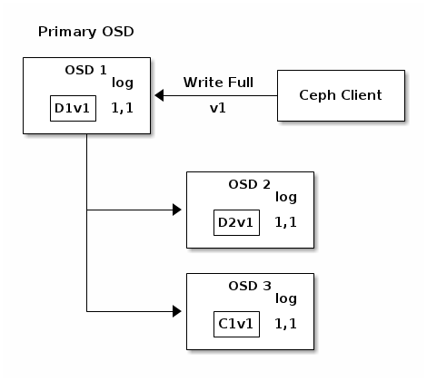

**OSD 1** is the primary and receives a **WRITE FULL** from a client, which means the payload is to replace the object entirely instead of overwriting a portion of it. Version 2 (v2) of the object is created to override version 1 (v1). **OSD 1** encodes the payload into three chunks: D1v2 (i.e. Data chunk number 1 version 2) will be on **OSD 1**, D2v2 on **OSD 2** and C1v2 (i.e. Coding chunk number 1 version 2) on **OSD 3**. Each chunk is sent to the target OSD, including the primary OSD which is responsible for storing chunks in addition to handling write operations and maintaining an authoritative version of the placement group logs. When an OSD receives the message instructing it to write the chunk, it also creates a new entry in the placement group logs to reflect the change. For instance, as soon as **OSD 3** stores C1v2, it adds the entry 1,2 ( i.e. epoch 1, version 2 ) to its logs. Because the OSDs work asynchronously, some chunks may still be in flight ( such as D2v2 ) while others are acknowledged and on disk ( such as C1v1 and D1v1).

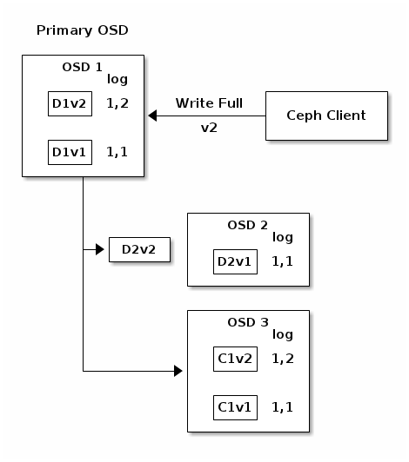

If all goes well, the chunks are acknowledged on each OSD in the acting set and the logs’ last\_complete pointer can move from 1,1 to 1,2.

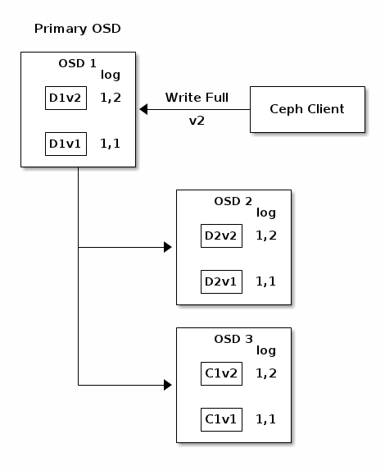

Finally, the files used to store the chunks of the previous version of the object can be removed: D1v1 on **OSD 1**, D2v1 on **OSD 2** and C1v1 on **OSD 3**.

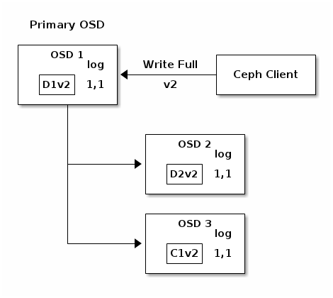

But accidents happen. If **OSD 1** goes down while D2v2 is still in flight, the object’s version 2 is partially written: **OSD 3** has one chunk but that is no not enough to recover. It lost two chunks: D1v2 and D2v2 and the erasure coding parameters K = 2 + M = 1 require that at least two chunks are available to rebuild the third. **OSD 4** becomes the new primary and finds that the last\_complete log entry (i.e., all objects before this entry were known to be available on all OSDs in the previous acting set ) is 1,1 and that will be the head of the new authoritative log.

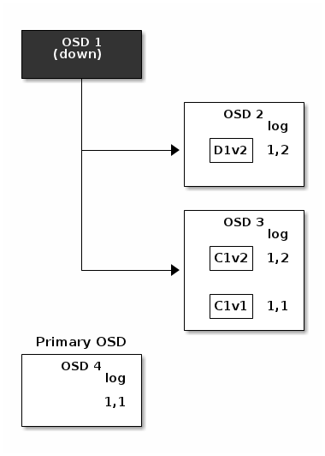

The log entry 1,2 found on **OSD 3** is divergent from the new authoritative log provided by **OSD 4**: it is discarded and the file containing the C1v2 chunk is removed. The D1v1 chunk is rebuilt with the decode function of the erasure coding library during scrubbing and stored on the new primary **OSD 4**.

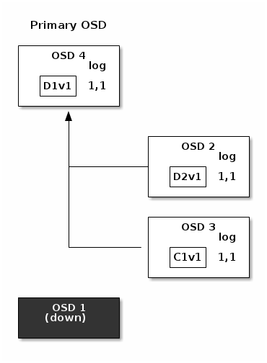

See [Erasure Code Notes](https://github.com/ceph/ceph/blob/40059e12af88267d0da67d8fd8d9cd81244d8f93/doc/dev/osd_internals/erasure_coding/developer_notes.rst) for additional details.

### Cache Tiering

A cache tier provides Ceph Clients with better I/O performance for a subset of the data stored in a backing storage tier. Cache tiering involves creating a pool of relatively fast/expensive storage devices (e.g., solid state drives) configured to act as a cache tier, and a backing pool of either erasure-coded or relatively slower/cheaper devices configured to act as an economical storage tier. The Ceph objecter handles where to place the objects and the tiering agent determines when to flush objects from the cache to the backing storage tier. So the cache tier and the backing storage tier are completely transparent to Ceph clients.

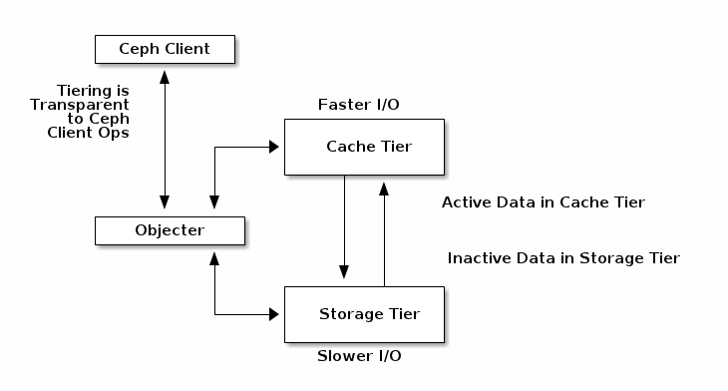

See [Cache Tiering](http://ceph.com/docs/master/rados/operations/cache-tiering) for additional details.

### Extending Ceph

You can extend Ceph by creating shared object classes called ‘Ceph Classes’. Ceph loads .so classes stored in the osd class dir directory dynamically (i.e., $libdir/rados-classes by default). When you implement a class, you can create new object methods that have the ability to call the native methods in the Ceph Object Store, or other class methods you incorporate via libraries or create yourself.

On writes, Ceph Classes can call native or class methods, perform any series of operations on the inbound data and generate a resulting write transaction that Ceph will apply atomically.

On reads, Ceph Classes can call native or class methods, perform any series of operations on the outbound data and return the data to the client.

Ceph Class Example

A Ceph class for a content management system that presents pictures of a particular size and aspect ratio could take an inbound bitmap image, crop it to a particular aspect ratio, resize it and embed an invisible copyright or watermark to help protect the intellectual property; then, save the resulting bitmap image to the object store.

See src/objclass/objclass.h, src/fooclass.cc and src/barclass for exemplary implementations.

### Summary

Ceph Storage Clusters are dynamic–like a living organism. Whereas, many storage appliances do not fully utilize the CPU and RAM of a typical commodity server, Ceph does. From heartbeats, to peering, to rebalancing the cluster or recovering from faults, Ceph offloads work from clients (and from a centralized gateway which doesn’t exist in the Ceph architecture) and uses the computing power of the OSDs to perform the work. When referring to [Hardware Recommendations](http://ceph.com/docs/master/install/hardware-recommendations) and the [Network Config Reference](http://ceph.com/docs/master/rados/configuration/network-config-ref), be cognizant of the foregoing concepts to understand how Ceph utilizes computing resources.

## Ceph Protocol

Ceph Clients use the native protocol for interacting with the Ceph Storage Cluster. Ceph packages this functionality into the librados library so that you can create your own custom Ceph Clients. The following diagram depicts the basic architecture.

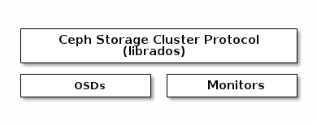

### Native Protocol and librados

Modern applications need a simple object storage interface with asynchronous communication capability. The Ceph Storage Cluster provides a simple object storage interface with asynchronous communication capability. The interface provides direct, parallel access to objects throughout the cluster.

* Pool Operations
* Snapshots and Copy-on-write Cloning
* Read/Write Objects - Create or Remove - Entire Object or Byte Range - Append or Truncate
* Create/Set/Get/Remove XATTRs
* Create/Set/Get/Remove Key/Value Pairs
* Compound operations and dual-ack semantics
* Object Classes

### Object Watch/Notify

A client can register a persistent interest with an object and keep a session to the primary OSD open. The client can send a notification message and payload to all watchers and receive notification when the watchers receive the notification. This enables a client to use any object a synchronization/communication channel.

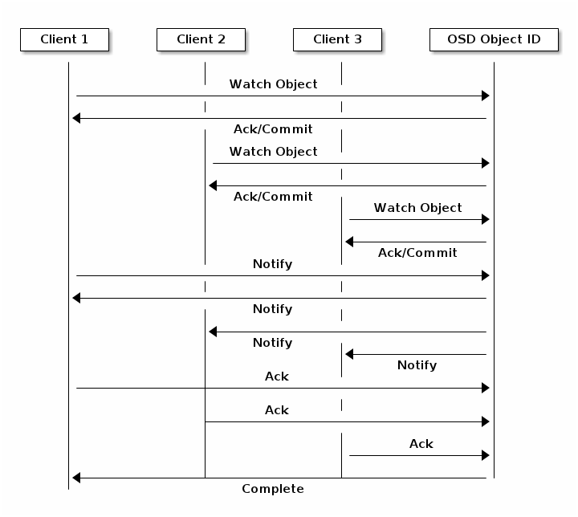

### Data Striping

Storage devices have throughput limitations, which impact performance and scalability. So storage systems often support [striping](http://en.wikipedia.org/wiki/Data_striping)–storing sequential pieces of information across across multiple storage devices–to increase throughput and performance. The most common form of data striping comes from [RAID](http://en.wikipedia.org/wiki/RAID). The RAID type most similar to Ceph’s striping is [RAID 0](http://en.wikipedia.org/wiki/RAID_0#RAID_0), or a ‘striped volume.’ Ceph’s striping offers the throughput of RAID 0 striping, the reliability of n-way RAID mirroring and faster recovery.

Ceph provides three types of clients: Ceph Block Device, Ceph Filesystem, and Ceph Object Storage. A Ceph Client converts its data from the representation format it provides to its users (a block device image, RESTful objects, CephFS filesystem directories) into objects for storage in the Ceph Storage Cluster.

Tip

The objects Ceph stores in the Ceph Storage Cluster are not striped. Ceph Object Storage, Ceph Block Device, and the Ceph Filesystem stripe their data over multiple Ceph Storage Cluster objects. Ceph Clients that write directly to the Ceph Storage Cluster via librados must perform the striping (and parallel I/O) for themselves to obtain these benefits.

The simplest Ceph striping format involves a stripe count of 1 object. Ceph Clients write stripe units to a Ceph Storage Cluster object until the object is at its maximum capacity, and then create another object for additional stripes of data. The simplest form of striping may be sufficient for small block device images, S3 or Swift objects and CephFS files. However, this simple form doesn’t take maximum advantage of Ceph’s ability to distribute data across placement groups, and consequently doesn’t improve performance very much. The following diagram depicts the simplest form of striping:

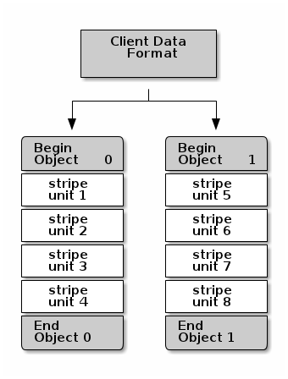

If you anticipate large images sizes, large S3 or Swift objects (e.g., video), or large CephFS directories, you may see considerable read/write performance improvements by striping client data over multiple objects within an object set. Significant write performance occurs when the client writes the stripe units to their corresponding objects in parallel. Since objects get mapped to different placement groups and further mapped to different OSDs, each write occurs in parallel at the maximum write speed. A write to a single disk would be limited by the head movement (e.g. 6ms per seek) and bandwidth of that one device (e.g. 100MB/s). By spreading that write over multiple objects (which map to different placement groups and OSDs) Ceph can reduce the number of seeks per drive and combine the throughput of multiple drives to achieve much faster write (or read) speeds.

Note

Striping is independent of object replicas. Since CRUSH replicates objects across OSDs, stripes get replicated automatically.

In the following diagram, client data gets striped across an object set (object set 1 in the following diagram) consisting of 4 objects, where the first stripe unit is stripe unit 0 in object 0, and the fourth stripe unit is stripe unit 3 in object 3. After writing the fourth stripe, the client determines if the object set is full. If the object set is not full, the client begins writing a stripe to the first object again (object 0 in the following diagram). If the object set is full, the client creates a new object set (object set 2 in the following diagram), and begins writing to the first stripe (stripe unit 16) in the first object in the new object set (object 4 in the diagram below).

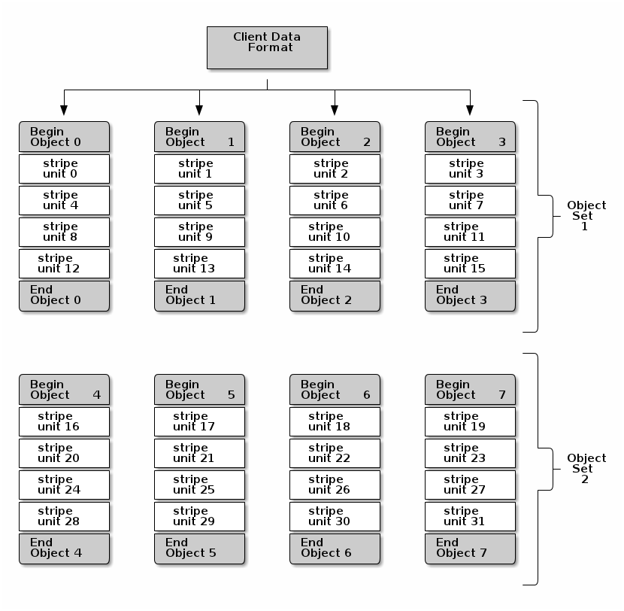

Three important variables determine how Ceph stripes data:

* **Object Size:** Objects in the Ceph Storage Cluster have a maximum configurable size (e.g., 2MB, 4MB, etc.). The object size should be large enough to accommodate many stripe units, and should be a multiple of the stripe unit.
* **Stripe Width:** Stripes have a configurable unit size (e.g., 64kb). The Ceph Client divides the data it will write to objects into equally sized stripe units, except for the last stripe unit. A stripe width, should be a fraction of the Object Size so that an object may contain many stripe units.
* **Stripe Count:** The Ceph Client writes a sequence of stripe units over a series of objects determined by the stripe count. The series of objects is called an object set. After the Ceph Client writes to the last object in the object set, it returns to the first object in the object set.

Important

Test the performance of your striping configuration before putting your cluster into production. You CANNOT change these striping parameters after you stripe the data and write it to objects.

Once the Ceph Client has striped data to stripe units and mapped the stripe units to objects, Ceph’s CRUSH algorithm maps the objects to placement groups, and the placement groups to Ceph OSD Daemons before the objects are stored as files on a storage disk.

Note

Since a client writes to a single pool, all data striped into objects get mapped to placement groups in the same pool. So they use the same CRUSH map and the same access controls.

## Ceph Clients

Ceph Clients include a number of service interfaces. These include:

* **Block Devices:** The [Ceph Block Device](http://ceph.com/docs/master/glossary/#term-ceph-block-device) (a.k.a., RBD) service provides resizable, thin-provisioned block devices with snapshotting and cloning. Ceph stripes a block device across the cluster for high performance. Ceph supports both kernel objects (KO) and a QEMU hypervisor that uses librbd directly–avoiding the kernel object overhead for virtualized systems.
* **Object Storage:** The [Ceph Object Storage](http://ceph.com/docs/master/glossary/#term-ceph-object-storage) (a.k.a., RGW) service provides RESTful APIs with interfaces that are compatible with Amazon S3 and OpenStack Swift.
* **Filesystem**: The [Ceph Filesystem](http://ceph.com/docs/master/glossary/#term-ceph-filesystem) (CephFS) service provides a POSIX compliant filesystem usable with mount or as a filesytem in user space (FUSE).

Ceph can run additional instances of OSDs, MDSs, and monitors for scalability and high availability. The following diagram depicts the high-level architecture.

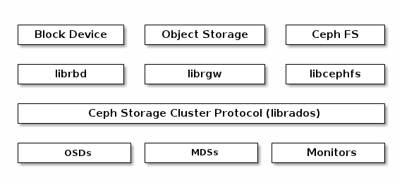

### Ceph Object Storage

The Ceph Object Storage daemon, radosgw, is a FastCGI service that provides a [RESTful](http://en.wikipedia.org/wiki/RESTful) HTTP API to store objects and metadata. It layers on top of the Ceph Storage Cluster with its own data formats, and maintains its own user database, authentication, and access control. The RADOS Gateway uses a unified namespace, which means you can use either the OpenStack Swift-compatible API or the Amazon S3-compatible API. For example, you can write data using the S3-compatible API with one application and then read data using the Swift-compatible API with another application.

S3/Swift Objects and Store Cluster Objects Compared

Ceph’s Object Storage uses the term object to describe the data it stores. S3 and Swift objects are not the same as the objects that Ceph writes to the Ceph Storage Cluster. Ceph Object Storage objects are mapped to Ceph Storage Cluster objects. The S3 and Swift objects do not necessarily correspond in a 1:1 manner with an object stored in the storage cluster. It is possible for an S3 or Swift object to map to multiple Ceph objects.

See [Ceph Object Storage](http://ceph.com/docs/master/radosgw/) for details.

### Ceph Block Device

A Ceph Block Device stripes a block device image over multiple objects in the Ceph Storage Cluster, where each object gets mapped to a placement group and distributed, and the placement groups are spread across separate ceph-osd daemons throughout the cluster.

Important

Striping allows RBD block devices to perform better than a single server could!

Thin-provisioned snapshottable Ceph Block Devices are an attractive option for virtualization and cloud computing. In virtual machine scenarios, people typically deploy a Ceph Block Device with the rbd network storage driver in Qemu/KVM, where the host machine uses librbd to provide a block device service to the guest. Many cloud computing stacks use libvirt to integrate with hypervisors. You can use thin-provisioned Ceph Block Devices with Qemu and libvirt to support OpenStack and CloudStack among other solutions.

While we do not provide librbd support with other hypervisors at this time, you may also use Ceph Block Device kernel objects to provide a block device to a client. Other virtualization technologies such as Xen can access the Ceph Block Device kernel object(s). This is done with the command-line tool rbd.

### Ceph Filesystem

The Ceph Filesystem (Ceph FS) provides a POSIX-compliant filesystem as a service that is layered on top of the object-based Ceph Storage Cluster. Ceph FS files get mapped to objects that Ceph stores in the Ceph Storage Cluster. Ceph Clients mount a CephFS filesystem as a kernel object or as a Filesystem in User Space (FUSE).

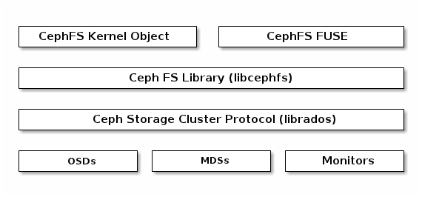

The Ceph Filesystem service includes the Ceph Metadata Server (MDS) deployed with the Ceph Storage cluster. The purpose of the MDS is to store all the filesystem metadata (directories, file ownership, access modes, etc) in high-availability Ceph Metadata Servers where the metadata resides in memory. The reason for the MDS (a daemon called ceph-mds) is that simple filesystem operations like listing a directory or changing a directory (ls, cd) would tax the Ceph OSD Daemons unnecessarily. So separating the metadata from the data means that the Ceph Filesystem can provide high performance services without taxing the Ceph Storage Cluster.

Ceph FS separates the metadata from the data, storing the metadata in the MDS, and storing the file data in one or more objects in the Ceph Storage Cluster. The Ceph filesystem aims for POSIX compatibility. ceph-mds can run as a single process, or it can be distributed out to multiple physical machines, either for high availability or for scalability.

* **High Availability**: The extra ceph-mds instances can be standby, ready to take over the duties of any failed ceph-mds that was active. This is easy because all the data, including the journal, is stored on RADOS. The transition is triggered automatically by ceph-mon.
* **Scalability**: Multiple ceph-mds instances can be active, and they will split the directory tree into subtrees (and shards of a single busy directory), effectively balancing the load amongst all active servers.

Combinations of standby and active etc are possible, for example running 3 active ceph-mds instances for scaling, and one standby instance for high availability.

References:

Ceph.com (for above content).

Google.com (for links in FAQ section).