QuickTools v1.3

Routing Devices Remote Reporting

Mark Addinall. Network Specialist. 2004
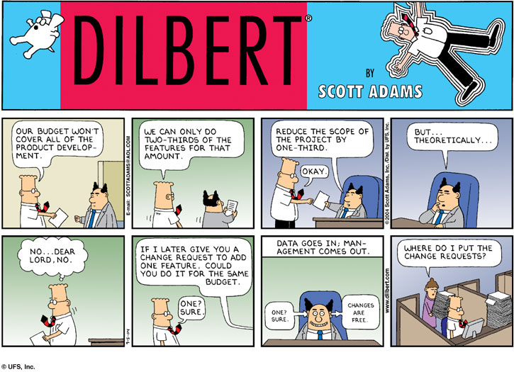
Description
This project provides an easy to use, friendly interface to the 20,000 routing devices and some 5000 servers (Solaris and Linux) managed by Telstra Australia. The application suite has been designed to provide enterprise wide support for the Telstra managed networks for some hundred major clients. The QuickTools software suite will provide some thirty reports specific to routing devices, and a dozen reports that can be applied to routers, switches or machines. During phase two, a quality assurance software suite will be added for the benefit of the NOC designers and installation staff.
The application suite will provide for a secure single sign-on for Telstra NOC/Support engineers from Windows workstations, UNIX servers and the Cisco/Nortel and Motorola devices. Cisco in the first instance of software development.
The common ODIN security level is to be implemented, but provision will be made to transition QuickTools from this model into a single point LDAP database.

System Build Tools

The languages, tools, and techniques used are :-
- PHP. Used to code the server-side Apache-httpd routines.
- Javascript. Used to code the client side GUI elements.
- PERL. Used to code the lower-level SNMP CISCO IOS routines.
- SSH/SSL. Used to provide the security requirements over the network.
- LDAP. Used to store the location and security level of potential users.
- HP OpenView (on Solaris platform) and associated tools, snmpget(), snmpwalk() and rnetstat().
- Oracle. DBMS used to store Customer, Network and Device information.
- Solaris, Linux, Windows XP.

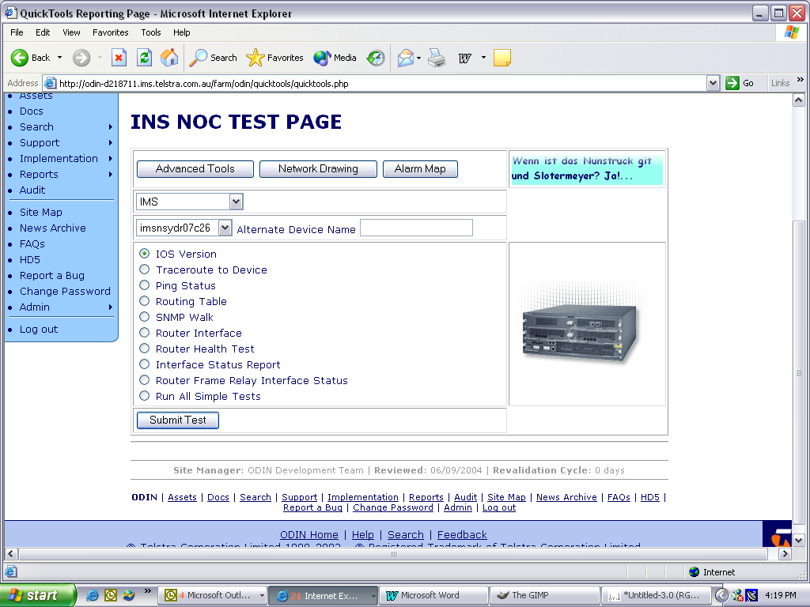
Figure 1. Choosing a Report.
QuickTools Basic Menu
This is stage one in the design and development of this network management tool suite. The Quicktools BASIC tool suite allows a NOC helpdesk person to run quite a sophisticated diagnostic test on a managed wide area network device, without having to have extended CISCO/Nortel IOS experience. At the conclusion of phase one this initial part of the tool suite supplied:
- IOS Version Report. Return the IOS version of the device.
- Traceroute to device. As the title states, a traceroute. This can be important if a managed segment is switched on or off, where changes in BGP topology are made or when the locations of DNS requests are in doubt.
- Ping status. Pings a device on one or more interfaces.
- Routing Table. This report returns the currently stored routing table for the device.
- SNMP walk report. This report currently returns an SNMP walk data stream based on the system.* OID entries in the MIB for the device.
- Router Health Test. This will be a commonly used test to determine the health of a managed device and to provide information to the second tier support team if escalation is required. The report provides information on the IOS version, the interface status, the frame status and the last ten entries of the device’s syslog().
- Router interface report. This report produces data concerning the number of device interfaces, the type of interfaces and their current status, up, down or suspended.
- Router frame relay interface report. Similar to the interface report but is specific to frame relay interfaces on managed devices. The report shows Interface Management Scheme, the Address Format and Length, the MaxVCs available and the Broadcast status.
- All Simple Tests. Runs all of the above in batch.
- Router ISDN BRI Report. This is a function enabled in the version of QuickTools under development and will be discussed at some length in that section.
Version 1.x is released and in production. Development time has been one man full time (Mark Addinall) for ten (10) normal working weeks.

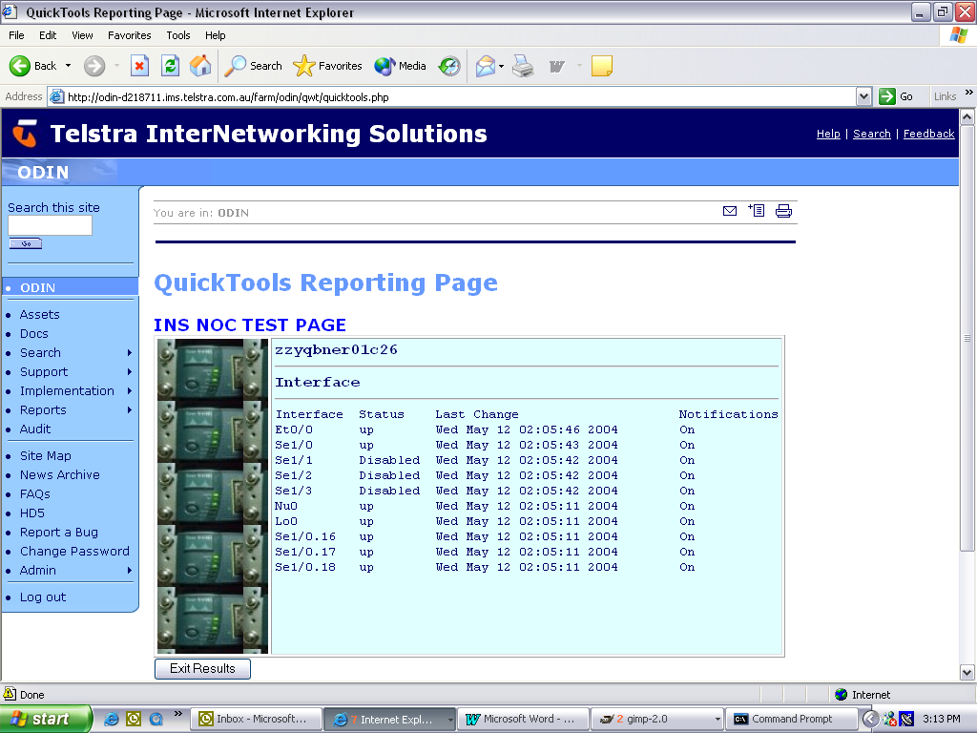
Figure 2. A router Interface Report.
QuickTools Report Output

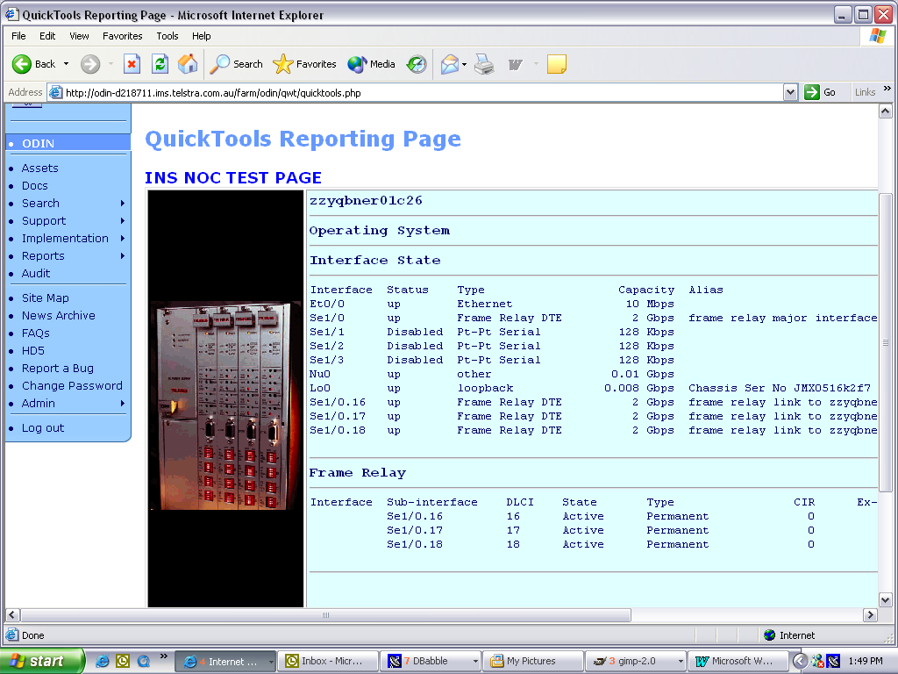
Figure 3. A device Health Test Report.

QuickTools Report Output. Highlighting

Colour highlighting has been added to the report output page. This was a sensible request from the NOC staff and was easily implemented.

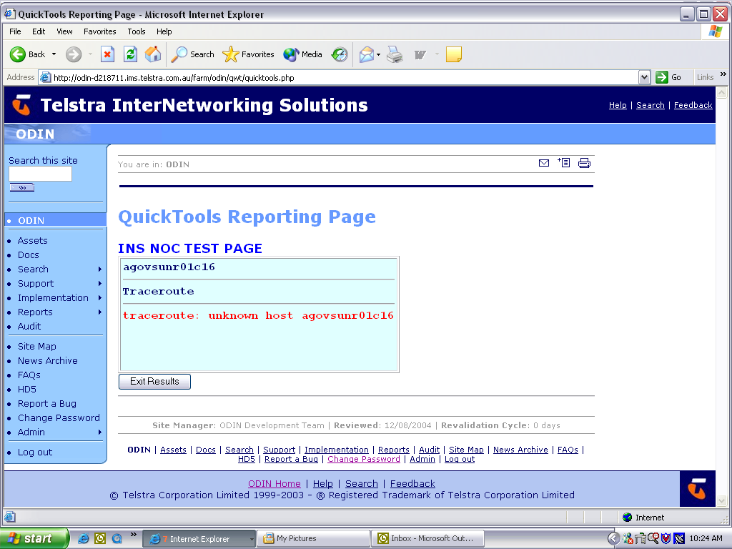
Figure 4(a). Error highlighting

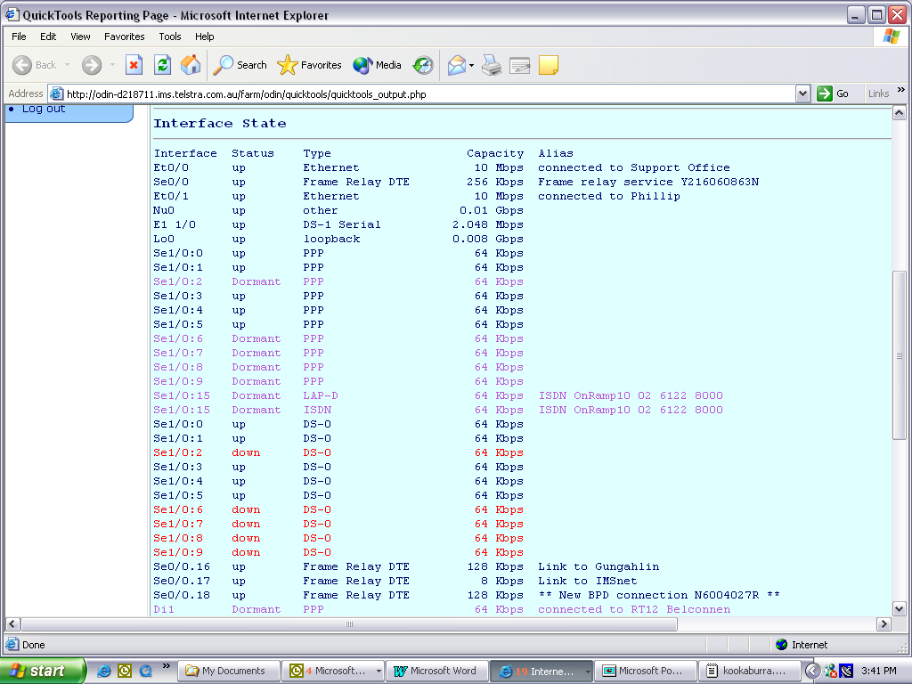
Figure 4(b) Error Highlighting

QuickTools Graphical Reports – Alarm Map

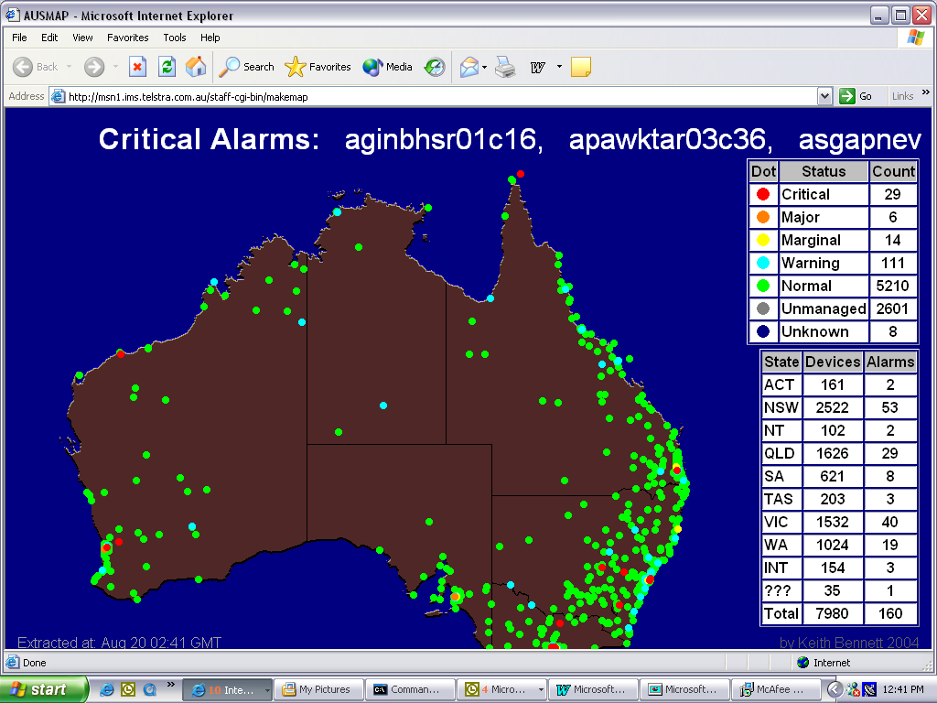
Figure 5. Critical Alarm Map of Australia
This tool does a snapshot of the current errors flagged in the ODIN database. From the stored location of the managed WAN device, the device is represented onto a map of Australia, and the criticality of the error state colour coded.

QuickTools Graphical Reports – Alarm Map

Figure 6. Customer Network Diagram.

This report interrogates the database created by the Network Designers of the managed WAN segments that correspond to the device being examined.

QuickTools Development Topology
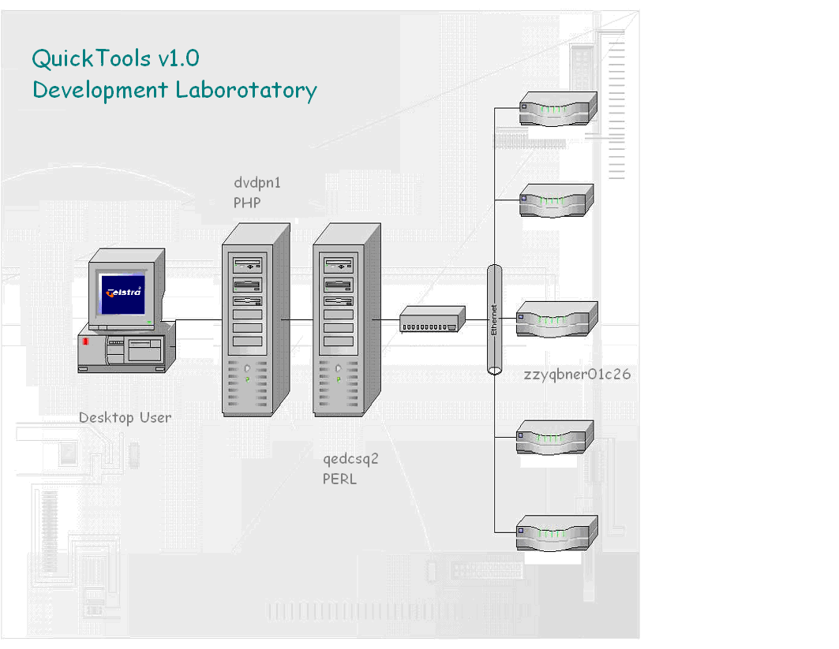
Figure 7. Current Development/Test Environment
The above diagram describes the development environment at 40 Creek Street, Brisbane that was used for the production of PHP code, PERL code and documentation (including this doc) by Mark Addinall. The sandbox used for the development was d218711-odin. A combination of Linux (RedHat 9.0 and SuSe 8) and Windows XP Pro/2003 on the desktop and Solaris ( 8 and 9 ) on the two development servers. GNU tools were used and the web server is Apache.
QuickTools Data Flow Diagram

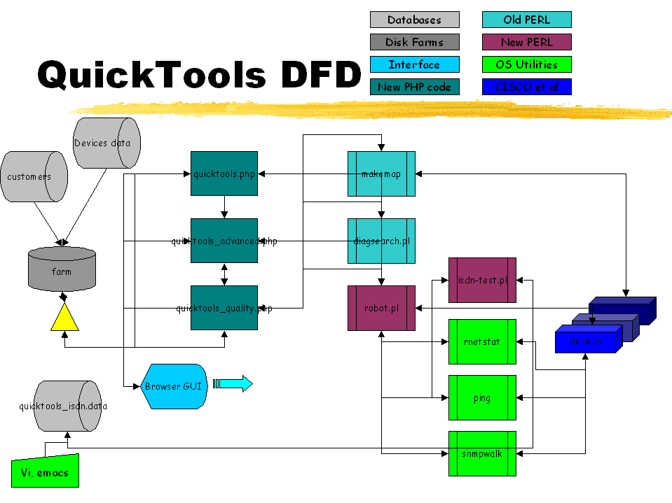
Figure 10. QuickTools Data Flow Diagram and Key

Quality Assurance Knowledge Base
QuickTools v2.x
Allowing the more sophisticated user to report more fully on Telstra’s devices and to allow the installers of managed WAN devices to complete a Web based Quality Assurance checklist.
- The advanced module of the QuickTools suite is complete and ready to be moved into production. The filename is quicktools_advanced.php. The advanced toolset makes use of the same PERL script, robot.pl developed by Mark Addinall, to investigated the devices. It was decided to start another ‘program’ file as adding more complexity to the simpletools will make the code harder to maintain and implement. The advanced toolset follows the same architecture as that of the basic suite, but provides more esoteric information regarding the managed WAN devices.
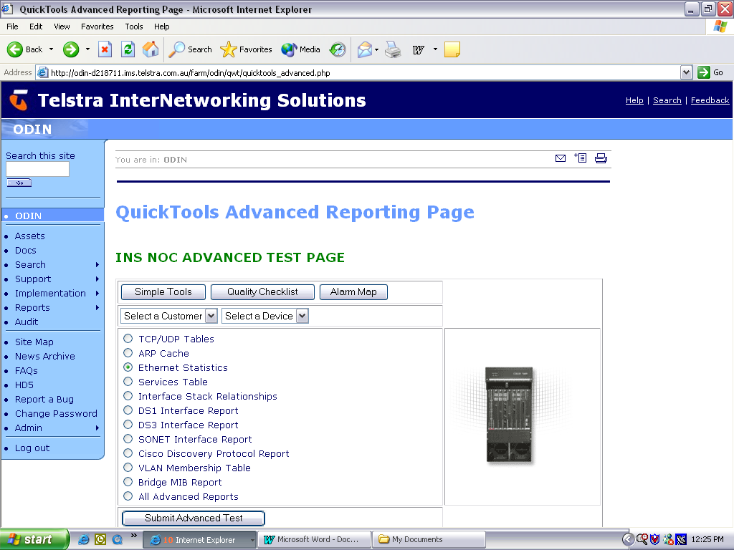
Figure 9. QuickTools v2.x Advanced Tests.

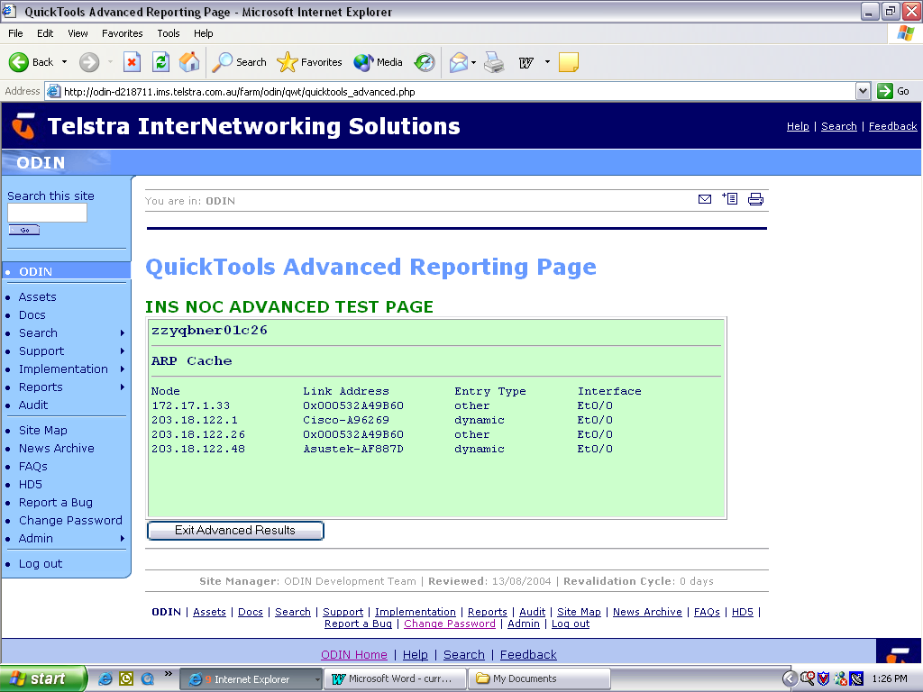
Figure 10. QuickTools Advanced Report. ARP Cache.

- Work has been started on the QuickTools Quality Audit functions. This start will be considered a prototyping exercise for discussion.
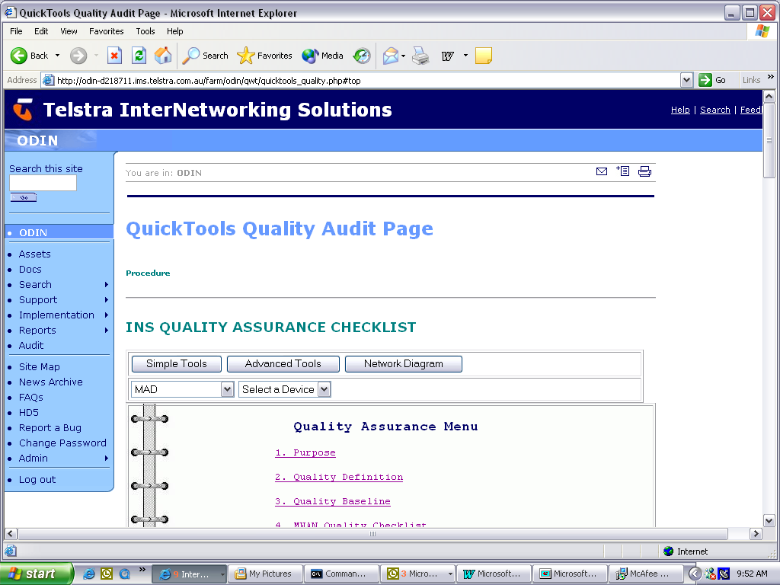
Figure 11. QuickTools Quality Assurance Checklist ‘Binder’ Menu

ISDN Reporting Module

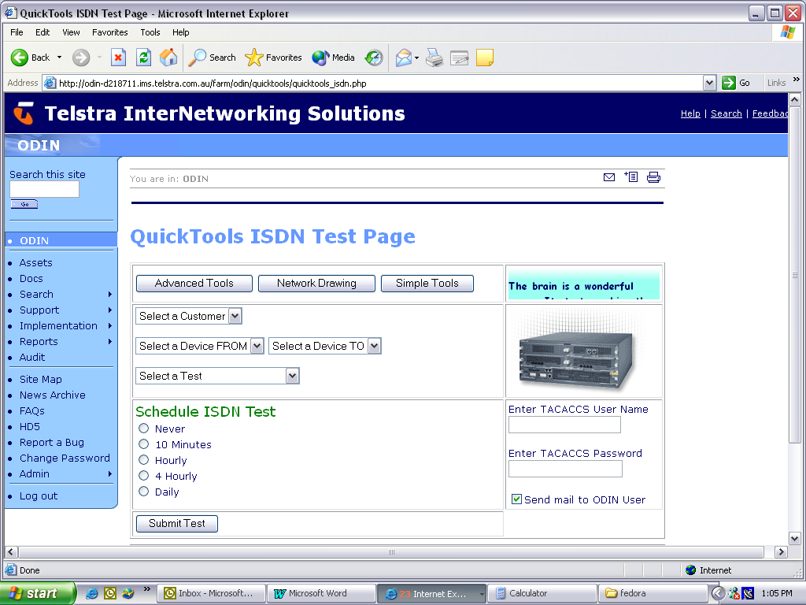
Figure 12. QuickTools ISDN Test Module
The work on the ISDN module is now complete. Some negotiation is required between System Development, Network Security and Systems Administration in IMS and in the NOCs as to the implementation of this code. It carries with it a number of security issues.
The debugging commands available and used after initiating a telnet() session with one or more ISDN enabled devices include :

- show interface BRI0
Shows the statistics, such as packets sent and received and the number of CRC's on the BRI interface. This is useful in seeing the amount of errors that the BRI interface is receiving. It is best used in conjunction with the clear counters BRI0 command so that the information listed is current.
- show dialer
Lists the general diagnostic information about an interface configured for DDR, such as the number of times the dialer string has been successfully reached, and the idle timer and fast idle timer values for each B channel. Current call-specific information is also provided, such as the length of the call, and the number and name of the device to which the interface is currently connected.
- show isdn active
Use to show if a call is in progress and which number is being dialed.
- show isdn status
Shows the statistics of the ISDN connection.
- show ip route
Displays the routes known to the router, including static and dynamically learned routes.
- debug isdn q921
Verifies that you have a connection to the ISDN switch.
- debug isdn q931
Displays call setup and teardown messages.
- debug dialer
Shows information such as what number the interface is dialing.
- shutdown/no shutdown
These commands can be used to disconnect any call in progress and reset an interface.
- clear interface BRI0
This command causes the BRI interface to reset itself and then to re-establish a connection to the switch and then dial-up to the number that it is configured for.
Here is a typical ISDN connection timeline.

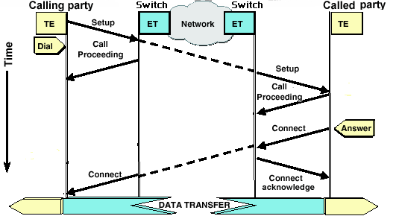
Figure 13. Typical ISDN call request

MWAN Device Management and Control
QuickTools v3.x

To add invasive access from QuickTools Advanced into MWAN devices the security of such a proposal needs to be considered at a number of levels. The system entry security should by now have been implemented. Whether this is an ODIN Oracle security entry or an implementation of LDAP, some structured method of securing access to the system will be in place. To allow access to devices from this application suite, it is suggested that using SSH provides a more comfortable level of security than raw telnet(). A description of SSH as implemented on Cisco devices is as follows:
- Additional Security
Before SSH, security was limited to Telnet security. SSH allows strong encryption to be used with Cisco IOS software authentication.
- RSA Authentication Not Supported
RSA authentication available in SSH clients is not supported in the SSH server for Cisco IOS software.
- Supported Authentication Methods
User ID and Password authentication only.
- DES and Triple DES Supported
SSH is supported on DES (56-bit) data encryption and Triple DES (168-bit) data encryption software images only. In the DES software images, DES is the only encryption algorithm available. In the Triple DES software images, both DES and Triple DES encryption are available.
- Supported Applications
Execution shell is the only application supported.
- Strong Encryption Limitations
Cisco IOS software images with strong encryption (including, but not limited to, 56-bit data encryption feature sets) are subject to United States government export controls, and have a limited distribution. Images to be installed outside the United States require an export license. Customer orders might be denied or subject to delays due to United States government regulations. Contact your sales representative or distributor for more information, or send e-mail to export@cisco.com.
The Secure Shell Version 1 Support feature module is related to the following existing features:
- Authentication, authorization, and accounting (AAA) feature—This feature is available in the Cisco IOS Security Configuration Guide , Release 12.1 and the Cisco IOS Security Command Reference , Release 12.1.
- IP Security Protocol (IPSec) feature—This feature is available in the Cisco IOS Security Configuration Guide , Release 12.1 and the Cisco IOS Security Command Reference , Release 12.1.
For related information on the SSH server feature, refer to the following documents:
- Cisco IOS Security Configuration Guide , Release 12.1
- Cisco IOS Security Command Reference , Release 12.1
- Cisco 1700 series
- Cisco 2600 series
- Cisco 3600 series
- Cisco 7200 series
- Cisco 7500 series
- Cisco ubr920 series

- IPSec Software Image Required
Although the version of ssh available on these devices is somewhat limited, we can still implement session level security for this systems to a satisfactory level. We could implement Perfect Forward Secrecy between the application and the Cisco devices. Cisco devices provide a configuration option, PFS or NO PFS. Authentication can be handled with the use of public keys when swapping a nonce, or swapping initial Diffie-Hellman partial keys, the IKE using the Diffie-Hellman algorithm, and the resultant symmetric key using DESede (3DES) or IDEA. A new key pair is generation per session and any prior keys generated do not influence the resultant secret key.

QuickTools Future. Ipv6 and IPSec/VPN
QuickTools v4.x
Moving the QuickTool suite towards Ipv6, IPSec and large-scale use of VPN Technology.

QuickTools v3.x should address the issues of deploying towards an Ipv6 network. The issues will include:
- IPv6 addressing
- IPv6 routing: IS-IS, OSPFv3 and BGP
- IPv6 ACLs and firewall settings
- IPv6 applications/services: DNS, Web, SMTP etc..
- IPv6 network management: use of network management tools
- Deployment of IPv6 in MAN, WAN and backbone environments.
Exponential growth curves have now begun to be part of accepted parlance. Also, over the past few years, the nature of traffic over the Internet has changed from being primarily text-based services such as e-mail to streaming video, VoIP, and online commerce. This is the era of the Web, where multimedia takes precedence over other components. Telstra, as Australia’s largest carrier will provide for a large percentage of this traffic. Plans for the implementation of Ipv6 as a business growth factor should be being made now.

Out-of-the-box, VPN products offer a username/password combination or shared-secret method of authenticating the participants in a secure channel. These same VPN products also offer integration with enhanced security solutions such as public-key infrastructure (PKI). It is extremely important to take advantage of this integration capability because a simple username/password combination is simply not secure enough to allow an organization to take full advantage of the benefits of VPN.
Using passwords as the method to identify users of a VPN exposes an enterprise to unnecessary risk. Passwords are recognized as insufficient for securing sensitive information because of the following vulnerabilities:
- Passwords are stored on local and network devices and can be easy to find
- Temptation to use the same password/shared secret across multiple devices increases likelihood of compromise
- Many username/password implementations send the password over the Internet in the clear
- Hackers can easily masquerade as legitimate users from any location
- Readily-available password-hacking tools make passwords easy to crack, but not as easy as the familiar use of post-it notes to affix a password to the machine it is intended to protect
- Implementing shared secrets has the same security limitations as username/ passwords and also creates significant administrative requirements and complexities for VPN administrators
Many of today's virtual private networks (VPNs) exist without the support of a public key infrastructure (PKI). VPN endpoints — be they security gateways or clients — authenticate each other when establishing IPSec tunnels. At its simplest, this can be accomplished by configuring the same shared secret — essentially a pair-wise password — at both tunnel endpoints. This rudimentary approach works fine on a small scale, but becomes unwieldy in larger VPNs, especially large remote access VPNs with hundreds or thousands of clients.
Pre-shared keys do not scale well when you are trying to deploy a large-scale VPN system without using a certification authority (CA). When using dynamic IP addressing such as Dynamic Host Configuration Protocol (DHCP) or Point-to-Point Protocol (PPP) dial-ups, the changing IP address can make key lookup difficult or impossible unless a wildcard pre-shared key is used. In the IKE shared secret feature that uses an AAA server, the shared secret is accessed during the aggressive mode of IKE negotiation through the AAA server. The ID of the exchange is used as the user name to query AAA if no local key can be found on the Cisco IOS® router to which the user is trying to connect. This was introduced in Cisco IOS Software Release 12.1.T. You must have aggressive mode enabled on the VPN Client to use this feature
Why are digital certificates more scalable than shared secrets? We no longer need to issue a unique pair of secrets for every pair of VPN devices. Each device has just one digital certificate. And we no longer have to reconfigure all other devices every time we add a new device to our VPN. Instead, we make certificates available to every device through a public directory — for example, using the Lightweight Directory Access Protocol (LDAP). Furthermore, if we want to join two VPNs, we can leverage existing certificates by having the issuers — two CAs — cross-certify each other. This is analogous to accepting passports issued by other countries as proof of identity.
Like passports, certificates have a specified validity period and can be revoked by the issuer when necessary. Present the signature associated with a non-existent, expired, or revoked certificate and you won't be successfully authenticated — at least that's the objective. Revocation can be a bit tricky if the authenticator doesn't check with the issuing CA. Even if the authenticator consults a list of revoked certificates (a CRL), the list may be obsolete. Do we issue the CRL weekly? Daily? Hourly? The answer is a matter of security policy and practice.
Administration functions can be distributed to Registration Authorities (RAs). The RA may be responsible for assigning names, generating or archiving key pairs, authenticating the end entity during enrollment, delivering authorization codes or keys to the end entity, and initiating revocation. The RA is effectively an administrative interface to the CA, but can be physically distributed for improved scalability and security, as well as for delegation of administrative responsibility to reflect organizational units. It is envisaged that this facility be included in the system administration functionality of QuickTools.

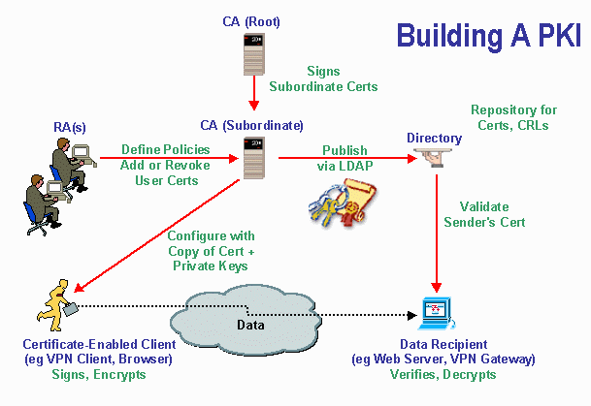

IPSec refers to a suite of protocols that has been specified by the IETF (Internet Engineering Task Force) to add security to IP. The IETF developed the IPSec protocols (RCFs 2401-2412) to provide security services at Layer 3. Because IPSec is integrated with IP, security is provided to any application using IP through:
- Authentication and data integrity . Either the AH (Authentication Header) protocol or the ESP (Encapsulating Security Payload) protocol can be used to provide connectionless integrity and data origin authentication for IP datagrams. These security services enable communicating parties to verify that received data came from the claimed IP source address and that the data was not modified in transit. These protocols also offer an optional antireplay feature when a sequence number field is added to help protect against certain denial-of-service attacks.
- Confidentiality . ESP protocol can be used to provide data confidentiality by using encryption and limited traffic flow confidentiality if used in tunnel mode. Encrypting data secures it against eavesdropping during transit. Tunneling ensures that the source and destination IP addresses are hidden.
- Secure communication session establishment . The IKE (Internet Key Exchange) protocol enables communicating parties to establish secure communication sessions with each other dynamically and negotiate their choices of protocols and algorithms to secure their user communication. IKE also distributes the needed encryption keys.
Securing a large number of VPN (or other) secure endpoints using a third-party CA can be an expensive model. The preferred model for an organisation with a requirement to manage more than 1000 secure endpoints would be that of “rolling your own” CA.

Regards,
Mark Addinall
InterNetworking Specialist
Telstra - InterNetworking Solutions
_______________________________
Freecall  1800 658 078 "A computer scientist is a person when told 'go to Hell'....
Phone  +61 7 3887 7322 sees the transport, rather than the destination, as worrying..."
Mobile  +61 4 1483 8097
Fax  +61 7 3406 0508
Snail  Level 1/40 Creek St. Brisbane. QLD. 4000
E-mail  mailto:Mark.Addinall@team.telstra.com

This communication may contain CONFIDENTIAL or copyright information of Telstra Corporation Limited (ABN 33 051 775 556). If you are not an intended recipient, you MUST NOT keep, forward, copy, use, save or rely on this communication, and any such action is unauthorised and prohibited. If you have received this communication in error, please reply to this e-mail to notify the sender of its incorrect delivery, and then delete both it and your reply. Thank you.

