TTK4147 Miniproject
Group 02, Kristian Krohn and Adrian Ribe

Task 1
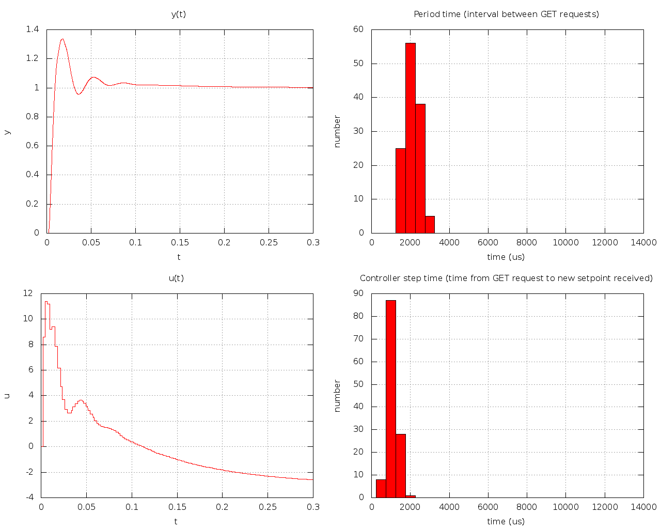

The periodtime of the controller is set fixed to 4ms with a sleep function. The sleep time is derived from 4ms - (end of calculation - start of calculation).

It was found by trial and error, starting without any delay in the program and finding the smallest period while having a decent response, continuously observing the controller step time towards the period time. Increasing the period until the controller met the deadlines.

Other design choices made are to include a anti-windup.

Task 2
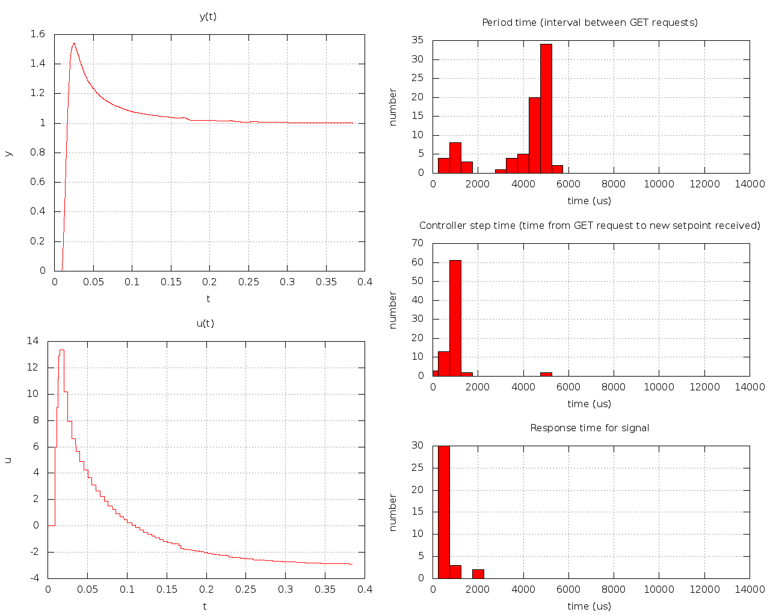
The controller's period was first set to be the same as in part 1. But found out that this would not suffice in part 2, as it would struggle to meet the deadline.
The same trial and error method was used, and we ended up with a period of 6ms, where the sleep time is derived from 6ms - (end of calculation - start of calculation).

The additional signaling affected the PID in such a way that the worst case execution time became less predictable, and making the integrator less precise by increasing the integral-part in the regulator.

integral = integral + (e * d);

d is directly related to the period.

This is comparable in the figures for u(t) where task 1 has a peak of almost 12, while task 2 has a peak of almost 14.

