Develop Student Project with the 8 Steps of Application Development

# 1. Design the application

HCM 9.0 - NAIT 1

Database: HRNAIT01

Project: NAIT###_STUDENT

MENU > BAIST > NAIT###>Student

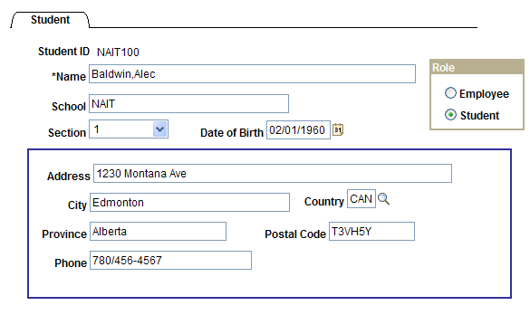

# 2. Define new fields

Cerate Student ID field

File > New > Field

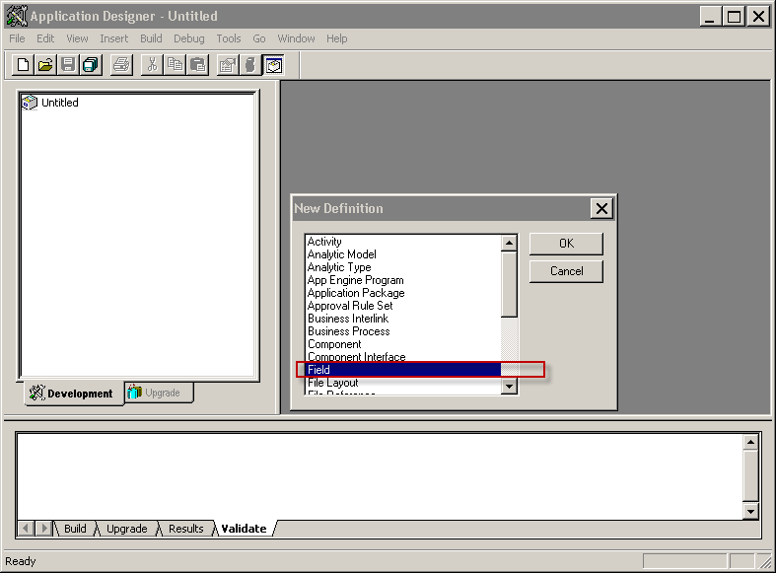

|  |  |
| --- | --- |
| 1. Field Type: Character | 4. Long Name: Student ID |
| 1. Field Length: 7 | 5. Short Name: Student ID |
| 1. . Label ID: STUDENT_ID | 6. Format Type: Uppercase |

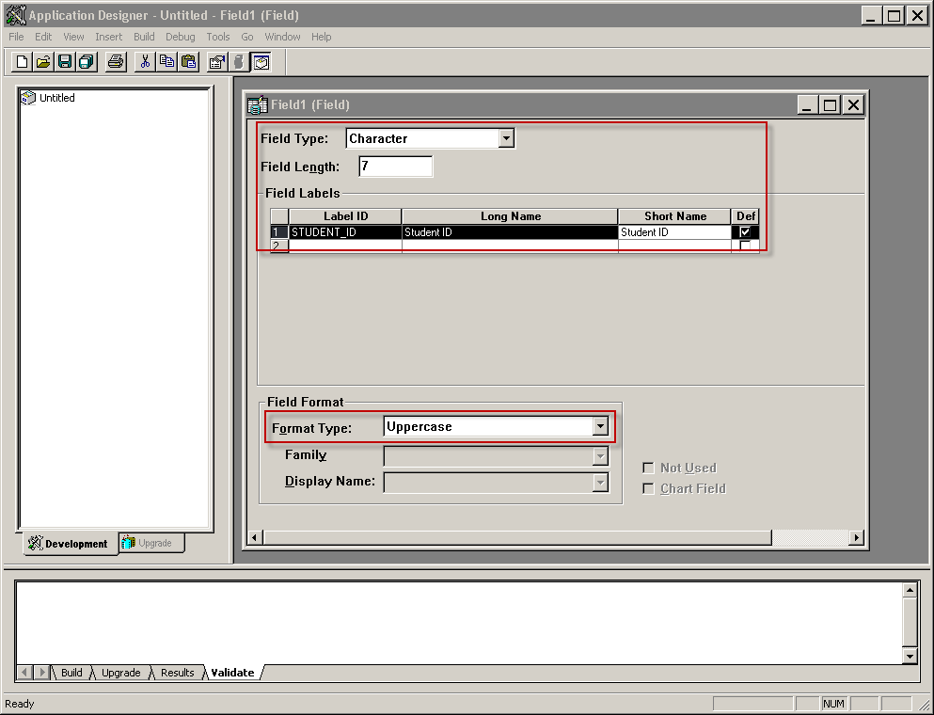

File > Save

Field Name: NAIT###_STUDENT_ID

Click: OK (Label ID is now greyed-out)

Insert Field into project

Insert > Current Definition into Project

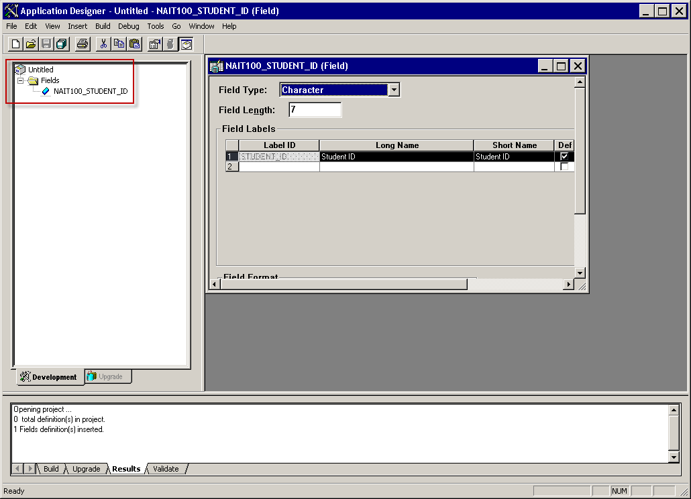

File > Save Project

NAIT100_STUDENT

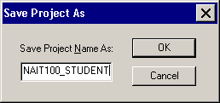

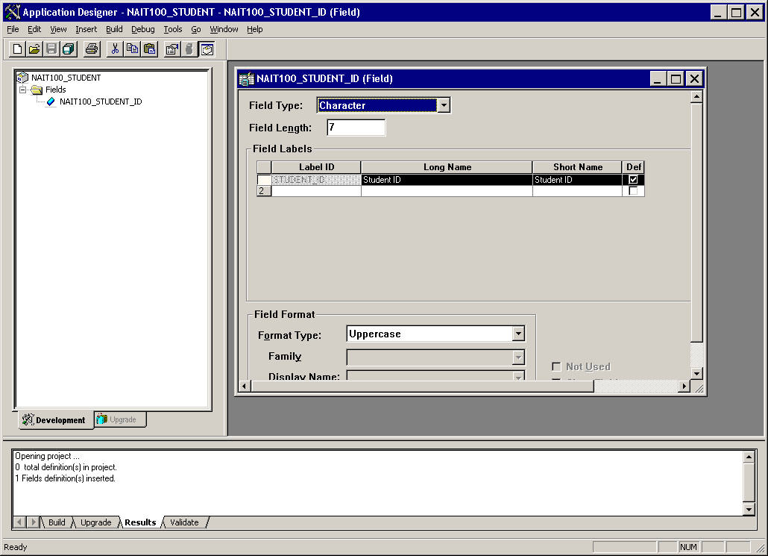

|  |  |
| --- | --- |
| 1. Create Section field | 5. Label ID: SECTION |
| 1. File > New > Field | 6. Long Name: Section |
| 1. Field Type: Character | 7. Short Name: Section |
| 1. Field Length: 1 | 8. Format Type: Uppercase |

File > Save

Field Name: NAIT###_SECTION

Click: OK

Add Translate Values

Select Properties Button

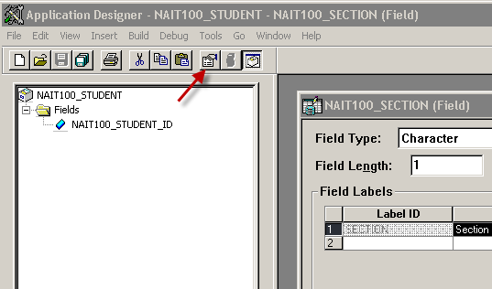

Select Translate Values Tab

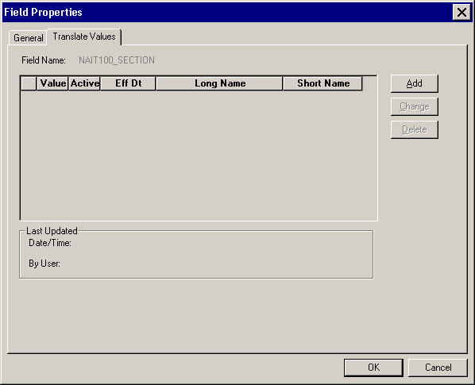

Add Translate Values

Click Add button

Add Translate Values (1)

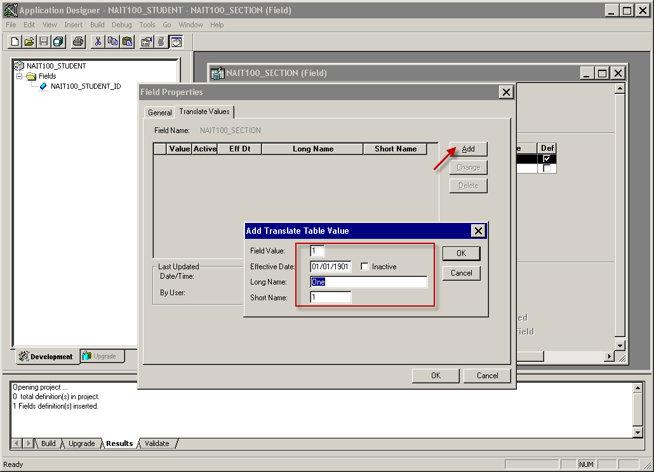

Add Translate Values (2)

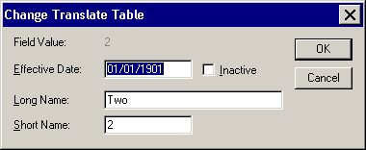

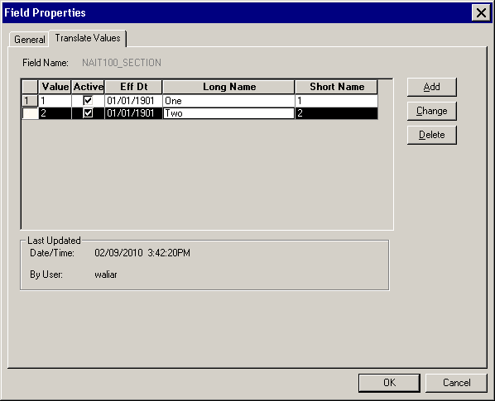

Save Field.

Insert Field into project

Insert > Current Definition into Project

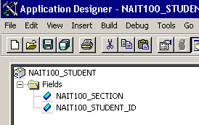

|  |  |
| --- | --- |
| 1. Create Role field | 5. Label ID: ROLE |
| 1. File > New > Field | 6. Long Name: Role |
| 1. Field Type: Character | 7. Short Name: Role |
| 1. Field Length: 1 | 8. Format Type: Uppercase |

File > Save

Field Name: NAIT###_ROLE

Click: OK

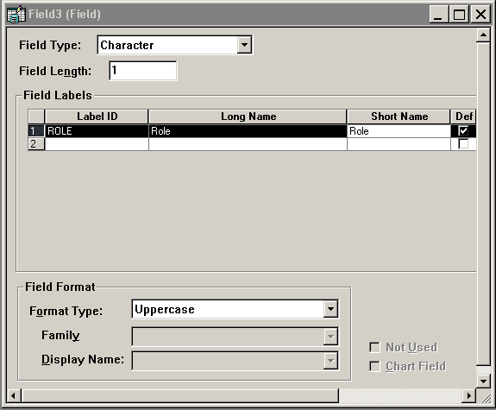

Add Translate Values

Select Properties Button and add Translate Values

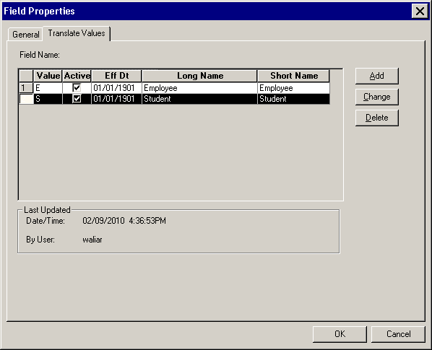

File > Save

Field Name: NAIT###_ROLE

Click: OK

Insert Field into project

Insert > Current Definition into Project

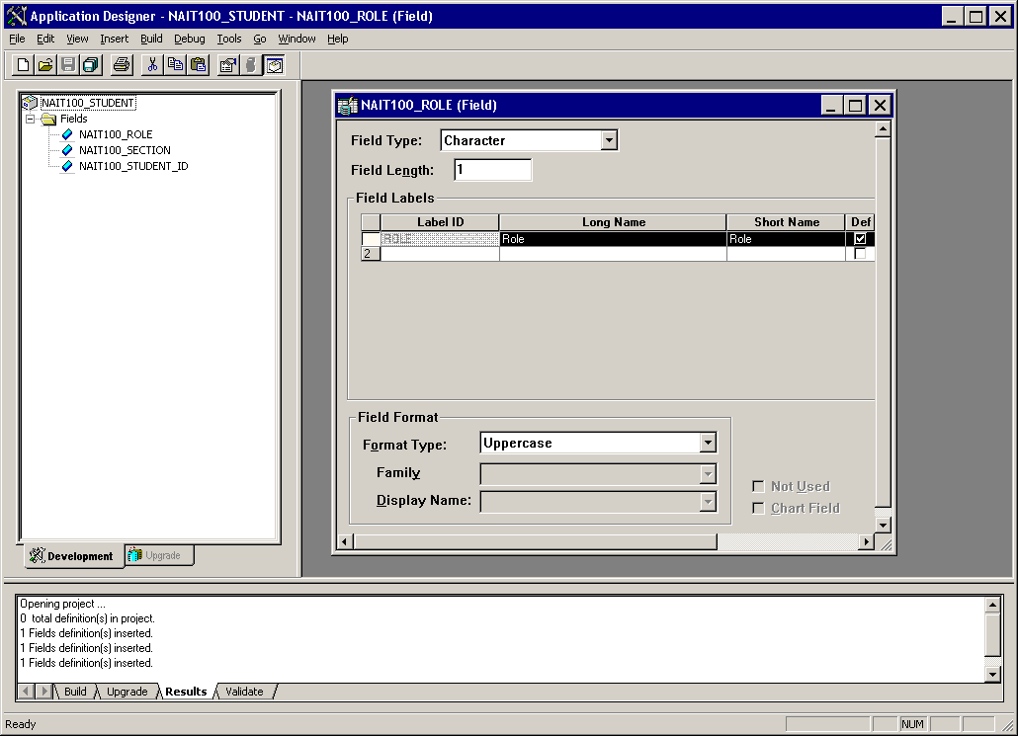

|  |  |
| --- | --- |
| 1. Create School field | 5. Label ID: SCHOOL |
| 1. File > New > Field | 6. Long Name: School |
| 1. Field Type: Character | 7. Short Name: School |
| 1. Field Length: 30 | 8. Format Type: Mixedcase |

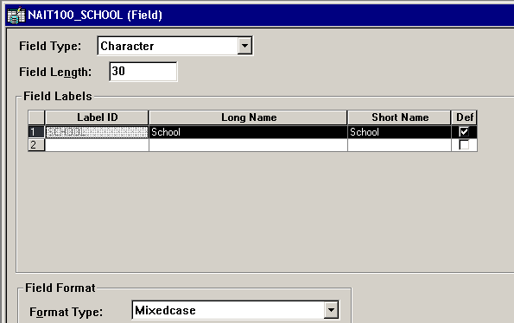

File > Save

Field Name: NAIT###_SCHOOL

Click: OK

File > Save

Insert Field into project

Insert > Current Definition into Project

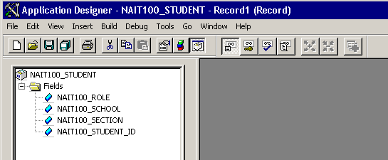

|  |  |
| --- | --- |
| 1. Create Province field | 5. Label ID: PROVINCE |
| 1. File > New > Field | 6. Long Name: Province |
| 1. Field Type: Character | 7. Short Name: Province |
| 1. Field Length: 20 | 8. Format Type: Mixedcase |

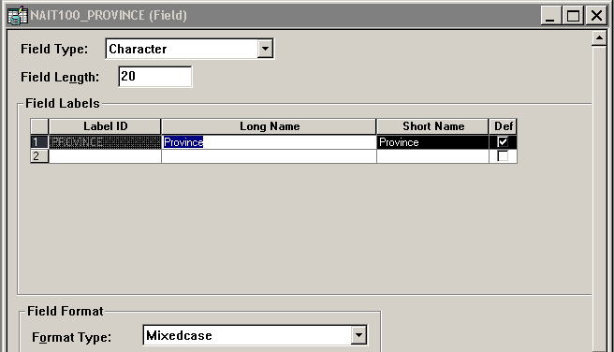

File > Save

Field Name: NAIT###_PROVINCE

Click: OK

Insert Field into project

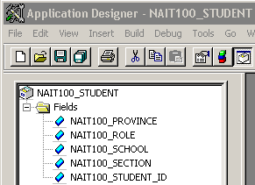

Save Project

Close all windows

Window > Close All

# 3. Create record definitions

Create a new Record

File > New > Record

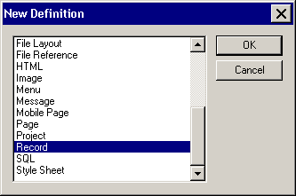

Add Fields to Record

Drag and drop the field Student ID to record

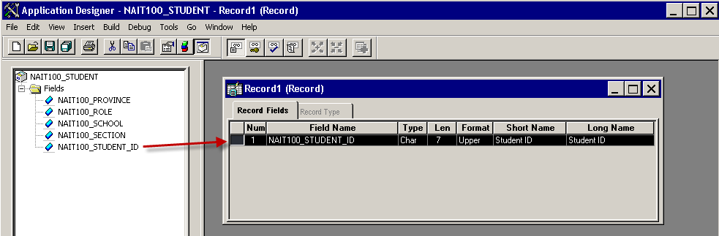

Double Click on the Student ID field and change properties:

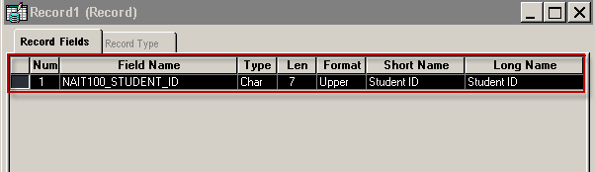

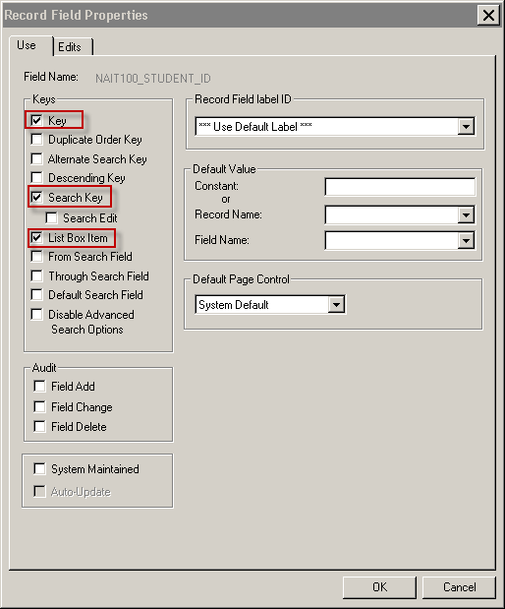

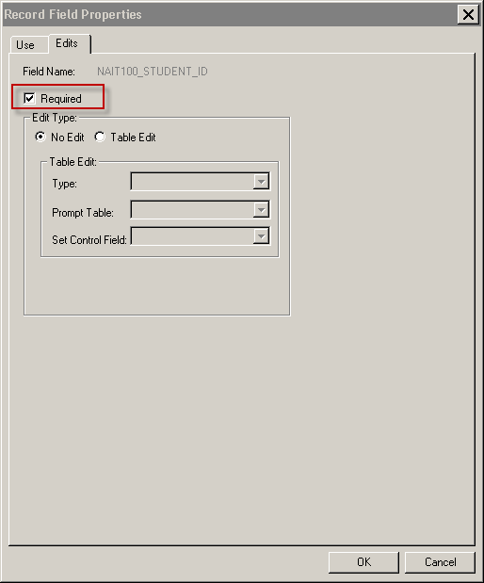

Add Name field to record

Insert > Field

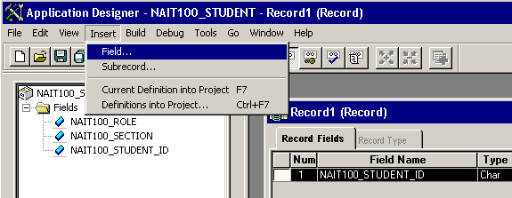

Select the field Name and click insert

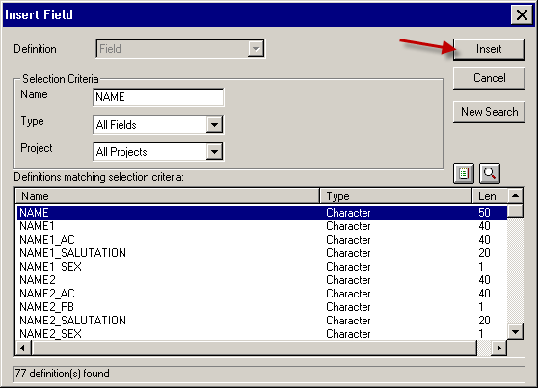

Double Click on the Name field and change properties

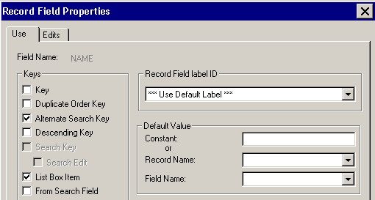

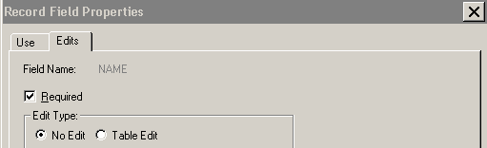

Insert fields

BIRTHDATE

Insert field and set properties:

NAIT###_ROLE (Alternate Search Key, List Box Item)

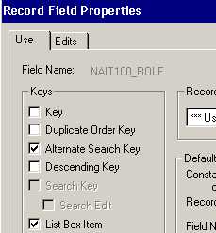

Insert field and set properties:

NAIT###_SECTION (Alternate Search Key, List Box Item)

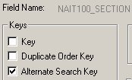

Insert field and set properties

NAIT###_SCHOOL (Default Value Constant: NAIT)



Insert fields:

ADDRESS1

CITY

NAIT###_PROVINCE

Insert field and set properties:

COUNTRY (Edit Type: Table Edit, Type: Prompt Table Edit, Prompt Table: COUNTRY_TBL)

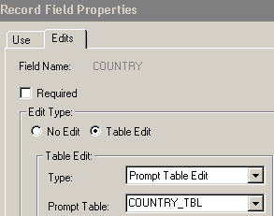

Insert fields:

POSTAL

PHONE

Save Record: NAIT###_STUDENT

Insert record into project

Save project

# Build the records

Build > Current Definition

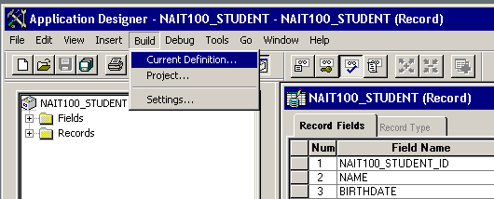

Check: Create Tables

Select: Execute SQL Now

Click: Build button

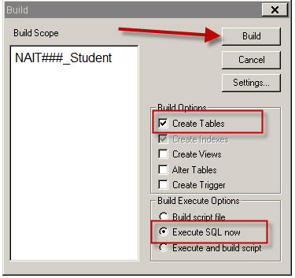

# 5. Create page definition

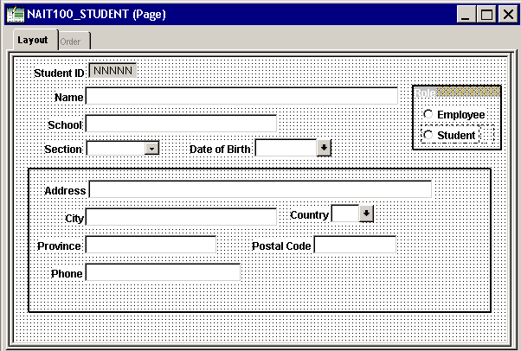

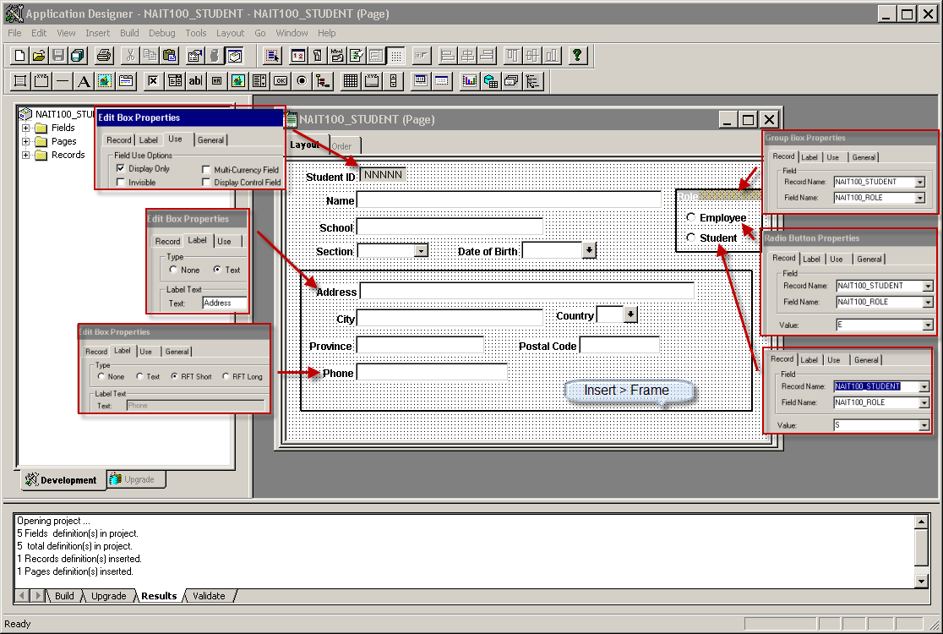

Click Default Ordering button to set the tab order,

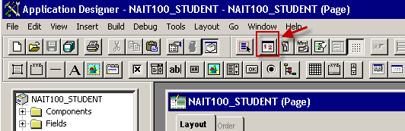

Save Page: NAIT###_STUDENT

Insert page into project

Save Project

Window > Close All

# Define the component

File > New > Component

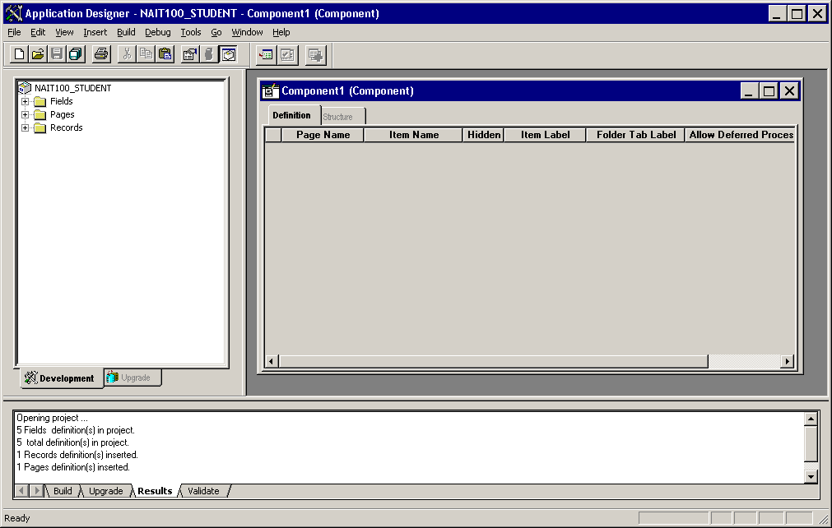

Drag Page from Project into Component

Change Item Label

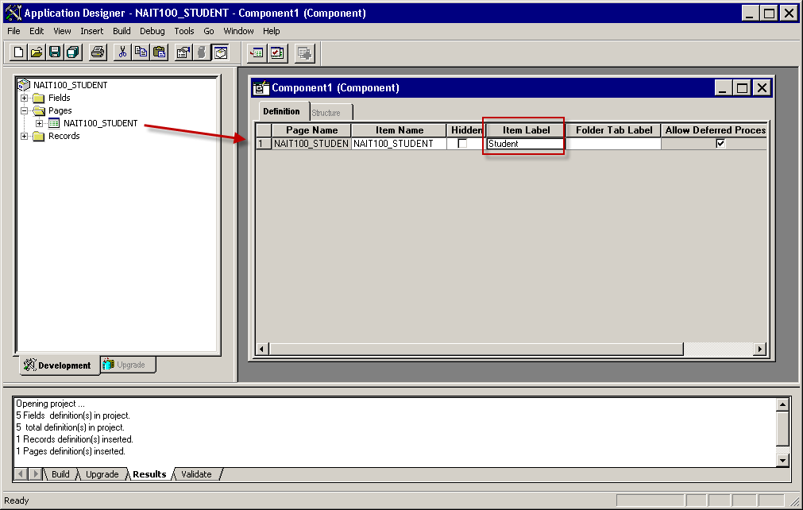

Set Properties

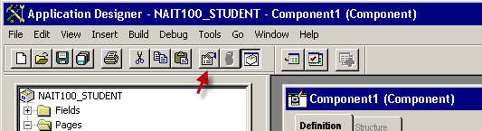

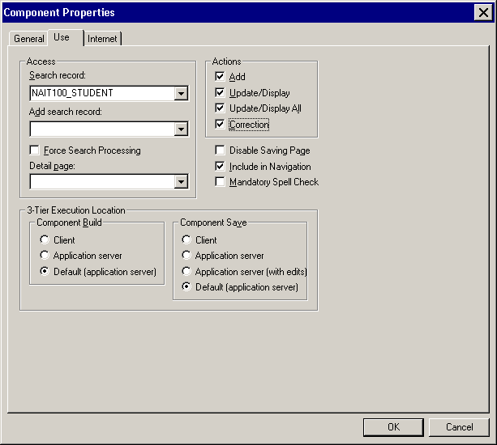

Click ok

Save component NAIT###_STUDENT

Click: OK

Insert component into project

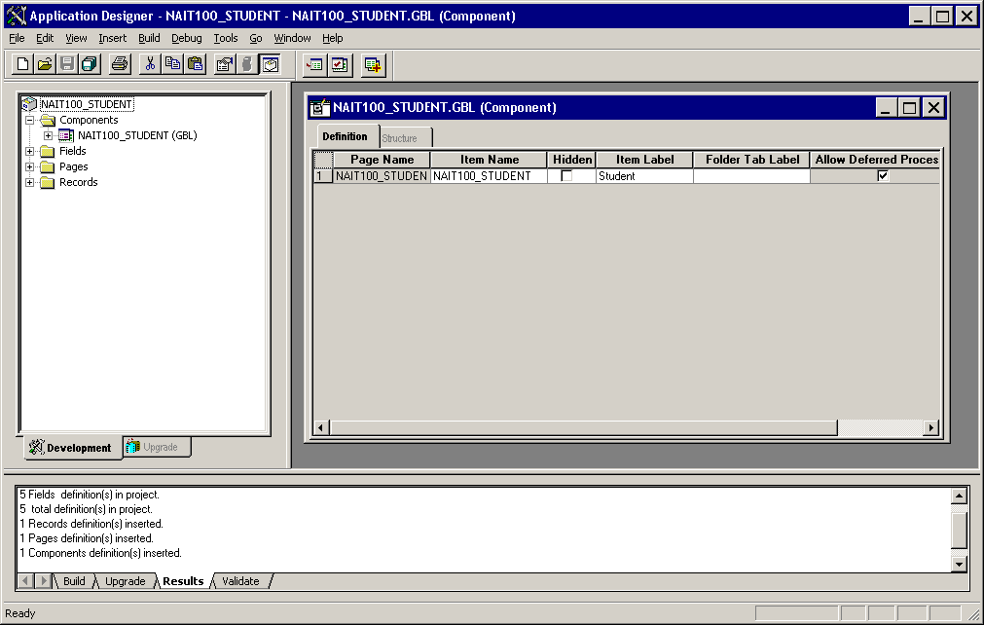

**Execute “Registering the component” series of steps ONLY ONCE!**

# Registering the component

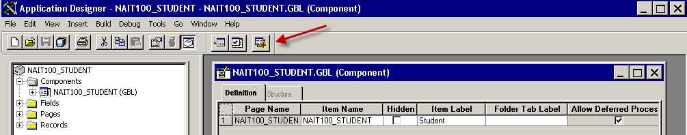

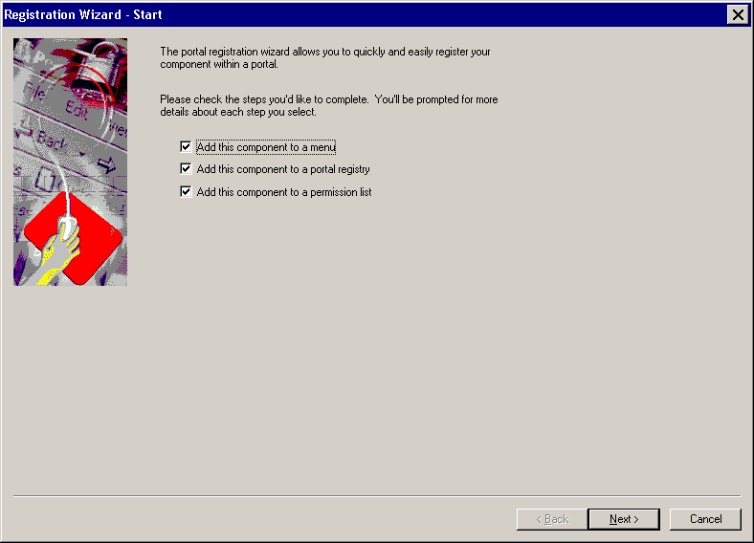

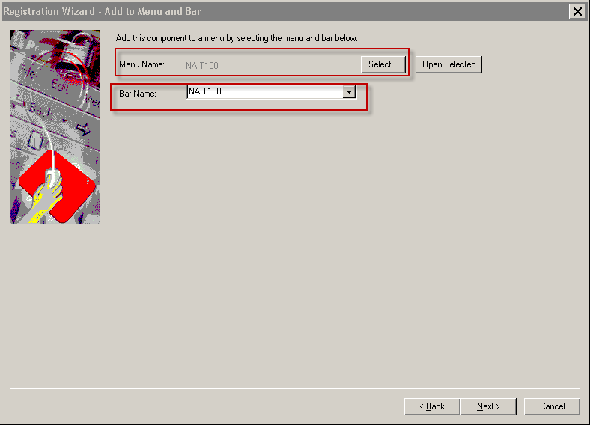

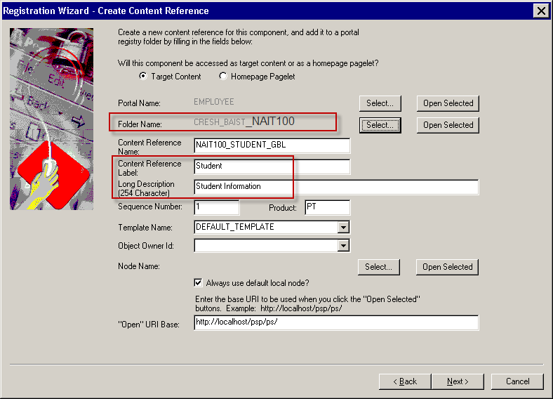

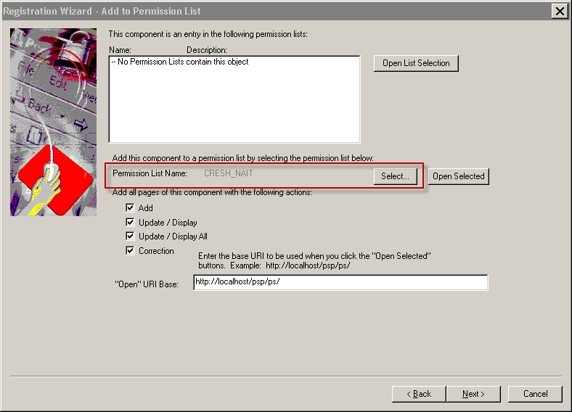

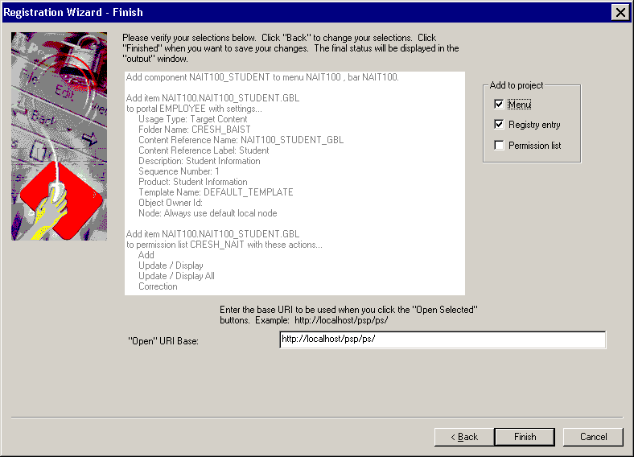

Save Project

Menu Label

Your project should have a menu add from the component registration. Open the properties for the menu item the and change the label.

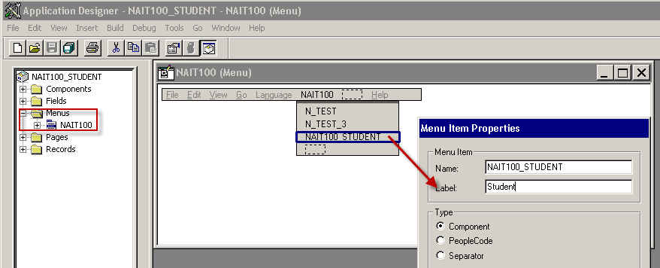

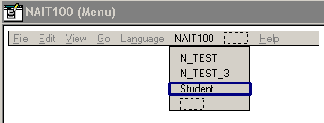

Save menu

# 8. Test the application

**Add 5 students with realistic test data!**