BAI3270 PeopleSoft Query
PeopleSoft Account Number: NAIT103
Name:Addison Babcock
Submit this document via Moodle
Note: All queries created are to be saved as “Public”.

- Run the query PER006__EE_MAILING_LABELS, how many rows are returned? __126__________ Describe the Criteria used in the query:
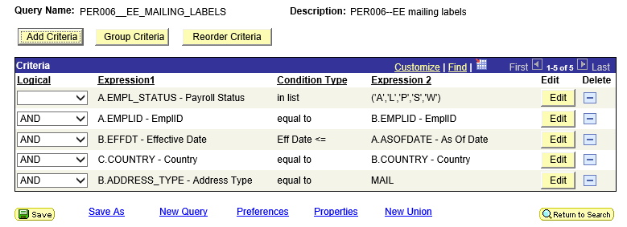

- Create a new query from the record: EMPLOYEES (Select OK for Effective Date criteria for this and all following queries).
The query should contain the following fields: EMPLID, EFFDT, EFFSEQ, NAME, COUNTRY, ADDRESS1, CITY, STATE, and POSTAL. The rows returned should be for the country Australia and the state of NSW (New South Wales). The output should be listed in ascending order of the name field.
Save the query using our naming standards: NAIT###_ AUSTRALIA_NSW and student name for the description.
Query Name: NAIT103_AUSTRALIA_NSW

- Create new query from the record: SALARY_PLAN. The query should contain all the fields
How many rows do you get back? 27
Save the query using our naming standards: NAIT###_SALARY_PLAN and student name for the description.
Query Name: NAIT103_SALARY_PLAN

- Create new query from the record: PERSONAL_DATA
The query should contain the following fields: Employee ID, Name, Last Name, First Name, Middle Name, Country, Address, City, State, Gender, and Date of Birth.
Use the following headings in the output: Employee ID, Name, Last Name, First Name, Middle Name, Country, Address, City, State, Gender, and Date of Birth. The output should only contain rows that have a last name starting with “Z”.
Save the query using our naming standards: NAIT###_ PERSONAL_DATA and student name for the description.
Query Name: NAIT103_PERSONAL_DATA

- Create new query from the record: VENDOR_ADDR
The query should contain all vendors in New York State.
Save the query using our naming standards: NAIT###_NEW_YORK_VENDOR_ADDR and student name for the description.
Query Name: NAIT103_NEW_YORK_VENDOR_ADDR

- Create a query based on the field Calculation Name. (See Figure 1 below). All Fields from the record.
Save the query using our naming standards: NAIT###_REVIEW_CALCULATION and student name for the description.
Query Name: NAIT103_REVIEW_CALCULATION

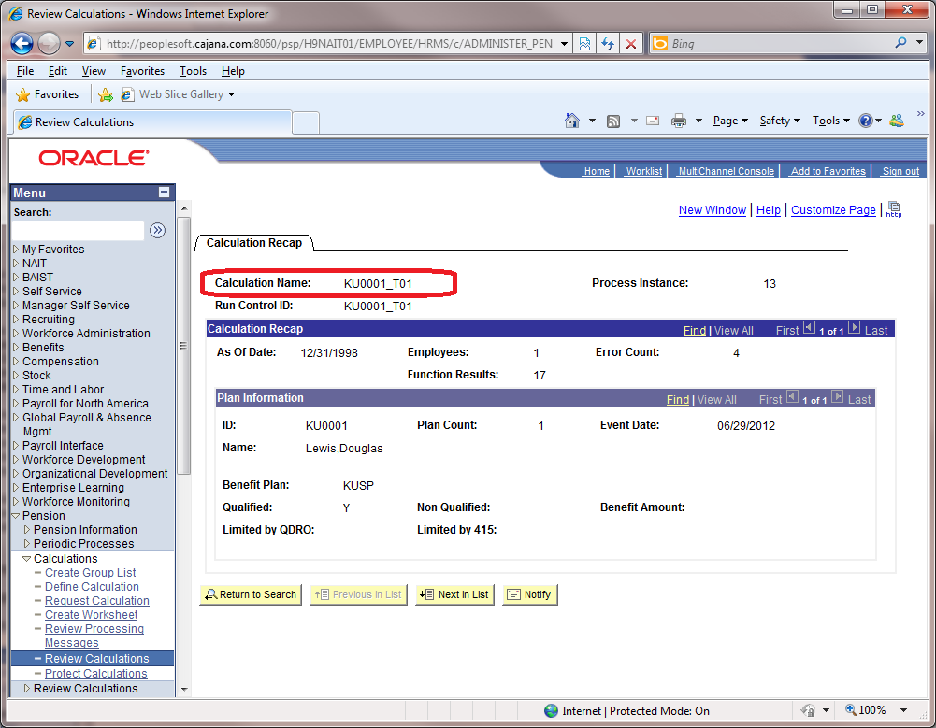
Figure 1

- How many Courses have Course Type ‘Human Resources’? 91
Hint: you do not need a query to answer this.

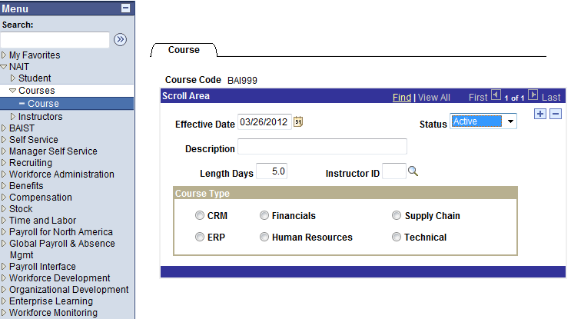
Figure 2

- Create a query based on the field Stock Plan. (See Figure 3) in descending order of stock plan name.
Save the query using our naming standards: NAIT###_ STOCK_PLAN and student name for the description.
Query Name: NAIT103_STOCK_PLAN

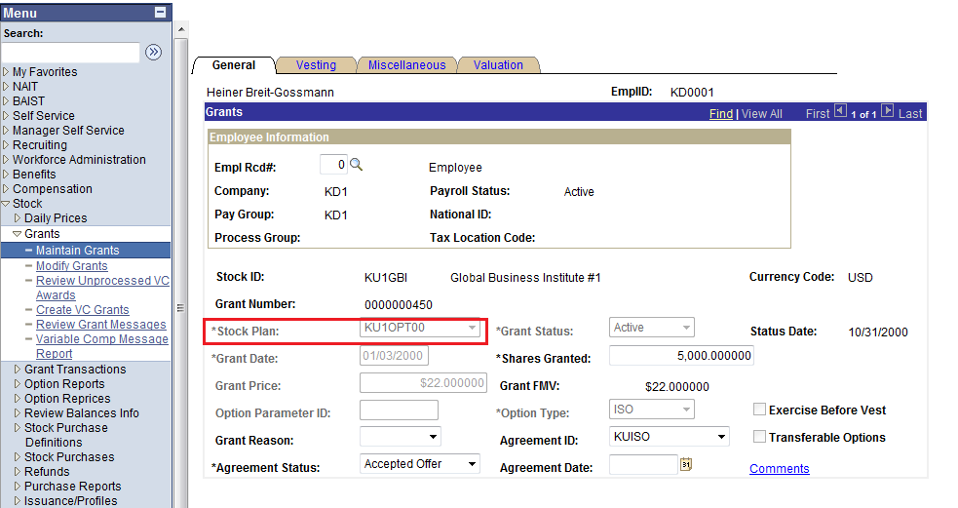
Figure 3

