BeckAddisonChapter1Lab

# Class Definition

Public Class Vehicle

'Create a “Vehicle” class. Each vehicle should have the following characteristics:

Private m_make As String ' Make

Private m_model As String ' Model

Private m_passengerCount As Integer 'Number of Passengers

Private m_tankCapacity As Integer ' Gas Tank Capacity

Private m_milesPerGallon As Integer ' Miles per Gallon

'Each vehicle should also have the following functionality:

'Create an object of itself (with and without parameters)

'without parameters

Public Sub New()

m_make = "make"

m_model = "model"

m_passengerCount = 0

m_tankCapacity = 0

m_milesPerGallon = 0

End Sub

'with parameters

Public Sub New(ByRef p_make As String, ByRef p_model As String, ByRef p_passengerCount As Integer, ByRef p_tankCapacity As Integer, ByRef p_milesPerGallon As Integer)

m_make = p_make

m_model = p_model

m_passengerCount = p_passengerCount

m_tankCapacity = p_tankCapacity

m_milesPerGallon = p_milesPerGallon

End Sub

'Property Blocks

Public Property Make() As String

Get

Return m_make

End Get

Set(value As String)

m_make = value

End Set

End Property

Public Property Model() As String

Get

Return m_model

End Get

Set(value As String)

m_model = value

End Set

End Property

Public Property PassengerCount() As String

Get

Return m_passengerCount

End Get

Set(value As String)

m_passengerCount = value

End Set

End Property

Public Property TankCapacity() As String

Get

Return m_tankCapacity

End Get

Set(value As String)

m_tankCapacity = value

End Set

End Property

Public Property MilesPerGallon() As String

Get

Return m_milesPerGallon

End Get

Set(value As String)

m_milesPerGallon = value

End Set

End Property

'Methods

'Calculate the range (in miles) for a full tank of gas

Public Function CalcFullTankMileage() As Integer

Dim mileage As Integer

mileage = (m_milesPerGallon * m_tankCapacity)

Return mileage

End Function

'Determine how much gas is needed to drive a user-input number of miles

Public Function CalcGasForTrip(ByVal tripMiles As Integer)

Dim gallons As Integer

gallons = (tripMiles / m_milesPerGallon)

Return gallons

End Function

'Output a string representation of itself

Public Overloads Function ToString(ByVal tripMiles As Integer) As String

Return m_make & " " & m_model & vbCrLf & vbCrLf & "Range Of A Full Tank: " & CalcFullTankMileage() & " miles" & vbCrLf & "Gallons Needed For Your Trip: " & CalcGasForTrip(tripMiles)

End Function

End Class

# Access Layer

Public Class HomePage

'Create an application that creates objects of the Vehicle Class.

'Create New Vehicle Instance

Dim vehicle As Vehicle

Dim vehicleList As New List(Of Vehicle)()

'Allow the user to enter the following data through the interface to create the following objects of the class

Private Sub formLoad(sender As Object, e As EventArgs) Handles MyBase.Load

cmbMake.SelectedIndex = 0

cmbModel.SelectedIndex = 0

cmbPassengerCount.SelectedIndex = 0

cmbTankCapacity.SelectedIndex = 0

cmbMilesPerGallon.SelectedIndex = 0

End Sub

'The objects, as they are added, should be displayed in a list box.

Private Sub btnAddVehicle_Click(sender As Object, e As EventArgs) Handles btnAddVehicle.Click

vehicle = New Vehicle

Dim count As Integer

vehicle.Make = cmbMake.Text

vehicle.Model = cmbModel.Text

vehicle.PassengerCount = CInt(cmbPassengerCount.Text)

vehicle.TankCapacity = CInt(cmbTankCapacity.Text)

vehicle.MilesPerGallon = CInt(cmbMilesPerGallon.Text)

vehicleList.Add(New Vehicle(vehicle.Make, vehicle.Model, vehicle.PassengerCount, vehicle.TankCapacity, vehicle.MilesPerGallon))

count = vehicleList.Count - 1

lstVehicles.Items.Add(vehicleList(count).Make & " " & vehicleList(count).Model)

End Sub

'When a vehicle is selected in the list box, the program should output (in a nicely formatted way)...

Private Sub lstVehicles_SelectedIndexChanged(sender As Object, e As EventArgs) Handles lstVehicles.SelectedIndexChanged

Dim tripMiles As Integer = numTripMiles.Value

Dim index As Integer = lstVehicles.SelectedIndex

txtOutput.Clear()

txtOutput.Text = vehicleList(index).ToString(tripMiles)

End Sub

'Added feature: also update the output text if tripMiles is changed

Private Sub numTripMiles_ValueChanged(sender As Object, e As EventArgs) Handles numTripMiles.ValueChanged

If lstVehicles.Items.Count >= 1 Then

If lstVehicles.SelectedIndex >= 0 Then

Dim tripMiles As Integer = numTripMiles.Value

Dim index As Integer = lstVehicles.SelectedIndex

txtOutput.Clear()

txtOutput.Text = vehicleList(index).ToString(tripMiles)

Else

Return

End If

End If

End Sub

End Class

# Screenshots

## On open

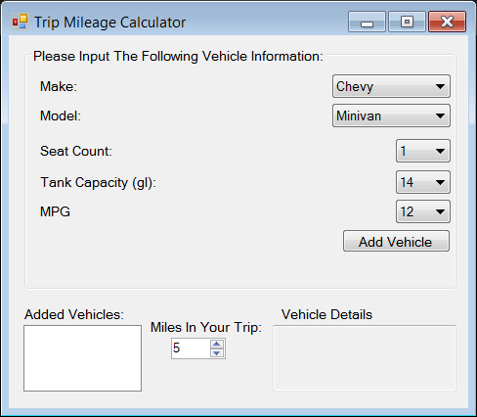

With cars added

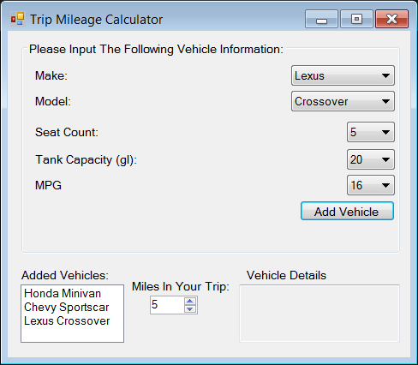

## With Car Selected 1

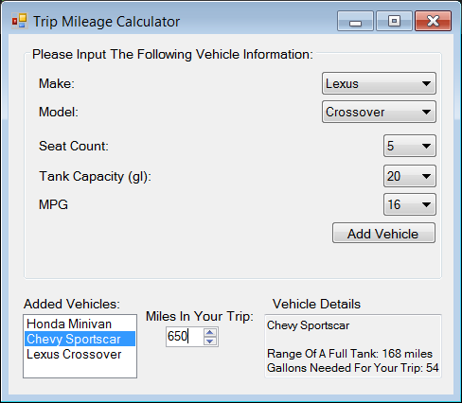

## With car selected 2

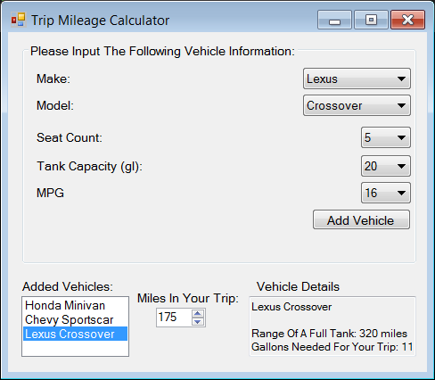

## With car selected 3

