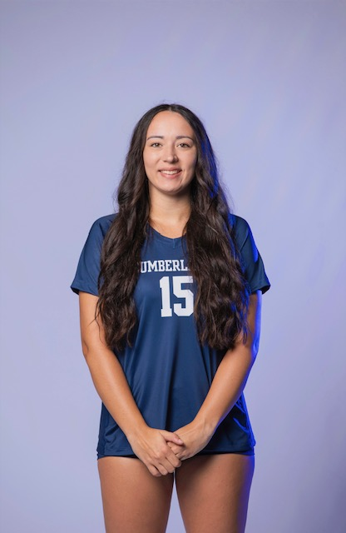 |  | Anna Blumeier  Data Scientist
Profile  Former student-athlete with two degrees in Mathematics and Information Technology Sciences. Developed skills in time management, leadership, problem solving, and teamwork while maintaining a 3.56 GPA. Academic background combines analytical problem solving with technological innovation, equipping me with skills in data analysis, programming, and IT systems. Pursuing a master’s degree in data science through the University of the Cumberlands online program in Fall 2025. Passionate about using data-driven insights to solve real-world challenges and am eager to contribute my skills to forward-thinking organizations.  Contact  PHONE:  502-386-4140  LinkedIn:  www.linkedin.com/in/anna-blumeier-2263a7314  EMAIL:  annablumeier03@gmail.com  Skills  Data Analysis  Programming experience (Python, SQL, C, machine learning)  IT Systems  Problem-solving  Statistics  Critical Thinking  Collaboration |  | EDUCATION  University of the Cumberlands  August 2021 – May 2025  B.S. Mathematics  University of the Cumberlands  August 2021 – May 2025  B.S. Information Technology Sciences  Experience/Volunteer work  University of the Cumberlands Student-Athlete  August 2021-December 2024  As a student-athlete, I was able to manage volleyball responsibilities while maintaining a 3.56 GPA. I have been able to learn various life skills including time management, leadership, communication, and the ability to work under pressure. Also, due to injury my senior year, I took on the role of statistician, which allowed me to practice statistics in practice and games.  Kentucky Indiana Volleyball Association (KIVA) - Volleyball Instructor  June 2021, December 2021, July 2022, December 2022  Taught and coached young volleyball athletes how to play volleyball, while using leadership, problem-solving, and communication skills.  UC Engage – Volunteer throughout the Williamsburg Community  August 2021–May 2025  Through the University of the Cumberlands UC Engage course, I was able to help the surrounding community with projects like food drives, volleyball camp leader, and supporting elementary kids.  Acheivements  University of the Cumberlands Academics  President’s List Spring 2023  Dean’s List Spring 2023, Fall 2024, Spring 2025  University of the Cumberlands Athletics  2022: MSC Second-Team All-Conference, NAIA Attacker of the Week, MSC Attacker of the Week  2023: MSC Academic All-Conference

