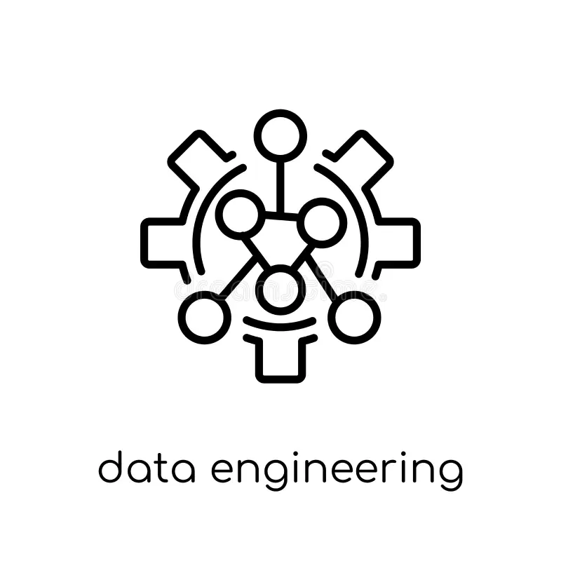
Pallavi Telakunchi
Senior Data Engineer
Email: telakunchipallavi1@gmail.com
+1 609-862-7207
PROFESSIONAL SUMMARY:
- Senior and Associate Data Engineer with 10 years of experience play a critical role in building and maintaining robust, scalable data pipelines and architectures that process large volumes of data from diverse sources.
- At Centene Corporation, the focus is on healthcare data systems, designing pipelines and data warehouses to enable timely analytics and compliance with health regulations.
- Collaboration with analytics teams ensures data availability for improving health outcomes.
- At BNY Mellon, the emphasis shifts to financial services, where data engineers architect scalable ETL systems supporting risk management, client reporting, and regulatory compliance.
- They ensure data quality and alignment with complex financial regulations while optimizing performance and automating workflows.
- For Vanguard, data engineering revolves around investment and asset management data pipelines, leveraging cloud platforms and programming languages like Python and SQL to transform business requirements into innovative data solutions that support analytics and AI initiatives.
- FM Global’s projects are uniquely centered on property insurance and risk assessment, integrating IoT sensor data, claims, and environmental factors to build real-time pipelines supporting underwriting, catastrophe modeling, and compliance with insurance regulations.
- At Ness Digital, data engineers support diverse clients with modern ETL pipelines, AI/ML enablement, and cloud technologies, ensuring data governance, workflow automation, and cross-team collaboration for digital transformation initiatives.
- Across these roles, data engineers drive operational efficiency by automating data workflows, ensuring data security and regulatory compliance, and empowering data scientists and business stakeholders with reliable, high-quality data for advanced analytics, machine learning, and strategic decision-making.
TECHNICAL SKILLS:
Category | Skills / Tools
Programming Languages | Python, SQL, Java, Scala
Big Data Frameworks | Apache Spark, Hadoop, Databricks
ETL/ELT Tools | Informatica PowerCenter, AWS Glue, Azure Data Factory, Apache NiFi
Cloud Platforms | AWS (S3, Lambda, Redshift, EMR, Kinesis), Microsoft Azure, Google Cloud Platform
Data Warehousing | Snowflake, Amazon Redshift, Google Big Query
Data Modeling & Databases | Relational DBs (PostgreSQL, MySQL, SQL Server), NoSQL DBs (MongoDB, Cassandra), Data Lakes
Automation & Orchestration | Apache Airflow, Jenkins, Cron
Data Quality & Governance | Data Validation Frameworks, Data Lineage, GDPR/HIPAA Compliance, NAIC Standards (Insurance), Security Best Practices
DevOps & Version Control | Git, Docker, Kubernetes
Machine Learning Platforms | MLflow, TensorFlow (collaboration with data scientists)
Reporting & Visualization | Power BI, Tableau, Custom Dashboards
APIs & Integration | REST APIs, SOAP, JSON/XML Data Parsing
Soft Skills | Problem-solving, Collaboration across cross-functional teams, Documentation, Mentorship

PROFESSIONAL EXPERIENCE:
Client: Centene Corporation
Role: - Senior Data Engineer | Oct 2024 – Present
Responsibilities:
- Develop, build, and operationalize scalable, real-time, and batch data pipelines for analytics, reporting, and business intelligence, ensuring high performance and data quality.​
- Development and implementation of complex data management processes around data staging, ingestion, transformation, provisioning, and destruction, ensuring data integrity and security for large-scale, high-volume environments.​
- Engineered Keystone-integrated healthcare data pipelines ensuring seamless ingestion and transformation of clinical, claims, and eligibility data aligned with HIPAA and HL7 standards.
- Leveraged Keystone orchestration with AWS services to automate data lineage, enhance compliance tracking, and enable secure cross-domain healthcare analytics.
- Use AWS cloud technologies pertinent to data storage, processing, and analytics to enhance data infrastructure and scalability.
- Drive the design of data architectures, including data warehouses, lakes, and data lakes—utilizing modern data processing frameworks like Spark, Frelk, and cloud-native solutions—aimed at optimizing data accessibility and processing efficiency.​
- Develop procedures and automation to validate data, troubleshoot data issues, and ensure data accuracy, consistency, and compliance with privacy and security standards.​
- Collaborate closely with data scientists, data analysts, DevSecOps teams, and business units to gather requirements, design solutions, and ensure data infrastructure supports analytical and operational goals.​
- Guide junior data engineers in implementing best practices, new technologies, and cloud data services, as well as reviewing code and architecture designs to ensure performance and maintainability.​
- Analyze data workflows, query performance, and bottlenecks within pipelines and systems; implement tuning and optimization techniques to enhance reliability and efficiency.​
- Develop, execute, maintain, and troubleshoot complex SQL scripts, reports, and analytics workflows; utilize Microsoft Excel and AWS data tools and services to support advanced data processing and reporting.
- Ensure compliance with data governance, privacy (GDPR, HIPAA), and security policies, including data encryption, access controls, and audits across all data systems and pipelines.​
- Explore emerging data technologies, automate repetitive tasks, and enhance data reliability, scalability, and automation to streamline data operations and support advanced analytics initiatives.​
- Maintain detailed documentation for data processes, architectures, and workflows, ensuring transparency and ease of maintenance.​
- Work with cross-functional teams to align data infrastructure development with Centene's strategic healthcare objectives, improving health outcomes through innovative data solutions.
Client: BNY
Role: - Senior Data Engineer | Jun 2022 – Sep 2024
Responsibilities:
- Developer, build, and optimize complex ETL/ELT data pipelines to support large-scale data integration, processing, and analytics workflows in a financial services environment.​
- Designed Keystone-based ETL frameworks supporting regulatory reporting, audit compliance, and risk data aggregation across multiple financial data domains.
- Implemented Keystone-driven data quality automation pipelines ensuring high accuracy for trade, transaction, and client data within Azure-based ecosystems.
- Design, develop, and optimize scalable data pipelines and ETL/ELT workflows using Azure Data Factory, Azure SQL Server, Azure Blob Storage, and other Azure cloud services to support data integration and analytics.
- Designed and implementation of scalable data architectures, including data warehouses, data lakes, and real-time streaming platforms, leveraging cloud technologies and big data tools.​
- Establish and enforce data quality control measures to ensure accuracy, completeness, and consistency of data used for client reporting, regulatory compliance, and analytics.​
- Work closely with business analysts, data scientists, risk management teams, and IT to align data engineering solutions with business goals and regulatory requirements.​
- Continuously monitor, tune, and automate data workflows and processes to enhance system performance, reliability, and scalability.​
- Implement data security, privacy, and governance practices, ensuring compliance with financial industry regulations such as GDPR, HIPAA, and internal audit standards.​
- Provide technical leadership and mentorship to junior engineers, sharing best practices in coding, architecture design, and data engineering methodologies.​
- Explore and apply emerging technologies, including AI/ML and advanced analytics, to enhance data insights, operational efficiency, and business intelligence capabilities.​
- Maintain comprehensive documentation of data pipelines, architecture, and operational procedures; support reporting and visualization needs with tools like Power BI.
Client: Vanguard
Role: Data Engineer | Jul 2020 – May 2022
Responsibilities:
- Build, maintain, and optimize ETL (Extract, Transform, Load) pipelines for both real-time and batch data processing, ensuring data availability and reliability for analytics and business needs.​
- Integrate complex, large-scale data from varied sources, troubleshoot issues, and ensure data consistency and integrity across systems.​
- Built Keystone-enabled data orchestration pipelines to streamline investment, portfolio, and performance data processing across multi-cloud environments.
- Integrated Keystone metadata and governance controls to improve data discoverability, compliance, and AI-driven analytics for asset management workflows.
- Convert business requirements into technical specifications and code, developing complex queries, reports, and well-structured, reusable programs using languages like Python, SQL, and Spark.​
- Partner with internal clients, data scientists, analysts, and other stakeholders to understand data needs, develop solutions, and enable business insights.​
- Provide guidance and mentorship to junior data engineers, apply quality control standards, and contribute to team best practices and standards development.​
- Perform thorough testing, including regression testing of new software releases, identify issues, and work with vendors to promote software into production.​
- Utilize cloud technologies (AWS preferred) to design and support data pipelines, including services like S3, EMR, Glue, Athena, Lambda, Kinesis, and Redshift, optimizing for performance and cost efficiency.​
- Implement data governance, security, and privacy best practices ensuring compliance with internal policies and regulatory standards.​
- Maintain detailed documentation of data processes, architectures, and workflows to ensure clarity and maintainability.​
- Analyze data workflows and system performance, troubleshoot data-related problems, and continuously seek improvements in data engineering practices.

Client: FM Global
Role: - Data Engineer | Aug 2018 – Jun 2020
Responsibilities:
- Design, build, and optimize end-to-end data pipelines and data lake architectures on Google Cloud Platform (GCP) to support large-scale analytics and data-driven business decisions.
- Develop and maintain ETL/ELT processes using Dataflow, Dataproc, Cloud Composer, Big Query, and Cloud Storage for both batch and real-time workloads.
- Build scalable data ingestion frameworks integrating on-premises and cloud data sources through APIs, Pub/Sub, and event-driven architectures.
- Implement data modeling, schema design, and partitioning strategies in Big Query to ensure high performance and cost optimization.
- Architected Keystone-based data lake workflows integrating IoT sensor, claims, and environmental data for real-time underwriting and catastrophe modeling.
- Utilized Keystone orchestration with GCP BigQuery and Pub/Sub to automate end-to-end risk assessment and predictive analytics pipelines.
- Collaborate with data scientists, analysts, and business stakeholders to deliver cleansed, curated, and well-documented datasets supporting predictive and operational reporting needs.
- Work closely with solution architects to define and implement best practices in GCP architecture, IAM, networking, and data security.
- Monitor and troubleshoot data pipelines, ensuring high data availability, reliability, and SLA adherence using Stack driver, Cloud Logging, and Cloud Monitoring.
- Implement CI/CD pipelines and Infrastructure-as-Code practices using Terraform, Cloud Build, and Git for data workflows and environment provisioning.
- Apply data quality and governance principles by developing validation frameworks, access controls, and metadata management practices.
- Lead cloud migration initiatives, including data warehouse modernization and legacy system data integration with GCP-native solutions.
- Optimize Big Query performance through query tuning, clustering, and table partitioning while effectively managing cost and resource utilization.
- Produce technical documentation, solution design artifacts, and operational runbooks to ensure long-term maintainability and knowledge sharing across teams.
- Drive adoption of modern data engineering standards, automation, and reusable components aligning to FM Global’s data strategy and cloud transformation goals.
Client: NESS Digital, India
Role: - Associate Data Engineer | Oct 2014 – Jul 2016
Responsibilities:
- Design, build, and optimize scalable ETL/ELT pipelines to process large volumes of data from diverse sources, ensuring data quality, reliability, and availability for analytics and business applications.
- Assist in data preparation and feature engineering to support the deployment and improvement of AI models, leveraging statistical and mathematical foundations in collaboration with data science teams.
- Integrate and transform structured and unstructured data using modern cloud platforms and tools (e.g., AWS) adhering to best practices in data engineering.
- Work closely with software engineers, data scientists, and business stakeholders to understand data requirements and translate them into technical solutions.
- Implement data governance policies and maintain compliance with data security and privacy standards relevant to client domains.
- Develop automation for data ingestion and validation processes, while monitoring pipeline performance to ensure operational excellence.
- Maintain clear documentation for data pipelines, standards, and procedures; contribute to continuous improvement initiatives to enhance data engineering practices.
- Contribute to fostering a collaborative, innovative team culture by sharing knowledge and best practices.
- Stay current with emerging data technologies and tools, proactively adopting innovative solutions to meet evolving client needs and business goals.

