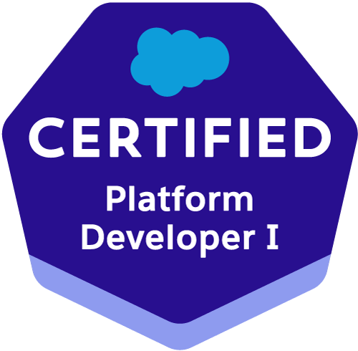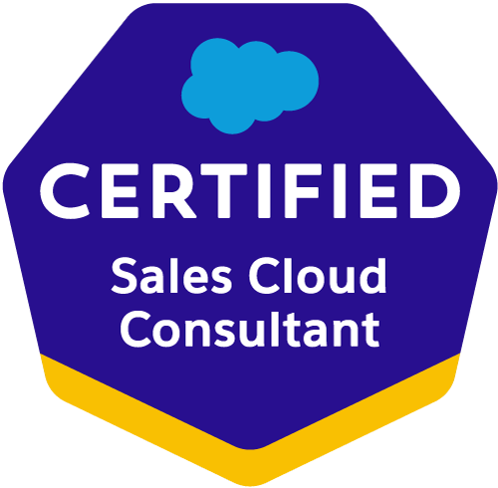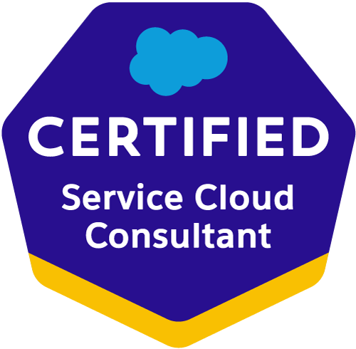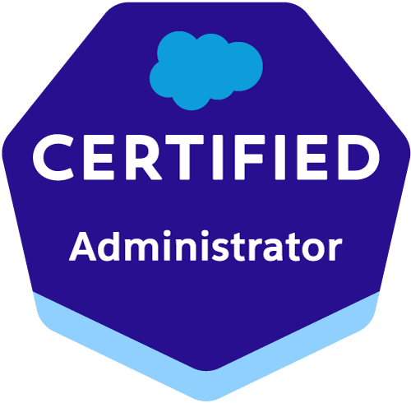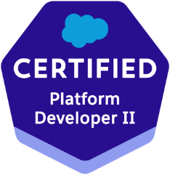
Akhiel Pasha Mohammad
Akhielpmd@gmail.com// +1 201-528-9021
https://www.salesforce.com/trailblazer/amohammad130
Professional Summary:
Salesforce developer/Admin with Around 10 years of experience in building, testing, iterating and deploying changes supporting technical maintenance, ongoing enhancements to existing features, and new functionality. Responsible for managing the SFDC platform and developed the CRM application. A proven problem solver with abilities in troubleshooting escalated support issues by performing analysis on the root cause and implementing short and long-term solutions.

- Experience in Software Development Life Cycle (SDLC) which involves requirement gathering, requirement analysis, design, development, implementation & enhancement of Projects in SalesForce.com and Java/J2EE technologies.
- Extensive experience in Salesforce Administration (SFA), Creating Roles, Profiles, Page Layouts.
- Good knowledge on Apex development in creating Apex Classes, Force.com API, Standard Controllers, Custom Controllers and Controller Extensions.
- Experience in Sales cloud, Service cloud, Custom cloud, Chatter and App Exchange applications,.
- Expert in customizing and implementing with Validation Rules, Workflows Rules, Process Builder, Approval process, Record Types, Assignment/Sharing Rules, Reports and Dashboards.
- Experience in Salesforce.com Apex Classes, Apex triggers, Visual force, Force.com API, complex SOQL&SOSL queries, DML statements and S objects
- Usage of wave analytics helped the organization improve the number of sales and also understand the flaws which are further taken care by sales team.
- Technical Knowledge about Salesforce lightning schema builder, process builder, app builder, components and lightning connect
- Experience in building re - usable Lightning components and using Lightning Framework
- Experience in using client side and server-side controllers in Lightning Design.
- Technical Knowledge about Salesforce lightning schema builder, process builder, app builder, components and lightning connect.
- Experienced in Object Oriented Analysis and Design and Object-Oriented Programming and Design Patterns under MVC (Model View Controller) Architecture.
- Created many Email Templates and Mail Merge Templates and was involved in doing the mail merge for different standard and custom objects in lightning experience.
- Worked on Web services using REST AP! Exclusively on obtaining the needed information using the URL approach
- Process knowledge of CRM processes like Sales, Marketing, customer service and customer support, Business processes and recommended solutions to improve their processes using Salesforce.com.
- Configured and Customized the Salesforce Sales Cloud, Service Cloud, Marketing cloud and Opportunity Management for business support for customers
- Having experience on REST methods such as Put (), Get (, Post ( and Delete
- Good understanding of key Salesforce architectural concepts (e.g. API and governor limits, security models and techniques) C and how they influence design.
- Develop custom applications using apex, visual force, JavaScript, Angular JS, HTML CSS.
- Experience with HTML 5, CSS, JQuery, Angular JS web services
- Experience in developing solutions for the Apttus Contract Lifecycle Management (CLM) system including x- Author for Word, development of clause libraries and contract templates.
- Experience in APTTUS Product Configuration and Pricing Configuration with some advanced functionality of SFDC
- Have knowledge in implementing various advanced fields like Pick lists, Custom Formula Fields, Many to Many Relationships, Lookups, Master-Details, Field Dependencies, Validation Rules, Work Flows, and Approval Processes for automated alerts, field updates & Email generation according to application requirements.
- Designed custom formula fields, field dependencies, validation rules, workflow rules and approval processes for automated alerts, field updates and email generation according to application requirements.
- Customized page layouts, search layouts, custom links, related lists and other components on a record detail and edit pages as per the business needs.
- Extensive experience in using Roles Profiles, Email Services, Page Layouts, Workflow Alerts and Actions, and Approval Process in Salesforce.com
- Experience in using Data Loader for exporting and importing the data Involved in documentation reviews and participating in bug reporting meetings.
- Experienced customizing standard objects Accounts, Contacts, opportunities. Products, Price books, Cases, Leads, Campaigns, Reports and Dashboards.
- Expertise in Apex Language, Apex Trigger, Apex Scheduler. Batch Apex, Apex Class & Apex Web Service, Visual Force (Page, Component & Controllers) & Ajax Tool Kit.

TECHNICAL SKILLS:

Salesforce Technologies | SalesForce.com, Force.com, Sales Cloud, Service Cloud, LWC, Lighting components, CPQ, Apttus CPQ, Apex Language, Apex Classes/Controllers, Apex Triggers, SOQL, SOSL, Visual Force Pages/ Component, s-Control, Apex Web Services, Partner WSDL & Enterprise WSDL, Workflow and Approvals, Dashboard, Analytic Snapshots.
Salesforce Tools | Force.com IDE (Eclipse), AJAX Tool Kit, Force.com API tools (Data Loader), Force.com Explorer, Force.com Platform
ETL Tools | Data Loader, Salesforce-to-Salesforce, Apex- Explorer, Informatica.
Languages | Apex, C/C++, Java, HTML, XML, CSS.

CERTIFICATIONS:

Salesforce Certified Platform Developer I:
Salesforce Certified Sales Cloud Consultant
Salesforce Certified Service Cloud Consultant
Salesforce Certified Administrator
Salesforce Certified Platform Developer II

PROFESSIONAL EXPERIENCE:

Client: State of NJ, PSEG, Edison, NJ Jan 2023 – present
Role: Salesforce Admin/Developer

Responsibilities:

- Worked extensively on Salesforce object and field management, efficiently customizing both standard and custom objects to meet diverse business needs.
- Customized standard and custom Salesforce objects, fields, and relationships using lookup and master-detail configurations to optimize data structure and meet business requirements.
- Designed relational data models and implemented robust process automation using Flows (Auto-launched, Record-Triggered, Scheduled), approval processes, Email-to-Case, Web-to-Case, and Batch/Async Apex to enhance operational efficiency.
- Developed Apex classes, triggers, batch processes, Lightning Web Components (LWCs), Visualforce pages, and custom controllers to extend Salesforce functionality.
- Created dynamic dashboards and reports for real-time insights into sales, service, and field operations, optimizing decision-making processes.
- Managed user accounts, roles, profiles, permissions, security settings, and sharing rules at object, field, and record levels to maintain organizational hierarchy.
- Integrated Salesforce with external systems using SOAP/REST APIs while leveraging JavaScript, XML, JSON technologies for seamless data exchange.
- Led the end-to-end implementation of Field Service Lightning (FSL), including configuring workflows, creating dashboards/reports to track technician productivity, job completion rates, SLAs, and service optimization.
- Configured Salesforce Sales Cloud and Service Cloud solutions for lead management, opportunity tracking, case escalation workflows, and customer service automation.
- Demonstrated expertise in Salesforce CPQ (Configure Price Quote), including product configurations, pricing rules, discount schedules, quote templates, and data management.
- Implemented Salesforce Marketing Cloud features such as Journey Builder, Automation Studio, Email Studio, AMPscript for dynamic content personalization, and API integrations.
- Conducted comprehensive testing using Salesforce’s Apex testing framework as well as tools like Postman and Selenium to ensure reliability with consistent code coverage above 90%.
- Applied agile methodologies and Test-Driven Development (TDD) practices to deliver high-quality solutions within iterative development cycles while maintaining alignment with project timelines.
- Collaborated effectively with cross-functional teams to gather requirements, provide technical guidance on Salesforce solutions, conduct code reviews, and ensure adherence to best practices.
- Utilized advanced testing tools such as SOAPUI and Selenium to ensure the reliability of Salesforce applications while implementing monitoring/logging techniques for system stability.
- Developed comprehensive test cases using Apex testing frameworks to validate business logic and user interactions within Salesforce applications.

Environment: Salesforce Sales Cloud, Service Cloud, Financial Services Cloud, Field Service Lightning (FSL), Marketing Cloud, CPQ, Apex, Lightning Web Components (LWC), Visualforce, SOQL/SOSL, REST/SOAP APIs, JavaScript, HTML, CSS, XML, Data Loader, Selenium, Postman, Agile Methodology.

Thomson Reuters, Oak Brook, IL Nov 2020 – Jan 2023
Salesforce Administrator/Developer

Responsibilities:
- Worked on analyzing the user stories, estimating complexity, story pointing and implementing the user stories.
- Developed complex Confidential, Apex classes, Triggers and Test classes.
- Worked on batch apex to auto create opportunities based on close date of a current contract.
- Developing Triggers with bulk-safe and have a minimum of 75% code coverage.
- Implemented auto create events on public calendar using trigger and custom settings.
- Developed Sales Cloud to improve forecasting. Campaign and partner portal.
- Ian-depth understanding of Salesforce.com's sales Cloud, service Cloud and Force.com product offerings and Health Cloud experience.
- Worked on to prioritize tasks across all their patients' needs with health cloud,
- Created the email templates to be used in Workflows, Assignment Rules and Auto Response Rules related to Lead Management module in Sales Cloud
- Experience working in service cloud, supporting cases, developed workflows and triggers for automated Case resolution
- Analyzed the changes performed in CRM application for marketing, sales etc. translated them to business and functional requirements for Sales and Service Clouds in SFDC
- Extracted the salesforce CRM information into BI Data Warehouse using Force.com API/Informatica on Demand to provide integration with oracle financial information to perform advanced reporting and analysis
- Responsible for performing administrative functions in Salesforce CRM such as create/modify pick lists and lookup fields
- Act as the primary point of contact for Multi call center sites.
- Design and implement optimal CRM workflow configurations for Call Center Operations.
- Supported 3 offices, over 200 Salesforce users - sales, marketing, finance, service, call center teams.
- Organized and directed sales conference calls -kept sales teams focus on initiatives and projects.
- Used Custom Settings to store frequently used data and Field Sets to avoid code changes when new fields are added.
- Mapped personal and professional caregiver networks with salesforce health cloud
- Used health cloud to integrate data from EHRs, wearables and more
- Implemented Mass Edit functionality for various functional needs using Visual Force page and apex.
- Used SoQL and SOSL with consideration to Governor Limits for data manipulation needs of the application using platform database object.
- Developed many applications using service max to automate operational planning.
- Worked on custom email notification using trigger and email templates.
- Implemented Inventory process using trigger, approval process and visual force page.
- Defined look up and master-detail relationships on the objects and created junction objects
- Handled administrator functions including user account maintenance, reports, dashboards and other routine tasks.
- Using Workflow rule implemented email alert field update changing record type and also created with time dependent workflow action.
- Implemented Web to Case, Email to Case functionalities to provide a better customer support to the customers.
- Created Workflow Rules and defined related tasks, Time- triggered tasks, email alerts, filed updates to implement business logic.
- Used Data loader for data migration and integration.
- Used Picklists. Dependent Picklists and Record types to enforce data quality.
- Used Tabular, Summary and Matrix reports to customize Standard reports and create Custom reports.
- Developed project in confidential environment and played role of Scrum Master.
- Implemented several optimizations techniques to make the code more efficient.
- Interacted with business user for gathering the requirements for Salesforce implementation.

Environment: Saleforce.com platform, Apex Language, Triggers, Visual Force (Pages, Component & Controllers), Chatter, Data loader,Salesforce.com Data Loader, Health cloud, Force.com API, Workflow & Approvals, Reports, Custom Objects, Batch Apex Interface, Custom Tabs, Email Services, Security Controls, Windows XP

Client: Slack System, Hyderabad Nov 2016 – August 2019
Role: Salesforce Admin/Developer
Roles and Responsibilities:
- Involved in Creating Custom Objects, Fields, Relationships and Tabs.
- Preliminary analysis on tickets raised by Country Admin.
- Resolve tickets as per country Salesforce admin and update them in Remedy Tool.
- Maintain and support custom objects, formulas, layouts, validation rules, workﬂows, process builder, approvals, and assignment rules.
- Expert in resolving the tickets as per SLA.
- Experience using Salesforce data tools (Data Loader, Import Wizard) for managing mass data updates.
- Designing of Reports and Dashboards according to the requirement
- Worked on salesforce security model.
- Having experience on conﬁgure and manage Sales and Service Cloud applications.
- Experience using salesforce inspector and workbench.
- Experience in writing SOQL queries
- Good knowledge on Apex Classes, Triggers, and visual force Pages to troubleshoot the issues through debug log.
- Preliminary analysis on tickets raised by Country Admin.
- Resolve tickets as per country Salesforce admin and update them in Remedy Tool.
- Working with management and end-users to create and manage workﬂow rules, data validation.
- Expert in resolving the tickets as per SLA.
- Experience using Salesforce data tools (Data Loader, Import Wizard) for managing mass data updates.
- Worked on salesforce security model.
- Having experience on conﬁgure and manage Sales and Service Cloud applications.
- Experience using salesforce inspector and workbench.
- Experience in writing SOQL queries.
- Good knowledge on Apex Classes, Triggers and visual force Pages to troubleshoot the issues through debug log.
- Used postman to update or verify API Calls.
Environment: Salesforce Sales Cloud, Service Cloud, Apex, Visualforce, SOQL, SOQL/SOSL, Data Loader, Import Wizard, Salesforce Inspector, Workbench, Remedy Tool, Postman, JavaScript, HTML, CSS, XML

TECH SOLUTION Hyderabad, INDIA Aug 2014 - Oct 2016
Salesforce Developer
Responsibilities:

- Gathered requirements and developing client-specific solutions by understanding customer's business and technical environment.
- Developed a comprehensive CRM strategy, defining Salesforce as the standard tool in both Sales Cloud and Service Cloud.
- Used Salesforce.com platform, Force.com IDE for development for Visualforce Pages, Apex classes, Triggers and creating Objects.
- Written Apex Classes, Controller, Extension Controllers and Apex Triggers in the application for various Business/functional requirements.
- Written SOQL, SOSL query language necessary for the application in Apex Classes and Triggers.
- Worked with various salesforce.com objects Lead, Account, Contact, Opportunity, Campaign, Cases, Solutions Standard objects & Custom Objects.
- Developed Reports and Dashboards, validation rules, formula fields for the application.
- Use various Visual force components like Action Function, Page Block, Input Field, Action Support, Data Table, Data list, Command Link, Command Button etc.
- Worked with Visualforce Controllers (Standard, Standard List, Custom, and Extension).
- Implemented Web-to-Lead and converted Lead to Account.
- Developed Workflow rules, Field, Email updates to implement the business logic for Standard and Custom Objects as per the business needs.
- Prepared data mapping document to map source and target system fields.
- Used Data loader to bulk load data into Salesforce.com.
- Configured/Created Profiles, Roles, and Permission Sets for the organization and setting up Field-level, Object-level security rules for the application.

Environment: Saleforce.com, Visualforce Pages, Saledforce.com Data Loader, Apex Triggers, Reports, Custom Objects, Custom Tabs, Email Services, SOSL, SOQL, HTML, Java Script, Eclipse IDE Plug-in, Windows.

Education Details:

- MS from Wilmington University, Delaware, USA 2021.
- Bachelors from Kakatiya Institute of Technology & Sciences, India 2014.

