Ajay Jalaparthi
+1 860-964-5511
Ajayjalaparthi16@gmail.com
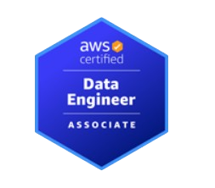

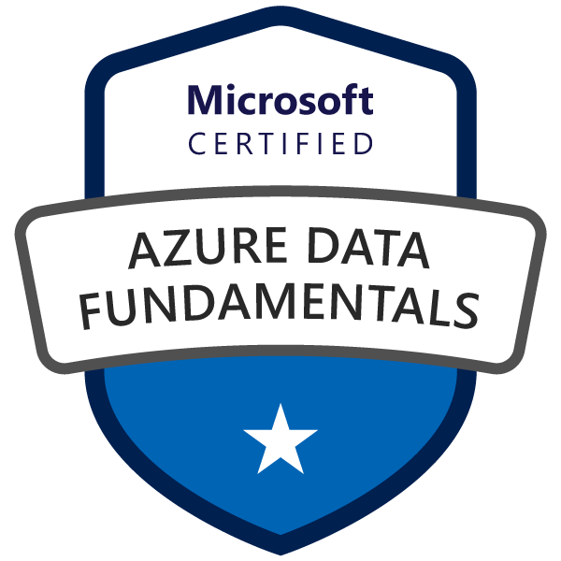
Data Engineer LinkedIn
Portfolio

OBJECTIVE
Results-driven Data Engineer with 4+ years of experience designing, developing, and deploying scalable data pipelines, cloud-based architectures, and advanced analytics solutions across AWS, Azure, Hadoop, and Snowflake. Proven expertise in building ETL/ELT workflows using Python (PySpark), Azure Data Factory, AWS Glue, and Airflow to process high-volume structured and unstructured datasets. Skilled in data modeling, OLTP/OLAP architecture, real-time streaming (Kafka, Kinesis, Flume), and distributed computing (Spark, MapReduce). Strong background in cloud infrastructure automation with AWS CloudFormation, CodePipeline, and Docker, as well as database development in Oracle, MySQL, PostgreSQL. Adept at delivering analytics-ready datasets, optimizing performance, and ensuring data quality, governance, and security compliance to enable business intelligence, AI/ML, and data-driven decision-making.
EDUCATION
New England College - New Hampshire, USA
- Master of Science in Data Science — Graduated: May 2025
CGPA: 3.74 / 4.00
TECHNICAL SKILLS
Cloud Services: | AWS (EC2, S3, IAM, VPC, RDS, Aurora DB, Redshift, DynamoDB, Data Catalog, Lambda, Athena, EMR, Kinesis, SQS, SNS, Data Pipeline, API, Apache Airflow, Code Pipeline), Azure (Azure Databricks, Azure SQL Database, Azure Functions, Logic Apps, App Services, Azure Key Vault, Azure VMs), Paas, Iaas, Saas, Relational databases, Non-relational databases, NLP.
Data Warehouses: | SQL Server, PostgreSQL, MySQL, Oracle, MongoDB, Kanban, Snowflake, Teradata, Azure Synapse, Linux, Unix, NoSQL.
CI/CD: | Jenkins, Azure DevOps, Terraform, Docker, Kubernetes, VMware, Open Source, Qlik.
Visualization & BI: | Power BI, Tableau, Kibana, Matplotlib, Outlook, Excel, Git, GitHub, GitLab, Bit Bucket.
Project Management Tools: | Problem-solving, Technical writing, TensorFlow, Pytorch, Microservices, Version control, Statistics, cross-functional, Root Cause Analysis, Troubleshooting, Jira, Communication skills, Mathematics, MATLAB, Source Code.
Programming: | Python (Pandas, NumPy, PySpark), R, Scala, C#, HTML/CSS
Big Data Technologies: | Apache Spark, Hadoop (HDFS, Hive, Pig, MapReduce), Apache Kafka, Apache Flink, Oozie, Flume, SAP.
ETL & Data Integration: | Azure Data Factory, AWS Glue, Informatica, SSIS, Data Modeling (OLTP, OLAP, Dimensional Modeling), data ingestion, data solutions, JSON, XML, Parquet, CSV Processing.
Data Quality & Data Goverance: | Data Quality Frameworks, Data Mining, Data architecture, Design patterns, Data models, Data analytics, Data visualization, Advanced analytics, Data structures, Data modeling, Data Reporting, Data strategy, Metadata Management.
Business & Analytics | Business Intelligence, Business analysis, Business strategy, Business objectives, Business models.
Google Cloud Platform: | GCP Cloud Storage, Big Query, Composer, Cloud Dataproc, Cloud Functions, Cloud technologies, Cloud Pub/Sub, Dataflow, Cloud Computing, clustering, cloud infrastructure.

RELEVANT EXPERIENCE
BMO Financial Group Saint Louis, Missouri, USA
Azure Data Engineer Jul 2024 to Current
- Designed and optimized ETL workflows using Python, PySpark, Spark SQL, Azure Data Lake, Azure Synapse Analytics, and Snowflake, processing 3TB+ of structured/unstructured data daily for customer insights and business reporting.
- Integrated Databricks with Azure Data Factory for batch and streaming workflows; developed JSON-based ADF pipelines orchestrating SQL activities and parallel job executions for faster processing.
- Built end-to-end transaction pipelines from AWS S3 to Redshift using PySpark, enabling same-day analytics and automated dashboard refreshes with optimized T-SQL transformations.
- Developed infrastructure-as-code with Terraform for Azure provisioning and CI/CD pipelines in Jenkins for automated workflow deployments and reduced release cycles.
- Ingested and transformed API and Kafka JSON data into Snowflake using Hive, Pig, R, and Python; standardized Elasticsearch usage patterns, cutting query-related incidents by 40%.
- Mentored junior engineers, enforced data quality validation, maintained robust documentation, and collaborated in SAFe Agile environments to align technical delivery with business goals.
Bridgewater Associates Westport, Connecticut, USA
AWS Data Engineer Nov 2023 to Jun 2024
- Built and maintained high-performance ETL pipelines using PySpark, Apache Spark, AWS Glue, and Hive to process large-scale financial datasets from multiple sources.
- Enabled real-time ingestion with Kafka and Spark Streaming, implementing data quality checks for rapid anomaly detection and improved operational response.
- Designed and automated AWS infrastructure with Terraform, reducing EMR cluster launch/configuration time by 70%, and optimized Spark job parameters for faster execution.
- Migrated large datasets into Snowflake and S3 for analytics, integrating Power BI dashboards to deliver secure, actionable business insights.
- Maintained Elasticsearch clusters, ensuring low-latency searches and ingestion pipelines to support high-availability systems.
- Mentored junior engineers, documented processes, and enforced data quality standards, enhancing team productivity and compliance readiness.
LyondellBasell Mumbai, India
GCP Data Engineer Jun 2022 to Jul 2023
- Built and managed GCP-based data lakes using BigQuery, Dataproc, and Pub/Sub to store and process large volumes of structured and unstructured data.
- Enabled near real-time analytics by implementing Change Data Capture (CDC) via Debezium, syncing 2M+ records/hour into BigQuery, with orchestration via Airflow and Cloud Composer.
- Designed and optimized ingestion and transformation pipelines in Azure Data Factory and Databricks, migrating data from ADLS Gen2 to Databricks for advanced analytics.
- Leveraged Apache Spark and Spark Streaming for large-scale data processing, delivering predictive maintenance insights and reducing downtime across manufacturing lines.
- Developed custom Python UDFs in Spark SQL to enable complex business transformations and improve pipeline performance.
- Delivered Power BI dashboards integrating data from BigQuery, Azure Synapse, and other enterprise sources, accelerating decision-making and operational efficiency.
Welspun World Mumbai, India
Data Engineer Mar 2021 to May 2022
- Designed and implemented ETL/ELT pipelines in Azure Databricks using Python, Scala, SQL, and Azure Data Factory to process large datasets from diverse sources, improving accessibility and scalability.
- Automated batch and streaming workflows using Apache Airflow, Oozie, and Jenkins CI/CD, reducing processing time by 40% and minimizing errors by 20%.
- Built real-time analytics pipelines integrating Kafka with Spark Streaming, delivering actionable customer and operational insights via Kibana dashboards.
- Migrated on-premises databases to Azure Data Lake Store and implemented dimensional and relational data models to optimize SQL queries for business and healthcare analytics.
- Integrated multi-source logs into Elasticsearch for near real-time monitoring and troubleshooting of enterprise transactions, reducing incident resolution time by 30%.
- Applied data governance and compliance best practices, including HIPAA standards, to safeguard sensitive data across cloud platforms.
Projects Summary
BMO Financial Group
Developed ETL pipelines using Databricks, Spark SQL, and ADF for financial analytics; migrated Redshift data to Snowflake; automated Azure infrastructure with Terraform; and standardized Elasticsearch usage, reducing query issues by 40%.
Bridgewater Associates
Built real-time streaming pipelines with Kafka, Spark, and AWS Lambda; optimized EMR clusters to cut processing time by 60%; integrated Docker + Kubernetes deployments; and monitored Elasticsearch clusters to ensure reliable data ingestion.
LyondellBasell
Designed GCP-based data lakes with BigQuery and Dataproc; migrated workflows to Databricks and Airflow; implemented CDC with Debezium for real-time inventory sync; and built Spark Streaming pipelines to support analytics at scale.
Welspun World
Developed Azure Databricks pipelines for customer insights; managed Kafka clusters for streaming data; automated CI/CD deployments with Jenkins; integrated Elasticsearch + Kibana dashboards; and migrated on-prem databases to Azure Data Lake.

Certifications:
IBM Data Science Graduate certificate Using Python programming and Data analysis, Machine learning(IBM2023)
Introduction to Data Analytics covering Python and SQL (SIMPLILEARN2020)
AWS Certified Data Analytics (2021)
Azure Data Engineer Associate
GCP Data Engineer(2022)

