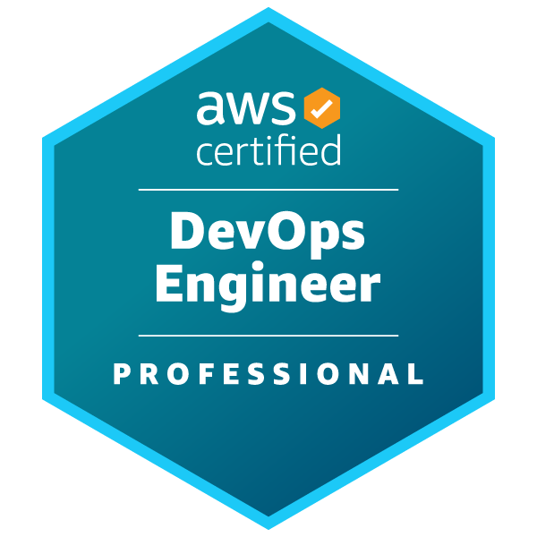
AJAY
(+1) 630-935-6565 | ajay9705702@gmail.com
PERSONAL SUMMARY
Certified DevOps Engineer with extensive experience in AWS and Azure cloud platforms, specializing in designing, deploying, and maintaining secure, scalable infrastructure. Proficient in CI/CD pipelines, containerization with Docker and Kubernetes, and monitoring with Jenkins, Datadog, and other observability tools. Strong expertise in version control (Git/GitHub), branching strategies, code reviews, and collaborative workflows, complemented by scripting skills in Python, Shell, and PowerShell.
In addition to DevOps, skilled in MLOps, operationalizing machine learning models into production environments. Experienced in building ML pipelines, automating model training, testing, deployment, and version control using MLflow and DVC. Adept at deploying models as scalable microservices on AWS SageMaker and Azure ML, ensuring reproducibility, monitoring, and continuous improvement of AI/ML workflows.
Also possesses full-stack development expertise with Python (Django/Flask), React.js, Node.js, and Spring Boot, enabling seamless integration of software engineering and data-driven solutions.
EDUCATION
Master's degree | Information Technology | DePaul University | Chicago, IL
Bachelor's degree | Computer Science | Jawaharlal Nehru Technological University (JNTUA)|Anantapur
Academic PROJECTS
Virtual Private Cloud (VPC) Using AWS
- Designed and deployed secure, scalable cloud environments with AWS VPC, configuring subnets, route tables, and security groups to optimize infrastructure performance and compliance.
- Monitored system efficiency using AWS CloudWatch and VPC Flow Logs, proactively identifying bottlenecks and improving resource utilization.
Git for Developers Using GitHub
- Managed version control through Git and GitHub, implementing branching and pull request workflows to ensure collaborative, conflict-free development.
- Integrated CI/CD pipelines to automate deployments, improving release speed and reducing manual errors in multi-developer environments.
Transforming IT Through Artificial Intelligence (AI) – Capstone Project
- Led research on AI implementation in IT environments, analyzing use cases across healthcare, education, and cybersecurity to enhance automation and decision-making.
- Developed ethical AI frameworks and data governance strategies, ensuring responsible AI adoption in line with privacy regulations.

CAREER HIGHLIGHTS
- Cloud Infrastructure Expertise: Developed and optimized secure cloud environments using AWS Virtual Private Cloud (VPC), gaining proficiency in AWS Management Console and enhancing security and performance across public and private cloud solutions.
- Collaborative Software Development: Strengthened team collaboration through hands-on Git and GitHub experience, mastering key version control practices like branching, merging, and pull requests to ensure seamless, efficient project management.
- Technical Skill Advancement: Acquired and applied essential technical skills in cloud networking, version control, and Git command line use, with a continued commitment to deepening expertise and achieving proficiency in cutting-edge tools and practices.
LICENCES & CERTIFICATIONS
- DevOps Course | Intellipaat Software Solution
- Docker for Developers | Intellipaat Software Solution
- Linux Training | Intellipaat Software Solution
- The Structured Query Language (SQL) | University of Colorado Boulder
- Microsoft Azure Certifications | Microsoft
- DevOps on AWS and Project Management | Amazon Web Services (AWS)
- Introduction to Cloud Computing | IBM
- Career Essentials in GitHub Professional Certificate
- DevOps on AWS | Code, Build, and Test
- Introduction to Career Skills in Software Development
- Introduction to Generative AI Learning Path Specialization | Google Cloud
- Introduction to Responsible AI | Google Cloud
- MLOps Fundamentals & ML Deployment | Google Cloud
- Python Scripting for DevOps
- Introduction to Large Language Models
- Responsible AI | Applying AI Principles with Google Cloud
TECHNICAL SKILLS:
Cloud Technologies | Azure, AWS, GCP
Configuration & Management tools | Ansible, Chef, Terraform, CloudFormation, Azure Resource Manager
CI/CD & Build Tools | Jenkins, Hudson, Bamboo, Puppet, ANT, Maven, Gradle, GitHub Actions, GitLab CI
Version Control Tools | GIT, Subversion, GitHub, GitLab, Bitbucket.
Monitoring & Observability Tools | Nagios, SPLUNK, ELK, New Relic, Graphene, Zabbix, Datadog, PagerDuty.
Languages | C, C++, JAVA, SQL, J2EE,
Databases | MySQL, NoSQL, MongoDB, DynamoDB, ElastiCache
Containerization Tools | Docker, Docker Compose, Docker swarm, Docker Mesos, Kubernetes.
Scripting language | Python, Ruby, Perl, PHP, Bash, PowerShell.
Virtualization Tools | VMware, Windows Hyper-V, Virtual box, Vagrant, Citrix Xen.
Atlassian Tools | JIRA, Confluence, Bitbucket, Bamboo.
Operating Systems | Linux (Red Hat, CENTOS & SUSE), Solaris, Ubuntu, Windows, DEBIAN.
Application servers | Web Logic Application Server, Apache Tomcat, Red Hat, JBOSS, WebSphere.
Development methodologies | Agile/Scrum, Waterfall
MLOps & DataOps Tools | MLflow, DVC (Data Version Control), Kubeflow, Airflow, SageMaker, Azure ML, Model Deployment & Monitoring
Web & Frontend Technologies | React.js, JavaScript, HTML, CSS, JSP, Servlets, XML, JSON

WORK EXPERIENCE

Software Engineer & IT Management
Treevah Jan 2025 – Present | Dover, Delaware, United States
- Served as Backend Developer, building and maintaining APIs with Java/Spring and integrating databases, optimizing queries, and ensuring secure third-party payment workflows.
- Contributed as Frontend Developer, developing responsive React.js, JavaScript, CSS components, implementing authentication flows with Azure AD, and improving UX with interactive features such as password visibility and reset flows.
- Actively supported IT Management, including Azure DevOps pipeline setup, managing access permissions, and registering applications in Azure Active Directory.
- Implemented MLOps workflows for model deployment pipelines, ensuring reproducibility using MLflow & DVC, and automated rollouts with Docker + Kubernetes.
- Integrated MLOps dashboards to monitor deployed models, improving system reliability and enabling proactive issue detection.
- Collaborated with cross-functional teams under Agile methodology, using Git/GitHub for version control and participating in sprint planning, stand-ups, and retrospectives.

Software Engineer

Elevate HireX Sep 2024 – Jan 2025 | Charlotte, North Carolina, United States
- Participated in a comprehensive training program focused on software development and MLOps workflows.
- Collaborated with senior developers on real-world projects, enhancing ML model deployment and monitoring.
- Applied software architecture principles to design scalable systems, improving project efficiency.
- Developed proficiency in programming languages and cloud-based MLOps technologies, contributing to team success.
- Participated in a structured training program covering core software development concepts, tools, and best practices.
- Utilized Git/GitHub for version control, managing branches, pull requests, and conducting peer code reviews.
- Practiced Agile methodologies (sprint planning, daily stand-ups, retrospectives) in collaborative project delivery.
- Worked with front-end and back-end technologies to build, test, and deploy scalable web applications.
- Explored cloud platforms (Azure/AWS), gaining hands-on insight into CI/CD pipelines, app hosting, and monitoring tools.
- Gained introductory MLOps experience, including model versioning with MLflow/DVC, deploying ML workflows on Azure ML & AWS SageMaker, and automating pipeline steps using Airflow/Kubeflow.

Python Developer
Amigo Software Solutions Private Limited Dec 2021 – Dec 2022 | Hyderabad, Telangana, India
- Engineered and optimized scalable backend applications using Python (Flask/Django) and SQLAlchemy, improving payment and pricing integration efficiency.
- Developed modular and responsive UI components with React, JavaScript, and CSS, enhancing overall user experience and reusability.
- Designed and consumed RESTful and SOAP APIs, enabling secure communication between distributed systems.
- Implemented business rule automation and message-driven workflows using Celery and RabbitMQ, ensuring high-performance, reliable applications.
- Managed database operations (PostgreSQL, MySQL, SQLite) with optimized queries, stored procedures, and ORM best practices, reducing query execution time.
- Used pytest and unittest frameworks for unit and integration testing, ensuring reliable, bug-free releases.
- Integrated logging and monitoring with ELK Stack, Sentry, and Prometheus, improving observability and issue tracking.
- Deployed and maintained applications using Docker containers, Kubernetes clusters, and cloud platforms (AWS & Azure), ensuring high availability and scalability.
- Implemented CI/CD pipelines using Jenkins, GitHub Actions, and GitLab CI, automating builds, testing, and deployments.
- Managed dependencies and reproducible builds with pip, poetry, and virtual environments.
- Worked extensively with version control (Git/GitHub/GitLab), managing branches, pull requests, merge conflicts, and releases.
- Assisted in cloud migration and containerization efforts, preparing applications for deployment on AWS and Azure.
- Optimized application performance through code refactoring, caching strategies (Redis/Memcached), and memory management techniques.
- Mentored junior developers in Python coding standards, design patterns, and best practices, improving team productivity.
- Collaborated in Agile/Scrum teams, participating in sprint planning, daily stand-ups, and retrospectives, delivering end-to-end solutions.
Python Developer Trainee
Amigo Software Solutions Private Limited Sep 2021 – Nov 2021 | Hyderabad, Telangana, India
- Assisted in debugging and troubleshooting Python applications, improving reliability and performance.
- Wrote unit tests using pytest/unit test to ensure functionality and reduce defects.
- Learned and applied database concepts with PostgreSQL/MySQL, performing CRUD operations on sample datasets.
- Integrated RESTful APIs with Python backend services for data exchange between applications.
- Documented code changes and workflows to maintain project clarity and facilitate team collaboration.
- Implemented small automation scripts in Python to streamline repetitive tasks during development and testing.
- Participated in Agile sprint meetings, contributing to daily stand-ups and team deliverables.

