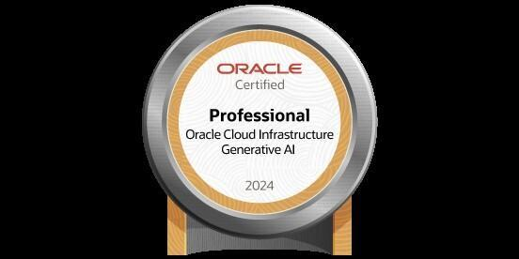
ASHUTOSH REDDY ATIMYALA
+14846206454 | ashutoshreddy.1510@gmail.com | https://www.linkedin.com/in/ashutosh-reddy-atimyala/
PROFESSIONAL SUMMARY

- Results-driven AI & Data Science Engineer with 4+ years’ experience deploying predictive ML models, automating retraining pipelines, and implementing CI/CD and monitoring solutions across Azure, AWS, and GCP. Proven success improving model reliability and drift detection through scalable MLOps frameworks. Adept at translating complex data insights into production-grade AI systems that deliver measurable business impact.
- Certification: Oracle Cloud Infrastructure 2024 Gen AI- Professional (LLMs, RAG, prompt engineering, responsible AI)
TECHNICAL SKILLS

Functional Competencies:
Model Deployment & Monitoring | Predictive Modeling | Model Retraining | Data Pipeline Automation | MLOps & CI/CD | Feature Engineering | Drift Detection | Reproducibility & Governance
Technical Tools:
Python | SQL | TensorFlow | PyTorch | scikit-learn | MLflow | Airflow | Docker | Kubernetes | Azure ML | AWS SageMaker | Jenkins | GitHub Actions | Prometheus | CloudWatch | FastAPI | Pandas | Spark | Databricks | Apache Kafka

WORK EXPERIENCE

Client: Wipro | Norristown, PA Oct 2023 - Present
Role: Machine Learning Engineer
- Operationalized ML models by deploying production-ready APIs and automated retraining pipelines, improving reliability and scalability across AWS and Azure.
- Built CI/CD pipelines using Docker, Kubernetes, and GitHub Actions—reducing deployment cycles by 30%.
- Implemented monitoring dashboards with MLflow and Prometheus for drift detection and performance alerts, ensuring 99.5% uptime.
- Developed data pipelines for ingestion, feature engineering, and model retraining, supporting RAG and predictive modeling workflows.
- Collaborated with Data Science and IT teams to integrate ML systems into production with robust versioning and reproducibility standards.
Client: Chiselon Technologies Private Limited | Hyderabad, India Sep 2020 - Aug 2021
Role: Software Engineer
- Deployed fraud detection and NLP models as scalable REST APIs, reducing detection time by 35%.
- Built automated retraining workflows using Kafka and Spark to adapt models to new data streams, improving detection accuracy by 30%.
- Maintained CI/CD pipelines with Jenkins and GitLab, ensuring reproducible deployments and compliance with MLOps best practices.
- Implemented explainable AI using SHAP, increasing stakeholder trust in model decisions.
Client: Bharat Heavy Electricals Limited | Hyderabad, India Apr 2019 - May 2020
Role: Software Engineer
- Developed predictive maintenance models using LSTMs on turbine sensor data, reducing system failures by 40%.
- Deployed condition monitoring microservices via FastAPI integrated with SCADA systems, improving real-time fault response time by 50%.
- Automated model monitoring and retraining using AWS Lambda and Airflow, enhancing operational resilience.
- Created dashboards in Tableau and Grafana to visualize drift, enabling proactive maintenance decisions.
EDUCATION

University of Maryland College Park | Maryland, US Aug 2021 - May 2023
Master of Engineering, Robotics
SRM Institute of Science and Technology | Tamil Nadu, IN Jul 2016 - Jun 2020
Bachelor of Technology, Mechatronics Engineering

