
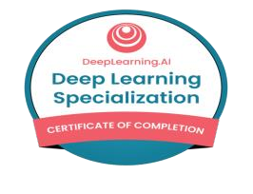
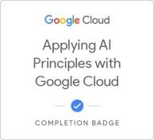
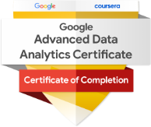
Eshwar Achampeta
Advanced Machine Learning
Data Analyst

OH, USA |eachampeta@gmail.com | +1 (908) 405-8169 | www.linkedin.com/in/eshwardataanalyst/

Professional Summary
I’m a data detective at heart, with over 3 years of hands‑on experience in Banking, Insurance, Healthcare and Retail. At Capital One, I built self‑serving dashboards and ETL pipelines that shaved 40% off reporting time—and even nudged campaign performance up by 18% through targeted A/B experiments. Whether I’m wrestling million‑row datasets in SQL/Python or translating analytics into clear, actionable stories, my goal is always the same: empower teams to make smarter decisions, faster. Certified in Azure AI and Advanced Analytics, I blend deep technical chops with a knack for connecting data to real business wins.

Professional Experience
Capital One, USA | Data Analyst | Oct 2023 – Present
- Analyzed customer transaction patterns using SQL and Python to identify spending trends, improving marketing campaign targeting by 18%.
- Automated weekly dashboards in Power BI to track KPIs across credit card products, reducing manual reporting time by 40%.
- Collaborated with cross-functional teams to clean, transform, and validate large datasets (1M+ records) from internal databases for business insights.
- Conducted A/B testing and statistical analysis to measure the impact of product changes, contributing to a 10% increase in user engagement.
- Built and maintained ETL pipelines in SQL and Excel VBA for regular reporting tasks, ensuring timely and accurate data delivery.
- Participated in data governance initiatives, ensuring data quality and compliance with Capital One’s privacy standards.
- Presented monthly findings to senior analysts and business stakeholders, improving data-driven decision-making in customer retention strategies.

Mphasis, India | Junior Data Analyst | Jan 2021 – Nov 2022
- Analyzed large datasets across Banking, Insurance, Healthcare, and Retail, driving insights for 5+ client projects.
- Developed 10+ interactive Power BI and Tableau dashboards, cutting manual reporting time by 35% and enabling real-time KPI monitoring.
- Cleaned and transformed data using SQL and Excel, boosting data accuracy to 88% for analytics.
- Collaborated on monthly reports highlighting trends in transactions, claims, and sales, improving campaign effectiveness by 12%.
- Identified anomalies in healthcare claims, reducing billing errors by 15% and ensuring HIPAA compliance.
- Translated stakeholder requirements into SQL queries and Excel models, speeding up ad hoc report delivery by 25% .

Education
Master in Management Data Analytics | Indiana Wesleyan University | 2023 - 2025 Bachelor in Computer Science | | 2016 - 2022

Skills
Languages & Tools: SQL, Python, Excel, Excel VBA
Visualization: Power BI, Tableau
ETL & Data Handling: ETL Pipelines, Data Cleansing, Data Transformation
Statistical Analysis: A/B Testing, Hypothesis Testing
Big Data Tools: Spark, Hadoop
Cloud Platforms: AWS, Azure, Google Cloud Platform (GCP) BI & Reporting Tools: Power BI Service, Excel Dashboards Data Storage: SQL Databases, Data Warehouses
Soft Skills: Stakeholder Communication, Cross-functional Collaboration, Decision Making
Domain Knowledge: Banking, Insurance, Healthcare, Retail
Compliance & Governance: HIPAA, Data Governance Standards

Certification
Azure Ai Fundamentals - Microsoft Certified Machine Learning - Deep Learning.Ai Applying Ai Principles - Google Cloud Advance Analytics - Google

