Gowtham Gajjala
DevOps / Cloud Engineer

Mississippi, USA
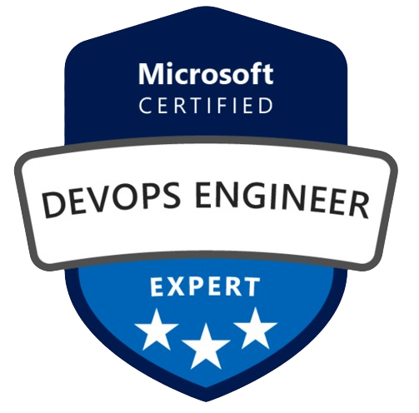
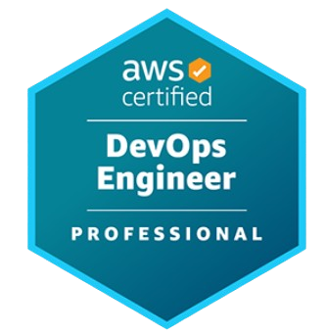
+16013079265


Gowtham.gajjala2@gmail.com

PROFILE SUMMARY:
- Results-driven DevOps & Cloud Engineer with over 3+ years of experience designing, automating, and optimizing mission-critical deployments on AWS, Azure, and Google Cloud Platform (GCP), delivering scalable, secure, and high-performing enterprise solutions across diverse industries.
- Expert in Infrastructure as Code (IaC) using Terraform, AWS CloudFormation, and Pulumi, enabling fully automated, reusable, and version-controlled provisioning of cloud infrastructure aligned with best practices in scalability and compliance. Strong CI/CD expertise with Jenkins, GitLab CI/CD, Azure DevOps, ArgoCD, and Spinnaker, driving end-to-end automation, blue-green and canary deployments, and seamless integration of testing and rollback mechanisms for zero-downtime releases.
- Hands-on with containerization and orchestration using Docker, Kubernetes, Helm, AWS EKS, and Azure AKS, ensuring reliable microservices deployment, scaling, and management across hybrid and multi-cloud environments. Proficient in configuration management and automation using Ansible, Chef, and Puppet, along with Python, Bash, and PowerShell scripting for automating build, monitoring, and operational tasks to improve system reliability and speed.
- Strong focus on cloud security and governance, implementing IAM, VPC, encryption, security groups, Vault, and compliance frameworks (HIPAA, SOC 2, GDPR) to safeguard data integrity and regulatory compliance.
- Expertise in observability and performance monitoring using Prometheus, Grafana, ELK Stack, Datadog, AWS CloudWatch, and Azure Monitor, enabling proactive alerting, root cause analysis, and system optimization for improved uptime and visibility.
- Adept at agile delivery and DevSecOps culture, collaborating across development, operations, and security teams to enable continuous improvement, cloud cost optimization, and faster time-to-market through automation, innovation, and best DevOps practices.
RELEVANT SKILLS:
- Cloud Platforms: AWS (EKS, EC2, S3, RDS) | Azure (AKS, VM Scale Sets) | On-Prem Virtualization (VMware, Bare-Metal)
- Platform Engineering & Developer Tools: GitLab CI/CD, Jenkins, JFrog Artifactory, SonarQube, Nexus, ArgoCD, Spinnaker, Helm, Kubernetes Operators, OpenTelemetry.
- Containerization & Orchestration: Kubernetes (EKS, AKS, GKE) | Helm | Docker | Podman | LXC
- Infrastructure as Code (IaC): Terraform, Ansible, CloudFormation, Pulumi, Packer
- CI/CD Tools: Jenkins, GitLab CI/CD, Azure DevOps, GitHub Actions, Ansible, Terraform, Maven, SonarQube, JFrog Artifactory
- Version Control: Git (GitHub, GitLab, Bitbucket), SVN
- Programming & Scripting: Python, Bash, Shell (csh, ksh), Groovy, PowerShell, Perl, Java (Test Drivers)
- Configuration Management: Ansible, Puppet, Chef, SaltStack
- Scripting & Automation: Python, Bash, PowerShell, Groovy
- Monitoring & Logging: Prometheus, Grafana, ELK Stack, Splunk, Azure Monitor, CloudWatch
- Networking & Security: TCP/IP, DNS, VPN, Firewalls, Load Balancers, IAM, Vault, KMS, Secrets Manager
- Databases & Storage: MySQL, PostgreSQL, SQL Server, DynamoDB, MongoDB, Cosmos DB, Redshift, BigQuery, S3, Azure Blob
- Build & Artifact Management: Maven, Gradle, Nexus, Artifactory, SonarQube
- Serverless & Automation: AWS Lambda, Fargate, Step Functions, Azure Logic Apps
- Workflow & Messaging: Apache Airflow, Azure Data Factory, Kafka, RabbitMQ, SNS/SQS
- Collaboration & Project Tools: Jira, Confluence, Trello, Slack, Microsoft Teams
EDUCATION:
- Masters In Computer Science from The University of Southern Mississippi, Usa (Jan 2024 - Dec 2025)
WORK EXPEREICNE:
Azure DevOps Engineer Mar 2025 - Current
BAE Systems, Vicksburg, Mississippi, USA
BAE Systems is a multinational defense and information security company. Responsible for designing, deploying, and maintaining high-availability DevOps and SRE platforms supporting hybrid and cloud-native workloads for mission-critical operations.
- Designed and implemented scalable, automated deployment pipelines using Azure DevOps, GitLab CI/CD, and Terraform, enabling seamless cloud and on-premises delivery.
- Architected Kubernetes (AKS)-based infrastructure integrated with Helm, supporting containerized workloads with zero-downtime deployments and autoscaling.
- Deployed monitoring and observability solutions using Prometheus, Grafana, and Loki, implementing Service-Level Objectives (SLOs) and proactive alerting for critical systems.
- Automated infrastructure and configuration management using Ansible and Terraform, enforcing infrastructure-as-code (IaC) principles across multiple regions.
- Designed roadmaps for platform automation and self-service DevOps environments that improved developer velocity and system reliability.
- Supported multi-site environments by integrating Azure Cloud, on-prem compute, and container orchestration clusters for continuous operation and redundancy.
- Maintained JFrog Artifactory repositories and CI artifacts to standardize build and deployment workflows across teams.
- Championed SRE best practices, reducing manual toil by 45% through automation of monitoring, scaling, and patching workflows.

AWS DevOps Engineer Aug 2024 - Feb 2025
Blue Cross & Blue Shield of Mississippi, Flowood, Mississippi, USA
Led the implementation of automation pipelines and observability frameworks supporting large-scale, secure healthcare systems hosted on AWS cloud environments.
- Designed and automated CI/CD pipelines using GitLab CI/CD and Jenkins for end-to-end deployment orchestration and version control.
- Implemented Kubernetes clusters (EKS) with Helm charts, managing service rollouts, configuration changes, and infrastructure scalability.
- Leveraged Terraform and Ansible to provision infrastructure and maintain consistent configuration management across multiple environments.
- Established monitoring dashboards and alert policies using Prometheus, Grafana, and CloudWatch, achieving measurable uptime improvements.
- Collaborated with application teams to integrate SLOs, error budgets, and capacity-planning metrics into operational dashboards.
- Automated routine infrastructure tasks, eliminating manual deployment bottlenecks and accelerating software release cycles.
- Deployed JFrog Artifactory and SonarQube to enhance artifact management and code quality governance.

DevOps / Cloud Engineer Jul 2022 - Nov 2023
Moody's Corporation, Bangalore, India
Moody’s Corporation is a global financial analytics company. Managed the design, automation, and monitoring of CI/CD pipelines and distributed systems for analytics workloads.
- Built multi-cloud automation frameworks using Terraform, Ansible, and GitLab CI/CD for consistent deployments across AWS and GCP.
- Implemented Kubernetes clusters (GKE) and automated service discovery, scaling, and fault recovery mechanisms for analytical platforms.
- Integrated Prometheus, Grafana, and Loki for comprehensive observability, improving MTTR by 40%.
- Automated infrastructure provisioning, container builds, and pipeline triggers, aligning with SRE and IaC methodologies.
- Maintained Helm chart repositories and GitOps workflows for reproducible infrastructure management.
- Collaborated with ML teams to enable MLOps integrations, managing containerized AI model deployments.
Cloud Engineer Apr 2021 - Jun 2022
Teva Pharmaceutical, Bangalore, India
Teva Pharmaceutical is a global leader in biopharma technology. Designed and implemented automated DevOps frameworks for production and R&D environments supporting regulated cloud workloads.
- Automated provisioning of AWS infrastructure using Terraform and CloudFormation with integrated compliance validation.
- Deployed Docker and Kubernetes (EKS) for scalable application environments with Helm-based configuration management.
- Developed Python and Bash scripts for system monitoring, log aggregation, and infrastructure-level automation.
- Configured Grafana, ELK, and CloudWatch dashboards to visualize resource utilization and improve service reliability.
- Partnered with security and DevOps teams to implement observability, SLO tracking, and DevSecOps automation pipelines.

