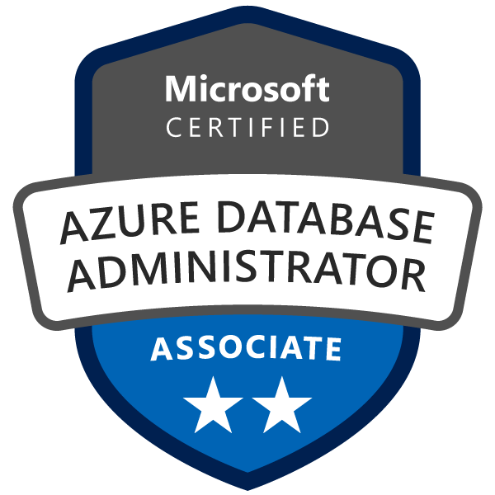
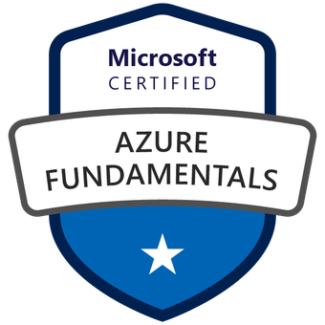
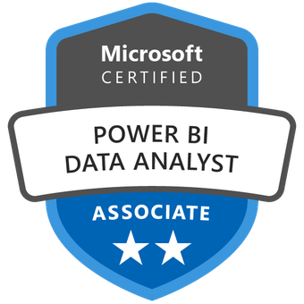
Jaya Sasanka Mouli L 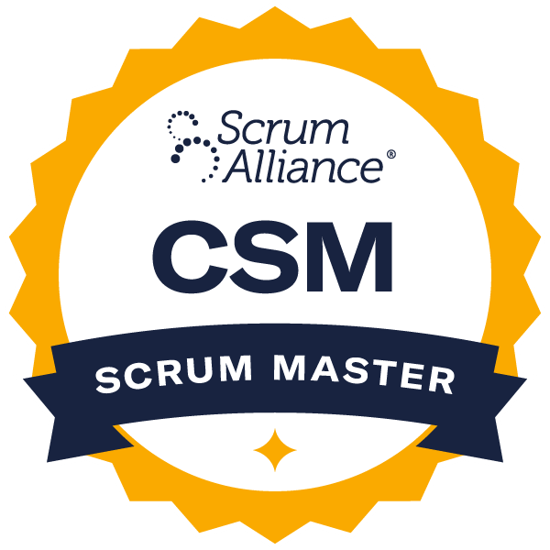

|Business Analyst| Certified Scrum Master|

Phone: (801)-770-3133 ext- 209

Email ID: teja@sonusoftwareinc.com

LinkedIn: linkedin.com/in/ljsm

Strategic Business Analyst with Certified Scrum Master and PMP certification (in progress), leveraging 8+ years of experience in data-driven decision-making, process optimization, and agile project leadership. Expertise in business process improvement, stakeholder management, and leading agile teams to deliver impactful solutions.
Professional Summary:

- Experienced Business Analyst with over 8 years specializing in Data Analysis, Design, Modeling, Development, and Testing of Data Warehouse applications.
- Skilled in SQL, Python, R, Excel, and Data Visualization tools such as Tableau and Power BI. Developed dynamic dashboards that enhanced executive reporting efficiency by 30%.
- Proficient in utilizing Python and R libraries including NumPy, Pandas, Matplotlib, SciPy, and ggplot2 for advanced data analysis and visualization.
- Extensive experience with cloud-based data platforms such as Amazon Web Services (AWS) and Microsoft Azure.
- Expertise in designing, managing, and optimizing relational databases; implemented schema enhancements that reduced query response times by 40%.
- Strong proficiency in SQL Queries, Stored Procedures, Functions, Packages, and Triggers using MySQL and MS SQL Server.
- Created comprehensive reports and dashboards to monitor KPIs; implemented effective customer segmentation strategies.
- Skilled in data collection, cleaning, wrangling, and performing thorough data analysis. Proficient in A/B Testing, ETL/ELT processes, and developing machine learning models.
- Identified trends, patterns, and anomalies, providing actionable recommendations and optimizing processes for cost savings.
- Effective communication of complex data insights to stakeholders; presented findings to C-level executives, influencing strategic decision-making.
- Proficient in Software Development Life Cycle (SDLC), with experience in Waterfall and Agile methodologies.
- Proficient in ensuring compliance with HIPAA standards, safeguarding sensitive healthcare data, and maintaining the highest level of data security and patient confidentiality.
- Proven ability to lead cross-functional teams in delivering data-driven projects on time and within budget.
- Experienced in managing end-to-end data projects, from initial requirements gathering to final implementation and support.
- Adept at creating automated reporting solutions, reducing manual effort and improving data accuracy.
- Strong understanding of data governance and compliance, ensuring data integrity and security across all projects.
- Expertise in leveraging big data technologies like Hadoop and Spark for large-scale data processing.
- Demonstrated success in improving operational efficiency and business performance through data-driven decision-making.
- Strong understanding of regulatory frameworks such as HEDIS and HIPAA, with a proven track record of ensuring healthcare data projects meet both quality and security standards.
- Collaborative team player with excellent problem-solving abilities and a keen attention to detail.
- Expertise in developing and implementing data quality frameworks to ensure the accuracy and reliability of data across various systems.
- Extensive experience in creating and maintaining data dictionaries and metadata repositories to support data governance initiatives.
- Skilled in using advanced analytics tools and techniques, such as time series analysis, clustering, and regression modeling, to derive actionable insights.
- Proven track record in mentoring and training junior data analysts, fostering a culture of continuous learning and improvement within the team.
- Experienced in conducting market research and competitive analysis to support strategic planning and business development efforts.
- Adept at managing stakeholder expectations and delivering high-quality analytical solutions in fast-paced, dynamic environments.
- Strong background in financial analysis and modeling, supporting budgeting, forecasting, and financial reporting activities.
- Proven leader in delivering business solutions that drive revenue growth and operational efficiency through agile methodologies and strategic data-driven decision-making.
- Extensive experience across diverse industries, including healthcare, finance, and technology, providing actionable insights and implementing process improvements tailored to specific business needs.
- Specialist in leading agile transformations, fostering cross-functional collaboration, and enabling teams to adapt quickly to market changes, ensuring project success within tight deadlines.

Certifications:

- Certified Scrum Master (CSM)
- Microsoft Certified: Power BI Data Analyst Associate
- Project Management Professional (PMP) (in progress)
- Cisco Networking Academy: Data Analytics Essentials
- Microsoft Certified: Azure Fundamentals (Certification ID: 995278406)
- Microsoft Certified: Azure Database Administrator Associate

Technical Summary:

Programming & Scripting | SQL, Python, R, PL/SQL
Data Visualizations | Tableau, Power BI, QuickSight, Excel,
Data Warehousing | Azure Synapse Analytics, AWS Redshift
ETL Tools | AWS Glue, Azure Data Factory, Airflow, Informatica
Cloud Platforms | AWS, Microsoft Azure, Google Cloud Platform (GCP)
Machine Learning | Scikit-learn, Exploratory Data Analysis (EDA)
Big Data Technologies | Spark, Hive
Project Management Tools | JIRA, Microsoft Project, Trello, Asana
Collaboration Tools | Slack, MS Teams, Confluence Jira, Microsoft Project, MS PowerPoint, MS Visio
Data Modeling | Dimensional Modeling, Star Schema,
Financial Analysis | Excel (Pivot Tables, Financial Modeling)
Healthcare Analysis | HEDIS, HIPPA
Business Analysis Tools | JIRA, MS Visio, UML, BPMN
Methodologies | SDLC, Waterfall, AGILE, Scrum, Kanban, RAD, JAD, RUP

Education:
Bachelor’s in Information Technology, Osmania University, India

Professional Experience:
McKinsey & Company, Houston, TX September 2023 – Present
Business Analyst
- Directed a series of strategic data analysis initiatives for Fortune 500 companies, where my insights contributed to an average revenue growth of 22% directly influencing clients' strategic decisions.
- Implemented advanced machine learning models to optimize client operations, resulting in a 25% increase in efficiency.
- Developed dynamic, interactive dashboards using Tableau and Power BI, which enhanced executive reporting efficiency by 40%.
- Utilized Python and R for sophisticated data manipulation, statistical analysis, and predictive modeling, contributing to a 30% improvement in forecast accuracy.
- Built custom Python scripts to automate repetitive data processing tasks, increasing overall team productivity
- Integrated Python-based analytical tools into existing workflows, streamlining operations and enhancing data-driven decision-making processes.
- Designed and managed scalable data pipelines using AWS and Google Cloud, ensuring seamless data integration and real-time analytics for large datasets.
- Employed big data technologies such as Hadoop and Spark to process and analyze terabytes of client data, leading to a 20% reduction in data processing time.
- Worked closely with C-level executives to translate business requirements into analytical solutions, significantly improving client satisfaction and project success rates.
- Delivered data-driven recommendations that led to a 15% cost reduction in client operations through optimized resource allocation and process improvements.
- Mentored a team of junior data analysts and interns, fostering a culture of continuous learning and professional development.
- Conducted workshops and training sessions on advanced data analytics techniques, resulting in a 50% increase in team productivity.
- Established data quality and governance frameworks to ensure the accuracy, consistency, and reliability of data across all projects.
- Implemented robust ETL processes to streamline data flow, enhancing data accuracy and reducing errors by 30%.
- Leveraged SQL and NoSQL databases to efficiently manage and query large datasets, improving data retrieval times by 25%.
- Developed automated reporting systems using scripting languages, reducing manual reporting time by 35%.
- Integrated data visualization best practices to improve the clarity and impact of presentations to stakeholders.

Environment: Exploratory Data Analysis (EDA), TensorFlow, Scikit-learn, Google Cloud Platform (GCP), Google BigQuery, Google Cloud Dataflow, Airflow, PostgreSQL, Tableau, Power BI, Microsoft Azure, Azure Data Factory (ADF), Azure Databricks, Azure Synapse Analytics, Matplotlib, SQL.

Fixity Technologies, Chicago, IL July 2022 - August 2023
Data and Research Analyst
- Engaged in data cleansing, requirements gathering, and process flow documentation to ensure data integrity and alignment with project goals.
- Applied expert knowledge of Python tools including Pandas and NumPy to refine machine learning models, boosting product forecast precision by 30% and delivering substantial cost reductions in supply chain operations.
- Conducted comprehensive Exploratory Data Analysis (EDA) on pharmaceutical datasets, revealing actionable insights and trends to support strategic decision-making.
- Automated ETL pipelines using Airflow to streamline data warehousing and modeling processes across PostgreSQL and Cassandra databases.
- Designed and implemented machine learning solutions leveraging Scikit-Learn and TensorFlow, resulting in significant improvements in model performance and accuracy.
- Managed production machine learning models on Google Cloud Platform (GCP), ensuring scalability, reliability, and ongoing performance monitoring.
- Developed custom Python modules for data transformation and validation, significantly improving data processing efficiency.
- Implemented Python-based machine learning workflows to enhance predictive modeling capabilities and project outcomes.
- Implemented scalable data processing using Google Cloud Dataflow, enhancing efficiency in handling large-scale datasets.
- Designed and optimized data warehouses on Google BigQuery, improving query performance and optimizing costs.
- Implemented data transformation logic within Snowflake, enhancing data quality and supporting business intelligence and reporting needs.
- Created interactive dashboards in Tableau and Power BI, providing visual insights for stakeholders and supporting data-driven decision-making.
- Employed SQL and NoSQL databases to efficiently handle and query extensive pharmaceutical datasets, improving data retrieval times by 20%.
- Developed automated data validation scripts to ensure data consistency and accuracy, reducing errors by 25%.
- Collaborated with cross-functional teams to integrate machine learning models into existing workflows, increasing overall project efficiency by 30%.
- Conducted training sessions on advanced Python libraries and machine learning techniques, fostering team skill development and enhancing analytical capabilities.

Environment: Exploratory Data Analysis (EDA), Python, Machine Learning (ML), TensorFlow, Scikit-learn, Snowflake, Google Cloud Platform (GCP), Google Big Query, Google Cloud Dataflow, Airflow, PostgreSQL, Cassandra, Tableau, Power BI, Microsoft Azure, Azure Data Factory (ADF), Azure Databricks, Azure Synapse Analytics, Matplotlib, SQL.

Blue Cross Blue Shield, IL May 2020 - Jun 2022
BI Consultant
- Led a fraud detection initiative, analyzing over 10 million health insurance claims and reducing fraudulent claims by 18%, equating to annual savings of over $3 million. Utilized advanced data analysis and predictive models to identify and mitigate fraud risks, ensuring compliance with HEDIS and HIPAA standards.
- Provided insights into cost drivers and suggested interventions, leading to a 15% reduction in unnecessary procedures.
- Led a study on emergency room usage patterns, creating a report that identified key factors contributing to high costs and recommendations for alternative care pathways.
- Automated ETL processes using Airflow, improving data integration and processing efficiency by 30%.
- Created an end-to-end ETL pipeline to process and integrate new member data into the data warehouse, reducing data lag from two days to four hours.
- Developed interactive dashboards in Tableau and Power BI to visualize key performance indicators (KPIs) for executive reporting.
- Ensured data analysis and reporting processes complied with HIPAA and other healthcare regulations.
- Created custom Python scripts for data extraction, transformation, and loading, reducing manual processing time by 40%.
- Enhanced data quality and consistency by implementing Python-based data validation frameworks.
- Leveraged advanced statistical methods to perform risk adjustment analysis, enhancing the accuracy of risk scores and improving reimbursement processes.
- Utilized big data technologies like Hadoop for efficient storage and processing of large datasets, reducing query times by 25%.
- Automated end-to-end reporting processes for healthcare claims analysis, reducing manual effort by 40%. Ensured that all reports were fully compliant with HIPAA standards while providing actionable insights to improve HEDIS metrics and healthcare quality.
- Collaborated with healthcare professionals to design data-driven strategies for patient care optimization, resulting in a 10% improvement in patient outcomes.
- Conducted training workshops on best practices for data analysis and BI tool usage, increasing team efficiency by 40%.

Environment: SQL, Python, Hedis ,Scikit-Learn, HIPPA ,Airflow, PostgreSQL, Big Query, Tableau, Power BI, Healthcare Data, Machine Learning, ETL Processes, Regulatory Compliance.

Sonus Software Solutions Pvt Ltd, India May 2016 - February 2020
Data Analyst
- Revamped data validation and cleansing protocols, achieving a 40% reduction in data discrepancies, which significantly bolstered the accuracy of strategic business decisions.
- Leveraged advanced proficiency in Excel, SQL, and Python to conduct comprehensive exploratory data analysis (EDA), meticulously uncovering intricate trends, anomalies, and actionable insights that drove strategic business decisions.
- Collaborated closely with cross-functional teams to develop insightful reports and dynamic dashboard effectively visualizing complex data findings
- Applied expertise in data visualization tools such as Tableau and Power BI to craft compelling visual representations, enhancing data comprehension and driving informed decision-making across organizational levels.
- Contributed significantly to the design, implementation, and maintenance of robust data pipelines and ETL processes, optimizing data flow efficiency and ensuring timely availability of critical business insights.
- Engaged in rigorous statistical analysis and hypothesis testing, validating data-driven insights and recommendations to support evidence-based strategies and operational improvements.
- Actively participated in collaborative team meetings and continuous learning opportunities, continuously expanding proficiency in data analysis methodologies and fostering a culture of knowledge sharing and growth.
- Developed automated data validation scripts to enhance the accuracy and reliability of data, reducing manual errors by 20%.
- Integrated Python-based statistical analysis techniques to enhance the accuracy and reliability of insights derived from data.
- Utilized machine learning algorithms to create predictive models, improving forecasting accuracy for key business metrics by 15%.
- Implemented data warehousing solutions using technologies like SQL Server and Oracle, optimizing storage and retrieval processes for large datasets.
- Conducted training sessions on advanced data analysis techniques and tools, elevating the overall analytical capabilities of the team.
- Integrated data from various sources into cohesive datasets, improving data accessibility and usability for different departments.
- Designed and executed A/B testing to evaluate the effectiveness of business strategies, providing actionable insights for optimization.
Environment: Excel, SQL, Python, Tableau, Power BI, Data Cleaning, Exploratory Data Analysis (EDA), Statistical Analysis, Data Visualization, ETL Processes.

