KUNDANA CHERUKURI

Senior Software Engineer 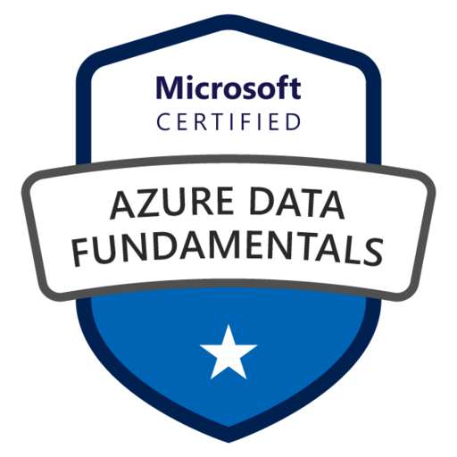 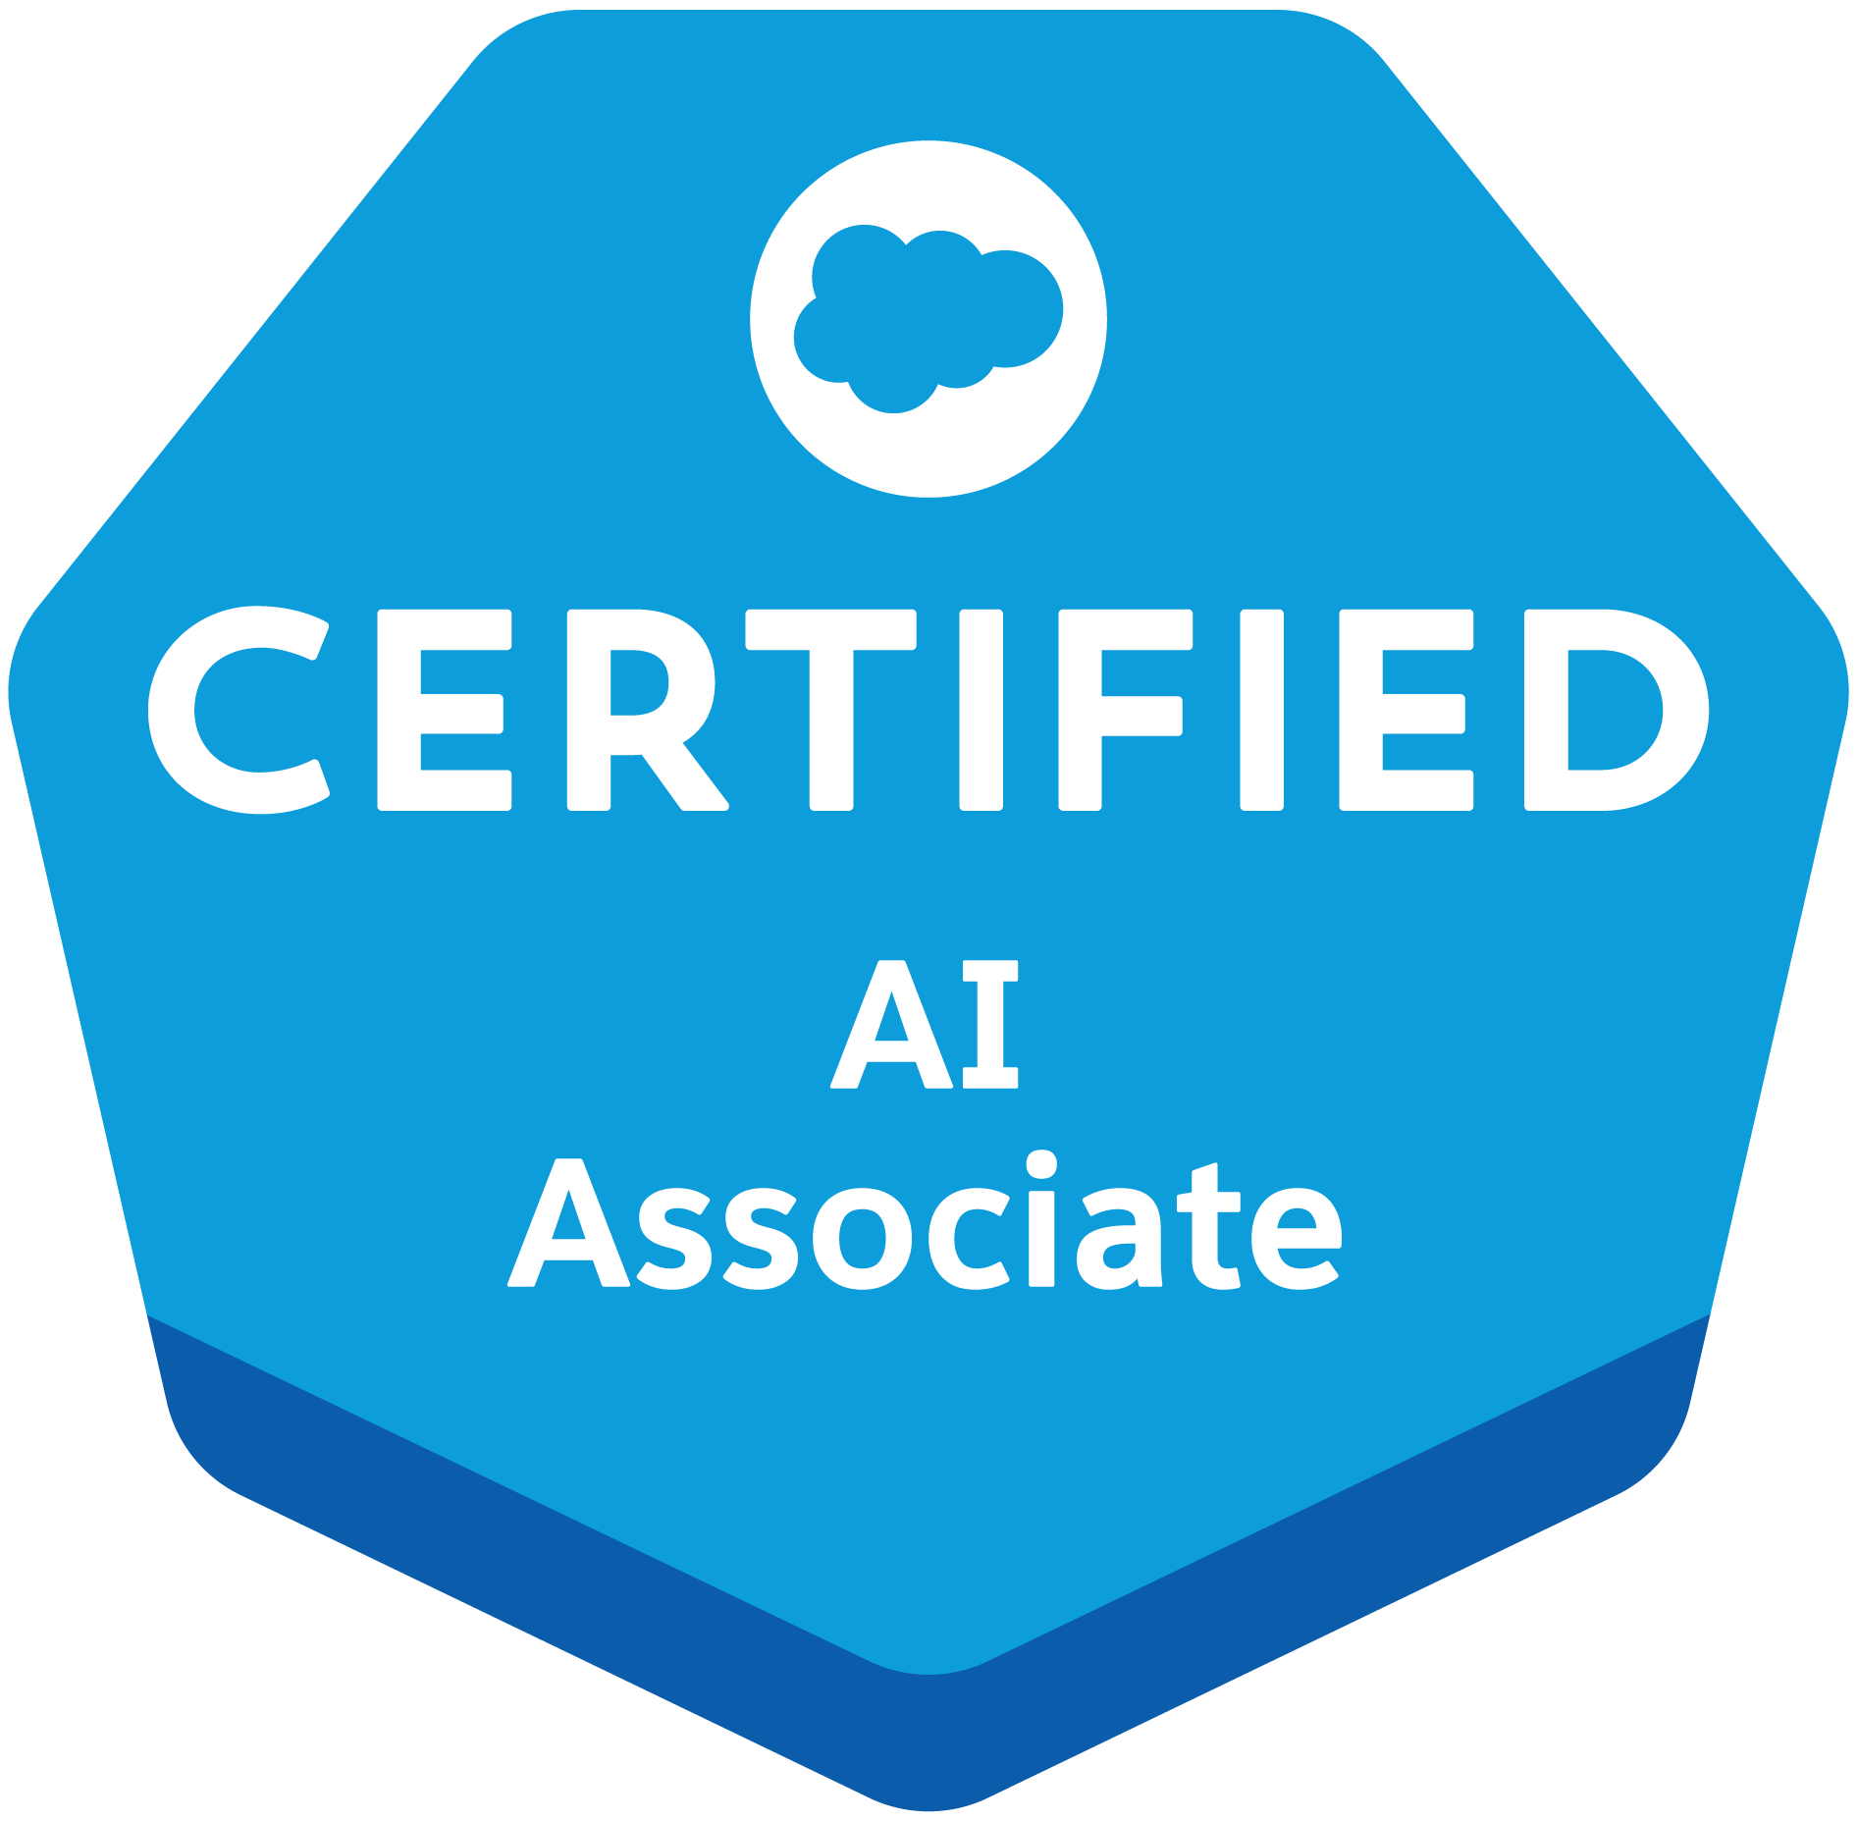 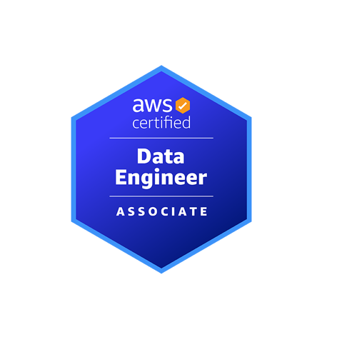
Email ID: kundanach9@gmail.com
Contact: +1 (571)409-6005
LinkedIn: www.linkedin.com/in/kundana-cherukuri
GitHub: https://github.com/Kundanach9
Professional Summary:
- Over 8 years of experience as a Software Engineer by delivering scalable ETL/ELT pipelines across AWS, Azure, GCPwith strong expertise in data integration, transformation, orchestration, and governance for business-critical systems.
- Specializing in building big data platforms using Apache Spark, Kafka, and Hadoop to support real-time and batch data processing pipelines with optimized performance and fault tolerance.
- Developed CI/CD pipelines with Terraform, Jenkins, and GitHub Actions to automate infrastructure provisioning, data workflows, and code deployments across development, QA, and production environments.
- Designed orchestration workflows using Apache Airflow and Azure Data Factory, managing dependency logic, retry strategies, and SLA monitoring for high-throughput, low-latency data movement.
- Built and maintained Delta Lake and Snowflake-based lakehouse architectures to unify streaming and historical analytics with scalable, cost-efficient, and query-optimized data models.
- Engineered event-driven data ingestion with Kafka Streams and AWS Kinesis for real-time pipeline execution, minimizing lag in telemetry and transactional datasets across cloud platforms.
- Proficient in Python, SQL, and PySpark for data modeling, transformation, and pipeline modularization; created reusable code libraries to support cross-functional development and onboarding.
- Built containerized microservices and dashboards using React.js, Node.js, HTML, and CSS, integrating them with backend APIs and databases to support internal operational tools.
- Managed infrastructure as code using Terraform and CloudFormation, enforcing security, version control, and scalability across DevOps layers for both data and application services.
- Delivered data quality pipelines using Great Expectations and in-DAG validation checks to ensure schema conformity, missing value detection, and downstream data integrity across workflows.
- Applied data governance policies, including encryption, masking, access control, and auditing to ensure HIPAA, GDPR, and SOC2 compliance across cloud-based data lakes and APIs.
- Created Power BI and Tableau dashboards from curated data marts to track KPIs, user behavior, and system health metrics for finance, healthcare, and customer analytics domains.
- Configured observability using CloudWatch, Prometheus, and Datadog for real-time insights into pipeline execution, API performance, and system-level resource usage.
- Designed and deployed optimized schemas in PostgreSQL, DynamoDB, and MongoDB to support low-latency access patterns in reporting tools and full-stack application services.
- Collaborated with product owners, analysts, and engineering teams across the SDLC, mentoring peers and owning solutions across data engineering, DevOps automation, and front-end delivery.
Areas of Expertise: ETL/ELT Pipelines, CI/CD Automation, Infrastructure as Code, Apache Spark, Kafka, Airflow, Snowflake, RESTful APIs, React.js, Node.js, Docker, Kubernetes, AWS, Azure, SQL/NoSQL, Monitoring & Alerting, Agile/Scrum, Data Modeling, Machine Learning Pipelines, Troubleshooting, User Interface (UI) Design, GraphQL, A/B testing.
Technical Skills
Cloud Platforms: AWS, Azure, GCP, Databricks Lakehouse, Snowflake Native App Framework
Data Engineering Tools: Apache Spark, Kafka, Airflow,Hadoop, dbt, AWS Glue, EMR, Dataflow, Databricks, Tableau, Power BI
Data Warehouses / Lakes: Snowflake, Redshift, BigQuery, Azure Synapse, Delta Lake, Lake Formation
ETL/ELT: Informatica, Talend, Glue Studio, ADF
Orchestration & Scheduling: Airflow, Cloud Composer, Azure Data Factory
Languages: Python, SQL, PySpark, Scala, Shell, R, JavaScript, TypeScript, HTML, CSS
Databases: PostgreSQL, MySQL, Oracle, DynamoDB, MongoDB, Firebase Realtime DB, SQLite
DevOps & CI/CD: GitHub Actions, Jenkins, Terraform, Docker, Kubernetes, AWS CodePipeline, Azure DevOps
Monitoring & Logging: CloudWatch, Stackdriver, Datadog, Prometheus, Grafana, ELK Stack
Version Control & Repos: Git, GitHub, GitLab, Azure Repos, Bitbucket
Web & Full Stack Technologies: React.js, Node.js, Express.js, REST APIs, Next.js, Bootstrap, Tailwind CSS
Professional Experience

Client: Home Depot- Boston
Role: Senior Software Engineer
January 2025 – Present
Responsibilities:
- Designed and deployed real-time data pipelines using Apache Kafka and Spark Structured Streaming to process event-driven datasets, supporting sub-second analytics and incident detection.
- Conducted performance benchmarking and capacity planning for Spark clusters using AWS CloudWatch, Spark UI, and dynamic resource scaling strategies.
- Built modular PySpark components to standardize batch and streaming ingestion, reducing pipeline development time by 40% and improving reusability across projects.
- Led Agile sprint planning, backlog refinement, and peer code reviews to ensure velocity and delivery quality in a fast-paced engineering environment.
- Orchestrated complex ETL workflows using Apache Airflow and dbt, transforming data from Amazon S3 into analytics-ready layers in Snowflake, with SLA monitoring and alerting via Slack.
- Implemented an end-to-end data quality framework using Great Expectations, embedding schema validation and null checks within Airflow DAGs.
- Developed CI/CD pipelines with GitHub Actions and Terraform for deploying data workflows and infrastructure, ensuring consistency across dev, QA, and production.
- Modeled Snowflake data marts and star schemas optimized for customer analytics, leveraging clustering keys and materialized views to reduce query latency by 60%.
- Collaborated with BI and product teams to define semantic data layers and KPI definitions, streamlining downstream reporting in Power BI and Tableau.
- Integrated monitoring solutions like Prometheus and Datadog to track Airflow DAG health, Spark executor metrics, and SLA violations.
- Architected lakehouse-style ingestion patterns using Delta Lake and Snowflake to unify batch and real-time processing for scalable analytical workflows.
- Mentored junior engineers on data governance, best practices, and pipeline architecture, fostering a knowledge-sharing culture aligned with engineering excellence.
- Optimized Snowflake compute costs by implementing Resource Monitors, auto-suspend/auto-resume, and multi-cluster warehouses, achieving a 25% reduction in compute resource consumption.
- Established row-level security, data masking, and access control policies in Snowflake and dbt to ensure fine-grained access management and data compliance with GDPR standards.
- Integrated Apache Atlas with Airflow and dbt to automatically catalog metadata and data lineage, improving traceability and audit readiness across data pipelines.
- Standardized unit, integration, and regression testing using Pytest and dbt tests in CI workflows, increasing deployment confidence and maintaining high code coverage.
- Partnered with platform engineers to evaluate and pilot a transition from legacy batch workflows to a Databricks Lakehouse model, benchmarking performance and cost trade-offs.
- Implemented a blue/green deployment strategy for data pipelines using feature flags and DAG versioning, enabling safe rollbacks and reducing production downtime risk.
Client: Citizens Bank- North Carolina
Role: Software Engineer
October 2023 – November 2024
Responsibilities:
- Implemented CI/CD pipelines using Jenkins and GitHub Actions for microservices deployments, reducing release failures by 70%.
- Automated AWS infrastructure provisioning with Terraform (EC2, VPC, IAM, RDS) using reusable modules and remote state.
- Containerized applications with Docker and deployed on Amazon EKS; configured ALB for secure ingress and blue-green rollouts.
- Developed Helm charts to manage templated Kubernetes deployments, enhancing release repeatability across environments.
- Integrated Prometheus and Grafana to monitor container health, resource metrics, and alert on anomalies.
- Built operational automations in Bash and Python for log parsing, diagnostics, and incident recovery.
- Centralized logging via ELK Stack (Elasticsearch, Logstash, Kibana) for distributed services in Kubernetes.
- Configured AWS IAM roles and security groups ensuring least-privilege access and compliance.
- Collaborated cross-functionally using Git branching, Jira, and Confluence, fostering code review discipline and sprint alignment.
- Optimized AWS costs by automating EC2 schedules and rightsizing with Trusted Advisor and CloudWatch insights.
- Educated peers on cluster architecture and best practices, and mentored junior team members on DevOps tooling.
- Designed and implemented ELT workflows using AWS Glue and Snowflake to extract operational and log data, load into raw zones.
- Apply dbt transformations for curated analytics-ready layers, ensuring schema compliance and performance optimization

Client: Tech Mahindra– Hyderabad, India
Role: Jr. Software Engineer
May 2021 – July 2023
Responsibilities:
- Led pipeline capacity planning and performance tuning using Azure Advisor and Azure Monitor, improving data integration throughput across development and production environments.
- Migrated legacy ETL pipelines to Azure Data Factory and Azure Synapse Analytics, utilizing mapping data flows, parameterized pipelines, and partitioned tables to reduce latency by 40%.
- Developed reusable PySpark modules in Azure Synapse Spark Pools to standardize ingestion and transformation logic for trading analytics and customer profiling use cases.
- Facilitated agile ceremonies, conducted peer code reviews, and maintained high Python test coverage using pytest, ensuring consistent delivery across sprints.
- Automated third-party API data ingestion using Python scripts triggered via Azure Functions and orchestrated with ADF, with embedded exception handling and data completeness checks.
- Built CI/CD pipelines using GitHub Actions, Terraform, and Azure DevOps Repos to automate deployment of ADF workflows and Azure Functions across environments.
- Implemented data governance using Azure Purview for cataloging, lineage tracking, and sensitivity labeling; monitored data movement with Azure Monitor Logs and Log Analytics Workspaces.
- Collaborated with data science teams to create feature stores and model-ready ETL pipelines, staging preprocessed features in Azure Synapse dedicated pools.
- (Hybrid Stack) Supported Snowflake on Azure Marketplace, designing dimension and fact tables for curated analytics layers used in Power BI reporting.
- Instrumented ADF pipeline metrics, trigger outcomes, and custom ingestion logs into Azure Monitor, enabling proactive SLA alerting through alerts, dashboards, and KQL queries.

Client: SAK INFORMATICS- Hyderabad, India
Role: Jr Software Engineer
April 2019– March 2021
Responsibilities:
- Conducted exploratory data analysis (EDA) on structured datasets using Excel and Python, identifying anomalies and trends via pivot tables and statistical summaries.
- Cleaned, transformed, and standardized raw data using Pandas and NumPy, handling outliers, nulls, and inconsistent formats to improve data readiness.
- Built visualizations using Matplotlib and Seaborn to communicate insights through histograms, heatmaps, and trend plots.
- Automated Excel dashboards using formulas, Macros, and VBA, delivering weekly KPIs for sales, operations, and marketing teams.
- Developed Python scripts to merge, join, and standardize data from multi-departmental CSV and Excel sources for faster reporting cycles.
- Participated in stakeholder meetings to gather data requirements and translated them into analytical queries and visual summaries.
- Utilized Excel functions like VLOOKUP, INDEX-MATCH, and IF statements to enhance data extraction accuracy and simplify reporting.
- Created data dictionaries and documented transformation pipelines to ensure reproducibility and team alignment.
- Performed time-series analysis to track customer behavior and product demand trends using moving averages and seasonal breakdowns.
- Supported A/B testing evaluations, performing hypothesis testing (t-tests) using Python's SciPy library to identify statistically significant differences.
Client: CodeBees PVT LTD– Hyderabad, India
Role: Software Engineer
February 2017 – March 2019
Responsibilities:
- Developed a responsive web application using React.js, HTML5, CSS3, and Bootstrap to manage client onboarding, access roles, and internal dashboards.
- Built RESTful APIs using Node.js and Express.js, integrated with PostgreSQL for secure CRUD operations and analytics endpoints.
- Implemented JWT authentication and role-based authorization to manage user sessions and enforce access control policies.
- Managed state with Redux, optimizing React component rendering and ensuring smooth data flow between frontend and backend layers.
- Wrote complex SQL queries and stored procedures in PostgreSQL to support reporting and advanced filtering features.
- Containerized the application using Docker, and created Docker Compose configurations for dev and staging environments.
- Integrated Stripe for billing and SendGrid for transactional email delivery to enhance application capabilities.
- Configured CI/CD pipelines using Jenkins (or Travis CI) for automated testing, code linting, and deployment to AWS EC2 instances.
- Developed unit and integration tests using Jest and Mocha, improving code reliability and reducing production defects.
- Used AWS S3 for secure document storage and generated pre-signed URLs for access control.
- Analyzed and improved frontend performance using Google Lighthouse and Chrome DevTools, optimizing lazy loading and re-renders.
- Worked closely with UX designers to convert wireframes into fully responsive, mobile-first designs with accessibility compliance.
- Led Git-based workflows for version control and peer-reviewed code to ensure adherence to best practices.
Certifications:
- Azure Fundamentals (AZ-900)
- Salesforce Certified AI Associate
- Aviatrix Certified Multi-Cloud Networking Associate (ACE-MCNA)
- AWS Certified Data Engineer Associate

