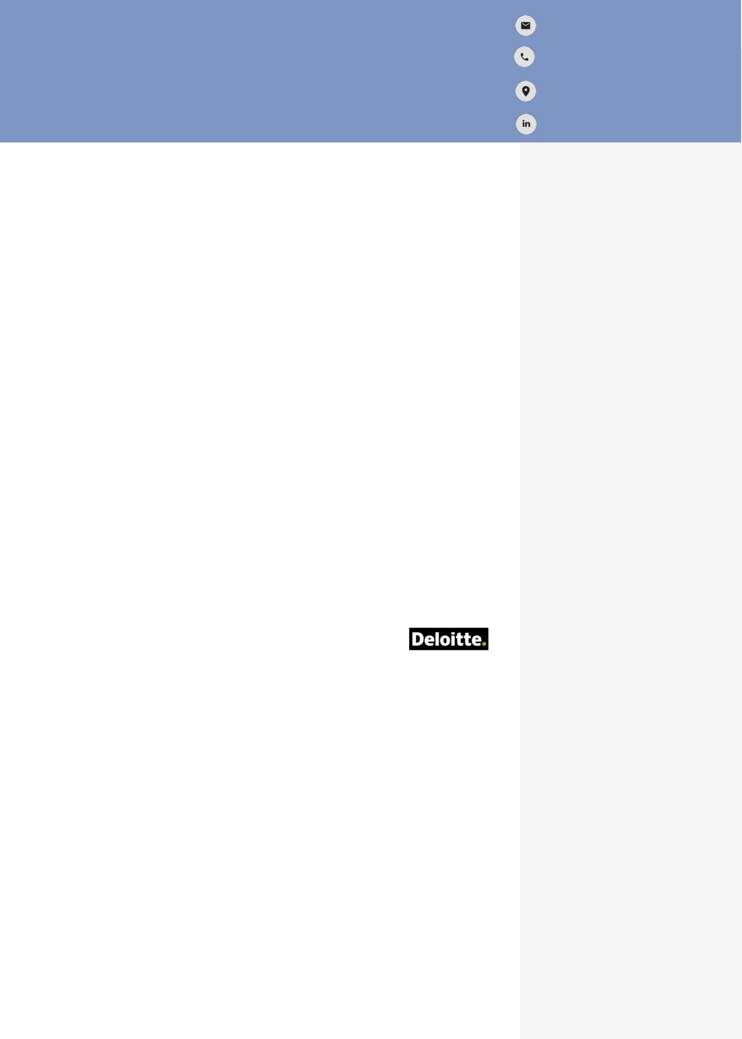

DURGA PAVANI ADDEPALLI
Microsoft Dynamics 365 Consultant
pavanidurga7@gmail.com

+1 (940) 901-6879

Irving, Texas
www.linkedin.com/in/durga- pavani-addepalli-138045199

OBJECTIVE
A Passionate, Diligent, Dynamic & Certified Microsoft Dynamics 365 Consultant with experience of 4+ years in the development, design, and Application support in the Agile Methodology oriented Project. Aspiring to be supportive Team member in your project to work in a pragmatic way where I can utilize my skills and experience to fulfill organization goals and gratify my professional & personal skills through engaging with a vibrant team.

Professional Synopsis
- Dynamics 365 Consultant
- RPA Analyst using Power Automate
- Business Analyst
- Design Team Member
- App Maker
- Sales Hub & Customer Service Hub Specialist
- Application Operations Team Member

Work Experience


Power Platform Automation Consultant
Jacobsen|Daniels, Michigan,US - May 2024 – September 2024
Roles & Responsibilities:
- Design and Develop process automation worklfows, and API’s using Microsoft Power Automate and Integrate existing systems using various connectors of power Automate.
- Using Sharepoint for Document Management, site creation, workflow Design, content types and Metadata in sharepoint.
- Automating the legacy Approval processes of organization using Approval Connector of Power Automate which in turn saving 100’s of hours of Manual efforts for company
- Collaborating with Developers, System Administrators and other stakeholders to ensure successful delivery of Automated Solutions.
- Designing Microsoft visio for workflow diagrams, Analyze scenarios, Design Process flows .
- Document Business Processes, Transform complicated text and tables that are hard to understand into visual diagrams that communicate information at a glance.
- Prepaing user guides, Training Manuals, Release Notes and conduct the end Training prior to rollout of new Automated processes.
- Conducting UAT sessions regularly with end users on the regular release items.
- Engaging in All Phases of SDLC and ensuring smooth delivery of project deliverables.
- Implemented Unit testing , QA testing and Regression testing for project Releases.
- Handling support tickets of end users and updating enhancement backlog as per suggestions of users.

Strengths
- Accountability
- Listening with Patience
- Punctuality
- Problem Solving
- Self- Management

Academic Background

Masters in Computer Science
Texas A&M University Commerce,
United States

Bachelor of Technology/ Computer Science
St. Mary’s Group of Institutions, India

CERTIFICATIONS

PL900 Power Platform Fundamentals
Issued in May 2023

AWARDS
Best Team Player Award- 2019
Appreciation with Cash Award - 3 times from Client On the Spot
Award-2021

Interests
- Cooking
- Playing Badminton

Technical Skills
Tools and Technologies used: Microsoft Dynamics 365, MS Dynamics CRM 2013,2015 and 2016, Power BI, Power Apps Jira, Azure Devops, Power Automate, XRM Toolbox.

Methodologies:
SDLC-Agile Scrum Methodology, Waterfall,
Devops Model

Workflow Tools:
MS Office (Word, Excel, Power Point, Outlook)

Databases:
MS SQL Server 2012,2014; MYSQL

Languages Known:
C, C++, C#, .NET, XML script, SQL,
Java Script, CSS, HTML

System Engineer

E-Horizons Software Solutions, India/ January 2018 – December 2021
Project Name: Media CRM
Client: Ericsson Media Solutions, United Kingdom

Roles & Responsibilities:
- Implemented multiple complex business solutions using Microsoft Dynamics
CRM 2013,2015,2016(On premise), D365 CE (Online) by Customizing,
Configuring & Extending MS Dynamics 365 /CRM Environment
which saved each business generate 80% quicker solutions and generate
Millions of Euros in Additional Revenue.
- Automated multiple Manual Business Processes using Power Automate
Instant and Scheduled Flows which saved business about 500+ hours of
Manual efforts.
- Expertise Hands-on experience on Dynamics 365 Sales Hub, Dynamics 365
Customer Service Hub modules which benefit me in forging suitable Application
Improvements over 70% of the time.
- Attained intricate knowledge of Power BI and Canvas Apps Development
which brings down my future learning time by at least 50%.
- Analyze the customer business to optimize the solutions and streamlining the
business processes as a Business Analyst.
- Implemented Asynchronous & Synchronous Workflows, Business Rules and
Form JavaScript as per Business Requirements which provided user friendly forms.
- Designed and Created Monthly reports, User Guides, Release Notes for the end users which accelerated the project onboarding process and shorten learning time.
- Expert level knowledge of security model concepts and implementing the Business Unit specific Access model by using Custom Security roles and Field security profiles.
- Implemented the Enhancements by Prioritizing the Product backlog items in each sprint.
- Liaise with design, development, and testing teams to make sure that they are aware of the functional changes in the applications.
- Worked on POC’s and participated in Pre-sales Analysis for future projects.
- Maintained Solution Deployments using Managed and Unmanaged solutions in Sandbox & Production environments to support change Management process of deploying enhancements and customizations. Experience in preparing all needed project documents (BRD, User interface, training guides, ER diagrams & Technical Project documents).
- Prepare documentation and materials for end-user training and conduct the training prior to the rollout of remediated systems.
- Expert in Customizing CRM Form ribbons, Sitemap, Business process Workflows.
- Troubleshoot and resolve technical issues related to Power Platform solutions
developed in-house.
- Perform configuration of fields, forms, relationships, charts, and Dashboards
using OOB features of Power Apps.
- Familiar with Power Pages in Sites creation, Sales Co-Pilot, and Low Code Plugins.
- Implemented custom workflows and Plug-ins using SDK as per Business use cases.
- Worked in all the phases of Software Development Life cycle: requirements gathering, analysis, design, review, scope, coding, testing, debugging, documenting, Knowledge Transfers, Trainings, and Solution deployments.
- Possess hands-on experience resolving issues raised by end users which enhanced the Customer Satisfaction Index (CSI) by over 95% every year.
- Involved in Understanding Customer Business process and suggesting Application improvements to Stakeholders.
- Facilitate and lead workshops, meetings and webinars pertaining to users and stakeholders of application.

